 | Rocznik Ochrona Środowiska
 | Volume 24 | Year 2022 ISSN 2720-7501 | pp. 371-382
 | https://doi.org/10.54740/ros.2022.026 open access
 | Received: 16 October 2022 Accepted: 24 November 2022 Published: 30 November 2022
Recycling of Gold From Waste Electrical
and Electronic Equipment by Electrorefining of Copper
Maciej Wędrychowicz*
Faculty of Mechanical Engineering,
Institute of Materials and Biomedical Engineering,
Department of Metallurgy and Materials Engineering,
University of Zielona Góra, Poland
https://orcid.org/0000-0002-6203-229X
Andrzej Piotrowicz
Faculty of Mechanical Engineering,
Institute of Materials and Biomedical Engineering,
Department of Metallurgy and Materials Engineering,
University of Zielona Góra, Poland
Izabela Gabryelewicz
Faculty of Mechanical Engineering,
Institute of Materials and Biomedical Engineering,
Department of Metallurgy and Materials Engineering,
University of Zielona Góra, Poland
https://orcid.org/0000-0002-0691-4108
Roman Stryjski
Faculty of Mechanical Engineering,
Institute of Materials and Biomedical Engineering,
Department of Metallurgy and Materials Engineering,
University of Zielona Góra, Poland
https://orcid.org/0000-0001-9191-2889
Patryk Krupa
Faculty of Mechanical Engineering,
Institute of Materials and Biomedical Engineering,
Department of Metallurgy and Materials Engineering,
University of Zielona Góra, Poland
https://orcid.org/0000-0002-8388-0175

Oliwia Okoniewska
Faculty of Mechanical Engineering,
Institute of Materials and Biomedical Engineering,
Department of Metallurgy and Materials Engineering,
University of Zielona Góra, Poland
Petr Besta
Department of Economics and Management in Industry,
Faculty of Materials Science and Technology,
VŠB – Technical University of Ostrava, Czech Republic
https://orcid.org/0000-0001-6309-708X
Andrea Samolejová
Department of Economics and Management in Industry,
Faculty of Materials Science and Technology,
VŠB – Technical University of Ostrava, Czech Republic
https://orcid.org/0000-0001-9418-1583
*corresponding author’s e-mail: mwedrychowicz@uz.zgora.pl
Abstract: This article presents the methods of processing gold-plated pins from, among others, used computer equipment and discusses the research results on the recovered metal. Due to the relatively small structure of the pins and the fact that the gold layer is only a few microns thick, recovering gold from them constitutes a significant challenge. On the other hand, gold is a precious metal which enables the collective removal of other metals to obtain pure gold. The suggested method involves compacting the gold-plated pins into an anode form and carrying out the electro-refining process. Metals, such as copper, tin and iron, pass into the anode sludge from which they can be extracted or serve as a commercial intermediate sold to smelter plants. The anode sludge was melted in the flame of an oxy-acetylene torch in a graphite crucible by adding borax. As a result of the melting, several metallic precipitates were obtained. Then they were hot-incorporated into a sample with a diameter of 30 mm and a height of 12 mm. Eventually, a pure gold alloy sample was obtained, which contains Cu 40.69%, Sn 9.61% and Au 48.58%.
Keywords: gold electro-refining, e-waste, gold recovery
1. Introduction
Nowadays, nearly all of us possess at least one electronic device. It is difficult to imagine our life without a computer, a TV or a washing machine (Burke 2007). Moreover, manufacturers launch new software for their devices more and more often, so the older devices need to be replaced with new ones, thus forcing users to shorten the interval between device replacements. According to Germany’s Digital Association (Marko 2022), the frequency of replacing electrical and electronic equipment has almost doubled in the last 20 years, which, combined with the increase in the human population and improved quality of life, poses a severe environmental threat due to the waste as well as the very industry participating in the production chain of the said devices (Lenort et al. 2019, Gabryelewicz et al. 2021, Woźniak et al. 2015).
Discarded electronic equipment includes many raw materials such as copper, iron, nickel, lead, zinc and silver (Mehr et al. 2021). Some of those, such as gold, palladium or platinum, are considered extremely rare, valuable and indispensable to the development of human society (EYL Sum, 1991). Although the recovery of these metals may make recycling more attractive and economically viable (Chamier-Gliszczyński 2011, Chamier-Gliszczyński 2011a), the methods of their processing must keep up with new challenges, such as the diversified composition of such waste, as well as the fact that the valuable raw materials they contain occur in trace amounts (up to 1%) (Syed 2012).
Since recycling electronic waste is very diverse and complex, the literature on the subject includes several methods of its processing (Tuncuk et al. 2012). Recently, much attention has been devoted to hydrometallurgical technologies for recycling gold (Lei et al. 2020, Martinez-Ballesteros et al. 2021, Marsden 2006). Following appropriate disassembly, discarded electronic components are rinsed to transform the metals into solution (Xiu et al. 2009). The gold in the solution is reduced to metallic form using zinc or iron powder. The analysed process depends on the comprehensive approach to the disassembly and the implementation of the process itself (Chamier-Gliszczyński 2011b). At this stage, it is worth implementing the solutions from the recycling of end-of-life cars (Chamier-Gliszcznski & Krzyzynski 2005, Chamier-Gliszczyński 2010). In processing electronic components, solvent extraction methods can also be applied, yet they generate significant amounts of waste (Petter 2014).
Despite testing several leaching solutions, i.e. cyanides, halides, and thiosulphates, which negatively affect the environment by volatilisation of organic substances containing chlorine and bromine into the atmosphere, leaching using these methods must be preceded by a high-temperature gasification process in order to eliminate the organic phases connecting the circuit board structure printed with non-volatile metallic and mineral phases. In order to avoid the gasification process, a method of extracting gold from solid electronic components using aqua regia, which eliminates organic substances, is applied (Chmielewski et al. 1997). Within ten years, more than 40 publications discussing the use of aqua regia emerged (Cyganowski et al. 2021). The process, however, has one major drawback – it is not selective. In the aqua regia leaching process, many other metallic components are recovered. Other approaches, such as the multistage leaching of waste material, as put forward by Sheng (Sheng et al. 2007), allow for the selective recovery of gold, simultaneously generating a significant amount of excessive waste solvents. Similar conclusions were arrived at by (Park et al. 2009), who used a mixture of a solvent that extracts tetraoctylammonium bromide to recover gold from printed circuit boards selectively. Moreover, it allows for some assumptions about the potential use of digital twins to better shape changes and improve the available methods (Kosacka-Olejnik et al. 2021). To find out if such a solution is effective, however, it is worth subjecting it to analyses using the design thinking method (Kostrzewski 2018).
2. Preparation of Cathodes from Waste Electrical and Electronic Equipment for Testing
For this study, two types of scrap were collected:
- discarded computer CPUs (Fig. 1),
- gold-plated computer pins (Fig. 2).

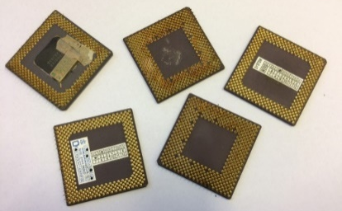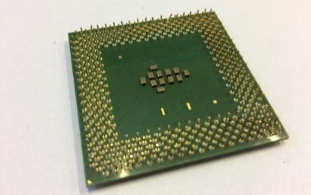
Fig. 1. On the left, a porcelain processor, on the right, a light processor

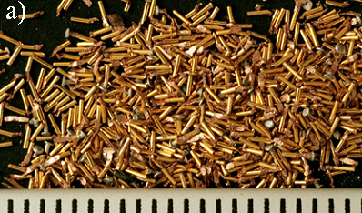 | 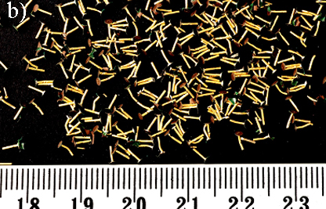
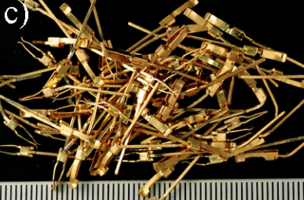
Fig. 2. Pins obtained after dismantling a CPU a) light b) ceramic c) PCB (printed circuit boards) subassembly

The preparation of the collected electronic scrap started with manual disassembly. First, CPUs were released from their sockets, and pins were removed from the components they were attached to. Ceramic CPUs are a rare raw material for gold recovery as their production stopped in 1999, and no additives in the form of precious metals were used in their production. Therefore, the pins from ceramic processors are expected to yield gold of relatively high concentration. Pins are extensions of electronic components that connect one element to another and are usually covered with a trace of gold to improve their conductivity (Lee et al. 2011).
Combining many tiny pins into one compact electrode (Fig. 3A) can be achieved in several ways: fusing the pins or pressing them (Vafaiee et al. 2019). In both the first and the second methods, fine copper powder or chips can be added (Fig. 2B) (Talebi et al. 2022). The addition of copper in a fine form fills the free spaces between the unevenly distributed pins and also forms a matrix in which, as a result of melting, the pins will be found (see Fig. 3C). Preferably, the copper used for compacting the anode is crude or scrap copper, as it can be refined by electro-refining. As a result of electro-refining, copper from raw copper and pins is transferred to the cathode. It is also possible that gold in the form of tiny flakes will float on the free surface of the electrolyte (yellow figures in Fig. 3).

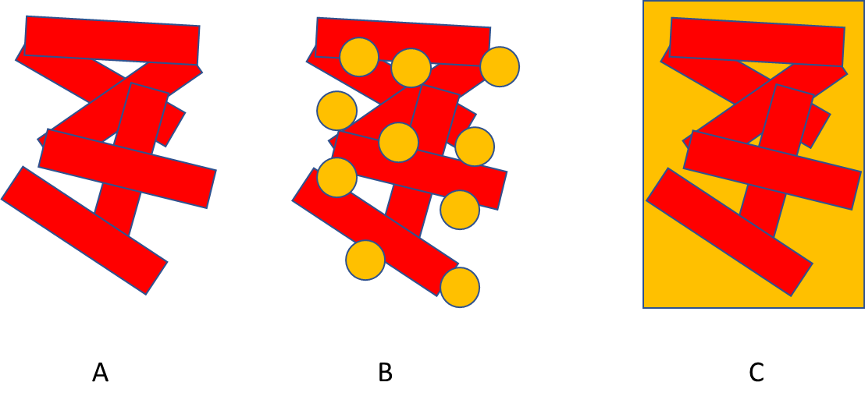
Fig. 3. The process of compacting the pins used as the anode: A) compressing the gold pins into a compact electrode, B) adding the copper powder to fill the existing gaps,
C) melting the pins and copper powder to form a uniform matrix

Compacted pins obtained after the dismantling of the CPU were oval, the total area of which (calculated as the sum of the areas parallel to the cathodes) was approx. 8 cm². The crucible used to cast the anode is shown in Fig. 4.

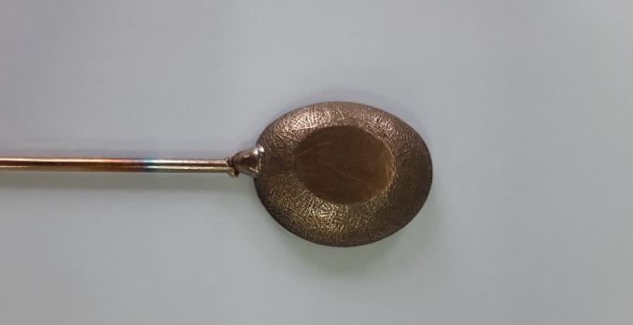
Fig. 4. Crucible for casting the anode
2.1. The Electro-refining Process and its Course
The electro-refining process was carried out in the configuration of one anode
– two cathodes. The cathodes were connected in series (Fig. 4).

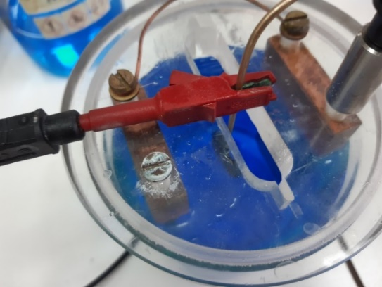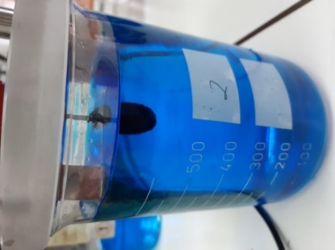
Fig. 5. Electrolyser in which the gold recovery process was carried out

In order to accelerate the electro-refining process, we used the electrolyte containing copper ions in the amount of 40 g Cu²⁺/l, sulfuric acid (VI) in the amount of 100 g H₂SO₄/l, and the following process parameters: 0.5 V and 0.5 A. The process parameters and the anode mass balance are summarised in Table 1.

Table 1. Parameters of the electro-refining process
Electrorefining parameters
voltage | 0.5 V | anode weight | 23.545 g
current | 0.5 A | anode slime mass | 0.981 g
anode surface | 7.912 cm²
During the electro-refining, gentle shaking of the anode was required as the anode got covered with anode sludge which would not fall off, effectively blocking the electrolysis process. Sludge was deposited at the bottom of the electrolyser. The entire process took five days. The anode did not completely dissolve due to solder breakage (possibly due to the electrolyte action) that connected the anode to the current source. Table 2 shows the chemical composition of the anode pre-process, post-process and anode sludge from industrial tests for comparison purposes.

Table 2. Chemical composition of the anode
Element | anode before  process [wt%] | anode after  process [wt.%] | anode sludge from test [wt.%] | industrial raw sludge (for comparison) [wt.%]
Ca | 0,1 | 0,18 | 0,4 | 0,9
Mn | 0,024 | nd | 0,031 | nd
Fe | 0,222 | 0,217 | 0,8 | nd
Ni | 1,54 | 2,59 | 6,18 | 0,3
Cu | 38,1 | 88,69 | 11,4 | 3,4
Ag | 0,41 | 0,15 | 1,2 | 37
Sn | 4,84 | 6,24 | 30,5 | nd
Au | 5,2 | 1,7 | 29,8 | 0
S | nd | 0,22 | nd | 20
Si | nd | nd | 0,6 | nd
Pb | 3 | nd | 19 | 36
Se | nd | nd | nd | 1,5

The anode contained 52% Au and approx. 40% Cu. As a result of the electro-refining, there was far less copper in the anode sludge compared to the anode composition, i.e. 11% Cu. Although unfortunately, other metals, such as nickel, tin and lead, also passed into the anode sludge in significant amounts, they can still be removed from the sludge in further steps of the gold recovery process. The added values of the process are obtaining gold concentrate in the form of anode sludge and recovering copper in metallic form as deposited on the cathodes. It is recommended that prior to remelting the pins, the tin, lead, iron and nickel should first be removed from their composition, e.g. by oxidative leaching in the NaOH-H₂O₂, then in diluted nitric acid (1 M) and/or in a mixture of sulfuric acid (VI) and organic acid (leaching reducing oxidised iron and nickel). These steps lead to the removal of less valuable impurities without damaging the copper.
Due to the small amounts of anode sludge obtained, the above-mentioned steps may be subsequent, i.e. follow the electro-refining process. The anode sludge was melted in the flame of an oxy-acetylene torch in a graphite crucible by adding borax. As a result of the melting, several metallic precipitates were obtained, which were then hot-incorporated into a sample 30 mm in diameter and 12 mm high. The metallographic examination was then performed.
2.2. Gold Alloy Finishing
Grinding and polishing were performed on STRUERS ROTOPOL-11 device. The process was carried out according to the following procedure:
Grinding:
- SiC sandpaper, grain size 320,
- SiC sandpaper, grain size 500,
- SiC sandpaper, grain size 800,
- SiC sandpaper, grain size 1200.
Polishing:
- MD-Largo disc using diamonds with a diameter of 9 µm sprayed with an atomiser bottle. STRUERS lubricant blue was used as the lubricant and coolant.
- MD-Mol disc using diamonds with a diameter of 3 µm sprayed with an atomiser bottle. STRUERS lubricant blue was used as the lubricant and coolant.
- MD-Mol disc using diamonds with a diameter of 1 µm sprayed with an atomiser bottle. STRUERS lubricant blue was used as the lubricant and coolant.

The last stage of preparation of the metallographic specimen was finishing polishing on the MD-Chem disc using the OP-S suspension by STRUERS (polishing time 150 s). The combination of chemical action and gentle abrasion of the material allows the samples obtained to be almost or entirely free of scratches and deformations. The samples prepared this way were then observed on the microscale. Hitachi SU-70 scanning microscope was used for observations.

Figures 6-8 present microstructures in different places of the sample, with magnification in the range from 500x to 5000x. A BSE detector was used for the observation. Additionally, the point analysis of the chemical composition and the map of the chemical decomposition were created to determine and confirm the presence of Au in the analysed area.

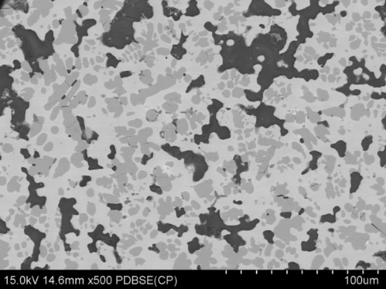
Fig. 6. The microstructure of the gold sample following the melting process
(x500 magnification)
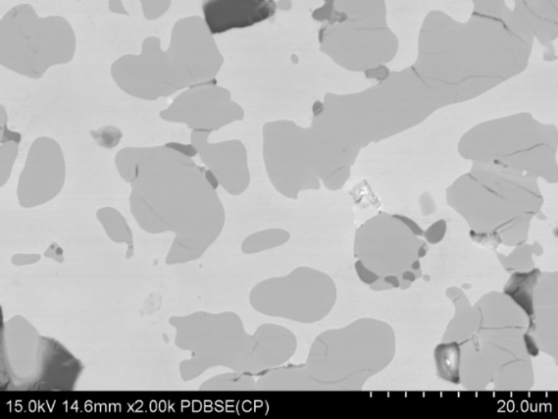
Fig. 7. The microstructure of the gold sample following the melting process
(x2000 magnification)
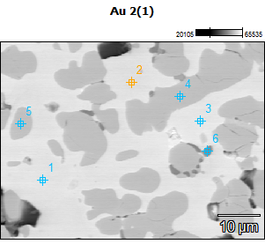
Fig. 8. Point analysis of the chemical composition

Table 3. The results of the point analysis of the chemical composition carried out in the places marked in Fig. 8 (wt.%)
Point number | Ni [wt.%] | Cu [wt.%] | Sn [wt.%] | Au [wt.%]
1 | 1.12 | 40.69 | 9.61 | 48.58
2 | 2.61 | 40.71 | 10.44 | 46.24
3 | 1.13 | 38.56 | 11.09 | 49.22
4 | 36.03 | 7.47 | 54.05 | 2.44
5 | 35.87 | 7.45 | 54.63 | 2.05
6 | – | 98.34 | 1.66 | –
3. Summary and conclusions
An alloy with a high concentration of gold was obtained as a result of the electro-refining process and melting of anode sludge,. The chemical analysis of the alloy and the images from the scanning microscope show the heterogeneous nature of the obtained alloy, revealing a thick, densely packed texture passing into a fine and coarse-porous surface at places. During the sludge smelting, the structure is transferred to the partially glassy phase, constituting a filling mass in which components, such as nickel, are suspended. Copper and gold create irregular or spherical forms up to several hundred micrometres in diameter, located within the transparent minerals.
Based on the research, the following conclusions can be drawn:
- methods of enriching electronic equipment waste by electro-refining lead to the reduction in the formation of gold-free wastewater. The sludge formed as a result of electro-treatment is easily separable from the solution, and after it has been dried, it can be subject to melting in a resistance furnace,
- the suggested method of compacting gold-plated pins from processors leads to the minimisation of losses of coexisting metals,
- in order to reduce the proportion of nickel in the alloy, it should be leached in diluted nitric acid (1 M) and/or in a mixture of sulfuric acid (VI), and organic acid,
- each type of electronic and electrical waste is structurally different, and its chemical composition is very diverse. Therefore, suggesting a universal method of processing it poses an extremely difficult challenge.

This research was supported by Polish National Centre for Research
and Development, grant number POIR.01.01.01-00-0362/19.
The work was supported by the specific university research of the Ministry of Education, Youth and Sports of the Czech Republic No. SP2022/27.

References
Burke, M. (2007). The gadget scrap heap, Chem. World, 45-48.
Chamier-Gliszczynski, N., Krzyzynski, T. (2005). On modelling three-stage system of receipt and automotive recycling. REWAS’04, Global Symposium on Recycling, Waste Treatment and Clean Technology 2005, 2813-2814, Madrid, Spain, 26-29 September 2004, Conference Paper, ISBN: 8495520060.
Chamier-Gliszczyński, N. (2010). Optimal Design for the Environment of the Means Transportation: A Case Study of Reuse and Recycling Materials. Sold State Phenomena, 165, 244-249. DOI: 10.4028/www.scientific.net/SSP.165.244
Chamier-Gliszczyński, N. (2011). Recycling Aspect of End-of Life Vehicles. Recovery of Components and Materials from ELVs. Key Engineering Materials, 450, 421-424. DOI: 10.4028/www.scientific.net/KEM.450.421
Chamier-Gliszczyński, N. (2011a). Reuse, Recovery and Recycling System of End-of Life Vehicles. Key Engineering Materials, 450, 425-428. DOI: 10.4028/www.scientific.net/KEM.450.425
Chamier-Gliszczyński, N. (2011b). Environmental aspects of maintenance of transport means, end-of life stage of transport means. Eksploatacja i Niezawodnosc - Maintenance and Reliability, 50(2), 59-71. http://ein.org.pl/podstrony/wydania/50/pdf/07.pdf
Chmielewski, A.G., Urbański, T.S., Migdał, W. (1997). Separation technologies for metals recovery from industrial wastes, Hydrometallurgy, 45, 333-344.
Cyganowski, P., (2017), The recovery of gold from the aqua regia leachate of electronic parts using a core-shell type anion exchange resin, Journal of Saudi Chemical Society, 21(6), 1-12.
Gabryelewicz, I., Lenort, R., Wędrychowicz, M., Krupa, P., Woźniak, W. (2021). Environmental Loads Resulting from Manufacturing Technology, Rocznik Ochrona Srodowiska, 23, 613-628. DOI: 10.54740/ros.2021.043
Guadalupe, M.B., Valenzuela-García J.L., Gómez-Alvarez, A., Encinas-Romero, A.M., Mejía-Zamudio, F.A., Rosas-Durazo, A.J., Valenzuela-Frisby, R. (2021). Recovery of Ag, Au, and Pt from Printed Circuit Boards by Pressure Leaching. Recycling, 6(4), 67. DOI: 10.3390/recycling6040067
Kosacka-Olejnik, M., Kostrzewski, M., Marczewska, M., Mrówczyńska, B., Pawlewski, P. (2021). How Digital Twin Concept Supports Internal Transport Systems? – Literature Review. Energies, 14, 4919. DOI: 10.3390/en14164919
Kostrzewski, M. (2018). One Design Issue – Many Solutions. Different Perspectives of Design Thinking – Case Study. In: Uden L., Hadzima B., Ting IH. (eds) Knowledge Management in Organisations. KMO 2018. Communications in Computer and Information Science, 877, 179-190. Springer, Cham, DOI: 10.1007/978-3-319-95204-8_16
Lee, C.H., Tang, L.W., Popuri S.R. (2011). A study on the recycling of scrap integrated circuits by leaching, Waste Management & Research., 29, 677-685.
Lei, L.I., Song, W., GuoDong, W., Heng, W., ShiDing, W. (2020), Extraction of platinum and gold from copper anode slimes by a process of chlorinating roasting ﬁrst and chlorinating leaching followed. Journal of Mining and Metallurgy Section B: Metallurgy, 56, 193-202.

Lenort, R., Baran, J., Wysokiński, M., Gołasa, P., Bieńkowska-Gołasa, W., Golonko, M., Chamier-Gliszczyński, N. (2019). Economic and environmental efficiency of the chemical industry in Europe in 2010-2016. Rocznik Ochrona Srodowiska, 21(2), 1398-1404.
Marko, A. (2022), European standardisation strategy,
https://www.bitkom.org/sites/main/files/2022-05/220225_Stellungsnahme_Europ%C3%A4ische_Normungsstrategie_eng.pdf [01.04.2022].
Marsden, J. House, I. (2006). The Chemistry of Gold Extraction Society for Mining, Metallurgy, and Exploration: Littleton, CO, USA.
Mehr, J., Haupt, M. (2021). The environmental performance of enhanced metal recovery from dry municipal solid waste incineration bottom ash, Waste Management, 119, 330-341.
Mohaddeseh, V., Manouucher, V., Raheleh, M., Pezhman, S. (2019). Gold-Plated Electrode with High Scratch Strength for Electrophysiological Recordings, Scientific Reports volume 9, Article number: 2985.
Park, Y.J., Fray, D.J. (2009). Recovery of high purity precious metals from printed circuit boards, Journal of Hazardous Materials, 164, 1152-115.
Petter, P.M.H., Veit, H.M., Bernardes, A.M. (2014). Evaluation of gold and silver leaching from printed circuit board of cellphones, Waste Manag., 34, 475-482.
Sheng, P.P., Etsell, T.H. (2007). Recovery of gold from computer circuit board scrap using aqua regia, Waste Management & Research, 25, 380-383.
Sum, E.Y.L. (1991). The recovery of metals from electronic scrap, The Journal of The Minerals, Metals & Materials Society, 43, 53-61.
Syed, S. (2012). Recovery of gold from secondary sources - A review, Hydrometallurgy, 115, 30-51.
Talebi, F., Ghafoorifard, H., Ghafouri-Fard, H., Jahanshahi, A., Daveci, H. (2022). A straight-forward, inexpensive, low power continuous-flow µPCR chip using PCB-based heater electrodes with uniform temperature distribution, Sensors and Actuators A: Physical, 333(1).
Tuncuk, A., Stazi, V., Akcil A., Yazici, E.Y., Deveci, H. (2012). Aqueous metal recovery techniques from e-scrap: Hydrometallurgy in recycling. Miner. Eng., 25, 28-37.
Wędrychowicz, M., Piotrowicz, A., Noga, P. (2022). Badania nad metodą recyklingu złota ze zużytego sprzętu elektrycznego i elektronicznego na drodze elektrorafinacji miedzi. Sprawozdanie wewnętrzne na zlecenie firmy nr UZ/IIMiB/3/2022, Zielona Góra.
Woźniak, W., Jakubowski, J. (2015). The choice of the cost calculation concept for the mass production during the implementation of the non-standard orders. 26th International-Business-Information-Management-Association Conference – IBIMA 2015, Madrid, Spain, pp. 2364-2371, ISBN: 9780986041952
Xiu, F.R., Zhang, F.S. (2009). Electrokinetic recovery of Cd, Cr, As, Ni, Zn and Mn from waste printed circuit boards: Effect of assisting agents, Journal of Hazardous. Materials, 170(1), 191-196.

