 | Rocznik Ochrona Środowiska
 | Volume 24 | Year 2022 ISSN 2720-7501 | pp. 360-370
 | https://doi.org/10.54740/ros.2022.025 open access
 | Received: 16 October 2022 Accepted: 24 November 2022 Published: 30 November 2022
Ecological Aspects in the Process
of Turning Cast Iron with Coated Tools
Mariusz Jenek
Department of Materials Science, Technology and Maintenance,
Institute of Mechanical Engineering, Faculty of Mechanical Engineering,
University of Zielona Góra, Poland
https://orcid.org/0000-0001-8310-3678
Michał Ociepa
Faculty of Mechanical Engineering, University of Zielona Góra, Poland
https://orcid.org/0000-0003-4937-6044
Waldemar Woźniak*
Department of Production and Transport Engineering,
Institute of Materials and Biomedical Engineering, Faculty of Mechanical Engineering,
University of Zielona Góra, Poland
https://orcid.org/0000-0002-4703-6823
Šárka Vilamová
Faculty of Materials Science and Technology,
VŠB – Technical University of Ostrava, Czech Republic
https://orcid.org/0000-0002-6486-7995
Eva Švecová
Faculty of Materials Science and Technology,
VŠB – Technical University of Ostrava, Czech Republic
https://orcid.org/0000-0002-8277-8590
*corresponding author’s email: w.wozniak@iizp.uz.zgora.pl
Abstract: The article presents the research results on the influence of the PVD coating on the cutting tool on the surface roughness and energy consumption in the cast iron turning process. It was shown that using coated tools leads to obtaining a surface qualitatively corresponding to the ground surface and to reducing the power consumption of the machine tool. In addition, the process itself, carried out without a cooling and lubricating liquid, is more eco-friendly, as it excludes its use, disposal and negative environmental impact.
Keywords: machining, PVD coatings, machine power consumption

1. Introduction
When analysing the ecological aspects of a product’s life cycle, we refer to the respective stages of this cycle. One such stage is production, where machining, as one of the basic manufacturing technologies, affects the environment. The demand of technological devices for electricity, technological fluids used in the technological process, and the use of tools and materials all make it necessary to engage in the recovery and recycling processes (Wędrychowicz 2021, Chamier-Gliszczyński 2011, Chamier-Gliszczyński 2011a). Activities aimed at managing post-production waste and waste in the form of end-of-life products are essential at this stage (Chamier-Gliszczynski & Krzyzynski 2005, Chamier-Gliszczyński 2010, Chamier-Gliszczyński 2011b). In the case of machining, increasing the environmental friendliness of production processes can be achieved by increasing the tool’s durability, eliminating operations, reducing the consumption of electricity necessary to carry out the process, and minimising or even eliminating cooling and lubricating liquids. Most conventional cooling and lubricating liquids are based on mineral oils enriched with emulsifiers and special additives (Bianchi et al. 2011). Their chemical composition threatens the environment (Gabryelewicz 2020) and machine tool operators’ health and life (Brinksmeier et al. 1999, Fratila 2010, Pusavec et al. 2010). Technologies and sustainable development of production operations and systems are accompanied by a simultaneous increase in the collection and availability of data in the production hall, as well as an improvement in raw material flows (Zwolińska et al. 2020), which generally translates into an increase in the quality of the end products. These processes can be further enhanced by tailoring them to the needs of specific users and customers who, through participation in the processes and operations, can lead to their improvement (e.g. as a result of the use of non-classical design methods such as design thinking, prediction markets, computational simulation methods (Kostrzewski 2018, Czwajda et al. 2019).
Starting from the 1960s, the most important direction in the development of cutting tools has been their coating with hard, wear-resistant layers with a thickness of several to a dozen micrometres, significantly extending their life (Wysiecki 1997).
As for cutting tools, there are currently two groups of thin-layer deposition techniques that are employed in industrial practice:
- CVD (chemical vapour deposition),
- PVD (physical vapour deposition).

In terms of their structure, anti-wear coatings can be divided into:
- single-layer (simple or complex, multi-component, metastable, multiphase, gradient),
- multi-layer (Kupczyk 2004).
Compared to CVD technology, PVD techniques offer several advantages, including:
- the possibility of using pure metals and gases as starting materials instead of often harmful compounds,
- ecological purity of the process,
- virtually any combination of substrates,
- the possibility of producing non-equilibrium and non-stoichiometric coating materials with different properties,
- possibility of producing composite layers in technological devices,
- the lower temperature of coatings production than in CVD processes, extending the spectrum of base materials (Kula 2000).

Coatings mounted on the tool should meet the following requirements:
- they should not deteriorate the mechanical properties of the substrate,
- they should improve tribological properties,
- compressive self-stresses should be present in the coating,
- the adhesive bond of the coating with the substrate should be strong, and the adhesive force should compensate for the stresses present in the coating (Burakowski & Wierzchoń 1995).

It should be noted that the use of coatings for cutting tools contributes to increasing their durability, reducing cutting force, lowering the temperature within the cutting zone, reducing frictional forces, and an increase in the cutting speed as well as extending the tool’s working time between tool sharpening (replacement) operations (Przybylski 2000).
Simultaneously, using tools with coatings may eliminate the elements of the grinding process and the use of cooling and lubricating liquids from the manufacturing processes, making the technological process simpler and more ecological.
Based on the analysis of the literature on the issues related to machining with coated tools, the research aimed to determine the possibility of obtaining elements of similar or better quality parameters in the technological process while increasing the environmental friendliness of the process by eliminating cooling and lubricating liquids from the production process and reducing the consumption of electricity.
2. Own Research
The research was devoted to assessing the influence of the coating on the surface roughness and energy consumption by the machine tool in the turning process. K10 cemented carbide plates were used in the tests, on which coatings with the recommended composition of (TiCr)N and thicknesses of 2 and 4 micrometres were applied at the Center for Physical and Technological Research at the Department of Highly Effective Machining Technologies at MGTU Stanskin in Moscow (Grigoriev & Volosova 2007, Vasin et al. 2001). The plates were mounted in a CSRPR 20-12 turning holder (according to ISO 5608), which geometry is shown in Fig. 1. The tests were carried out on a CU502 universal lathe.

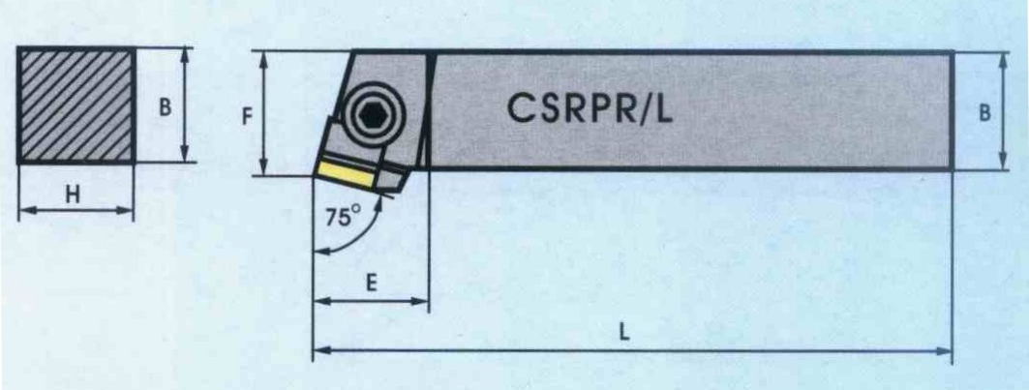

Marking | H | B | L | F | E | λ_{s} | γ_{ο}
CSRPR 2020-12 | 20 | 20 | 125 | 25 | 25 | 0° | 5°
Fig. 1. The geometry of the turning tool used in the research (PAFANA tools catalogue)
The turning was performed on GJV350 cast iron rollers with a diameter of 45 mm, the chemical composition of which is presented in Table 1.

Table 1. Chemical composition and properties of the cast iron used for the tests
C | Si | Mn | P | S | Cr | R_{m}
3.64 | 2.57 | 0.337 | 0.016 | 0.014 | 0.027 | 347 MPa
Mo | Ni | Al. | Cu | Mg |  | A₅
0.011 | 0.011 | 0.009 | 0.068 | 0.025 |  | 4.3%
The following machining parameters were applied in the tests:
- cutting speed v_{c} = 100, 140, 200 [m/min],
- feed f = 0.10, 0.15, 0.20 [mm/rev.],
- depth of cut a_{p} = 0.5, 1.0, 1.5 [mm].

Seven surface roughness measurements were performed on each tested surface using Tr-200 profilographometre. The obtained results were statistically processed using the Statistica program.
The machine power consumption tests were carried out using the MPS 7 network parameter meter manufactured by Metrol Research and Development Institute of Electrical Metrology in Zielona Góra, which was connected to the lathe’s electrical system. In order to determine the influence of the coating and its thickness on the electric energy consumption, the active power of the machine tool was read first, with all the relations of the tested parameters included in the test plan, while running the machine idle. Then, the power consumption during machining was measured. The difference between the active power consumed during machining and the power consumed while operating in the idle gear, with the same parameters, was assumed as the power lost on cutting. Finally, all the collected results were entered into the Statistica program for statistical processing and obtaining mathematical dependencies.
3. Findings
The research was carried out according to the experimental design on 27 samples and involved seven repetitions. Based on the results of surface roughness measurement using mathematical statistics, the following mathematical dependency was obtained, describing the changes in roughness as a function of the machining parameters analysed. Only statistically significant factors were included in the presented dependency.
A model with two-factor linear-quadratic interactions (R² = 0.963)
$$Ra=3748.431829a_{p}∙g-857979.824544a_{p}∙g^{2}-1809.253634a_{p}^{2}∙g$$$+ 396218.796984a_{p}^{2}∙g^{2}+0.343855v_{c}∙f-1.092566v_{c}∙f^{2}$ (1)
where:
a_{p} – depth of cut [mm],
f – feed [mm/rev],
v_{c} – cutting speed [m/min],
g – coating thickness [μm].
Figures 2, 3 and 4 show the diagrams of the above-mentioned mathematical dependency obtained in the course of turning of GJV 350 cast iron with a tool made of tungsten carbide coated with a (TiCr)N coating with thicknesses 2 and 4 μm.
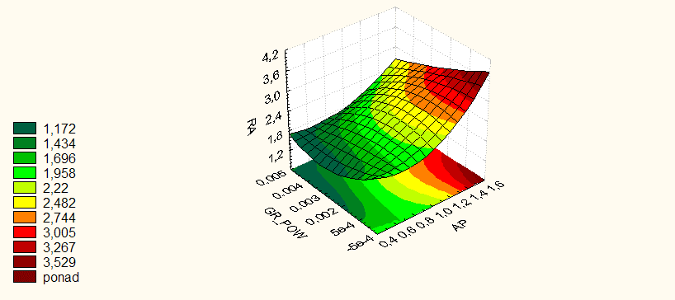
Fig. 2. Diagram of changes in surface roughness as a function of coating thickness and depth of cut. Constant feed and cutting speed (f = 0.15 mm/rev, v_{c} = 145 m/min)

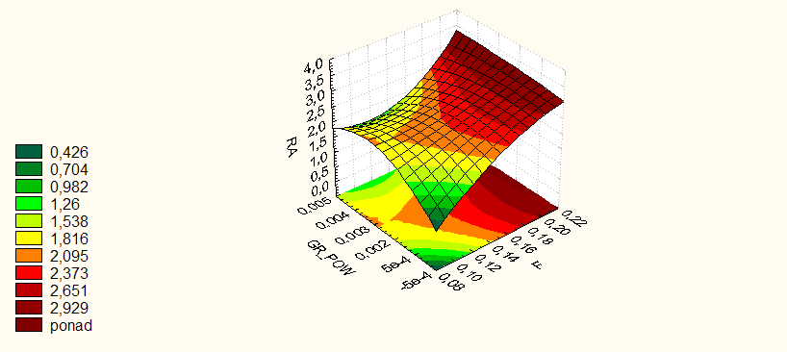
Fig. 3. Diagram of changes in surface roughness as a function of coating thickness and feed. Constant cutting depth and speed (a_{p} = 1.0 mm, v_{c} = 145 m/min)
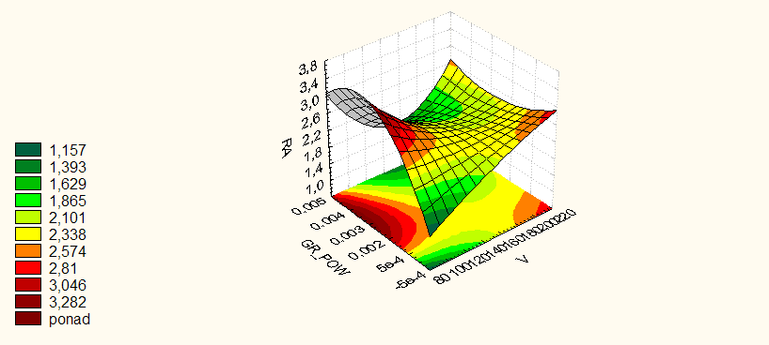
Fig. 4. Diagram of changes in surface roughness as a function of coating thickness and speed of cut. Constant feed and depth of cut (f= 0.15 mm/rev, and_{p} = 1.0 mm)

The research on the active power consumed by the machine tool during machining allowed us to arrive at the mathematical dependency. For the (TiCr) N coating, a mathematical model was obtained (R² = 0.984):
$$P=0.995-0.070a_{p}-0.231a_{p}^{2}+116.828g+138.889g^{2}-0.015v_{c}$$$+0.0000342v_{c}^{2}-4.686f+2.047f^{2}-67.045a_{p}∙g+0.0067a_{p}∙v_{c}+3.016a_{p}∙f-0.282g∙v_{c}-130.051g∙f+0.032v_{c}∙f$ (2)
where:
a_{p} – depth of cut [mm],
f – feed [mm/rev],
v_{c} – cutting speed [m/min],
g – coating thickness [μm].
In Fig. 5, 6 and 7, the effect of the coating thickness on the tool and the technological parameters of the processing on the active power consumption of the machine tool in the cast iron turning process is visually presented.
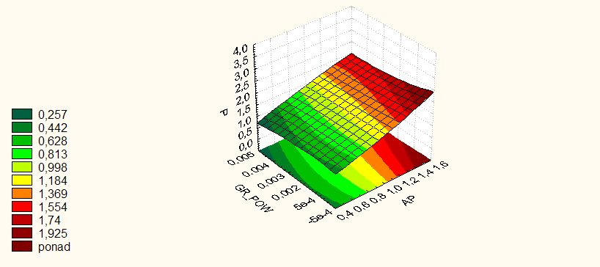
Fig. 5. Diagram of changes in effective electrical power as a function of coating thickness and depth of cut. Constant feed and cutting speed (f = 0.28 mm/rev,
v_{c} = 140 m/min)

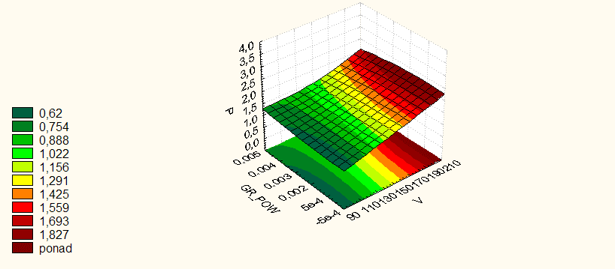
Fig. 6. Diagram of changes in active power as a function of coating thickness and speed of cut. Constant feed and depth of cut (f = 0.28 mm/rev, and_{p} = 1.0 mm)
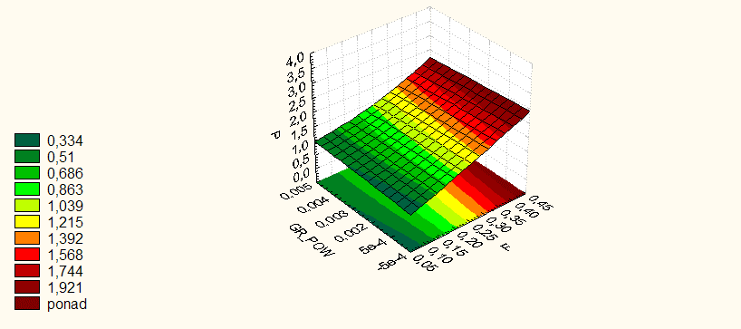
Fig. 7. Diagram of changes in effective electrical power as a function of coating thickness and feed. Constant cutting speed and depth(v_{c} = 140 m/min., a_{p} = 1.0 mm)

When analysing the test results of the (TiCr)N coating (Figs. 5-7), it should be noted that the application of the coating caused a reduction (about 10%) of the active power consumed by the lathe. The power reduction is more noticeable when machining with higher technological parameters. As the tool’s coating thickness increases, a slight power consumption increase can also be noticed. It may be due to the increase in the rounding radius of the cutting edge with the increase in coating thickness. At small values of the thickness of the machined layer, the increase in resistance resulting from the increase in the rounding of the cutting edge is more significant. On the other hand, technological parameters of machining increase causes an increase in cutting resistance resulting from the increase in the radius of the rounding of the cutting edge is smaller than the dissipation of energy on the friction of the chip against the rake surface of the tool.
4. Conclusions
Summing up the research, it should be stated that the (TiCr)N coating on the K10 tool material is of significant importance to the stereometric condition of the surface layer. It should be noted that with the increase in the technological parameters of the machining, especially the thickness of the scarred layer a_{p}, an increase in the thickness of the coating leads to a decrease in surface roughness (Fig. 2). The tests carried out also show the possibility of maintaining and even reducing the surface roughness while increasing the machining parameters for tools made of conventional materials to which coatings have been applied. In technically justified cases, this offers the possibility of eliminating the grinding process. And in turn, it leads to a reduction in production costs and an increase in the environmental friendliness of the process as a result of the lack of cooling and lubricating liquids used in grinding processes. Power consumption tests showed a significant effect of the coating thickness on the cutting tool on energy consumption in the cast iron turning process (Fig. 5-7). In future research, sensitivity analysis may be carried out for the process under consideration (Kostrzewski 2020). It seems advisable to conduct further research on the proper selection of the type and thickness of the coating on the tool for processing individual types of materials in order to reduce electricity consumption and the possibility of eliminating the cooling-lubricating liquid from the technological process.

This research was funded by the Polish Minister of Education and Science
under the program “Regional Initiative of Excellence” in 2019-2022,
project No. 003/RID/2018/19, funding amount PLN 11 936 596.10.
The work was supported by the specific university research of the Ministry of Education, Youth and Sports of the Czech Republic No. SP2022/27.
References
Bianchi, E.C., Aguiar, P.R., Diniz, A.E., Canarim, R.C. (2011). Optimisation of ceramics grinding. Advances in Ceramics-Syntezis and Characterization. Processing and Specific Application. InTech.
Brinksmeier, E., Heinzel, C., Wittmann, M. (1999). Friction, cooling and lubrication in grinding. Annals of the CRIPP, 48(1999)2, 581-598.
Burakowski, T., Wierzchoń, T. (1995). Inżynieria powierzchni metali. WNT Warszawa (in Polish).
Chamier-Gliszczynski, N., Krzyzynski, T. (2005). On modelling three-stage system of receipt and automotive recycling. REWAS’04, Global Symposium on Recycling, Waste Treatment and Clean Technology 2005, 2813-2814, Madrid, Spain, 26-29 September 2004, Conference Paper, ISBN: 8495520060.
Chamier-Gliszczyński, N. (2010). Optimal Design for the Environment of the Means Transportation: A Case Study of Reuse and Recycling Materials. Sold State Phenomena, 165, 244-249. DOI: 10.4028/www.scientific.net/SSP.165.244
Chamier-Gliszczyński, N. (2011). Recycling Aspect of End-of Life Vehicles. Recovery of Components and Materials from ELVs. Key Engineering Materials, 450, 421-424. DOI: 10.4028/www.scientific.net/KEM.450.421
Chamier-Gliszczyński, N. (2011a). Reuse, Recovery and Recycling System of End-of Life Vehicles. Key Engineering Materials, 450, 425-428. DOI: 10.4028/www.scientific.net/KEM.450.425
Chamier-Gliszczyński, N. (2011b). Environmental aspects of maintenance of transport means, end-of life stage of transport means. Eksploatacja i Niezawodność – Maintenance and Reliability, 50(2), 59-71. http://ein.org.pl/podstrony/wydania/50/pdf/07.pdf
Czwajda, L., Kosacka-Olejnik, M., Kudelska, I., Kostrzewski, M., Sethanan, K., Pitakaso, R. (2019). Application of prediction markets phenomenon as decision support instrument in vehicle recycling sector. LogForum, 15(2), 265-278. DOI: 10.17270/J. LOG.2019.329
Fratila, D. (2010). Macro-level environmental comparison of near-dry machining and flood machining. Journal of Cleaner Production, 18, 1031-1039.
Gabryelewicz, I., Stryjski, R., Wędrychowicz, M., Dąbrowski, T. (2020). The State of the Air Quality in Poland, Rocznik Ochrona Środowiska, 22, 998-1013.
Grigoriev, S.N, Volosova, M.A. (2007). Nanoszenie powłok i modyfikacja powierzchniowa narzędzi. MGTU Stankin Moskwa (in Russian).
Kostrzewski, M. (2020). Sensitivity Analysis of Selected Parameters in the Order Picking Process Simulation Model, with Randomly Generated Orders. Entropy, 22(4), 423. DOI: 10.3390/e22040423
Kostrzewski, M. (2018). One Design Issue – Many Solutions. Different Perspectives of Design Thinking – Case Study. In: Uden, L., Hadzima, B., Ting, I.H. (eds) Knowledge Management in Organisations. KMO 2018. Communications in Computer and Information Science, 877, 179-190. Springer, Cham. DOI: 10.1007/978-3-319-95204-8_16
Kula, P. (2000). Inżynieria warstwy wierzchniej. Wydawnictwo Politechniki Łódzkiej
(in Polish).
Kupczyk, M. (2004). Inżynieria powierzchni. Powłoki przeciwzużyciowe na ostrza skrawające. Wydawnictwo Politechniki Poznańskiej 2004 (in Polish)
Przybylski, L. (2000). Strategia doboru warunków obróbki współczesnymi narzędziami. Politechnika Krakowska (in Polish).
Pusavec, F., Krajnik, D., Kopac, J. (2010). Transitioning to sustainable production – Part I: Application on machining technologies. Journal of Cleaner Production, 18, 1211-1221.
Wędrychowicz, M., Besta, P., Gabryelewicz, I., Stryjski, R., Krupa, P. (2021). The Recycling of Secondary Waste in Polish Recycling Companies. Rocznik Ochrona Środowiska, 23, 715-730. DOI: 10.54740/ros.2021.050
Wysiecki, M. (1997). Nowoczesne materiały narzędziowe. WNT, Warszawa (in Polish).
Vasin, S.A., Vereshchaka, A.S., Kushneer, V.C. (2001). Skrawanie materiałów. Wydawnictwo MGTU Baumana, Moskwa (in Russian).
Zwolińska, B., Tubis, A.A., Chamier-Gliszczyński, N., Kostrzewski, M. (2020). Personalization of the MES System to the Needs of Highly Variable Production. Sensors, 20, 6484. DOI: 10.3390/s20226484
Katalog narzędzi firmy PANANA tools catalogue – https://pafana.pl

