|  |  |  |  |
| --- | --- | --- | --- |
|  |  | | |
| **Rocznik Ochrona Środowiska** | | |
| Volume 24 | Year 2022 ISSN 2720-7501 | pp. 345-359 |
|  | https://doi.org/10.54740/ros.2022.024 open access | | |
|  | Received: 06 October 2022 Accepted: 23 November 2022 Published: 27 November 2022 | | |

Distribution of Selected Drug-resistant *Enterococcus* Species   
in Meat Plants in Poland

Anna Ławniczek-Wałczyk*

Department of Chemical, Aerosol and Biological Hazards,   
Central Institute for Labour Protection – National Research Institute, Warsaw, Poland

https://orcid.org/0000-0001-8234-340X

Marcin Cyprowski

Department of Chemical, Aerosol and Biological Hazards,   
Central Institute for Labour Protection – National Research Institute, Warsaw, Poland  
https://orcid.org/0000-0001-6704-4567

Rafał L. Górny

Department of Chemical, Aerosol and Biological Hazards,   
Central Institute for Labour Protection – National Research Institute, Warsaw, Poland  
https://orcid.org/0000-0001-5703-5835

*corresponding author’s e-mail: anlaw@ciop.pl

**Abstract:** This study aimed to assess the prevalence of enterococci (including vancomycin-resistant, VRE) strains in meat plants and evaluate their biofilm-forming potential. In two Polish meat plants, 75 samples of raw pork meat, swabs from work surfaces (floors, tables, machine parts and tools) and employees’ hands were collected. The analyses indicated that enterococci were present in more than 72% of the tested samples. In addition, VRE isolates were found in more than 25% of the tested samples (especially in cutting and processing rooms). VRE strains of *Enterococcus faecium* and *E. faecalis* were resistant to penicillin, ampicillin, erythromycin, and rifampicin. Moreover, 77% of *E. faecium* and 43% of *E. faecalis* isolates showed biofilm-forming ability. The observed high biofilm-forming potential among the analyzed VRE strains indicates that these agents may play an essential role in spreading drug resistance in the food chain through contaminated surfaces, meat, and workers’ hands.

**Keywords:** enterococci, antibiotic resistance, biofilm, meat production

1. Introduction

Bacteria of the *Enterococcus* genus are essential to the microbiota colonizing the gastrointestinal tract of healthy humans and animals. Enterococci are also quite common in the environment, especially in soil, water, and on plants. As enterococci enhance nutrition absorption from the gastrointestinal tract and help maintain the proper balance of the intestinal microbiota, they are used as probiotics in both humans and livestock (Lebreton et al. 2014). Enterococci also belong to the lactic acid bacteria (LAB) group, which are used as starter cultures in producing fermented foods such as sausages, cheeses or ham. Research on the use of bacteriocins produced by some enterococci as antimicrobial agents in the treatment of difficult bacterial infections and food preservation (e.g., meat, dairy, and vegetarian products) has been ongoing for many years (Hanchi et al. 2018). Despite their many favourable uses, these Gram-positive bacteria are also considered etiologic agents of endocarditis, vascular bed infections and urinary tract infections in humans and animals. The clinical importance of enterococci is highlighted by their low sensitivity to a wide range of antimicrobial drugs, including aminoglycosides, cephalosporins, and sulfonamides. Therefore, therapeutic options for treating enterococcal infections are increasingly limited. Currently, diseases caused by vancomycin-resistant enterococci (VRE), which account for one-third of all nosocomial infections worldwide, are of great public health importance (Zhao et al. 2022). In particular, diseases caused by *E. faecium* and *E. faecalis* are associated with significant morbidity, mortality and the resulting economic burden in many countries worldwide (Lawpidet et al. 2021). In 2017 only in the USA, VRE bacteria caused 54,500 infections and were responsible for 5,400 deaths (CDC 2019). It is estimated that about 40% of all infections caused by this bacterial group occur outside the hospital environment. The scientific literature shows that many species of drug-resistant enterococci can be found in raw and ready-to-eat animal and plant products (Giraffa 2002, Said et al. 2022). Enterococci from animal sources commonly possess a high capacity to acquire and accumulate antibiotic resistance through easy gene exchange between different bacterial strains, species, and even genera. Hence, the associated risk of human infections through contaminated food products of animal origin is highly probable (Galié et al. 2018, Zhao et al. 2022). While drug-resistant enterococci from food have not been clearly identified as a direct cause of clinical infections, consuming contaminated meat and contacting slaughtered animals is a highly probable pathway for their spread. It may result in the transfer of antibiotic-resistance genes into the microbiota colonizing the human gastrointestinal tract (Lawpidet et al. 2021).

One of the important virulence factors in foodborne pathogens is their ability to form multicellular biofilms organized clusters of microorganisms surrounded by extracellular polymeric substances (EPS) that they secrete. The biofilm formation by bacteria on surfaces having direct contact with meat increases their resistance to drying, temperature changes, mechanical damage, and chemicals used in sanitization and disinfection processes in the meat industry (Galié et al. 2018). About 80% of all bacterial infections are considered to be associated with biofilm formation on biological and abiotic surfaces. In addition, biofilm-forming enterococci are the etiologic agents of many nosocomial infections (including wounds, respiratory, urinary, and gastrointestinal contagions) (Ch’ng et al. 2019). Although procedures and chemicals used for cleaning and disinfection in the meat industry are constantly improving, the knowledge of their appropriate selection for the specific production technology and the types of biohazards is not widely available. Hence, the biofilm is not effectively removed from surfaces and often becomes an active source of contamination in meat plants (Galié et al. 2018, Zhu et al. 2022).

Due to their naturally high resistance to adverse environmental conditions occurring during various technological processes in meat processing, enterococci can be an important indicator of proper hygienic quality of products, surfaces and workers’ hands in production facilities. Data on the prevalence of antibiotic-resistant enterococci on contact surfaces in meat plants are still scarce. However, they would be extremely useful in assessing the spread of antibiotic resistance genes in the meat food chain. Hence, this study aimed to assess the prevalence of vancomycin-resistant enterococci strains in meat plants and to evaluate their biofilm-forming potential.

2. Materials and Methods

The study was conducted in two meat plants in the Mazovia Province (Central Poland), processing about 20-100 pork carcasses daily. The technological process in both plants was subjected to strict veterinary control. It was under the systems of good hygiene practice (GHP), good manufacturing practice (GMP), good veterinary practice (GVP), and Hazard Analysis and Critical Control Points (HACCP).

2.1. Sampling and Identification of Enterococci

A total of 75 samples were collected, including 45 swab samples from usable surfaces (i.e., cutting, de-boning and preparation tables, floors, doors, machine parts, and tools), 20 swabs from employees’ hands, and 10 samples of raw meat. The surfaces were previously subjected to a cleaning and disinfection procedure before testing, according to the daily hygiene plan of the tested plants. Swabs from usable surfaces and hands were taken with sponges soaked in a buffer that allows efficient quantitative recovery of microorganisms (Whirl-Pak® Hydrated Speci-Sponge® Bags, Madison, USA) following PN-A-82055-19. Swabs from workers’ hands were collected after washing them with soap and disinfectant from the surfaces of both hands (from between the fingers and the outer parts of the fingers, including around the fingernails).

After sponges were extracted in a suitable medium, inoculations were made on the following microbiological media (bioMérieux SA, Marcy l’ Etoile, France): bile and esculin agar (DCO) and tryptose-soy agar with 5% addition of de-fibered sheep blood (TSA). Brilliance VRE Agar (Oxoid, Basingstoke, UK) was used for screening vancomycin-resistant isolates. Samples of raw pork meat (25g) were taken using sterile instruments into bags containing buffered peptone water solution for homogenization. The diluted meat samples were spread on analogous microbiological media as for surface swabs. After a 24 h incubation period at 36°C, the concentration of bacteria was determined: a) for surface samples – in colony-forming units (CFU) per 1 cm2 of the tested surface (CFU/cm2); b) for hand swabs in CFU per 1ml of washings (CFU/ml); c) for meat samples in CFU per 1 g of meat. Each sample was analyzed in triplicate.

Qualitative analysis of bacteria isolated from the samples was carried out by culture methods and subsequently elaborated by macro- and microscopic observations followed by biochemical characterization of the isolated strains (Rapid tests, Oxoid). The strains, which biochemical profile did not allow reliable identification, were additionally analyzed using a MALDI-TOF mass spectrometer (Bruker Daltonics, Bremen, Germany).

2.2. Antimicrobial Susceptibility Testing

Determination of the susceptibility of *Enterococcus* bacteria to antibiotics was carried out by the disk-diffusion method according to the recommendations of EUCAST (European Committee on Antimicrobial Susceptibility Testing, 2022). For this purpose, a suspension of isolated species was prepared from a 24 h fresh bacterial culture in sterile physiological NaCl solution (0.85%) and set at 0.5 on the McFarland scale. Then, using a sterile swab, the suspension was spread three times over the entire surface of Mueller-Hinton medium (MHA, bioMérieux SA), turning the plate 60° each time. Discs with selected antibiotics were placed on the inoculated medium. The plates were incubated under aerobic conditions for 16-18 h at 35°C, and after incubation, the diameter of the inhibition zone of microbial growth was measured. The tested antibiotics were as follows: penicillin (10 µg), ampicillin (10 µg), cefotaxime (30 µg), imipenem (10 µg), kanamycin (30 µg), gentamicin (30 µg), norfloxacin (10 µg), levofloxacin (5 µg), erythromycin (15 µg), quinupristin/dalfopristin (15 µg), tetracycline (30 µg), rifampicin (5 µg), sulfamethoxazole+trimethoprim (1.25-23.75 µg), linezolid (10 µg), fosfo-mycin (50 µg), nitrofurantoin (100 µg), and vancomycin (5 µg).

2.3. Biofilm Formation Assay

Evaluation of the biofilm-forming ability of the isolated strains was carried out using a modified microplate method (Stepanović et al. 2007). For this purpose, 24h bacterial colonies were suspended in sterile saline to obtain a starter suspension with a density of 0.5 on the McFarland scale (108 CFU/ml). Then, 180 µl of TSB medium with 1% glucose (Oxoid) was applied to the microplate each time, and 20 µl of the starter suspension was added in 8 replicates. The negative control was 200 µl of TSB medium in 8 replicates. The positive control was a suspension with the biofilm-forming strain *S. epidermidis* ATCC 35984. The coated plate was incubated for 24h at 36°C. After this time, microplate wells were washed 3 times with sterile PBS buffer (300 µl) and then placed in an incubator at 60°C for 60 min to fix the adhered cells. In order to stain the biofilm, 150 µl of crystal violet was applied to each well, and the plate was incubated for 15 min at room temperature. After another washing, 150 µl of ethanol was applied to each well, and the plate was again incubated for 30 min. After this time, the optical density (OD) was measured at 570 nm using the iMark microplate reader (BioRad, Hercules, USA). Each experiment was performed in triplicate. Strains were classified according to their ability to form a biofilm (1):

ODs<ODc – unable to produce biofilm (1)

ODc<ODs<2×ODc – poor ability to produce biofilm

2×ODc<ODs – moderate ability to produce biofilm

4ODc<ODs – high capacity for biofilm production

where:

ODc – average negative control OD+(3×standard deviation of negative control),

ODs – average sample OD–ODc.

2.4. Statistical Analysis

The collected data were statistically analyzed using Kruskal-Wallis, Chi-square, and Fisher’s exact tests using the MedCalc package (MedCalc Software Ltd., Ostend, Belgium 2015), taking p < 0.05 values as statistically significant.

3. Results

3.1. Quantitative and Qualitative Analyses of Enterococci

The results of the quantitative analysis of enterococci in swab samples from usable surfaces, workers’ hands, and raw meat samples are shown in Figure 1.

The microbiological contamination of samples was significant. *Enterococcus* bacteria were present in more than 72% of the analyzed samples (54/75 samples). The concentrations of the studied microorganisms in the surface swab samples ranged between 0-1.6×102 CFU/cm2. The highest enterococci pollution was found in swabs from floors in the meat cutting rooms (1.2×102 CFU/cm2; standard deviation, SD=4.2×101) (Kruskal-Wallis test: p<0.05). In contrast, no such bacteria were found in the heat treatment room samples. Enterococci were detected in raw pork samples, with a mean concentration of 1.1×102 cfu/g (SD=1.7×102). In swabs taken from the workers’ hands, the average concentration of enterococci ranged between 0-1.2×102 CFU/ml. The percentages of selected enterococci species in the samples are shown in Figure 2. In collected samples, 8 bacterial species of the *Enterococcus* genus were identified: *E. avium*, *E. casseliﬂavus, E. durans, E. faecalis, E. faecium, E. gallinarum, E. hirae*,and *Enterococus* spp. Among the identified species, *E. faecium* and *E. faecalis* prevailed (Fig. 2). *E. faecium* species were most abundant in swabs from usable surfaces and meat samples (57-73%), while *E. faecalis* species dominated in swab samples from the hands of workers (41%).



**Fig. 1.** The average concentrations of *Enterococcus* spp. in various samples taken in the meat plants. The whiskers represent the standard deviation of 3 repeats. CR – meat cutting rooms, PR – processing rooms, HTR – heat treatments rooms

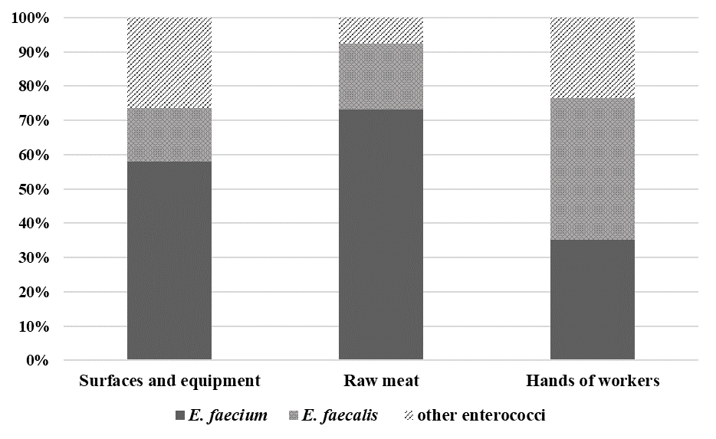

**Fig. 2.** Percentages of selected bacterial species concerning the total enterococci isolated from the studied samples

3.2. Antibiotic Resistance of Selected Enterococci

Due to a significant predominance of *E. faecium* and *E. faecalis* species among analyzed samples and their relevance in the context of public health, both these isolated microorganisms were tested for their susceptibility or resistance to the most commonly used antibiotics. More than 25% of tested samples were positive for VRE strains of *E. faecium* and *E. faecalis* (Table 1). In this study, 20 VRE strains were isolated, of which 13 were *E. faecium* and 7 *E. faecalis*. More than 50% of the identified VRE strains came from the meat cutting rooms and 25% from machine processing rooms. VRE strains were also detected in 2 meat samples and 3 swabs from workers’ hands. Only in samples taken along the thermal processing of meat no VRE strains were found.

**Table 1.** Distribution and prevalence of VRE strains of *E. faecium* and *E. faecalis* species in the tested samples. CR – meat cutting rooms, PR – processing rooms,   
HTR – heat treatments rooms

|  |  |  |  |  |  |
| --- | --- | --- | --- | --- | --- |
| Type of sample | No.  of samples | *E. faecium* VRE | | *E. faecalis* VRE | |
| No.  of isolates | Prevalence (%) | No.  of isolates | Prevalence (%) |
| Floors, CR | 3 | 1 | 33 | 1 | 33 |
| Worktops, CR | 5 | 2 | 40 | 1 | 20 |
| Knives, CR | 4 | 2 | 50 | 1 | 25 |
| Meat containers, CR | 4 | 0 | 0 | 1 | 25 |
| Doors, CR | 2 | 0 | 0 | 1 | 50 |
| Meat grinders, PR | 4 | 1 | 25 | 0 | 0 |
| Stuffing machine, PR | 4 | 0 | 0 | 0 | 0 |
| Worktops, PR | 4 | 2 | 50 | 1 | 25 |
| Floors, PR | 3 | 1 | 33 | 0 | 0 |
| Doors, PR | 2 | 0 | 0 | 0 | 0 |
| Meat containers, PR | 4 | 0 | 0 | 0 | 0 |
| Smoke trolleys, HTR | 3 | 0 | 0 | 0 | 0 |
| Steaming and smoking chambers, HTR | 3 | 0 | 0 | 0 | 0 |
| Raw meat | 10 | 2 | 20 | 0 | 0 |
| Hands of workers | 20 | 2 | 10 | 1 | 5 |

A comparison of the drug resistance profiles of the identified VRE strains of *E. faecium* and *E. faecalis* species is shown in Figure 3. The tested *E. faecium* and *E. faecalis* strains were resistant to penicillin (46% and 28%, respectively) and ampicillin (38% and 14%), erythromycin (38% and 43%), rifampicin (31% and 29%). Statistical analysis showed significant differences in the resistance profiles of the tested isolates (p < 0.001). *E. faecium* strains showed significantly higher resistance to cefotaxime (23%), tetracycline (38%), and phosphomycin (15%) than *E. faecalis* strains. In contrast, *E. faecalis* isolates showed higher insensitivity to quinupristin/dalfopristin (57%), norfloxacin (29%), levofloxacin (29%), and linezolid (14%).

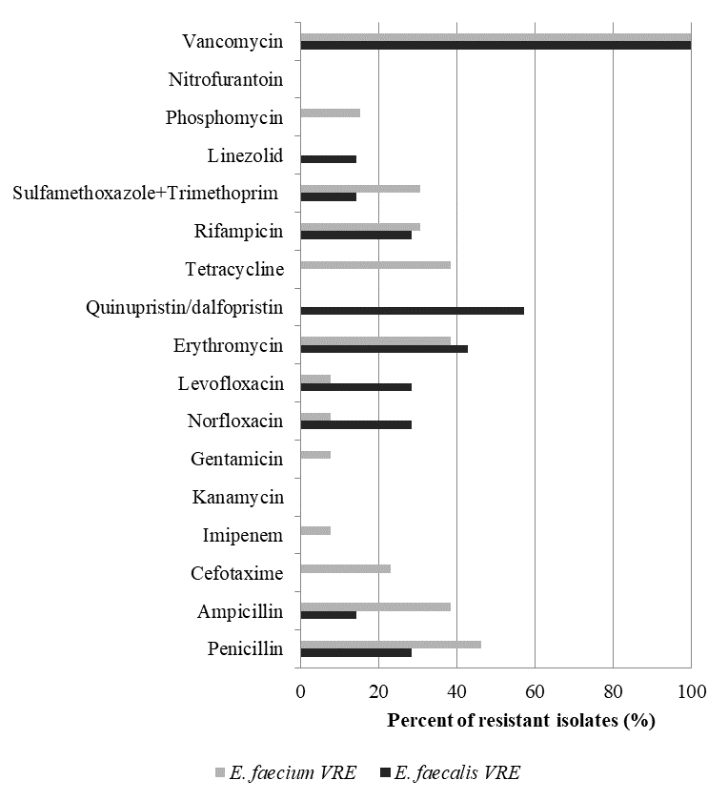

**Fig. 3.** Antimicrobial resistance profile of VRE strains from *E. faecium* and *E. faecalis* species

3.3. Evaluation of Biofilm-forming Ability

The biofilm-forming ability of the tested VRE strains is shown in Figure 4. The study showed that more than 77% of *E. faecium* and 43% of *E. faecalis* isolates showed biofilm-forming ability. About 57% of *E. faecalis* isolates demonstrated no biofilm-forming ability, and the remaining 43% were characterized by medium or poor biofilm-forming ability. Among *E. faecium* strains, 23% of isolates had strong biofilm-forming potential, and 54% had the weak biofilm-forming ability. There were no statistically significant differences between the biofilm-forming potential profiles of the analyzed groups of enterococci.

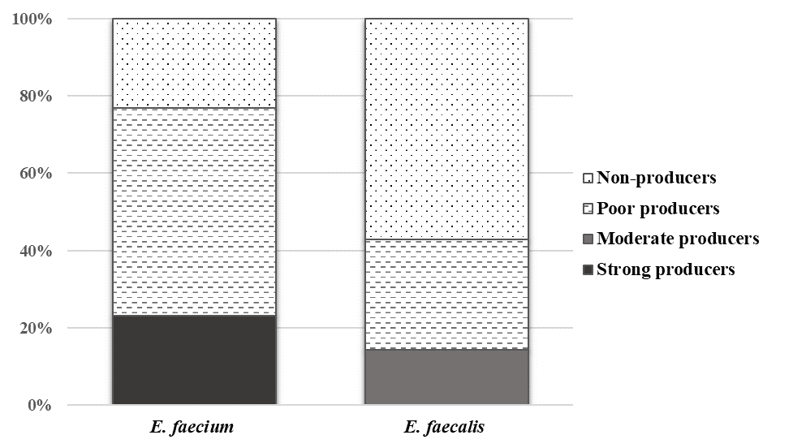

**Fig. 4.** Biofilm forming ability in VRE isolates from *E. faecium* and *E. faecalis* species

4. Discussion

According to the World Health Organization (WHO), the increasing resistance of bacterial pathogens to antibiotics is among the biggest public health challenges today. It is estimated that infections caused by drug-resistant microorganisms are annually responsible for 5 million deaths (WHO 2021). Therefore, increasing attention from the scientific and medical world has been focused on the issue of antibiotic resistance genes transmission through the food chain (Xiong et al. 2018, Rybak et al. 2022). However, routine microbiological tests used in food safety inspections have not considered testing for the presence of drug-resistant microorganisms in production and processing environments. The major difficulty associated with detecting drug-resistant bacteria, especially among non-pathogenic microorganisms, is that their carriage in infected animals is often asymptomatic (Argudín et al. 2017).

Among many microbiological hazards found in meat production, vancomycin-resistant species from *Enterococcus* genus are of particular interest. Their sources in the studied meat plants are animal carcasses, meat, equipment and tools, often contaminated with faeces. Contamination can occur due to the poor sanitary regime during slaughtering and evisceration and during further processing of meat. The high percentage of positive samples for enterococci indicates poor hygiene in tested meat plants and insufficient hand hygiene of workers. The results obtained in this study are in line with the observations of other researchers. Significant enterococcal contamination has been observed in Czech poultry and swine slaughter plants (Schlegelová et al. 2010). Enterococci contaminated 66% of 140 tested raw meat samples and swabs from contact surfaces that had been previously sanitized and disinfected. A significantly higher rate of positive samples for enterococci was obtained in a study carried out by American researchers (Hayes et al. 2003). It was shown that 99% of the about 1,000 samples of retail beef, pork, and poultry meat were contaminated with these bacteria. The present study observed a higher prevalence of isolation of E. faecium (55%) and E. faecalis (25%) over the other enterococci species. Similar relationships in the isolation frequency of *E. faecium* and *E. faecalis* from meat samples were shown in studies by Kročko et al. (2008) (72% and 10%, respectively) and Hayes et al. (2003) (61% and 29%, respectively). By contrast, in a study by Schlegelová et al. (2010), both *E. faecalis* and *E. faecium* strains were present in 45% and 7% of analyzed swab samples, respectively.

The sources of enterococcal infection in the studied Polish facilities were animal carcasses, surfaces, and tools contaminated with faecal bacteria. Their presence in large numbers after the sanitization and disinfection process revealed the poor hygiene in the companies during the cutting and processing of meat. It should be noted that there are currently no widely accepted limit values regarding the degree of microbiological contamination of surfaces in meat plants. Until 2006, the decision of the European Commission of 8 June 2001 (2001/471/EC), laying down rules on general hygiene control in slaughterhouses and meat-cutting plants, was in force. It defined, among other things, methods of collecting bacteriological samples and assessing the cleaning and disinfection of surfaces in these establishments. Based on the limits included therein, it can be concluded that bacterial concentrations in some of the tested swabs from cutting (floors and tables) and processing (stuffing machines, floors and containers) rooms exceeded limit values for mesophilic bacteria (10 CFU/cm2). However, in the scientific literature, other proposals for permissible levels can also be found and used to evaluate the surfaces’ hygienic quality in the food industry. For example, Italian researchers proposed the following limits for the total number of bacteria: a) from 0 to 49 CFU/cm2 for clean surfaces, b) between 50-499 CFU/cm2 for acceptable contamination, and c) above 500 CFU/cm2 for unacceptable contamination (Losito et al. 2027). According to these researchers, such limits are much more practical and achievable in industrial establishments and food distribution systems. Considering the limit values mentioned above, the surfaces in studied Polish plants had a high or acceptable level of cleanliness.

In turn, the bacterial load on the hands of workers in the studied plants was at the level of 10 CFU/ml and, as such, was similar to those observed by other researchers in meat and retail plants (Lues & Tonder 2007, Lambrechts et al. 2014, Jovanovic et al. 2021). It should be noted that hands are an excellent carrier for many harmful microorganisms. Contaminated hands can also lead to re-contamination of other surfaces and tools that person has been in contact. The results of the present study indicate the need to implement additional hand hygiene training at workplaces in the tested Polish meat plants.

Despite the European Union’s ban on the use of antibiotics as feed additives (Regulation (EC) no. 1831/2003), antibiotics may be used metaphylactically and prophylactically in livestock when the risk of infection spreading in a group of animals is high (Regulation EU 2019/6). Unfortunately, insufficient control of antibiotic marketing and administration by livestock farmers contributes to the spread of drug-resistant strains in the food chain (Vidovic & Vidovic 2020). The present study in Polish meat plants showed the occurrence of VRE strains in 25% of the tested samples. The tested isolates of *E. faecium* and *E. faecalis* showed resistance primarily to penicillin, ampicillin, erythromycin, rifampicin, tetracycline, and quinupristin/dalfopristin. The such observed prevalence of VRE strains and their antibiotic resistance profiles were within the ranges reported by other researchers. Slovakian studies showed that more than 40% of *E. faecium* and 14% of *E. faecalis* isolates from beef and pork were resistant to vancomycin. High resistance to ampicillin (67% of *E. faecium* and 60% of *E. faecalis*), gentamicin (19% and 40%, respectively), erythromycin (8% and 60%) and tetracycline (8% and 80%) was also found among isolates tested by Kročko et al. (2008). A high isolation frequency of drug-resistant strains was also noted in swabs and poultry meat samples in butcher stores in Portugal. More than 48% of these tested samples contained vancomycin-resistant enterococci and enterococci highly resistant to gentamicin (34%), streptomycin (32%) and kanamycin (30%) (Novais et al. 2005). In contrast, in one American study, no VRE strains were detected in meat samples. However, a high percentage of enterococci resistant to quinupristin/dalfopristin (*E. avium* – 100%, *E. casseliflavus* – 41%, *E. faecium* – 26%), erythromycin (*E. casseliflavus* – 31%, *E. gallinarum* – 44%), and nitrofurantoin (*E. avium* – 100%, *E. casseliflavus* – 55%, *E. faecium* – 43%) were reported (Hayes et al. 2003). Several studies that analyzed the transmission of antibiotic-resistant bacteria from animals to humans found a high prevalence of drug-resistant bacteria, particularly among individuals having direct contact with animals, such as veterinarians (Jackson & Villarroe 2012) and animal farm workers (Nadimpalli et al. 2018). Another European study observed the carriage of drug-resistant enterococci among restaurant workers. Enterococci isolates from faecal samples of restaurant workers showed significantly greater resistance to erythromycin, moxifloxacin, tetracycline, and vancomycin-teicoplanin than enterococci from a control group (del Campo et al. 2003).

Drug-resistant bacteria that produce biofilm may cause a potential threat to food safety and public health. The analyzes performed in Polish meat plants showed that about 60% of tested VRE isolates were able to produce a biofilm. These results are in line with the findings of quantitative analysis from other studies, which indicated relatively frequent contamination of the examined meat plants with enterococci. High humidity and the presence of organic matter on working surfaces in meat plants, especially in difficult-to-keep-clean areas and machinery, create an ideal environment for biofilm development. A study by Chotinantakul et al. (2020) on multi-drug resistant enterococci from pork meat showed that up to 97% and 53% of tested strains could form biofilm at 25°C and 4°C, respectively. Nowadays, the ability of pathogenic bacteria to form a biofilm is considered among the important virulence factors (López-Salas et al. 2013, Iweriebor et al. 2015, Ch’ng et al. 2019). In the study by Wozniak-Biel et al. (2019), it was observed that all clinical enterococci and the strains isolated from turkey farms were biofilm producers. A large percentage of isolates originating from humans and animals were resistant to tetracycline (86% and 94%, respectively), erythromycin (38% and 76%), ciproﬂoksacin (30% and 24%), and vancomycin (25% and 16%) (39). It should also be noted that the high density of cells in the biofilm and increased genetic competence promote the spread of antibiotic-resistance genes (Ch’ng et al. 2019, Abebe 2020, Chotinantakul et al. 2020, Ławniczek-Wałczyk & Górny 2022). Hence, biofilms in slaughtering, meat production, and processing facilities can be potential sources of antibiotic resistance.

5. Summary

The analyzes conducted in Polish meat plant indicated that enterococci contaminated raw meat, surfaces, and hands of workers. Among the identified strains, *E. faecium* and *E. faecalis* species predominated. This study revealed the high isolation frequency of strains resistant to vancomycin, penicillin, ampicillin, erythromycin, rifampicin, tetracycline, and quinupristin/dalfopristin. The observed high biofilm-forming potential among the VRE isolates indicates that these agents may play an important role in the spread of drug resistance in the food chain through contaminated surfaces, meat, and workers’ hands. This study clearly shows that implementing antibiotic resistance assessment of selected bacterial groups into routine monitoring in animal farms and slaughterhouses could allow early identification of contamination sources of meat products and reduce the spread of drug resistance.

*This work has been based on the results of a research task no. II.PB.12 carried out within the scope of the fifth stage of the National Programme   
“Improvement of safety and working conditions” partly supported in 2020-2022 within the scope of research and development – by the National Centre   
for Research and Development. The Central Institute for Labour Protection   
– National Research Institute is the Programme’s main co-ordinator.*

References

2001/471/EC: Commission Decision of 8 June 2001 laying down rules for the regular checks on the general hygiene carried out by the operators in establishments according to Directive 64/433/EEC on health conditions for the production and marketing of fresh meat and Directive 71/118/EEC on health problems affecting the production and placing on the market of fresh poultry meat (Text with EEA relevance) (notified under document number C(2001) 1561).

Abebe, G.M. (2020). The Role of Bacterial Biofilm in Antibiotic Resistance and Food Contamination. *International Journal of Microbiology*, *2020*, 1705814. DOI: 10.11 55/2020/1705814

Argudín, M. A., Deplano, A., Meghraoui, A., Dodémont, M., Heinrichs, A., Denis, O., Nonhoff, C., Roisin, S. (2017). Bacteria from Animals as a Pool of Antimicrobial Resistance Genes. *Antibiotics*, *6*(2):12. DOI: 10.3390/antibiotics6020012

CDC. *Antibiotic Resistance Threats in the United States, 2019*. (2019). Atlanta, GA: U.S. Department of Health and Human Services, CDC. www.cdc.gov/info [06-09-2022]

Ch'ng, J.H., Chong, K., Lam, L.N., Wong, J.J., Kline, K.A. (2019). Biofilm-associated infection by enterococci. Nature reviews. *Microbiology*, *17*(2), 82-94. DOI: 10.10 38/s41579-018-0107-z

Chotinantakul, K., Chansiw, N., Okada, S. (2020). Biofilm formation and transfer of a streptomycin resistance gene in enterococci from fermented pork. *Journal of Global Antimicrobial Resistance*, *22*, 434-440. DOI: 10.1016/j.jgar.2020.04.016

del Campo, R., Ruiz-Garbajosa, P., Sánchez-Moreno, M. P., Baquero, F., Torres, C., Cantón, R., Coque, T.M. (2003). Antimicrobial resistance in recent fecal enterococci from healthy volunteers and food handlers in Spain: genes and phenotypes. *Microbial drug resistance* (Larchmont, N.Y.), *9*(1), 47-60. DOI: 10.1089/10766290 3764736346

EUCAST. (2022). *European Committee on Antimicrobial Susceptibility Testing Breakpoint tables for interpretation of MICs and zone diameters*. Version 12.0, 2022 http://www.eucast.org [06-04-2022]

Galié, S., García-Gutiérrez C., Miguélez E.M., Villar C.J., Lombó F. (2018). Biofilms in the Food Industry: Health Aspects and Control Methods. *Frontiers In Microbiology*, *9*, 898. DOI: 10.3389/fmicb.2018.00898

Giraffa, G. (2002). Enterococci from foods. *FEMS microbiology reviews*, *26*(2), 163-171. DOI: 10.1111/j.1574-6976.2002.tb00608.x

Hanchi, H., Mottawea, W., Sebei, K., Hammami, R. (2018). The Genus Enterococcus: Between Probiotic Potential and Safety Concerns-An Update. *Frontiers in Microbiology*, *3*, 1791.

Hanchi, H., Mottawea, W., Sebei, K., Hammami, R. (2018). The Genus *Enterococcus*: Between Probiotic Potential and Safety Concerns-An Update. *Frontiers in microbiology*, *9*, 1791. DOI: 10.3389/fmicb.2018.01791

Iweriebor, B.C., Obi, L.C., Okoh, A.I. (2015). Virulence and antimicrobial resistance factors of Enterococcus spp. isolated from fecal samples from piggery farms in Eastern Cape, South Africa. *BMC microbiology*, *15*, 136. DOI: 10.1186/s12866-015-0468-7

Jackson, J., Villarroe, A. (2012). A survey of the risk of zoonoses for veterinarians. *Zoonoses and Public Health*, *59*, 193-201. DOI: 10.1111/j.1863-2378.2011.01432.x

Jovanovic J., Nikolic, A., Brankovic, Lazic I. , Mrdovic, B., Raseta, M., Lilic, S., Geric, T. (2021). Food contact surfaces and food handler’s hygiene in one Serbian retail chain - estimation and trend. *IOP Conf. Series: Earth and Environmental Science*, *854*, 012041. DOI: 10.1088/1755-1315/854/1/012041

Kročko, M., Čanigová, M., Ducková, V. (2008). Occurrence of enterococci in raw pork and beef and their antibiotics multiresistance. *Acta Universitatis Agriculturae et Silviculturae Mendelianae Brunensis*, LVI, *2*, 101-106. DOI: 10.11118/actaun2008 56020101

Lambrechts, Aa., Human, Is., Doughari, Jh, Lues, Jfr. (2014). Bacterial contamination of the hands of food handlers as indicator of hand washing efficacy in some convenient food industries in South Africa. *Pakistan Journal Of Medical Sciences*, *30*(4), 755-758. PMID: 25097511.

Ławniczek-Wałczyk, A., Górny, R.L. (2022). Biofilm as a threat in food production and processing facilities. *Bezpieczeństwo Pracy: nauka i praktyka*, 3, 10-15. DOI: 10.542 15/BP.2022.03.6.Lawniczek-Walczyk (in Polish).

Lawpidet, P., Tengjaroenkul, B., Saksangawong, C., Sukon, P. (2021). Global Prevalence of Vancomycin-Resistant Enterococci in Food of Animal Origin: A Meta-Analysis. *Foodborne pathogens and disease*, *18*(6), 405-412. DOI: 10.1089/fpd. 2020.2892

Lebreton, F., Willems, R. J.L., Gilmore, M.S. (2014). Enterococcus diversity, origins in nature, and gut colonization. IN: M.S. Gilmore, D.B. Clewell, Y. Ike (Eds), *Enterococci: from Commensals to Leading Causes of Drug Resistant Infection*,   
(1-46). Boston, MA: Massachusetts Eye and Ear Infirmary.

López-Salas, P., Llaca-Díaz, J., Morfin-Otero, R., Tinoco, J. C., Rodriguez-Noriega, E., Salcido-Gutierres, L., González, G. M., Mendoza-Olazarán, S., Garza-González, E. (2013). Virulence and antibiotic resistance of Enterococcus faecalis clinical isolates recovered from three states of Mexico. Detection of linezolid resistance. *Archives of medical research*, *44*(6), 422-428. DOI: 10.1016/j.arcmed.2013.07.003

Losito, P., Visciano P., Genualdo, M., Satalino, R., Migailo, M., Ostuni, A., Luisi, A., Cardone, G. (2017). Evaluation of hygienic conditions of food contact surfaces in retail outlets: six years of monitoring. *LWT – Food Science and Technology*, 77,   
67-71. DOI: 10.1016/j.lwt.2016.11.029

Lues, J.F.R., Van Tonder, I. (2007). The occurrence of indicator bacteria on hands and aprons of food handlers in the delicatessen sections of a retail group. *Food Control*, *18*, 326-332. DOI: 10.1016/j.foodcont.2005.10.010

Nadimpalli, M.L., Stewart, J.R., Pierce, E., Pisanic, N., Love, D.C., Hall, D., Larsen, J., Carroll, K.C., Tekle, T., Perl, T.M., Heaney, C.D. (2018). Face Mask Use and Persistence of Livestock-associated *Staphylococcus aureus* Nasal Carriage among Industrial Hog Operation Workers and Household Contacts, USA. *Environmental health perspectives*, *126*(12), 127005. DOI: 10.1289/EHP3453

Novais, C., Coque, T.M., Costa, M.J., Sousa, J.C., Baquero, F., Peixe, L.V. (2005). High occurrence and persistence of antibiotic-resistant enterococci in poultry food samples in Portugal. *The Journal of antimicrobial chemotherapy*, *56*(6), 1139-1143. DOI: 10.1093/jac/dki360

PN-A-82055-19: Determination of microbiological and surface cleanliness devices, equipment, rooms, as well as packaging and hands of employees. (03-07-2000).

Regulation (EC) No 1831/2003 Of The European Parliament and of The Council of 22 September 2003 on additives for use in animal nutrition..OJ L 268, 18.10. 29-43

Regulation (EU) 2019/6 of the European Parliament and of the Council of 11 December 2018 on veterinary medicinal products and repealing Directive 2001/82/EC OJ L 4, 7.1. 2019, s. 43-167.

Rybak, B., Potrykus, M., Plenis, A., Wolska, L. (2022). Raw Meat Contaminated with Cephalosporin-Resistant Enterobacterales as a Potential Source of Human Home Exposure to Multidrug-Resistant Bacteria. *Molecules*, *27*(13), 4151. DOI: 10.3390/ molecules27134151

Said, M.S, Tirthani, E., Lesho, E. *Enterococcus Infections*. (2022). StatPearls Treasure Island (FL): StatPearls Publishing.

Schlegelová, J., Babák, V., Holasová, M., Konstantinová, L., Necidová, L., Šišák, F., Vlkov,á H., Roubal, P., Jaglic, Z. (2010). Microbial contamination after sanitation of food contact surfaces in dairy and meat processing plants. *Czech Journal of Food Sciences*, *28*(5), 450-461. DOI: 10.17221/65/2009-CJFS

Stepanović, S., Vuković, D., Hola, V., Di Bonaventura, G., Djukić, S., Cirković, I., Ruzicka, F. (2007). Quantification of biofilm in microtiter plates: overview of testing conditions and practical recommendations for assessment of biofilm production by staphylococci. *APMIS : acta pathologica, microbiologica, et immunologica Scandinavica*, *115*(8), 891-899. DOI: 10.1111/j.1600-0463.2007.apm_630.x

Vidovic, N., Vidovic, S. (2020). Antimicrobial Resistance and Food Animals: Influence of Livestock Environment on the Emergence and Dissemination of Antimicrobial Resistance. *Antibiotics* (Basel, Switzerland), *9*(2), 52. DOI: 10.3390/antibiotics9020052

WHO. (2021). *WHO strategic priorities on antimicrobial resistance: preserving antimicrobials for today and tomorrow*. https://www.who.int/publications/i/item/9789240041387 [07-09-2022]

Woźniak-Biel, A., Bugla-Płoskońska, G., Burdzy, J., Korzekwa, K., Ploch, S., Wieliczko, A. (2019). Antimicrobial Resistance and Biofilm Formation in Enterococcus spp. Isolated from Humans and Turkeys in Poland. *Microbial drug resistance* (Larchmont, N.Y.), *25*(2), 277-286. DOI: 10.1089/mdr.2018.0221

Xiong, W., Sun, Y., Zeng, Z. (2018). Antimicrobial use and antimicrobial resistance in food animals. *Environmental science and pollution research international*, *25*(19), 18377-18384. DOI: 10.1007/s11356-018-1852-2

Zhao, J., Liu, R., Sun, Y., Yang, X., Yao, J. (2022). Tracing enterococci persistence along a pork production chain from feed to food in China. *Animal Nutrition*, *9*, 223-232. DOI: 10.1016/j.aninu.2022.01.005

Zhu, T., Yang, C., Bao, X., Chen, F., Guo, X. (2022). Strategies for controlling biofilm formation in food industry. Grain & Oil Science and Technology, 2022, DOI: 10.1016/ j.gaost.2022.06.003