 | Rocznik Ochrona Środowiska
 | Volume 24 | Year 2022 ISSN 2720-7501 | pp. 294-306
 | https://doi.org/10.54740/ros.2022.021 open access
 | Received: 28 July 2022 Accepted: 16 November 2022 Published: 27 November 2022
Performance Analysis of Systems
Powered by a Ground Source Heat Pump
Natalia Fidorów-Kaprawy*
Faculty of Environmental Engineering,
Wroclaw University of Science and Technology, Poland
https://orcid.org/0000-0002-0162-5796
Edyta Dudkiewicz
Faculty of Environmental Engineering,
Wroclaw University of Science and Technology, Poland
https://orcid.org/0000-0002-6276-5290
Vasyl Zhelykh
Institute of Civil Engineering and Building Systems,
Lviv Polytechnic National University, Ukraine
https://orcid.org/0000-0002-5063-5077
*corresponding author’s e-mail: natalia.fidorow-kaprawy@pwr.edu.pl
Abstract: Heat pumps are known as zero-emission heating and cooling devices at the point of energy production. In order to exploit their advantages, they are combined with low-temperature heating systems. Using the example of a residential building in five climatic zones in Poland and one in Ukraine, systems analyses were carried out, in which heat into rooms is supplied in two different ways: low-temperature radiators and thermally active ceilings. The energy demand for heating, cooling and domestic hot water preparation was calculated. The seasonal coefficient of performance of the ground source heat pump was estimated to compare the systems. The results of the analysis confirmed that the thermo-active ceiling (with a flow temperature of 35°C) ensures a lower final energy demand when it works throughout the year in the heating and natural cooling mode compared to the low-temperature radiators (with a flow temperature of 45°C) which facilitate only the heating mode in the heating season. Performance analysis demonstrated differences in final electric energy demand from 8% in the I climatic zone to 9% in the V climatic zone in Poland and 10% in Ukraine.
Keywords: heat pump SCOP, heating and cooling ceiling, low-temperature radiators, climatic conditions in Poland and Ukraine
1. Introduction
The advantages of heat pumps (HP) are well known, and the devices have been used for a long time for heating and cooling various buildings. They guarantee zero emissions at the point of heat and/or cooling production. Furthermore, in the case of additional renewable energy sources application, e.g. photovoltaic modules, they become a virtually emission-free solution (Rabczak & Proszak-Miasik 2020). In the case of using an HP for heating and cooling, the investment costs may turn out to be attractive because of the two functions in one system and could be one of the most economically viable solutions ensuring appropriate microclimatic conditions.
In the case of the HP application as a heat source for the building, it is obvious to use an installation with the lowest possible flow temperature, e.g. floor heating, low-temperature radiators, or thermally active ceilings which are divided into false ceiling, ceiling slabs and beam systems (Sinacka 2019). Radiant systems, compared to a heating and cooling system using fan coils, contribute to the energy efficiency of a building by maintaining a lower indoor air temperature in winter and a higher indoor air temperature in summer while maintaining a similar level of thermal comfort. These resulted in cost and energy savings and were estimated by many authors (Oravec et al. 2021, Tye-Gingras & Gosselin 2011).
In Poland, it has become frequent for ceiling heating and cooling systems to be used in residential blocks of flats belonging to the Social Housing Association (so-called TBS in Poland). They install pre-fabricated heating ceilings using brine-to-water heat pumps as heating sources. The system maintains the temperature in the perceptible range of thermal comfort. Thermal comfort and the right temperature are attributed to the high level of energy accumulation in the building envelope (Wojtkowiak & Amanowicz 2016).
The variability of the heat load may be relatively high and depends on the weather conditions and local requirements for the thermal protection of buildings or the required internal temperature values (Kowalski & Szałański 2019). In Poland, these requirements are summarised in the regulation (Dz.U. 2022 poz. 1225), while in Ukraine, in technical standard (DBNV.2.6-31:2016). The requirements concerning the heat transfer coefficients in Ukraine are less strict than in Poland; in combination with slightly higher required internal temperatures, this results in higher heat load and energy requirements for buildings localised in Ukraine (Fedorczak-Cisak et al. 2019, Savchenko & Lis A 2020). All these conditions will affect the HP heating system’s efficiency.
Brine-to-water heat pumps, equipped with additional devices set (heat exchanger, circulation pump and three-way valves), may extract excess heat from rooms in summer and transfer it to GHE (ground heat exchangers) without using a compressor. It may increase thermal comfort in rooms while simultaneously regenerating a heat sink with a simultaneous increase in the efficiency of HP operation.
This article aims to assess the energy efficiency of a ground source HP in multifamily residential buildings in various climatic zones. The heat in rooms is supplied by two different systems: low-temperature radiators and thermally active ceilings. The ceiling system will also serve as a cooling system in summer (in passive mode), which should have increased thermal comfort in summer and enhanced ground regeneration. Five locations in Poland and one in Ukraine, each placed in a different climatic zone, were considered in the analysis to assess the differences in energy use range. The locations’ climatic conditions and the type of devices were considered.
2. Materials and Methods
2.1. Building and Heat Pump System Description
The three-story multifamily residential building without a basement (Fig. 1) belonging to TBS was chosen to illustrate the efficiency of the ceiling system and low-temperature radiators powered by a ground source HP. The area of one floor is equal to 637.4 m², while for heating and cooling, 1912.3 m². There are two staircases with 7 flats in the left and 6 in the right segments. In total, there are 39 flats in the building. There are one-, two- and three-bedroom apartments. The staircases do not require heating devices (the gains from neighbouring rooms heat them).
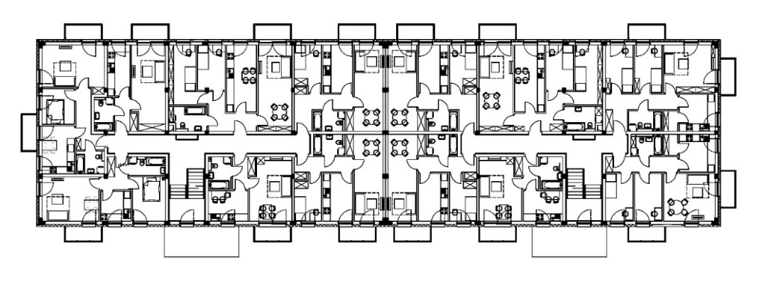
Fig. 1. The TBS residential building plan for the repetitive storey

It was assumed that the building would be heated and cooled by the brine-to-water HP, which is the option of natural cooling, which simplified scheme is presented in Fig. 2.
HP provides the heating agent to the radiant ceiling system, the low-temperature radiators, and the hot water tank for DHW preparation. In addition, the HP may provide the cooling agent for the ceiling system for excessive heat dissipation in the summer months. Then natural cooling systems do not require a compressor; additionally, they allow for the GHE active regeneration.
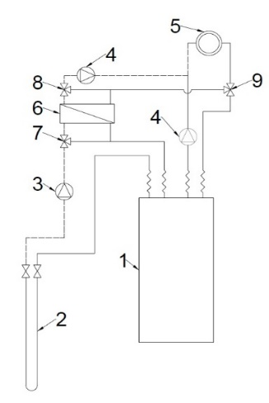 | 1 – brine to water heat pump  2 – ground heat exchanger  3 – lower energy source circulation pump  4 – circulation pump for heating and cooling system  5 – ceiling heating and cooling system  6 – heat exchanger of the natural cooling system  7 – three-way switching valve for brine  8 – three-way mixing valve  9 – three-way heating/cooling switch valve
Fig. 2. Simplified scheme of the natural cooling system

2.2. The Heating and Cooling Systems
Pre-fabricated heating and cooling ceilings and low-temperature radiators powered by heat pumps were selected for the analysis.
To eliminate the overheating phenomenon in a 3 m high room heated by chosen pre-fabricated thermo-active ceiling technology, the maximum temperature of the ceiling surface, according to the producer’s guidelines, should not exceed 35°C (Dennert, Kuhnhenne 2018).
The second HP-powered systems utilise unique design low-temperature radiators with copper tubes and aluminium plates, making them more efficient than steel radiators. They transfer heat to the room through both convection and radiation.
Comparison of the main features: the way of heat transfer, cooling possibilities, occupation of space and aesthetics (which is an objective feature) of both systems with thermo-active ceilings and radiators is presented in Table. 1.

Table 1. The main features of the two systems
Feature | Heating/cooling ceiling | Low-temp. radiators
Heating medium temp. | 35°C | 45°C
Heat transfer | Radiation | Radiation + Convection
Temperature regulation | Control valves on a manifold, electronic sensors in a room | Thermostatic valves
Cooling possibilities | Yes | No
Occupation of space | No | Yes
Aesthetics | High, the system is not visible | Typical, radiators  are visible
2.3. Heat Load and Energy Demand
Audytor OZC 7.0 Pro software was chosen to estimate the heat load and energy demand for heating and cooling purposes and prepare the DHW for the TBS residential building. In Poland, one location in each of five climatic zones (with external design temperature every 2°C from -16°C to -24°C) was chosen (Gdańsk, Wrocław, Kraków, Białystok and Suwałki). Locations represent the range of climatic conditions in Poland. In Ukraine, where there are two zones (with external design temperature values of -19°C and -22°C), the location of Lviv was chosen for analysis because of the data availability.
The heat load was estimated according to the EN 12831 standard, based on the introduced building model and climatic data (external design and annual average temperature) for the various locations of the building in two countries. Data for five locations in Poland are included in the software following EN 12831 standard, and data for Lviv in Ukraine were entered manually as the addition of another weather station in strict to DBNV.2.6-31 standard.
The thermal protection conditions for the building are assumed following national requirements in Poland, given in the regulation (Dz.U. 2022 poz. 1225), and Ukraine, given in the DBNV.2.6-31 standard. The minimum thermal insulation requirements for Poland are much stricter than for Ukraine. For example, the assumed U-value for walls was 0.141 < 0.2 W/(m²·K) in Polish locations, while in Ukrainian, it was 0.283 < 0.3 W/(m²·K). In case of windows it was 0.76 < 0.9 W/(m²·K) in Poland and 1.1 < 1.33 W/(m²·K) in Ukraine.
The usable energy demand for heating and cooling, as well as the energy demand for DHW preparation purposes, have been calculated according to the Regulation of the Minister of Infrastructure and Development of 27 February 2015 on the methodology to determine the energy performance of a building or part of a building and the energy performance certificates (Regulation of the Minister of Infrastructure and Development of 27 February 2015). In addition, a performance analysis was carried out that included five temperature zones in Poland and one zone in Ukraine (UA_I) in the example city of Lviv. Similarly, as in the case of heat load, the climatic data for Poland are included in the software and data for Lviv were entered manually.
In order to determine the seasonal efficiencies of a ground source HP for two different systems in all zones, the energy demand values were determined without heat generation efficiency but including system efficiencies and heat loss. The efficiency of the heating system taken into account for the calculation assumed: water heating from a local heat source located in the building, with insulated pipes with central and local control and use of a buffer tank in the heating system. As the cooling load is required while determining the brine temperature in the EED software (for later SCOP calculations), the amount of energy and system efficiency were determined. When calculating the cooling system efficiency for ceilings only, the following was considered: surface water cooling, with central and local control, chilled water system with thermostatic valves and buffer tank in the cooling system. When calculating the efficiency of DHW preparation: centralised preparation, insulated circuits, limited circulation time, and contemporary storage tank in the DHW system have been assumed. Particular months were considered when estimating energy demand for heating Q_{H}, cooling Q_{C} and DHW preparation Q_{W}.
Observing Fig. 3, there are visible differences between the values calculated in the climatic zones in Poland, with the lowest and the highest design temperature values. The weaker insulation of the building envelope in Ukraine causes a higher energy demand for the building each month. Furthermore, it is enhanced by the higher internal air temperature in the rooms in Ukraine in comparison to Poland: bathrooms – 25.0°C vs 24.0°C; bedrooms and living rooms – 22.0°C vs 20.0°C; kitchens and halls 19.5°C vs 20.0°C.

Fig. 3. Usable energy demand of residential building: columns from left to right – Ukraine: climatic zone I), Poland: climatic zones V and I. Heating demand – yellow; DHW preparation – red; cooling demand – blue

Proper thermal insulation of the envelope and the building geometry make the energy demand for cooling not very high but noticeable. The highest value in the III climatic zone is 29,019 kWh/year of usable energy, while in zone V, it is 13,737 kWh/year. In Lviv, 23,613 kWh/year of energy would be consumed for cooling. Therefore, the yearly energy demand for the preparation of DHW (without heat generation efficiency but including system efficiency) is equal to 88,474 kWh. The energy for DHW preparation has been assumed the same in all cases for reasons of comparability.

2.4. Heat Pump and Ground Heat Exchanger
Based on the total heat load under design conditions, a brine/water HP was sized for the building in each climatic zone. Therefore, two heat pumps operating in the cascade were required. Their selection is presented in Table 2. Due to the weaker insulation, the heat load is the greatest in the climatic zone I in Ukraine.

Table 2. Heat pump selection
Climatic zone  (design temp.) | Heat load, kW | Heating  capacity, kW | Cooling  capacity*, kW | Type
I (-16°C) | 65.6 | 2·36.6 | 60.2 | 2·Vitocal  BW/BWS 351.B33
II (-18°C) | 69.0 | 2·36.6 | 60.2
III (-20°C) | 72.6 | 2·36.6 | 60.2
IV (-22°C) | 76.2 | 2·46.4 | 75.0 | 2·Vitocal  BW/BWS 351.B42
V (-24°C) | 79.9 | 2·46.4 | 75.0
UA_I (-22°C) | 90.3 | 2·46.4 | 75.0
*extracted from the boreholes in heating mode (for heat sink size determination)
The EED 4.2 software was implemented to simulate GHE for the heat pumps. The sizes of the vertical heat exchangers were determined, and the average temperature of the brine was calculated for each month of the year. The assumptions on the construction of the GHE and the flow rate of the working fluid are presented in Fig. 4. The GHE configuration is shown in Fig. 4: a) 21 boreholes mounted in a 20x60 m area for a building located in climatic zones I, II, III; b) 28 boreholes on an area of 30x60 m for the building in zones IV, V and UA_I. Because the distance between exchangers must be sufficient for effective performance in the analysed case, 10 m was proved to be proper.

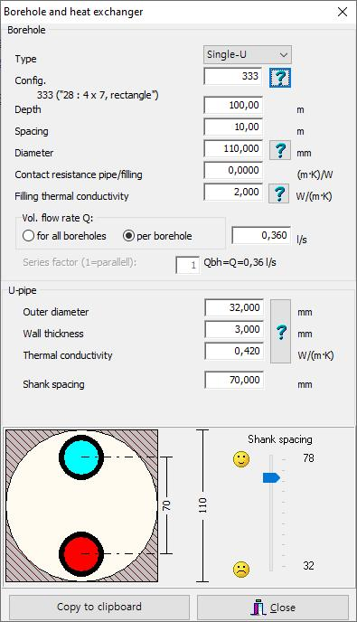 | a)
b)
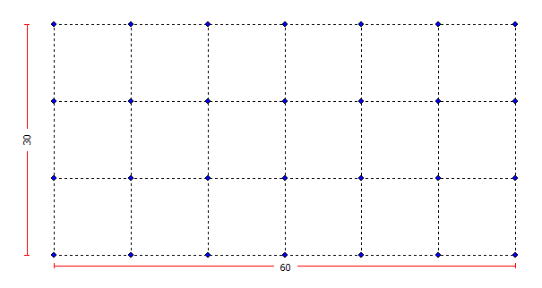
Fig. 4. Selection and location of the borehole and GHE in a) climatic zone I, II and III; b) climatic zone IV, V and UA_I

 | Ceiling heating and cooling system |  |  |  |  |  |  | Low-temperature radiators
 | I PL | II PL | III PL | IV PL | V PL | I UA |  | I PL | II PL | III PL | IV PL | V PL | I UA
Jan | 3.8 | 2.7 | 2.5 | 2.5 | 2.1 | 1.4 |  | 3.6 | 2.5 | 2.2 | 2.5 | 2.2 | 1.4
Feb | 3.4 | 2.9 | 2.2 | 3.3 | 2.3 | 2.0 |  | 3.2 | 2.7 | 1.9 | 3.3 | 2.4 | 2.0
Mar | 5.3 | 5.3 | 5.3 | 5.3 | 4.7 | 4.2 |  | 5.1 | 5.0 | 4.9 | 5.2 | 4.7 | 4.0
Apr | 6.5 | 6.3 | 6.4 | 6.9 | 6.2 | 6.0 |  | 6.1 | 5.9 | 5.9 | 6.3 | 6.0 | 5.7
May | 6.9 | 7.1 | 7.2 | 7.9 | 6.8 | 6.9 |  | 6.3 | 6.1 | 6.0 | 6.5 | 6.3 | 6.0
Jun | 8.1 | 8.9 | 9.8 | 8.5 | 7.5 | 7.9 |  | 6.4 | 6.2 | 6.1 | 6.6 | 6.4 | 6.2
Jul | 10.1 | 8.4 | 9.7 | 7.6 | 7.8 | 8.6 |  | 6.4 | 6.3 | 6.2 | 6.7 | 6.5 | 6.3
Aug | 8.3 | 9.2 | 8.9 | 7.2 | 7.4 | 8.1 |  | 6.5 | 6.3 | 6.2 | 6.7 | 6.5 | 6.3
Sep | 7.4 | 7.3 | 7.5 | 7.1 | 7.0 | 7.1 |  | 6.5 | 6.3 | 6.3 | 6.8 | 6.6 | 6.4
Oct | 6.9 | 6.9 | 7.1 | 6.7 | 6.4 | 6.3 |  | 6.3 | 6.2 | 6.2 | 6.4 | 6.1 | 5.8
Nov | 4.7 | 4.8 | 4.3 | 4.6 | 3.9 | 3.9 |  | 4.3 | 4.3 | 3.7 | 4.4 | 3.8 | 3.6
Dec | 3.6 | 2.6 | 2.9 | 3.4 | 2.8 | 2.0 |  | 3.3 | 2.3 | 2.4 | 3.4 | 2.8 | 1.8
Fig. 5. The average brine temperature over the 25 years of heat pump operation in all analysed locations while using ceiling heating and cooling system and while using
low-temperature radiators
The brine temperature for each month was calculated using EED software. Fig. 5 shows, by month of the year, the average brine temperature over 25 years of HP operation. On the left-hand side, in the case of a thermo-active ceiling system, the influence of the passive cooling regeneration is visible, as the brine temperature in summer is higher from 1.3 up to 3.7 K than in the case of low-temperature radiators. It can be observed that the regeneration effect, clearly visible in summer months, is barely seen in winter. The temperature difference is lower than 0.5 K (in December) when comparing both stems in the respective climatic zones. It may be caused by the greater energy withdrawal in the case of the ceiling heating system – lower flow temperature causes a greater COP value which means that more energy comes from the ground and less from the compressor. However, the regeneration effect is visible in the higher SCOP value in case of DHW preparation, and the building users’ comfort is greater because of the cooling possibility in summer.
2.5. Heat Pump – SCOP Estimation
The seasonal efficiency of the chosen heat pumps has been calculated considering monthly energy demand values, COP catalogue values for various supply temperatures and brine temperatures estimated using EED software. As mentioned above, the mean brine temperatures were established and iterated to obtain better accuracy in estimating. Monthly energy values for heating and the preparation of DHW were taken as the energy values without taking into account the efficiency of heat generation but including other efficiencies and heat loss of the system. The flow temperatures were assumed to be constant at 35°C for the ceiling heating system, 45°C for low-temperature radiators and 68°C for the preparation of DHW in the hot water tank. COP values for individual months were determined for the flow and brine temperature valid for this month and system. The monthly electric energy demand for the heating and preparation of DHW was calculated by dividing the final energy demand by the corresponding COP value. The annual energy demand for heating divided by the annual electric energy demand gave the SCOP value for heating. The SCOPs for DHW preparation were calculated in the same way. The SCOP for the entire system is the weighted average of the two values.

a) |  | b)
Fig. 6. The COP characteristics of the brine-to-water heat pumps selected
for the analysis, flow temperature of 35°C – blue, 45°C – grey, 68°C – orange
3. Results and discussion of performance analysis
The analysis results of two systems: low-temperature radiators and the thermo-active ceiling powered by the ground source HP in five climatic zones in Poland and the first climatic zone in Ukraine are presented in Table 3. It displays: the usable energy demand for heating Q_{uH}, cooling Q_{uC} and for the preparation of hot water Q_{uDHW}; the seasonal coefficient of performance of the HP working with the ceiling heating system SCOP_{H}^{chs}; the seasonal coefficient of performance of the HP for the DHW preparation working with ceiling heating system SCOP_{DHW}^{chs}; seasonal coefficient of performance of the HP for heating/cooling of the entire system by a ceiling and DHW preparation SCOP_{sys1}; seasonal coefficient of performance of the HP working with low-temperature radiators SCOP_{H}^{lth}; seasonal coefficient of performance of the HP for the DHW preparation working with low-temperature radiators SCOP_{DHW}^{lth}; seasonal coefficient of performance of the HP for the whole heating system by low-temperature radiators and DHW preparation SCOP_{sys2}; the final electric energy demand for all purposes of both systems Eel_{sys1}, Eel_{sys2}; and relative differences between final energy demand for particular zones ΔEel.
In the estimation following efficiencies were assumed according to the Regulation of the Minister of Infrastructure and Development of 27 February 2015: for the heating system η_{sys}^{H} =0.81, for the cooling system η_{sys}^{C}=0.87 and for the DHW preparation η_{sys}^{W} = 0.60 (assumptions for all efficiencies values were described in details in section 2.3).
In Poland, in climatic zone V, the value of energy demand is 79% higher than in the I one. On the other hand, in Ukraine, more energy is used for building heating, i.e. 14% more than in zone V in Poland. Two factors influence this result: the weaker insulation of the building envelope (see section 2.3) and the higher mean internal air temperature in apartments (also section 2.3).
Table 3. Performance analysis results
Climatic zone | I | II | III | IV | V | UA_I
Usable energy demand
Q_{uH,} kWh | 44,134 | 50,375 | 54,314 | 69,178 | 78,898 | 89,751
Q_{uC,} kWh | 18,214 | 19,939 | 25,139 | 14,636 | 11,900 | 20,456
Q_{uDHW,} kWh | 52,642
Ceiling heating and cooling system
SCOP_{H}^{chs} | 5.48 | 5.39 | 5.36 | 5.11 | 5.05 | 5.00
SCOP_{DHW}^{chs} | 2.75 | 2.73 | 2.74 | 2.79 | 2.76 | 2.76
SCOP_{sys1} | 3.39 | 3.43 | 3.47 | 3.59 | 3.62 | 3.68
Eel_{sys1,} kWh | 42,150 | 43,869 | 44,790 | 48,437 | 51,262 | 54,142
Low-temperature radiators
SCOP_{h}^{lth} | 4.29 | 4.22 | 4.19 | 4.14 | 4.09 | 4.04
SCOP_{DHW}^{lth} | 2.70 | 2.69 | 2.68 | 2.76 | 2.75 | 2.73
SCOP_{sys2} | 3.16 | 3.16 | 3.17 | 3.30 | 3.32 | 3.33
Eel_{sys2,} kWh | 45,392 | 47,603 | 48,989 | 52,592 | 55,923 | 59,748
Relative difference in final energy consumption
ΔEel | 1.08 | 1.09 | 1.09 | 1.09 | 1.09 | 1.10

The seasonal coefficient of performance of the HP for the ceiling heating and cooling system is 23% to 28% higher than SCOP for the HP that powers low-temperature radiators. The SCOP_{DHW} values associated with DHW preparation are slightly higher (< 2%) for the system with thermo-active ceilings than with low-temperature radiators. This is an effect of the higher temperature of the brine, while passive cooling is used, resulting in the regeneration of the borehole during the discharging of excess heat.
As expected, the highest SCOP for heating can be observed in the thermo-active ceiling in climatic zone I in Poland (5.48). In climatic zones with lower outdoor temperatures, SCOP decreases. An analogous observation can be made when low-temperature radiators are used. The opposite trend is observed when considering the SCOP for the entire system (heating and DHW), with the highest value for Ukraine (3.68) and the lowest for zone I in Poland (3.39). It is due to the decreasing impact of the lower SCOP value for DHW (compared to heating) and the increasing demand for heating energy in particular climatic zones.
The determined energy demand for natural cooling in the building with thermo-active ceilings turned out to be considerable, from 11.9 to 25.1 MWh in considered locations. Without the operation of the compressor, the energy demand for pumping the medium in GHE and the thermo-active ceiling will only be needed. The consideration of additional investment costs would allow deliberate the system concept with free cooling function for this TBS building (heat exchanger, etc., see Fig. 2).
A conscious approach to energy consumption for the year-round operation and the advantages of the thermo-active ceiling system are of the essence for stakeholders.
4. Conclusions
Performance analysis of the ground source heat pump serving as a heat source in a multifamily residential building in Poland and Ukraine was carried out. The calculated usable energy demand equal to 89,751 kWh was the highest for a building with a heated area of 1,912.3 m² in Lviv. The weaker insulation of the building envelope and higher internal air temperature in the Ukraine rooms compared to Poland influenced the value.
The thermo-active ceiling and low-temperature radiator systems were adopted for energy analysis. Both systems require a low-temperature medium, but thermo-active ceilings allow additional cooling of the building in summer. The free cooling option does not require the use of energy for the compressor but allows for ground regeneration. The solution has shown that regeneration increases the brine temperature up to 3.7 K in summer, resulting in a slight increase in efficiency for DHW preheating, up to 2%.
In climatic zone I in Poland, the highest SCOP for heating was observed in the case of the thermo-active ceiling (5.48). However, when considering the SCOP for the entire system (heating and DHW), the highest value for Ukraine (3.68) and the lowest for zone I in Poland (3.39) was determined. It is due to the increasing demand for heating energy in the particular zones and the associated decreasing impact of the lower SCOP value for DHW. A similar relation can be seen in the case of low-temperature radiators.
The pivotal observation is that even when it delivers energy throughout the year for heating and cooling, the ceiling system is more efficient than low-temperature radiators. Performance analysis showed differences in final electric energy demand from 8% to 9% in climatic zones I and V, respectively, and 10% in Lviv in Ukraine.

References
Announcement by the Minister of Development and Technology of 15 April, 2022 on the announcement of the unified text of the Regulation of the Minister of Infrastructure on the technical conditions to be met by buildings and their location (Dz.U. 2022 poz. 1225) (in Polish).
DBNV.2.6-31:2016 Constructions of buildings. Insulation of Buildings
Dennert, DX – the ceiling system, https://www.dennert.pl/ (accessed on 4 April 2022)
Fedorczak-Cisak, M., Knap, K., Kowalska-Koczwara, A., Pachla, F., Pekarchuk, O. (2019). Energy and Cost Analysis of Adapting an Existing Building to 2017 Technical Requirements and Requirements for NZEB, IOP Conference Series: Materials Science and Engineering, 11(471), DOI: 10.1088/1757-899X/471/11/112094
Kowalski, P., Szałański, P. (2019). Seasonal coefficient of performance of air-to-air heat pump and energy performance of a building in Poland, E3S Web of Conferences 116 00039. DOI: 10.1051/e3sconf/201911600039
Kuhnhenne, M. (2018). Dennert DX Therm Messung und Berechnung der thermischen Leistung, RWTH Aachen.
Oravec, J., Šikula, O., Krajčík, M., Arıcı, M., Mohapl, M. (2021). A comparative study on the applicability of six radiant floor, wall, and ceiling heating systems based on thermal performance analysis. Journal of Building Engineering, 36, DOI: 10.1016/ j.jobe.2020.102133
Rabczak, S., Proszak-Miasik, D. (2020). Analysis of energy yields from selected types of photovoltaic panels, Journal of Ecological Engineering. 1(28) 20-28. DOI: 10.12911/ 22998993/113471
Regulation of the Minister of Infrastructure and Development of 27 February 2015 on the methodology for determining the energy performance of a building or part of a building and energy performance certificates. (in Polish).
Savchenko, O., Lis, A. (2020). Economic indicators of a heating system of a building in Ukraine and Poland, Construction of optimised energy potential, 2(10), 89-94,
DOI: 10.17512/bozpe.2020.2.11
Sinacka, J. (2019). Thermally activated building systems with high thermal capcity, Materiały Budowlane, 1, 56-58. DOI: 10.15199/33.2019.01.10. (in Polish).
Tye-Gingras, M., Gosselin, L. (2011). Investigation on heat transfer modeling assumptions for radiant panels with serpentine layout, Energy Building, 43, 1598-1608. DOI: 10.10 16/j.enbuild.2011.03.004
Wojtkowiak, J., Amanowicz, Ł. (2016). Investigation of heating and cooling power of ceiling panel. Ciepłownictwo Ogrzewnictwo Wentylacja, 10(47), 413-417. DOI: 10.15199/9. 2016.10.4 (in Polish).

