 | Rocznik Ochrona Środowiska
 | Volume 24 | Year 2022 ISSN 2720-7501 | pp. 276-293
 | https://doi.org/10.54740/ros.2022.020 open access
 | Received: 28 August 2022 Accepted: 18 November 2022 Published: 27 November 2022
Assessment of Treatment Effect of Heavy Metal Pollution
from Sewage Sludge in Wastewater Treatment Plant Discharge
in China’s Nanjing MV Industrial Park
Lingjuan Xu
College of Economics and Management,
Nanjing University of Aeronautics and Astronautics, Nanjing 211106, China
https://orcid.org/0000-0003-3634-0659
Fengqi Sun
China-Canada Class of Nanjing No.13 High School, Nanjing 210008, China
https://orcid.org/0000-0002-9720-8523
Xiuyan Han*
School of Economics, Qufu Normal University – Rizhao Campus,
Rizhao, Shandong 276826, China
https://orcid.org/0000-0002-1860-1977
*corresponding author’s e-mail: nuaaxulj@163.com
Abstract: To explore methods for a comprehensive assessment of the treatment effect of heavy metal pollution in the sewage sludge from China’s industrial parks, we studied the wastewater treatment plant of the Nanjing MV Industrial Park as an example. Eight common heavy metals in sewage sludge – Zinc (Zn), Copper (Cu), Lead (Pb), Mercury (Hg), Chromium (Cr), Nickel (Ni), Arsenic (As), Cadmium (Cd) were studied. The treatment effect of these containments was comprehensively assessed using the absolute niche fitness model, the relative niche model and the spatial niche fitness model. All three models showed that Pb > Cu > Ni > Hg > Cd > Cr > Zn > As in the samples. However, they produced – different numerical values – the absolute niche suitability model < the spatial niche suitability model < and the relative niche suitability model. Therefore, we concluded that special attention should be paid to the carcinogenic risk of As and Cr heavy metals to the person exposed to the sewage sludge.
Keywords: assessment of treatment effect, heavy metal pollution, niche model, sewage sludge, wastewater treatment plant
1. Introduction
With the fast development of wastewater treatment plants in China’s industrial parks, while continuously improving the water quality, a large amount of sewage sludge is also produced (Zhang et al. 2013, Li et al. 2019). Sewage sludge produced by these wastewater treatment plants is a biologically active mixture containing many bacteria, germs, and toxic substances (Yang et al. 2019, Szarek 2020). Sewage sludge is used frequently as fertiliser in agriculture, sometimes as landfill, and occasionally incinerated. No matter which treatment method is adopted, the heavy metals in the sewage sludge will pollute the environment to some extent, threatening people’s health and even life (Yang et al. 2019, Li et al. 2019). Therefore, it is crucial and urgent to study the treatment effect of heavy metal pollution in sewage sludge from the wastewater treatment plant in those industrial parks.
In the early 20th century, the scientific committee of the British Medical Association studied the general toxic effects of heavy metals after subcutaneous injection and advocated for the development of relevant regulatory standards (Moore et al. 1913). Physicians in the United States found that excessive intake of Zn and Ni could cause permanent damage (Salant and Mitchell 1915). Research on heavy metal pollution in developed countries began in the late 1940s. Dr Heller observed a medical accident when using combined heavy metal therapy to treat syphilis and called for assessing the toxicity effect (Heller 1946). Studies on heavy metal pollution in wastewater and its treatment effect assessment began in the early 1960s. Jenkins and Cooper (1964) analysed the presence of heavy metals in sewage sludge and found that heavy metal exposure from sewage sludge had a negative impact on human health. After decades of efforts, the research on heavy metal pollution and its health risk assessment in developed countries has achieved specific results (Ukah et al. 2019). Mainly there are many studies focused on industrial parks (Selvam et al. 2017, Pobi et al. 2019, Xu et al. 2020). The research on this topic started late in China. The earliest research appeared in the early 21st century. Early studies mainly focused on heavy metal pollution’s impact (Huang et al. 2009). After 2010, Chinese scientists began to look into heavy metal pollution in sewage sludge of industrial parks and its treatment effect assessment (Peng et al. 2013, Liang et al. 2014). Subsequently, scientists began to study the pollution degree of heavy metals in the sewage sludge of wastewater treatment plants in industrial parks and its treatment effect assessment (Chang et al. 2019, Mao et al. 2020). Since then, academic research on this issue has begun to show the trend of specialisation and multi-methods (Liew et al. 2021).
From the above literature review, there have been some research achievements on heavy metal pollution and its treatment effect assessment by scientists. Domestic research on this problem is still limited, and research on the treatment effect assessment of heavy metal pollution in sewage sludge is even more scarce. The rapid development of China’s industrial parks has gradually exposed some challenges to controlling environmental pollution, including the lag of treatment, the relative shortage of investment and the limited treatment ability. Therefore, the authors’ modelling of environmental pollution degree and assessment of its treatment effect in this study and the application of these models are essential innovations and make a significant contribution to the exploration of the comprehensive assessment method for the treatment effect of heavy metal pollution from sewage sludge of large wastewater treatment plants in China’s industrial parks.
2. Materials and Methods
2.1. The Basic Thinking Framework
The treatment effect assessment of heavy metal pollution from sewage sludge of wastewater treatment plants is a major research topic that needs to be solved urgently. This problem has become a key factor affecting the ecological environment quality in China’s industrial parks. In order to effectively solve this critical problem, the author has determined the basic research framework of this paper, which is illustrated in Fig. 1.
2.2. Sewage Sludge Sample Collection and Analysis
According to the statistical data of the bulletin of China’s ecological environment status, at the end of 2020, China had 2,679 urban wastewater treatment plants. Their designed daily treatment capacity has reached 192 million cubic meters. It can meet the sewage treatment requirements of China’s cities, which discharge sewage at a pace of 60 billion cubic meters per year and an average of 164.38 million cubic meters per day. There are many kinds of heavy metals in sewage sludge, including Zn, Pb, Cu, Cd, Cr, Ni, Hg and As. Among them, Cd, Cr, As, and Ni are carcinogenic heavy metals. As is a non-metallic. Because it has the characteristics of heavy metals, the Chinese government also classifies it as a heavy metal.
The Nanjing MV Industrial Park is located in the high-tech development zone of Pukou District, Nanjing, China. The wastewater treatment plant concentrates on treating wastewater from the production and living of enterprises in the industrial park. The wastewater treatment plants have an annual processing – capacity of about 8 million cubic meters and discharge 16500 tons of sewage sludge annually. Due to the discovery of excessive heavy metals in the sewage sludge from these plants, starting from 01 October 2019, the wastewater treatment plant in Nanjing Industrial Park has taken a series of treatment measures for heavy metals exceeding the standard, and the treatment effect has been assessed through regular testing. Therefore, we accepted the invitation from the wastewater treatment plants to participate in the inspection and assessment research work, which lasted from 15 September to 29 December 2020. One sample of sewage sludge was taken every five days, and a total of 20 samples were collected.
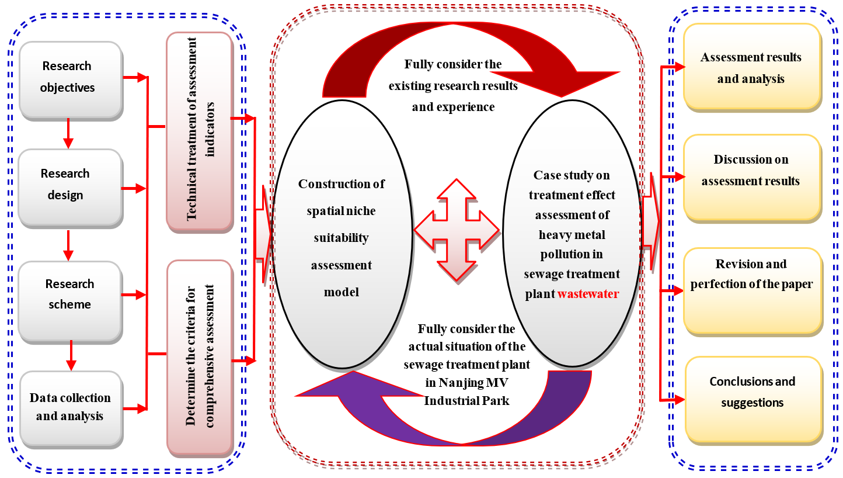
Fig. 1. The research idea of this paper

The samples were packed with tin foil paper, numbered from 001 to 020 following the time sequence, and sent to the Taihu Lake Environmental Monitoring Institute laboratory. The laboratory technicians processed the sewage sludge samples with certified equipment according to standard operating procedures, including drying, grinding, screening and digestion of the measured samples. Because this test is carried out as part of the annual assessment of the pollution treatment effect of excess heavy metal content in sewage sludge commissioned by the plant, the sampling process did not consider the impact of seasonal changes. The test results are listed in Table 1.

Table 1. Results of heavy metals content determination in sewage sludge samples Unit: mg/kg
No. | Pb | Zn | Cu | Hg | Cr | As | Cd | Ni
001 | 38.48 | 109.48 | 50.34 | 0.18 | 78.28 | 15.32 | 0.11 | 39.37
002 | 41.49 | 115.38 | 52.39 | 0.11 | 62.32 | 6.28 | 0.18 | 28.31
003 | 27.51 | 81.27 | 37.37 | 0.09 | 28.39 | 15.62 | 0.09 | 41.28
004 | 52.29 | 96.25 | 69.28 | 0.13 | 70.26 | 8.29 | 0.22 | 17.49
005 | 33.49 | 98.32 | 41.23 | 0.1 | 38.38 | 14.84 | 0.18 | 35.28
006 | 45.29 | 101.28 | 45.98 | 0.15 | 56.39 | 13.29 | 0.1 | 36.72
007 | 28.37 | 93.29 | 59.32 | 0.14 | 65.38 | 5.39 | 0.2 | 19.31
008 | 55.48 | 96.28 | 32.29 | 0.07 | 31.28 | 15.39 | 0.22 | 40.28
009 | 37.38 | 65.39 | 73.28 | 0.14 | 69.62 | 16.39 | 0.25 | 14.74
010 | 39.18 | 118.29 | 59.64 | 0.16 | 58.39 | 18.29 | 0.21 | 40.82
011 | 33.85 | 113.29 | 61.28 | 0.21 | 41.28 | 21.38 | 0.16 | 38.37
012 | 32.39 | 115.38 | 46.32 | 0.12 | 32.38 | 20.37 | 0.15 | 15.39
013 | 53.49 | 72.53 | 55.26 | 0.22 | 60.29 | 18.39 | 0.07 | 30.38
014 | 28.39 | 75.25 | 43.29 | 0.13 | 43.26 | 12.39 | 0.21 | 13.48
015 | 35.98 | 115.18 | 56.92 | 0.17 | 71.39 | 6.09 | 0.16 | 38.94
016 | 41.62 | 78.28 | 71.29 | 0.08 | 70.36 | 9.28 | 0.16 | 40.21
017 | 38.39 | 98.29 | 34.63 | 0.23 | 66.35 | 18.39 | 0.25 | 31.38
018 | 30.29 | 67.29 | 52.39 | 0.12 | 29.38 | 18.28 | 0.11 | 12.89
019 | 26.96 | 126.26 | 37.59 | 0.09 | 57.62 | 20.21 | 0.08 | 39.78
020 | 52.49 | 92.39 | 62.26 | 0.21 | 55.63 | 16.29 | 0.21 | 30.32
Average
 | 38.64 | 96.47 | 52.12 | 0.14 | 54.33 | 14.51 | 0.17 | 30.24
Standard Deviation
 | 4.8758 | 28.1822 | 3.9235 | 0.0831 | 4.3740 | 2.1597 | 0.0397 | 3.1933
Coefficient of Variation
 | 0.1828 | 0.2799 | 0.1255 | 0.1838 | 0.0749 | 0.1316 | 0.1803 | 0.0826
Data source: laboratory test results of sewage sludge samples.
2.3. Construction of Assessment Models for Treatment Effect of Heavy Metal Pollution
In order to effectively evaluate the treatment effect of heavy metal pollution in sewage sludge discharged from the wastewater treatment plant, we selected the niche model as the evaluation method based on comprehensive analysis. Based on the traditional degree model, the spatial ecology model is constructed by combining the absolute ecology model and the relative niche model. The resultant spatial niche suitability model is suitable for Nanjing (Han and Cao, 2021). If there are n ecological factors in a region, the quantitative values of these ecological factors are expressed by $X_{i}$. The ecological factors matrix can be expressed as X= {$X_{1},X_{2},⋯, X_{n}$}. Then the ecological factors of m regions can form a $\left(n×m\right)$ dimensional quantised values matrix of ecological factors (EM), which can be expressed as:

$EM=\left(\begin{matrix}x_{1\left(t_{1}\right)} & x_{2\left(t_{1}\right)} & \begin{matrix}⋯ & x_{n\left(t_{1}\right)}\end{matrix} \\ x_{1\left(t_{2}\right)} & x_{2\left(t_{2}\right)} & \begin{matrix}⋯ & x_{n\left(t_{2}\right)}\end{matrix} \\ \begin{aligned}⋮ \\ x_{1\left(t_{m}\right)}\end{aligned} & \begin{aligned}⋮ \\ x_{2\left(t_{m}\right)}\end{aligned} & \begin{matrix}\begin{aligned}⋮ \\ ⋯\end{aligned} & \begin{aligned}⋮ \\ x_{n}\left(t_{m}\right)\end{aligned}\end{matrix}\end{matrix}\right)$ (1)

where $i=1,2,⋯,n;j=1,2,⋯m.$ $x_{i}\left(t_{j}\right)$is a subset of the n-dimensional ecological factor space $E^{n}$ at time $t_{j}$. $f\left(x_{1}\left(t_{j}\right),x_{2}\left(t_{j}\right),⋯,x_{n}\left(t_{j}\right)\right)$ is called the niche of the ecosystem. If the actual value of an ecological factor is:
$X_{t}=\left(x_{1}\left(t_{j}\right),x_{2}\left(t_{j}\right),⋯,x_{n}\left(t_{j}\right)\right)$, the most suitable value is
$X_{α}=\left(x_{1}\left(α\right),x_{2}\left(α\right),⋯,x_{n}\left(α\right)\right)$. The approach degree between the two is the niche suitability of ecological factors, expressed in ${NS}_{t}$. Then: ${NS}_{t}=\left(X_{i}，X_{α}\right)$. The niche suitability model can be determined by using the distance formula as follows:
(2)
where${ δ}_{it}=\left|x_{i}\left(t_{j}\right)-x_{i}\left(α\right)\right|$，$δ_{max}=max\left\{δ_{it}\right\}=max\left\{\left|x_{i}\left(t_{j}\right)-x_{i}\left(α\right)\right|\right.$,$δ_{max}=max\left\{δ_{it}\right\}=min\left\{\left|x_{i}\left(t_{j}\right)-x_{i}\left(α\right)\right|\right\}. i=1,2,⋯,m；t=1,2,⋯,n;$ is the model parameter (0 ≤ ≤ 1), in the average case $=0.5$. In order to improve the effectiveness of the niche suitability model assessment, we used the heavy metal concentration value in sewage sludge as the niche value, $X_{i}\left(t_{j}\right)$ represents the heavy metal concentration value of the i_{th} sample in the j_{th} period. In order to construct the comprehensive assessment model of niche suitability, the generalised correlation degree in grey theory is introduced to calculate the niche of ecological factors (Ye et al., 2016). In order to facilitate the calculation of niche suitability, the assessment indicators need to be normalised to between [0,1], which can be calculated as follows:
(3)
If $X_{i}\left(α\right)$ is the most appropriate value in the assessment indicators in line$i$, $X_{iα}^{'}$is the most appropriate value of the assessment indicators after normalisation, which is calculated as follows:

(4)

In order to construct the absolute niche suitability model, the following formula is used to carry out the absolute null transformation of the assessment indicator:

(5)

Then, according to the results of absolute null transformation, the absolute niche suitability model is constructed. The specific model of absolute niche suitability is as follows:
(6)

where . is the absolute null transformation value of the k_{th} assessment indicators (k = 2,3,..., n-1), and is the absolute null transformation value of the n_{th} assessment indicators. , is the absolute null transformation value of the optimal value of the k_{th} assessment indicators (k = 2,3,..., n-1), and is the absolute null transformation value of the optimal value of the nth assessment indicators. . In order to construct the relative niche suitability model, the following equation is used to perform relative zero transformation on the assessment indicator:

(7)

On this basis, the relative niche suitability model is constructed by using the above relative null transformation calculation results. The specific assessment model of relative niche suitability is as follows:

(8)
where . is the relative null transformation value of the k_{th} assessment indicator. is the absolute null transformation value of the n_{th} assessment indicators. . is the relative null transformation value of the optimal value of the k_{th} assessment indicators.is the relative null transformation value of the optimal value of the n-th assessment indicators.
. The comprehensive assessment model of spatial niche suitability is the weighted average of the absolute and relative niche suitability models. If $W$ is a relative weight, there are:

$SNS_{tα}=W⋅ANS_{tα}+\left(1-W\right)RNS_{tα}$ (9)
2.4. Determination of Assessment Criteria for Treatment Effect of Heavy Metal Pollution
In order to obtain a comprehensive assessment of the treatment effect of sewage sludge heavy metal pollution in the Nanjing MV Industrial Park wastewater treatment plant, the evaluation standards of heavy metal pollution level should be determined first. Therefore, we drew on the research results of domestic environmental management scholars (Zhang et al. 2018, Yan et al.2019) and referred to China’s Urban Sewage Treatment Sludge (GB T24188-2009), Request for Comments on Technical Standard for Sludge Treatment of Urban Sewage Treatment and Urban Sewage Treatment Pollutant Discharge Standard (GB18918-2016). The standards of heavy metal pollution degree in the wastewater treatment plant of the Nanjing MV Industrial Park are shown in Table 2.
Table 2. Assessment standard of heavy metal pollution content indicator in sewage sludge Industrial Park’s wastewater treatment plant
Pollution  Level | Pb | Zn | Cu | Hg | Cr | As | Cd | Ni
LevelⅠ | 0-25 | 0-75 | 0-30 | 0-0.15 | 0-60 | 0-10 | 0-0.20 | 0-30
LevelⅡ | 25-150 | 75-150 | 30-120 | 0.15-0.3 | 60-90 | 10-15 | 0.2-0.3 | 30-50
Level Ⅲ | 150-350 | 150-350 | 120-280 | 0.30-0.5 | 90-210 | 15-30 | 0.3-0.6 | 50-100
Level Ⅳ | 350-500 | 350-500 | 280-400 | 0.5-1.0 | 210-300 | 30-40 | 0.6-1 | 100-200
Level Ⅴ | >500 | >500 | >400 | >1.00 | >300 | >40 | >1.00 | >200

According to the heavy metal pollution treatment standards of sewage sludge from wastewater treatment plants formulated by the national and local governments, the value range of the assessment result is [0,1]. We divided the pollution treatment effect of heavy metals in the sewage sludge of the Nanjing MV Industrial Park wastewater treatment plant into five levels. The specific standards are as follows: Level Ⅰ∈[0.90,1.00] indicating non-pollution; Level Ⅱ∈[0.80,0.90], indicating micro-pollution; Level Ⅲ∈[0.60,0.80] indicating mild-pollution; Level Ⅳ∈[0.40,0.60] indicating moderate-pollution; and Level Ⅴ∈[0,0.40] indicating heavy-pollution.
3. Results and Discussion
3.1. Normalisation Processing of Comprehensive Assessment Indicators
Since the assessment indicators are all reverse indicators, equations (3) and (4) need to be used for normalisation. The normalisation results of specific assessment indicators are shown in Table 3.

Table 3. Processing results of the normalisation process of assessment indicators
Indicators | Pb | Zn | Cu | Hg | Cr | As | Cd | Ni
X₁ | 0.9230 | 0.7810 | 0.8742 | 0.8200 | 0.7391 | 0.6170 | 0.8900 | 0.8032
X₂ | 0.9170 | 0.7692 | 0.8690 | 0.8900 | 0.7923 | 0.8430 | 0.8200 | 0.8585
X₃ | 0.9450 | 0.8375 | 0.9066 | 0.9100 | 0.9054 | 0.6095 | 0.9100 | 0.7936
X₄ | 0.8954 | 0.8075 | 0.8268 | 0.8700 | 0.7658 | 0.7928 | 0.7800 | 0.9126
X₅ | 0.9330 | 0.8034 | 0.8969 | 0.9000 | 0.8721 | 0.6290 | 0.8200 | 0.8236
X₆ | 0.9094 | 0.7974 | 0.8851 | 0.8500 | 0.8120 | 0.6678 | 0.9000 | 0.8164
X₇ | 0.9433 | 0.8134 | 0.8517 | 0.8600 | 0.7821 | 0.8653 | 0.8000 | 0.9035
X₈ | 0.8890 | 0.8074 | 0.9193 | 0.9300 | 0.8957 | 0.6153 | 0.7800 | 0.7986
X₉ | 0.9252 | 0.8692 | 0.8168 | 0.8600 | 0.7679 | 0.5903 | 0.7500 | 0.9263
X₁₀ | 0.9216 | 0.7634 | 0.8509 | 0.8400 | 0.8054 | 0.5428 | 0.7900 | 0.7959
X₁₁ | 0.9323 | 0.7734 | 0.8468 | 0.7900 | 0.8624 | 0.4655 | 0.8400 | 0.8082
X₁₂ | 0.9352 | 0.7692 | 0.8842 | 0.8800 | 0.8921 | 0.4908 | 0.8500 | 0.9231
X₁₃ | 0.8930 | 0.8549 | 0.8619 | 0.7800 | 0.7990 | 0.5403 | 0.9300 | 0.8481
X₁₄ | 0.9432 | 0.8495 | 0.8918 | 0.8700 | 0.8558 | 0.6903 | 0.7900 | 0.9326
Table 3. cont.
Indicators | Pb | Zn | Cu | Hg | Cr | As | Cd | Ni
X₁₅ | 0.9280 | 0.7696 | 0.8577 | 0.8300 | 0.7620 | 0.8478 | 0.8400 | 0.8053
X₁₆ | 0.9168 | 0.8434 | 0.8218 | 0.9200 | 0.7655 | 0.7680 | 0.8400 | 0.7990
X₁₇ | 0.9232 | 0.8034 | 0.9134 | 0.7700 | 0.7788 | 0.5403 | 0.7500 | 0.8431
X₁₈ | 0.9394 | 0.8654 | 0.8690 | 0.8800 | 0.9021 | 0.5430 | 0.8900 | 0.9356
X₁₉ | 0.9461 | 0.7475 | 0.9060 | 0.9100 | 0.8079 | 0.4948 | 0.9200 | 0.8011
X₂₀ | 0.8950 | 0.8152 | 0.8444 | 0.7900 | 0.8146 | 0.5928 | 0.7900 | 0.8484

All the above indicators have been converted into positive indicators. As a result, it is not necessary to consider the reverse nature of the assessment indicators in the specific comprehensive assessment process.
3.2. Assessment Results of Different Niche Suitability Models
According to the research design, we used the absolute niche suitability model, the relative niche suitability model and the spatial niche suitability model to comprehensively assess the treatment effect of heavy metal pollution in the sewage sludge discharged from the wastewater treatment plant of the Nanjing MV Industrial Park(Han & Cao, 2022). First, the absolute null transformation value and the relative null transformation value need to be calculated using equations (5) and (7). In order to save space, specific calculation results are omitted. On this basis, equations (6), (8) and (9) are used to calculate the assessment results of the three methods, respectively. The results are presented in Table 4.
The absolute niche suitability model concluded that Pb and Cu are at level Ⅰ (non-pollution) level, Ni, Hg and Cd are at Level Ⅱ (micro-pollution) level, Cr and Zn are at level Ⅲ(mild-pollution) level, while As is at level Ⅳ (moderate-pollution) level. The relative niche suitability model concluded that Pb, Cu, Ni and Hg are at level Ⅰ (non-pollution), Cd, Cr and Zn are at Level Ⅱ (micro-pollution), while As is at level Ⅲ (mild-pollution). The spatial niche suitability model concluded that Pb and Cu are at level Ⅰ (non-pollution), Ni, Hg, Cd and Zn are at Level Ⅱ (micro-pollution), while As is at level Ⅲ (mild-pollution). According to these results, it can be seen clearly that the spatial ecology varies with the models, and the final assessment results largely depend on the changes in relative weights (Luo et al., 2022). In order to reflect the impacts of changes in the relative weights of the assessment indicators on the assessment results, we used 11 different grades from 0 to 1 and calculated the results summarised in Table 5.
In order to illustrate the influence of different relative weights on the assessment results of the spatial niche suitability model, the data in Table 5 are plotted as histograms in Fig. 2, which reflect the impact of different relative weights on the spatial ecological degree of influence of bit suitability.

Table 4. Assessment results of the treatment effect of heavy metal pollution in sewage sludge from wastewater treatment plant
Methods | Indicators | Pb | Zn | Cu | Hg | Cr | As | Cd | Ni
$${ANS}_{tα}$$ | $$\left|S_{t}\right|$$ | 0.0412 | 0.0453 | 0.0622 | 0.0752 | 0.0879 | 0.0761 | 0.1277 | 0.1502
 | $$\left|S_{α}-S_{t}\right|$$ | 0.1325 | 0.0972 | 0.0876 | 0.0671 | 0.0467 | 0.0218 | 0.0128 | 0.0008
 | 1+$\left|S_{α}\right|$+$\left|S_{t}\right|$ | 0.3167 | 0.2714 | 0.3275 | 0.3159 | 0.3042 | 0.2258 | 0.3303 | 0.3520
 | 1+$\left|S_{α}\right|$+$\left|S_{t}\right|$+$\left|S_{α}-S_{t}\right|$ | 0.4492 | 0.3687 | 0.4254 | 0.3923 | 0.3539 | 0.2489 | 0.3509 | 0.3596
 | Assessment results | 0.9396 | 0.7826 | 0.9027 | 0.8504 | 0.7927 | 0.5727 | 0.8217 | 0.8626
 | Level | Ⅰ | Ⅲ | Ⅰ | Ⅱ | Ⅲ | Ⅳ | Ⅱ | Ⅱ
$${RNS}_{tα}$$ | $$\left|S_{t}\right|$$ | 0.1722 | 0.0374 | 0.0568 | 0.0695 | 0.0831 | 0.0755 | 0.1271 | 0.1433
 | $$\left|S_{α}^{'}-S_{t}^{'}\right|$$ | 0.1017 | 0.0919 | 0.0903 | 0.0687 | 0.0478 | 0.0226 | 0.0129 | 0.0008
 | 1+$\left|S_{α}^{'}\right|$+$\left|S_{t}^{'}\right|$ | 0.3073 | 0.3040 | 0.3584 | 0.3493 | 0.3424 | 0.2616 | 0.3724 | 0.3789
 | 1+$\left|S_{α}^{'}\right|$+$\left|S_{t}^{'}\right|$+$\left|S_{α}^{'}-S_{t}^{'}\right|$ | 0.3990 | 0.3843 | 0.4399 | 0.4126 | 0.3841 | 0.2796 | 0.3853 | 0.3798
 | Assessment results | 0.9802 | 0.8176 | 0.9455 | 0.9001 | 0.8575 | 0.6393 | 0.8977 | 0.9028
 | Level | Ⅰ | Ⅱ | Ⅰ | Ⅰ | Ⅱ | Ⅲ | Ⅱ | Ⅰ
$${SNS}_{tα}$$ | $${ANS}_{tα}$$ | 0.9396 | 0.7826 | 0.9027 | 0.8504 | 0.7927 | 0.5727 | 0.8217 | 0.8626
 | $${RNS}_{tα}$$ | 0.9802 | 0.8176 | 0.9455 | 0.9001 | 0.8575 | 0.6393 | 0.8977 | 0.9028
 | W | 0.50 | 0.50 | 0.50 | 0.50 | 0.50 | 0.50 | 0.50 | 0.50
 | Assessment results | 0.9599 | 0.8001 | 0.9241 | 0.8752 | 0.8251 | 0.6060 | 0.8597 | 0.8827
 | Level | Ⅰ | Ⅱ | Ⅰ | Ⅱ | Ⅱ | Ⅲ | Ⅱ | Ⅱ

Table 5. Effects of different W values on the assessment results of the spatial niche suitability model
$${ANS}_{tα}$$ | 0.9396 | 0.7826 | 0.9027 | 0.8504 | 0.7927 | 0.5727 | 0.8217 | 0.8626
$${RNS}_{tα}$$ | 0.9802 | 0.8176 | 0.9455 | 0.9001 | 0.8575 | 0.6393 | 0.8977 | 0.9028
${RNS}_{tα}$ (W = 0.0) | 0.9802 | 0.8176 | 0.9455 | 0.9001 | 0.8575 | 0.6393 | 0.8977 | 0.9028
${RNS}_{tα}$ (W = 0.1) | 0.9761 | 0.8141 | 0.9412 | 0.8951 | 0.8510 | 0.6326 | 0.8901 | 0.8988
${RNS}_{tα}$ (W = 0.2) | 0.9721 | 0.8106 | 0.9369 | 0.8902 | 0.8445 | 0.6260 | 0.8825 | 0.8948
${RNS}_{tα}$ (W = 0.3) | 0.9680 | 0.8071 | 0.9327 | 0.8852 | 0.8381 | 0.6193 | 0.8749 | 0.8907
${RNS}_{tα}$ (W = 0.4) | 0.9640 | 0.8036 | 0.9284 | 0.8802 | 0.8316 | 0.6127 | 0.8673 | 0.8867
${RNS}_{tα}$ (W = 0.5) | 0.9599 | 0.8001 | 0.9241 | 0.8752 | 0.8251 | 0.6060 | 0.8597 | 0.8827
${RNS}_{tα}$ (W = 0.6) | 0.9558 | 0.7966 | 0.9198 | 0.8703 | 0.8186 | 0.5993 | 0.8521 | 0.8787
${RNS}_{tα}$ (W = 0.7) | 0.9518 | 0.7931 | 0.9155 | 0.8653 | 0.8121 | 0.5927 | 0.8445 | 0.8747
${RNS}_{tα}$ (W = 0.8) | 0.9477 | 0.7896 | 0.9113 | 0.8603 | 0.8057 | 0.5860 | 0.8369 | 0.8706
${RNS}_{tα}$ (W = 0.9) | 0.9437 | 0.7861 | 0.9070 | 0.8554 | 0.7992 | 0.5794 | 0.8293 | 0.8666
${RNS}_{tα}$ (W = 1.0) | 0.9396 | 0.7826 | 0.9027 | 0.8504 | 0.7927 | 0.5727 | 0.8217 | 0.8626

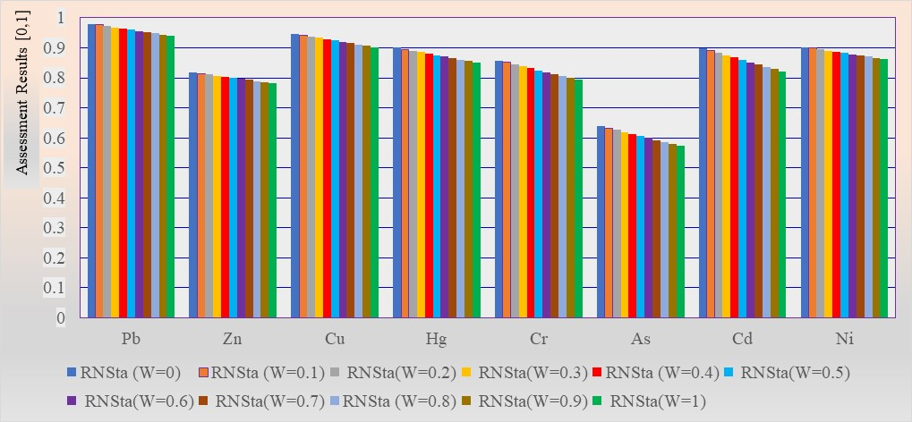
Fig. 2. Analysis of the variation range of the assessment results of the spatial niche model

From Fig. 2, it can be seen that the assessment results of the spatial niche fitness model are biased towards the assessment results of the relative niche fitness model with a relatively large value (plus literature on the spatial niche). The assessment results of the spatial niche fitness model are mainly affected by the difference between the assessment results of the absolute niche suitability assessment model and the relative niche suitability assessment results and the change of relative weights. The assessment results of the suitability model are adjusted between the assessment results of the absolute niche assessment model and the assessment results of the relative niche suitability assessment model (Guo et al. 2022) to increase the content of the combination of objectivity and subjectivity in the decision-making results.
3.3. Discussion on Difference in Assessment Results of Different Niche Assessment Methods
Three different niche suitability models were used to comprehensively assess the treatment effect of heavy metal pollution in the sewage sludge discharged from a large wastewater treatment plant in the Nanjing MV Industrial Park. The conclusions of the assessment results are the same, with only differences in the values (Han & Cao 2022). In order to show and analyse the differences in the assessment result values of the three niche suitability models. The cone chart in Fig. 3 shows the change rules of the assessment result values of the three niche assessment models.
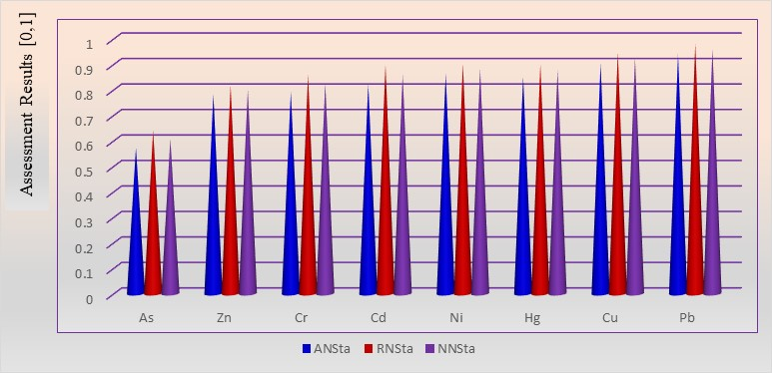
Fig. 3. Difference in assessment results of different niche suitability models

In Fig. 3, the assessment results of the treatment effects of heavy metals are in order from poor to good. The treatment outcome of As is the worst, showing the most severe pollution. On the other hand, the treatment outcome of Pb is the best, showing no pollution. Therefore, according to the assessment results, we recommend that the Nanjing MV Industrial Park wastewater treatment plant pay special attention to the pollution treatment of As, Zn and Cr in sewage sludge heavy metal pollution treatment. Furthermore, among these three contaminants, the focus should be on As and Cr, which are carcinogenic. Since part of the sewage sludge from the wastewater treatment plant in the Nanjing MV Industrial Park is used as waste by farmers in the outer suburbs, it could pose health risks to the residents of Nanjing.
3.4. Discussion on the Difference in Assessment Results from Different Niche Assessment Models
In this paper, the samples are collected from the settled sewage sludge in the sedimentation tank. The treatment effect of the sewage entering the sedimentation tank directly determines the degree of heavy metal pollution. The quality of sewage treatment and the way of sewage sludge treatment also determine the health risk (Yang et al. 2019). Therefore, it is the key to continuously improve the treatment effect to monitor the content of heavy metals in sewage sludge dynamically and continuously strengthen the treatment of heavy metal pollution according to the monitoring results. The assessment results of the treatment effect of heavy metal pollution in the sewage sludge of the Nanjing MV Industrial Park wastewater treatment plant in this paper are mainly based on the results of 20 sewage sludge samples. Fig. 4 presents the variation between the normalised results of the heavy metal contents in these 20 samples. The measured values from these samples ultimately determine the treatment effect of heavy metal pollution in the sewage sludge of the wastewater treatment plant. Due to various reasons, the sampling time in this study was relatively short, and the number of samples was relatively small. These factors have greatly affected the final assessment. It is worth noting that the assessment method in this paper is a dynamic assessment method, which needs to be continuously tested and assessed to find out the change of heavy metal content in the sewage sludge over time. Effective heavy metal pollution treatment measures need to be taken according to the change to ensure the continuous improvement of the treatment effect of heavy metal pollution in the sewage sludge of the wastewater treatment plant and to minimise the health risk posed by the heavy metal pollution in the sewage sludge to the exposed population.

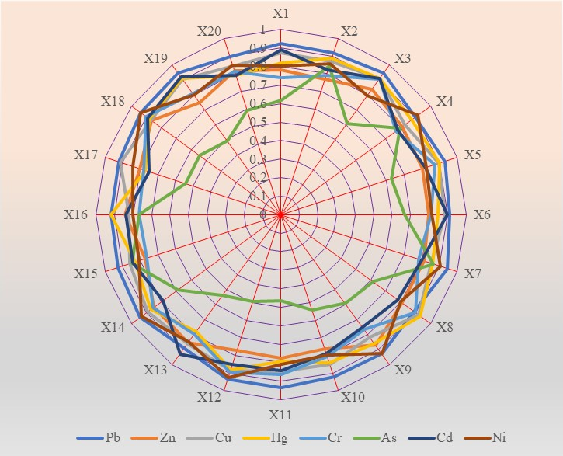
Fig. 4. Variation diagram of main influencing factors of the treatment effect of heavy metal pollution

4. Conclusions
In order to explore the effective method of a comprehensive assessment of the treatment effect of heavy metal pollution in sewage sludge from the wastewater treatment plant, 20 sampling samples were taken from the Nanjing MV industrial park, and eight heavy metal content indicators (Zn, Cu, Pb, Hg, Cr, Ni, As, Cd) are analysed. Three basic assessment methods are adopted in the study, including the absolute niche fitness model, relative fitness model and spatial niche fitness model. It is found that the order of the assessment results of the treatment effect of heavy metal pollution in sewage sludge from wastewater treatment plants are consistent from all three models, where there are differences in the assessment result values. The assessment result value of the absolute niche suitability model is the smallest, the assessment result value of the relative niche suitability model is the largest, and the assessment result value of the spatial niche suitability model is between the two. Its trend can be adjusted by changing the weight, which has the characteristics of stationarity. The assessment results of the three niche suitability models are Pb > Cu > Ni > Hg > Cd > Cr > Zn > As. According to the assessment results of the spatial niche suitability model, Pb and Cu are at level Ⅰ (non-pollution), Ni, Hg, Cd and Zn are at Level Ⅱ (micro-pollution), while As is at level Ⅲ (mild-pollution).
City residents usually do not have direct contact with sewage sludge from wastewater treatment plants. However, some of the sewage sludge from the Nanjing MV Industrial Raw Wastewater Treatment Plant is used by farmers in remote suburbs, which poses a health risk to Nanjing residents. Therefore, we recommend that wastewater treatment plants strengthen the control of heavy metal pollution in sewage sludge and take timely control measures according to the findings of this assessment.

This paper is supported by the Humanities and Social Sciences Foundation of the Ministry of Education: “Research on China’s systemic financial risk
prevention and control based on three-dimensional structural analysis”
(NO.: 19YJA790098). Also, we would like to thank the Management Committee of the Nanjing MV Industry Park for providing access to the data used in this study.
References
Chang, H.Q., Jiao, C.F., Zheng, C.J., Wu, J., Wang, Q.Z., Zhu, X.X., Xu, X.F. (2019). Characteristics and Risk Assessment of Heavy Metal Content in Sewage Sludge from Different Sources. Journal of Henan Agricultural Sciences, 48(3), 70-76. DOI: 10.15933/j.cnki.1004-3268.2019.03.010
Guo, P.Y., Sun, F.Q, Han, X.Y. (2022). Study on comprehensive evaluation of environmental pollution treatment effect in coal mine subsidence area: taking Xinglongzhuang mining area of Yanzhou energy as an example. Environmental Science and Pollution Research. DOI: 10.1007/s11356-022-22532-9
Han, X.Y., Cao, T.Y. (2021). Study on ecological environment quality assessment of the energy consumption pollution treatment in industrial parks. Environmental Science and Pollution Research, 28, 28038-28057.
Han, X.Y., Cao, T.Y. (2022). Study on the assessment of ecological compensation effect for environmental pollution loss from energy consumption: Taking Nanjing MV Industrial Park as an example. Environmental Technology & Innovation, 27. 102473.
Heller, R. (1946). Results of Rapid Treatment of Early Syphilis. The Journal of the American Medical Association, 132(5), 258-263. DOI: 10.1001/jama.1946.02870400006002
Huang, H.H., Tian, T., Zou, X.J., Zhou, X.Y., Senthilkumar, P., Qiu, R.L. (2009). Bioavailability Assessment of Heavy Metals in the Vicinity of Dabaoshan Mine. Acta Scientiarum Naturalium Universitatis Sunyatseni, 48(4), 125-136.
Jenkins, S.H., Cooper, J.S. (1964). The Solubility of Heavy Metal Hydroxides in Water, Sewage and Sewage Sludge. 3. The Solubility of Heavy Metals Present in Digested Sewage Sludge. Air and water pollution, 8, 695-703, https://www.nature.com/arti- cles/srep34250/
Li, Q.F., Yao, J., Huang, X.R., Zhang, Y.J., Liu, X.L., Song, W.H., Wang, X.B. (2019). Ecological Risk and Health Risk Assessment on Heavy Metals in Sludge of the Sewage Treatment Plant in Qianjiang District. Journal of Southwest University (Natural Science Edition), 41(3), 120-129. DOI: 10.13718/j.cnki.xdzk. 2019. 03.017
Liang, J.N., Liu, J., Chen, J., Zhang, J., Li, W.H., Gao, M. (2014). Characteristics of Heavy Metals in Atmospheric Deposition in Heating Periods of an Industrial Park in Western Shaanxi Province, China. Acta Scientiae Circumstantiate, 34(2), 318-324, DOI: 10.13671/j.hjkxxb.2014.02.015
Liew, C.S., Kiatkittipong, W., Lim, J.W., Lam, M.K., Ho, Y.C., Ho, C.D., Ntwampe, S.K.O., Mohamad, M. & Usman, H.A. (2021). Stabilisation of heavy metals loaded sewage sludge: Reviewing conventional to state-of-the-art thermal treatments in achieving energy sustainability. Chemosphere, 277, 130310. DOI: 10.1016/j.chemosphere.2021.130310
Mao, K., Chen, H.M., Chen, T.M., Xia, X.Y., Cao, Z.H., Zhao, Y.W. (2020). Adsorption Effects of Sludge Biochar of Different Particle Sizes on Zn Contamination in Water. Acta Scientiae Circumstantiate, 40(2), 536-545, DOI: 10.13671/j.hjkxxb.2019.0345
Moore, B.J., Oldershaw, G.F., Williams, O.T. (1913). The Science Committee of The British Medical Association. On The General Toxic Effect of Heavy Metals After Subcutaneous Injection, And On “The Question of Poisoning by Volatile Emanations from Paints”. The British Medical Journal, 2(2744), 217-221. https://www. jstor.org/stable/25302431
Peng, Y.D., Qiu, G.L., Jiang, H.L., Wang, Y.P. (2013). Study on the Soil Heavy Metal Pollution in Songjiang Industrial Park of Hengyang City. Safety and environmental engineering, 20(1), 45-59.
Pobi, K.K., Satpati, S., Dutta, S., Nayek, S., Saha, R.N., Gupta, S. (2019). Sources and Ecological Risk Assessment of Heavy Metals Accumulated Within a Natural Stream of Durgapur Industrial Zone, India, by Using Multivariate Analysis and Pollution Indices. Applied Water Science, 9(3), 1-16. DOI: 10.1007/s13201-019-0946-4
Salant, W.L., Mitchell, C.W. (1915). The Action of Heavy Metals on the Isolated Intestine. Proceedings of the Society for Experimental Biology and Medicine, 13(1), 15-16. DOI: 10.3181/00379727-13-11
Selvam, S., Ravindran, A., Venkatramanan, S., Singaraja, C. (2017). Assessment of Heavy Metal and Bacterial Pollution in Coastal Aquifers from SIPCOT Industrial Zones, Gulf of Manner, South Coast of Tamil Nadu, India. Applied Water Science, 7(2), 897-913. DOI: 10.1007/s13201-015-0301-3
Szarek, Ł. (2020). Leaching of heavy metals from thermal treatment municipal sewage sludge fly ashes. Archives of Environmental Protection, 46(3), 49-59. DOI: 10.24425/ aep.2020.134535
Ukah, B.U., Egbueri, J.C., Unigwe, C.O., Ubido, O.E. (2019). Extent of heavy metal pollution and Health Risk Assessment of Groundwater in a Densely Populated Industrial Area, Lagos, Nigeria. International Journal of Energy and Water Resources, 3(4), 291-303. DOI: 10.1007/s42108-019-00039-3
Xu, X.X., Yang, Y., Wang, G.Y., Zhang, S.R., Cheng, Z., Li, T., Yang, Z.B., Xian, J.R., Yang, Y.X., Zhou, W. (2020). Removal of heavy metals from industrial sludge with new plant-based washing agents. Chemosphere, 246. 125816. DOI: 10.1016/j.chemosphere.2020.125816
Yan, F., Liu, C.L., Wei, B.W. (2019). Assessed ion of heavy metal pollution in the sediment of Poyang Lake based on stochastic geo-accumulation model (SGM). Science of The Total Environment, 659, 1-6. DOI: 10.1016/j.scitotenv.2018.12.3110048-9697/2018 Elsevier B.V.
Yang, H.J., Xu, Y.H., Liu, Y.B., Wu, P., Shu, Q., Luo, X.F., Wu, G. (2019). Pollution Characteristics and Ecological Risk Assessment of Heavy Metals in Sediments of the Qingshuitang Industrial District. Earth and Environment, 47(5), 671-679. DOI: 10.14 050/j.cnki.1672-9250.2019.47.113
Yang, T., Xiao, Y.D., Huang, H.J., Lai, F.Y., Chang, Y.C., Pan, Z.Q., Xiao, X.F. (2019). Assessment Optimisation of the Contamination Degree and Ecological Risk of Heavy Metals in Sewage Sludge. Environmental Science & Technology, 42(2), 202-209. DOI: 10.19672/j.cnki.1003-6504.2019.02.031
Yang, Y.Y., Li, J.X., Liu, Y.P., Fang, Y.C., Cui, T., Liu, Z.Y., Cheng, G. (2019). Pollution Characterisation and Assessment of Potential Ecological Risk of Heavy Metals Municipal Sludge from Wastewater Treatment Plants in Beijing. Environmental Pollution & Control, 9, 1098-1102+1107. DOI: 10.15985/j.cnki.1001-3865.2019.09.018
Ye, J., Dang, Y.G., Ding, S. (2016). Grey prediction model of interval grey numbers based on axiom of generalised non-decrease grey degree. Control and Decision, 31(10), 1831-1836.
Zhang, C., Chen, H., Yu, Y., Wang, L.J., Han, J.B., Tao, P. (2013). Pollution Characteristics of Heavy Metals in Sludge from Wastewater Treatment Plants and Sludge Disposal in Chinese Coastal Areas. Environmental Science, 34(4), 1345-1350.
DOI: 10.13227/j.hjkx.2013.04.048
Zhang, J.Y., Liu, X.D., Pang, S.D., Yu, Y.C. (2018). Pollution Assessment of Heavy Metals in Urban Green Land Soils in Nanjing City based on the Matter-Element Extension Model. Research of Environmental Sciences, 31(9), 1572-1579. DOI: 10.13198/ j.issn.1001-6929.2018.03.39
Luo, Y.N., Sun, F.Q., Yan, X.L., Sun, T. (2022). Research on Comprehensive Assessment of Effect on Environmental Pollution Collaborative treatment: Taking China’s Yangtze River Delta Urban Agglomeration as an Example. Polish Journal of Environmental Studies, 31(6), 1-12. DOI: 10.15244/pjoes/151494

