 | Rocznik Ochrona Środowiska
 | Volume 24 | Year 2022 ISSN 2720-7501 | pp. 214-230
 | https://doi.org/10.54740/ros.2022.016 open access
 | Received: 30 August 2022 Accepted: 20 October 2022 Published: 14 November 2022
The Short-Term and Seasonal Trend Detection of Sediment Discharges in Turkish Rivers
Halil Ibrahim Burgan
Department of Civil Engineering, Akdeniz University, Antalya, Turkey
https://orcid.org/0000- 0001-6018-3521
corresponding author’s e-mail: burgan@akdeniz.edu.tr
Abstract: Hydrometeorological variables are tested by trend methods to detect trends in river basins. Mann-Kendall and Spearman’s rho tests are widely used as traditional trend methods. Besides, some new trend tests are applied to hydrometeorological variables, such as Innovative Trend Analysis (ITA). Sediment discharge observations are more complicated than other hydrometeorological variables. In general, sediment data are observed on a monthly time scale. Therefore, there are minimal studies on sediment data, especially in Turkey. In this study, Innovative Trend Analysis (ITA), Mann-Kendall, Correlated Mann-Kendall and Seasonal Mann-Kendall trend analyses are applied to sediment discharges in Turkish river basins. According to Mann-Kendall, Correlated Mann-Kendall and Seasonal Mann-Kendall results, positive trends have detected only 8, 2 and 20 gauging stations, respectively. Then, 30 positive and 15 negative trends were detected by ITA methodology. The trend slopes calculated from ITA methodology are categorised because some positive and negative trends are weak. The applied trend methods are evaluated together, considering the climate properties of hydrological regions in Turkey. Increasing trends in sediment data are detected from the rivers in the Mediterranean region of Turkey. The results of the study would help to manage water resources as well as sustainable development in the Turkish river basins.
Keywords: Innovative Trend Analysis (ITA), Mann-Kendall, Seasonal Mann-Kendall, Sediment discharge, Trend, Turkish rivers
Research Highlights
- Innovative Trend Analysis (ITA), Mann-Kendall, Correlated Mann-Kendall and Seasonal Mann-Kendall trend analyses are applied to sediment discharges in Turkish rivers.
- The sediment data for the 2006-2012 period from 45 gauging stations are used in the study.
- Increasing and decreasing trends in sediment data are significantly detected from the coastal rivers in the Mediterranean and Black Sea regions of Turkey.

1. Introduction
Sediment transport is an essential and natural phenomenon in rivers. It is known that the sediment transport mechanism is related to precipitation and runoff directly in a hydrological basin. So, it is easily affected by climate change and anthropogenic effects, and it affects the capacity of human-made reservoirs. The increase in sediment adversely affects the safety of dams and reduces energy production, water storage, discharge capacity and flood attenuation capabilities (Wang et al. 2005). Seasonal variations in sediment transport from an Arctic glacier are also investigated in previous studies (Hodgkins 1996).
There are many studies on sediment estimations based on artificial intelligence (AI) methods for the future due to the importance of the subject (Bajirao et al. 2021, Chen & Chau 2019, Cigizoglu 2004). The trend component, one of the stochastic processes, should be separated from time series data. The regressional equations from 14 sediment gauging stations in Kansas are produced for each of them considering the 1970-2002 period (Putnam & Pope 2003). Some biggest rivers from different geographic regions in the world are evaluated by annual changes in sediment and long-term cumulative annual sediment corresponding to cumulative annual runoff after 1950 (Li et al. 2020, Walling & Fang 2003).
The studies on sediment and runoff changes in the rivers are primarily from Chinese rivers in the literature. The main reason is sediment problems in Chinese rivers, especially the Yellow River. Industrial development and urbanisation, many river basin characteristics, such as the percentage of vegetation cover (including secondary vegetation), may alter substantially with economic growth. Consequently, the rainfall-runoff process should be different from its original condition and sediment transport by the river systems should change (Liu et al. 2008).
Yangtze River flows 6300 km and is the longest river in Asia and the third longest in the world. There are many studies about sediment changes in the Yangtze River. Sediment and runoff changes of the Yangtze River and its tributaries are evaluated using Mann-Kendall trend analysis (Zhang et al. 2006). Gongshui River, one of eight Yangtze River tributaries, is selected as a study area. Mann-Kendall and Pettitt tests are used for trend and change-point analyses, respectively. The double-mass curve method is employed to quantify the effects of precipitation change and human activities on hydrological regime shifts (Guo et al. 2018).
Trend and change-point analyses of streamflow and sediment are determined for the Yellow River, the second-longest river in China (Gao et al. 2010). Mann-Kendall trend analysis, Pettitt test for change-point analysis and double-mass curve methods are used in the study. Similarly, the changes in streamflow and sediment and the response to human activities in the middle reaches of the Yellow River are investigated by Mann-Kendall trend analysis, the Pettitt test for change-point analysis and double-mass curve methods (Gao et al. 2011). Climate change is generally characterised by changing temperature and precipitation variability. Precipitation generates runoff which has a direct impact on both river streamflow and the capacity of sediment. So, precipitation data is correlated with streamflow data to analyse the influence of climate change. Mann-Kendall test for monotonic trend is applied to 15 gauging stations on the Yellow River. Then, interannual changes of annual Normalised Difference Vegetation (NDVI) values in the Yellow River basin for 1982-2006 are calculated (Miao et al. 2010).
The trends of streamflow and sediment from three hydrometric gauging stations over the past 25 years of development in the state of Selangor, Peninsular Malaysia, are analysed using the Mann-Kendall and Pettitt tests. Landscape metrics for establishing the relationship between land-use changes and trends of hydrological time series are calculated. The hydrological trends are also studied regarding rainfall variations and artificial features (Memarian et al. 2012). Both satellite imagery and in situ data are compiled to produce a 32-year time series (1984-2016) of sediment data in the Amazon River, the largest river by streamflow volume of water in the world. The seasonal Mann-Kendall test is applied for temporal trend detection (Montanher et al. 2018). The sediment trends are characterised using the Weighted Regressions on Time, Discharge and Season (WRTDS) model. The correlations between sediment trends and concurrent changes in land use/cover, hydrology and climate are often stronger at sites draining watersheds with more homogenous, human-related land uses (i.e., agricultural and urban lands) compared to mixed-use or undeveloped lands (Murphy 2020).
The recent trends in sediment and the influence of the climatic and human forcing mechanisms on the land-ocean fluvial systems are examined. A significant dataset containing sediment time series of various timescales from 133 gauging stations dispersed across India’s tropical river basins from 1986-1987 to 2005-2006 is analysed. (Panda et al. 2011). The annual sediment time series trend from seven major basin gauging stations in India using Mann-Kendall (MK) trend test. Subsequently, the trends in the time series are extracted using the empirical mode decomposition method. The same procedure is followed for the annual precipitation of the basin, and the trend is compared to sediment data (Adarsh et al. 2016). The trends of daily streamflow and sediment are investigated in Subarnarekha and Burhabalang basins in India. Bivariate linear regression, Mann-Kendall and Pettitt tests are implemented on data from the Water Resources Information System of India (Das 2019).
The trend of Orinoco River (Venezuela and Colombia) sediment data is studied using MODIS satellite images. 10-daily sediment data produced and processed by the SO-HYBAM observation program. The calibration is made by stream gauges and MODIS satellite images (Gallay et al. 2019). As mentioned above, Mann-Kendall, Pettitt test and double mass curve method are commonly used for trend analyses. Innovative Trend Analysis (ITA) is also used for trend detection in recent hydrometeorological studies (Ateeq-Ur-Rehman et al. 2017).
There are many studies on the trends of streamflow and precipitation data in Turkey (Akçay et al. 2022, Güçlü 2020, Sen & Aksu 2021). However, there are very few studies about sediment trends in Turkish rivers. Mann-Kendall, Mann-Kendall Rank Correlation and Spearman’s Rho tests are used to evaluate the trend of streamflow, sediment and precipitation data in Sakarya River, Turkey (Ceribasi et al. 2013).
In terms of data variability and its very high range, the static analysis of sediment discharge time series is very difficult. It depends on the amount of water in the river, so it is known that there is a very strong regressional relationship between streamflow discharge and sediment amount in the river. There are minimal and fewer studies on sediment discharge in the literature. There are some new studies about sediment yield analysis and sediment deposition of a dam (Darama et al. 2019, Guvel et al. 2021). This paper is the first on the trend of sediment data on the country scale in Turkey, and ITA is applied to sediment data in Turkish rivers for the first time.
2. Study Area and Data
Turkey is located at the geographic coordinates of 36-42° N latitudes and 26-45° E longitudes. The river basins in Turkey have different hydroclimatological characteristics. The Mediterranean climate properties are shown on the coastal sides of the Mediterranean, Aegean and Marmara Seas. Summer seasons in this climate are hot and dry. Although winter seasons are mild and rainy, there is no significant difference between summer and winter precipitation. North parts of Turkey have the Black Sea climate properties. Summer seasons are cool, and winter seasons are warm on the coastal sides and snowy and cold at higher parts, in this climate. The interior and eastern parts of Turkey have Terrestrial climate properties. Winters are cold and snowy, while summers are generally hot and dry in this climate.
Sediment discharges have a very high correlation with streamflow data. The annual surface flow is 186.6 billion m³, with Turkey’s rainfall-runoff coefficient of 0.37 (Aksoy 2020). The spatial map of sediment gauging stations in the study is presented in Figure 1. In this study, 45 sediment gauging stations are considered. The 2006-2011 (6 years) period was selected as a standard period for observations with continuous data. The statistical properties of monthly sediment data are presented in Table 1. The scatter diagram shows the correlation between sediment drainage area (km²) and annual mean sediment discharge (t/day) in Figure 2. Although there is a positive correlation between the data, it is seen from the graph that this relationship is weak.

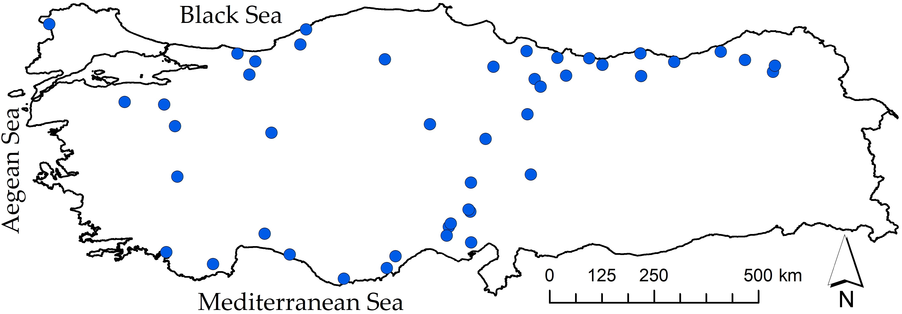
Fig. 1. The location map of sediment gauging stations in the study

Table 1. The statistical characteristics of monthly sediment data
 | Sediment drainage area (km²) | Mean (t/day) | Min (t/day) | Max (t/day) | St Dev (t/day) | C_{v} | C_{s} | r₁
Min | 191.4 | 5.23 | 0.2 | 57.5 | 10.98 | 0.658 | 1.426 | -0.0536
Max | 27250.8 | 9479 | 82.1 | 365169 | 43015 | 8.013 | 8.476 | 0.410

Only ten sediment gauging stations have sediment drainage areas smaller than 750 km^{2,} with the smallest area of 191.4 km². Other 35 sediment gauging stations have sediment drainage areas greater than 750 km^{2,} with the greatest area of 27250.8 km². Similarly, the means of monthly sediment data are smaller than 100 t/day in ten gauging stations, with the smallest mean of 5.23 t/day. Means of monthly sediment data are greater than 100 t/day in the other 35 gauging stations, with the greatest mean of 9479 t/day. Minimums of monthly sediment data are smaller than 1 t/day in seven gauging stations, with the smallest minimum of 0.2 t/day. Minimums of monthly sediment data are greater than 1 t/day in the rest 38 gauging stations, with the greatest minimum of 82.1 t/day. Similarly, the maximums of monthly sediment data are smaller than 1000 t/day in seven gauging stations, with the smallest maximum of 57.5 t/day. Maximums of monthly sediment data are greater than 1000 t/day in the other 38 gauging stations, with the greatest maximum of 365169 t/day.

Fig. 2. The scatter diagram of the drainage area and annual mean sediment discharge

The standard deviations of monthly sediment data in six gauging stations are smaller than 100 t/day with the smallest value of 10.98 t/day. The rest standard deviations of monthly sediment data in 39 gauging stations are greater than 100 t/day, with the greatest value of 43015 t/day. The variation coefficients (C_{v}) of monthly sediment data are smaller than two in eight gauging stations, with the smallest value of 0.658. C_{v} values of monthly sediment data are greater than two in the other 37 gauging stations with the greatest value of8.013. The greater C_{v} coefficients indicate that the distribution level of the data is high around the mean.
Only five sediment gauging stations have skewness coefficients smaller than three, with the smallest coefficient of 1.426. The other 40 gauging stations have skewness coefficients greater than three, with the greatest coefficient of 8.476. All C_{s} coefficients are greater than zero. All sediment time series have already tended to have positive skewness, as expected. Finally, the autocorrelation coefficients (r₁) of monthly sediment data are greater than 0.2 in only nine gauging stations, with the greatest coefficient of 0.410. The rest autocorrelation coefficients of monthly sediment data are smaller than 0.2 in 36 gauging stations, with the smallest coefficient -0.0536. The coefficients indicate no relationships between each value in months of sediment time series, as expected.

3. Methods
The trend analyses are Mann-Kendall, Correlated Mann-Kendall and Seasonal Mann-Kendall and Innovative Trend Analysis (ITA) in this study. Their methodological backgrounds are presented below in sections.
3.1. Mann-Kendall Trend Test
The test checks the trend in time scales (daily, monthly, seasonal or annual) of hydrometeorological data. The World Meteorological Organization (WMO) proposed the Mann-Kendall test for measuring trends in time series. The simple method does not require the data to fit normal distribution and is not affected much by outliers. Most hydrometeorological data do not conform to normality, and this test gives better results than a parametric test such as a t-test. The null hypothesis (H₀) shows no trend, and the alternative hypothesis (H₁) represents the presence of either a gradual increasing or decreasing trend in a given time series X (x₁, x₂, … , x_{n}) (Cavus et al. 2019). The Mann-Kendall test statistic is calculated according to:
The standardised test statistics $Z$ is calculated as
$$Z=\left\{\begin{matrix}{\left(S-1\right)}/{\sqrt{Var S}} ; & S>0 \\ 0 ; & S=0 \\ {\left(S+1\right)}/{\sqrt{Var S}} ; & S<0\end{matrix}\right.$$ | (1)
The positive and negative $Z$ value specifies an increasing and decreasing trend, respectively. The test is carried out at any significance level, where,
$$S=\sum_{i=1}^{n-1}{\sum_{j=i+1}^{n}{sgn \left(x_{j}-x_{i}\right)}}$$ | (2)
with $sgn$ the signum function.
$$sgn \left(x_{j}-x_{i}\right)=\left\{\begin{matrix}+1 ; & x_{j}>x_{i} \\ 0 ; & x_{j}=x_{i} \\ -1 ; & x_{j}<x_{i}\end{matrix}\right.$$ | (3)
The mean of $S$ is $μ$ = 0. The variance of $S$ values is calculated as
$$Var\left(S\right)=\frac{1}{18}\left[n\left(n-1\right)\left(2n+5\right)-\sum_{i=1}^{n}{t_{i} \left(t_{i}-1\right)\left(2t_{i}+5\right)}\right]$$ | (4)
where $t_{i}$ is the number of data points.

3.2. Seasonal Mann-Kendall Trend Test
The test is an extension of the Mann-Kendall test. The Mann-Kendall test is mainly preferred when the seasonality is not expected or trends are found in different ways (increase or decrease) for distinct seasons.
The standardised test statistics $Z$ is calculated as
$$Z=\left\{\begin{matrix}{\left(S_{g}-1\right)}/{\sqrt{Var S_{g}}} ; & S_{g}>0 \\ 0 ; & S_{g}=0 \\ {\left(S_{g}+1\right)}/{\sqrt{Var S_{g}}} ; & S_{g}<0\end{matrix}\right.$$ | (5)
The Mann-Kendall statistic for the $g$-th season is calculated as:
$$S_{g}=\sum_{i=1}^{n-1}{\sum_{j=i+1}^{n}{sgn \left(x_{jg}-x_{ig}\right)} ; \left(1≤g≤m\right)}$$ | (6)
The mean of $S_{g}$ is $μ_{g}$ = 0. The variance of $S$ values is calculated as
$$Var\left(S_{g}\right)=\frac{1}{18}\left[n\left(n-1\right)\left(2n+5\right)-\sum_{i=1}^{n}{t_{ig} \left(t_{ig}-1\right)\left(2t_{ig}+5\right)}\right]; \left(1g≤m\right)$$ | (7)
3.3. Correlated Mann-Kendall Trend Test
The test performs a Seasonal Mann-Kendall test under the presence of correlated seasons. Firstly, Mann-Kendall values are computed for each season separately. Then, the variance-covariance matrix is calculated. Finally, the corrected $Z$ statistics for the all-time series are calculated as follows, whereas a continuity correction is employed for $n≤10$:
$$Z=\frac{1^{T} S}{\sqrt{1^{T} Γ 1}}$$ | (8)
A vector with all members equal to one is denoted by $1$. $Z$ indicates the standard normal distribution quantile. $Γ$ is the variance-covariance matrix. $S$ presents a vector of Mann-Kendall values for each season.
3.4. Innovative Trend Analysis (ITA)
Innovative Trend Analysis (ITA) is proposed as a new method to determine the trends in time series data (Sen, 2012). The method considers 1:1 as the straight line on the Cartesian coordinate system. The observed hydrometeorological data is separated into two equal-length series in this procedure. Then, the two separated series are sorted in ascending order. Following that, using the Cartesian coordinate system, the first series is plotted as abscissa against the second as ordinate. The absence of a trend in the time series is indicated if the depicted data points are gathered on the 1:1 line. Furthermore, a negative trend is shown if the data points fall in the lower triangular half of the 1:1 line, and a positive trend is shown if the data points fall in the upper triangular half of the 1:1 line. This approach may also determine trends in various hydrologic regimes such as low, medium and high.
4. Results and Discussion
The trend analyses are applied to 72 monthly sediment data for 2006-2011 in Turkish rivers. According to Mann-Kendall trend test results, positive trends are found in only eight sediment gauging stations. Two gauging stations have positive trends from Correlated Mann-Kendall trend results. The seasonal Mann-Kendall trend test has detected positive trends for 20 gauging stations. These gauging stations cover positive trends detected gauging stations by Mann-Kendall and Correlated Mann-Kendall (Figure 3).

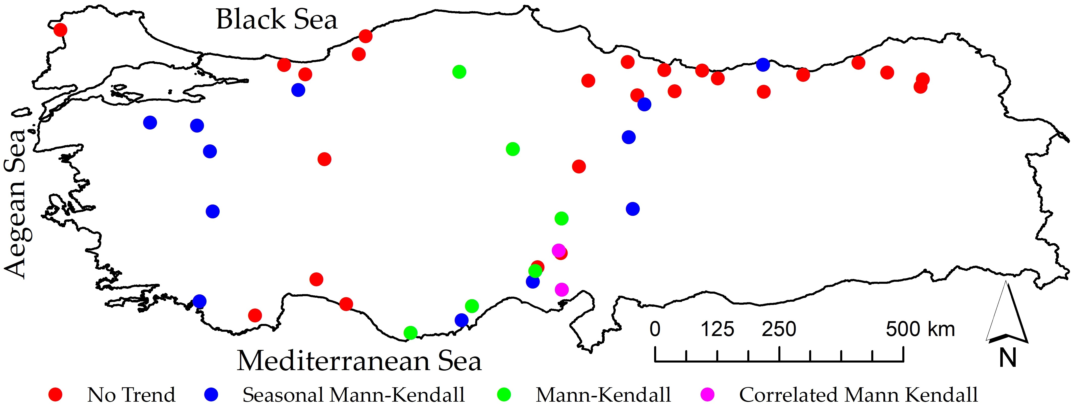
Fig. 3. The map of sediment gauging stations based on trend analyses results

The innovative Trend Analysis (ITA) method detects 30 positive and 15 negative trends for sediment gauging stations (Figure 4). The trend slopes calculated from ITA methodology are categorised as weak, medium and strong. The category of positive and negative trends is presented in Table 2.

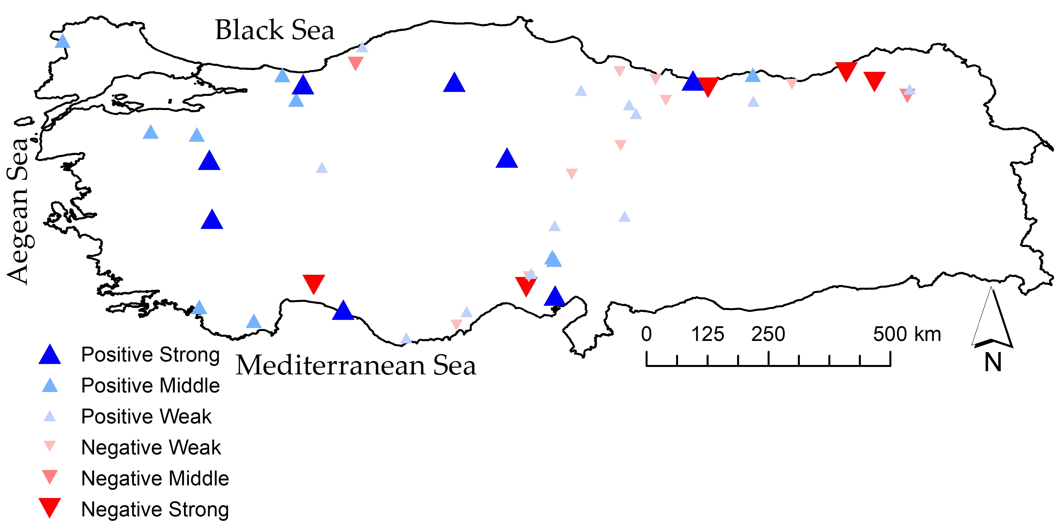
Fig. 4. The map of sediment gauging stations based on only ITA results

Table 2. The category of positive and negative ITA trends
Sign | Category | Trend Slope (TS)
Positive | Strong | TS > 30
 | Middle | 30 > TS > 10
 | Weak | 10 > TS > 0
Negative | Weak | -3 < TS < 0
 | Middle | -6 < TS < -3
 | Strong | TS < -6

Eight gauging stations have strong positive ITA trends. The trend slopes of strong positive ITA results are between 32-238. The sediment discharge areas are between 770.7-9676.8 km². The lowest strong positive is observed in the Susurluk River Basin near Marmara Basin. The highest strong positive is observed in Eastern Black Sea Basin. Positive and high trend slopes can be seen in Figure 5.
Ten gauging stations have middle positive ITA trends. The trend slopes of middle positive ITA results are between 10-29. The sediment discharge areas are between 191.4-27250.8 km². The lowest middle positive is observed in Meric River Basin near Marmara Basin. The highest middle positive is observed in Western Mediterranean Basin.

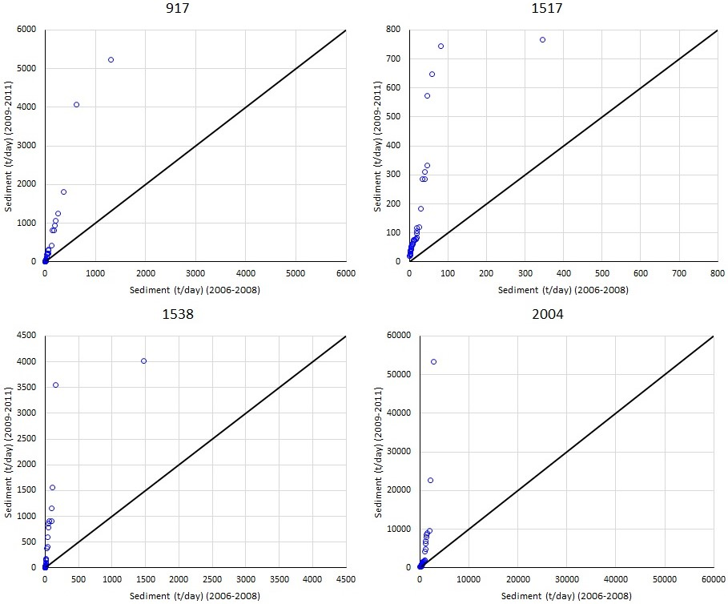
Fig. 5. ITA result samples for the strong positive trend

Twelve gauging stations have weak positive ITA trends. The trend slopes of weak positive ITA results are between 0.46-8.94. The sediment discharge areas are between 203.8-18596.8 km². The lowest weak positive is observed in Sakarya River Basin near Marmara Basin. The highest weak positive is observed in Western Black Sea Basin. Positive and low trend slopes can be seen in Figure 6.

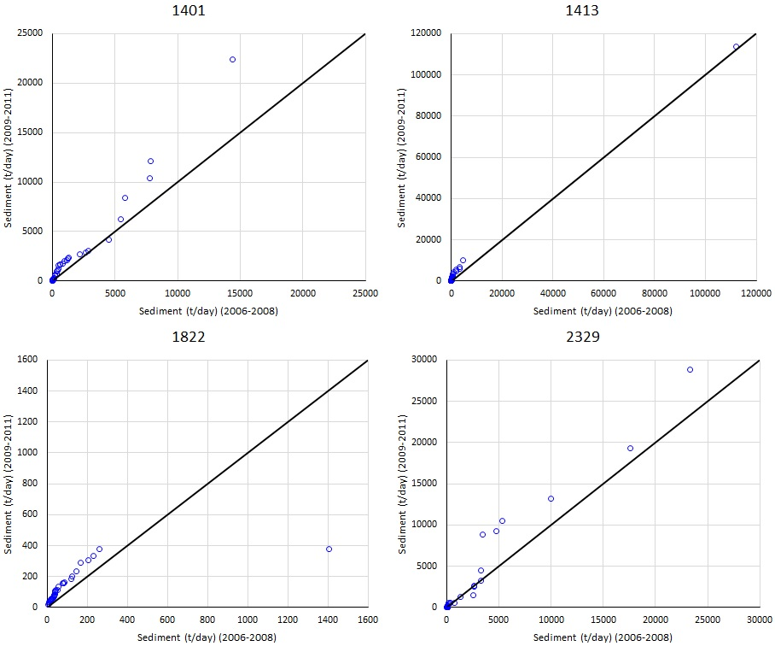
Fig. 6. ITA result samples for weak positive trend

Eight gauging stations have strong negative ITA trends. The trend slopes of strong negative ITA results are between (-9.19)-(-6.62). The sediment discharge areas are between 586-1936.7 km². The lowest strong negative is observed in Eastern Black Sea Basin. The highest strong negative is observed in Coruh River Basin near Eastern Black Sea Basin. Negative and high trend slopes can be seen in Figure 7.
Only two gauging stations have middle negative ITA trends. The trend slopes of middle negative ITA results are between (-4.81)-(-3.94). The sediment discharge areas are between 1762-1839 km². The lowest middle negative is observed in Coruh River Basin near Eastern Black Sea Basin. The highest middle negative is observed in Western Black Sea Basin.

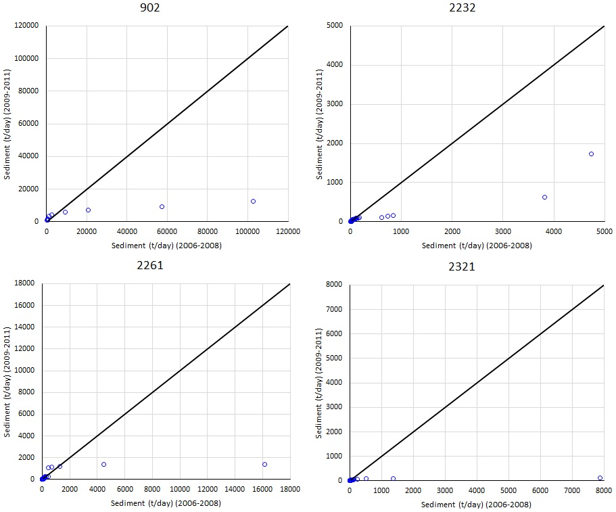
Fig. 7. ITA result samples for a strong negative trend

Five gauging stations have weak negative ITA trends. The trend slopes of weak negative ITA results are between (-2.92)-(-0.59). The sediment discharge areas are between 232.8-12825.9 km². The lowest weak negative is observed in Eastern Mediterranean Basin. The highest weak negative is observed in Eastern Black Sea Basin. Negative and high trend slopes can be seen in Figure 8.

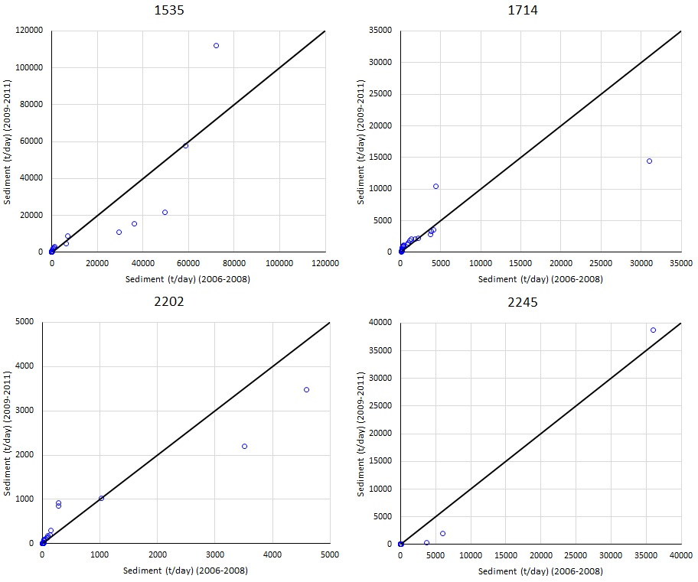
Fig. 8. ITA result samples for weak negative trend

In the first stage, Mann-Kendall, Correlated Mann-Kendall and Seasonal Mann-Kendall trend tests are applied to sediment discharges in Turkish rivers. The gauging stations with the highest number of trends were obtained according to the results of the Seasonal Mann-Kendall trend test, and the gauging stations with the least number of trends were obtained according to the results of the Correlated Mann-Kendall trend test. Therefore, the Seasonal Mann-Kendall trend test can be used practically in trend analysis of sediment discharge data. Innovative Trend Analysis (ITA) is applied to sediment discharges in the second stage. Then, ITA application results are categorised as strong, middle and weak for negative and positive trends. Finally, ITA application results are symbolised on the study country map for comparison according to new categorisation.

5. Conclusions
The trend, one component of the stochastic processes of modelling, needs to be identified in the data. This study evaluates the trends of sediment data in Turkey. Mann-Kendall, Correlated Mann-Kendall and Seasonal Mann-Kendall and Innovative Trend Analysis (ITA) methods are used for this aim. ITA methodology is applied to sediment data to detect trends for the first time in Turkey. Traditional trend analysis methods play an essential role in specifying observed data trends. In addition, innovative trend analysis methods such as ITA have recently been widely preferred in defining the trend’s magnitude. First, a new classification for negative and trend slopes is suggested in this study. Then, the magnitudes increasing and decreasing trend results of the applied trend analysis methods are presented on the maps.
Turkish main river basins have a wide variety of hydroclimate. Hence, there are considerable variability and uncertainty in the hydrological and meteorological data. There is erratic rainfall, particularly in the Black Sea regions of Turkey. This component of the hydrological cycle in river basins directly affects runoff, then sediment discharge. Increasing and decreasing trends in sediment data are significantly detected from the coastal rivers in the Mediterranean and Black Sea regions of Turkey.
Finally, the Correlated Mann-Kendall method detected trends for very few gauging stations. Mann-Kendall results show that they almost overlap Correlated Mann-Kendall results, they are not much different. The Seasonal Mann-Kendall method says that seasonality must be considered in the monthly sediment data trend analysis. The results show that it is appropriate to use the ITA methodology to define the increases and decreases in monthly sediment data analysis and classify their magnitude. Although there are seasonal changes in the monthly observed sediment data for the short term, the changes in the annual total sediment discharges in the long term are an issue that must be examined.

The sediment data provided by State Hydraulic Works (DSI) of Turkey is publicly available and downloadable from https://www.dsi.gov.tr/Sayfa/Detay/767.
References
Adarsh, S., VishnuPriya, M. S., Narayanan, S., Smruthi, M. S., George, P., Benjie, N.M. (2016). Trend analysis of sediment flux time series from tropical river basins in India using non-parametric tests and multiscale decomposition. Modeling Earth Systems and Environment, 2(4), 1-16. DOI: 10.1007/s40808-016-0245-0
Akçay, F., Kankal, M., Şan, M. (2022). Innovative approaches to the trend assessment of streamflows in the Eastern Black Sea basin, Turkey. Hydrological Sciences Journal, 67(2), 222-247. DOI: 10.1080/02626667.2021.1998509
Aksoy, H. (2020). Surface Water. In Water Resources of Turkey (pp. 127-158). DOI: 10.10 07/978-3-030-11729-0_5
Ateeq-Ur-Rehman, S., Bui, M., Rutschmann, P. (2017). Variability and Trend Detection in the Sediment Load of the Upper Indus River. Water, 10(1). DOI: 10.3390/w10010016
Bajirao, T. S., Kumar, P., Kumar, M., Elbeltagi, A., Kuriqi, A. (2021). Superiority of Hybrid Soft Computing Models in Daily Suspended Sediment Estimation in Highly Dynamic Rivers. Sustainability, 13(2). DOI: 10.3390/su13020542
Cavus, Y., Orta, S., Burgan, H. I., Eris, E., Aksoy, H. (2019). Trend Analysis of Low Flows The 9th International Symposium on Atmospheric Sciences (ATMOS 2019), Istanbul, Turkey.
Ceribasi, G., Dogan, E., Sonmez, O. (2013). Evaluation of Sakarya River Streamflow and Sediment Transport with Rainfall using Trend Analysis. Fresenius Environmental Bulletin, 22(3a), 846-852.
Chen, X.-Y., Chau, K.-W. (2019). Uncertainty Analysis on Hybrid Double Feedforward Neural Network Model for Sediment Load Estimation with LUBE Method. Water Resources Management, 33(10), 3563-3577. DOI: 10.1007/s11269-019-02318-4
Cigizoglu, H. K. (2004). Estimation and forecasting of daily suspended sediment data by multi-layer perceptrons. Advances in Water Resources, 27(2), 185-195. DOI: 10.10 16/j.advwatres.2003.10.003
Darama, Y., Selek, Z., Selek, B., Akgul, M. A., Dagdeviren, M. (2019). Determination of sediment deposition of Hasanlar Dam using bathymetric and remote sensing studies. Natural Hazards, 97(1), 211-227. DOI: 10.1007/s11069-019-03635-y
Das, S. (2019). Four decades of water and sediment discharge records in Subarnarekha and Burhabalang basins: an approach towards trend analysis and abrupt change detection. Sustainable Water Resources Management, 5(4), 1665-1676. DOI: 10.1007/s40899-019-00326-1
Gallay, M., Martinez, J.-M., Mora, A., Castellano, B., Yépez, S., Cochonneau, G., Alfonso, J. A., Carrera, J. M., López, J. L., Laraque, A. (2019). Assessing Orinoco river sediment discharge trend using MODIS satellite images. Journal of South American Earth Sciences, 91, 320-331. DOI: 10.1016/j.jsames.2019. 01.010
Gao, P., Mu, X. M., Wang, F., Li, R. (2011). Changes in streamflow and sediment discharge and the response to human activities in the middle reaches of the Yellow River. Hydrology and Earth System Sciences, 15(1), 1-10. DOI: 10.5194/hess-15-1-2011
Gao, P., Zhang, X., Mu, X., Wang, F., Li, R., Zhang, X. (2010). Trend and change-point analyses of streamflow and sediment discharge in the Yellow River during 1950-2005. Hydrological Sciences Journal, 55(2), 275-285. DOI: 10.1080/026266 60903546191
Guo, L.-P., Yu, Q., Gao, P., Nie, X.-F., Liao, K.-T., Chen, X.-L., Hu, J.-M., Mu, X.-M. (2018). Trend and Change-Point Analysis of Streamflow and Sediment Discharge of the Gongshui River in China during the Last 60 Years. Water, 10(9). DOI: 10.3390/ w10091273
Guvel, S.P., Akgul, M. A., Aksu, H. (2021). Sediment Yield Analysis in Tahtaköprü Dam Basin. European Journal of Science and Technology. DOI: 10.31590/ejosat.987725
Güçlü, Y.S. (2020). Improved visualisation for trend analysis by comparing with classical Mann-Kendall test and ITA. Journal of Hydrology, 584. DOI: 10.1016/j.jhydrol. 2020.124674
Hodgkins, R. (1996). Seasonal trend in suspended-sediment transport from an Arctic glacier, and implications for drainage-system structure. Annals of Glaciology, 22, 147-151.
Li, L., Ni, J., Chang, F., Yue, Y., Frolova, N., Magritsky, D., Borthwick, A.G.L., Ciais, P., Wang, Y., Zheng, C., Walling, D.E. (2020). Global trends in water and sediment fluxes of the world’s large rivers. Science Bulletin, 65(1), 62-69. DOI: 10.1016/j.scib. 2019.09.012
Liu, C., Sui, J., Wang, Z.-Y. (2008). Sediment load reduction in Chinese rivers. International Journal of Sediment Research, 23(1), 44-55. DOI: 10.1016/s10016279(08)60004-9
Memarian, H., Balasundram, S. K., Talib, J. B., Sood, A. M., Abbaspour, K. C. (2012). Trend analysis of water discharge and sediment load during the past three decades of development in the Langat basin, Malaysia. Hydrological Sciences Journal, 57(6), 1207-1222. DOI: 10.1080/02626667.2012.695073
Miao, C., Ni, J., Alistair G.L., B. (2010). Recent changes of water discharge and sediment load in the Yellow River basin, China. Progress in Physical Geography: Earth and Environment, 34(4), 541-561. DOI: 10.1177/0309133310369434
Montanher, O.C., Novo, E. M. L. d. M., Souza Filho, E. E. d. (2018). Temporal trend of the suspended sediment transport of the Amazon River (1984-2016). Hydrological Sciences Journal, 63(13-14), 1901-1912. DOI: 10.1080/02626667.2018.1546387
Murphy, J.C. (2020). Changing suspended sediment in United States rivers and streams: linking sediment trends to changes in land use/cover, hydrology and climate. Hydrology and Earth System Sciences, 24(2), 991-1010. DOI: 10.5194/hess-24-991-2020
Panda, D.K., Kumar, A., Mohanty, S. (2011). Recent trends in sediment load of the tropical (Peninsular) river basins of India. Global and Planetary Change, 75(3-4), 108-118. DOI: 10.1016/j.gloplacha.2010.10.012
Putnam, J.E., Pope, L.M. (2003). Trends in Suspended-Sediment Concentration at Selected Stream Sites in Kansas, 1970-2002. U. S. G. Survey.
Sen, K., Aksu, H. (2021). İstanbul İçin Standart Süreli Gözlenen En Büyük Yağışların Eğilimleri. Teknik Dergi. DOI: 10.18400/tekderg.647558
Sen, Z. (2012). Innovative Trend Analysis Methodology. Journal of Hydrologic Engineering, 17(9), 1042-1046. DOI: 10.1061/(asce)he.1943-5584.0000556
Walling, D.E., Fang, D. (2003). Recent trends in the suspended sediment loads of the world’s rivers. Global and Planetary Change, 39(1-2), 111-126. DOI: 10.1016/s09 21-8181(03)00020-1
Wang, G., Wu, B., Wang, Z.-Y. (2005). Sedimentation problems and management strategies of Sanmenxia Reservoir, Yellow River, China. Water Resources Research, 41(9). DOI: 10.1029/2004wr003919
Zhang, Q., Xu, C.-y., Becker, S., Jiang, T. (2006). Sediment and runoff changes in the Yangtze River basin during past 50 years. Journal of Hydrology, 331(3-4), 511-523. DOI: 10.1016/j.jhydrol.2006.05.036

