|  |  |  |  |
| --- | --- | --- | --- |
|  |  | | |
| **Rocznik Ochrona Środowiska** | | |
| Volume 24 | Year 2022 ISSN 2720-7501 | pp. 163-171 |
|  | https://doi.org/10.54740/ros.2022.012 open access | | |
|  | Received: 22 June 2022 Accepted: 08 September 2022 Published: 14 November 2022 | | |

Numerical Analysis of Convective Heat Transfer   
for Selected Geometric System

Magdalena Orłowska

Koszalin University of Technology, Poland  
https://orcid.org/0000-0002-2072-1791

corresponding author’s e-mail: magdalena.orlowska@tu.koszalin.pl

**Abstract:** The contemporary problems and issues of environmental protection refer to a large extent to problems related – generally speaking – to energy. Currently, the production processes mainly concern the combustion of energy fuels, transport – over long distances, and their use for utility purposes, e.g. engine drive or heating. These processes significantly negatively impact the environment and are magnified by their enormous intensity and size. While energy production and transport processes have been studied for many years, and their results are widely published, the issues related to the application and operation of heating devices are little known and require much observation and research. The operating indicators of heating devices are generally characterized by low values (natural convection), and their artificial increase (intensity) cannot be used due to the acoustic effects and additional (significant) investment costs. The article presents some research results on the intensification of heat flow – i.e. the thermal efficiency of flat heaters placed in a room with a specific temperature. Physical phenomena were investigated numerically by shaping the heat exchange space. The tested systems concerned a room with a free-standing heater, a heater with a vertical panel mounted in parallel, and a system with a curved bottom plate forming the so-called de Laval nozzle. Interesting results of air velocity and temperature fields and values of the heat transfer coefficient along the height of the heater were obtained. Based on the presented research, it can be concluded that the creation of convection surfaces around the heater is advisable because it affects the intensity of heat exchange, which can be increased without energy-intensive energy expenditure, i.e. in a non-mechanical way. Undoubtedly contributes positively to investment and operating costs, which is essential in environmental protection issues.

**Keywords:** convection, intensification, protect, environment

1. Introduction

Heat exchange based on free convection finds much interest in scientific research. The vast process complexity sometimes makes it impossible to understand the mechanisms controlling the phenomenon entirely. Therefore, simplifications should be introduced. This complexity is based, for example, on the fact that the fluid is in motion. Many physical quantities of fluid are associated with movement, e.g. density, viscosity, specific heat, temperature, and speed. The geometry of the heat exchange space is also essential. Experimental studies provide new data on fluid behaviour when introducing various boundary conditions, including various geometric systems, that affect fluid movement. The author has conducted numerous numerical and experimental studies on free convection from a flat plate heater in a partially limited space and described the results in publications (Czapp et al. 2016, Orłowska 2018, Orłowska et al. 2019, Orłowska 2017, Orłowska 2018). Due to the low participation in the heat exchange process, radiation was omitted. Numerical analysis in the field of convection is very well developed. CFD testing is based on the equations entered into the calculation codes. Nowadays, analyzes are performed not only in 2D but also in 3D format. The author undertook computational simulations in her works on convection.

2. Research

Scientists from many countries deal with various cases of free convection. Work (Purusothaman et al. 2019) concerns the numerical studies of dielectric liquid in a cubic module. Studies have shown that the thermal efficiency of the studied system is an increasing function of the heat-generating source’s shape factor and Rayleigh numbers for two different settings of the generating source. The intensity of heat exchange can be increased or decreased by selecting the appropriate parameters such as thermal conductivity coefficient, Rayleigh number, shape factor and orientation of the generating source. In the works (Pukhal 2016), heat exchange from the floor convector heater in residential and public buildings was dealt. Convectors embedded in the floor plane create a convective stream that spreads to the glazing. The effect of different glazing distances from the convector was simulated. Air velocity and temperature fields were determined. It has been shown, among others, that to eliminate uneven heating of the glass, the distance between the floor convector and the glazing should be at least 100 mm. The publication (Pukhal 2017) covered the convector research and the effect of the distance of the heating element placed in the box on heat exchange. The heating element was placed in three variants: on the side of the room, by the box wall, from the glazing side by the box wall and in the middle of the box. The article Tacutu et al. 2019) concerned numerical and experimental works related to thermal distribution around two man-shaped mannequins. One mannequin was in a lying position, the other in a standing position. The numerical model represented an operating room with a patient and two surgeons, and a UAF unidirectional airflow diffuser. The experimental study was carried out in an air-conditioning chamber having a similar air distribution system using PIV image anemometry and IR infrared tomography. The resulting thermal plumes were compared with each other and literature to verify numerical models.

Another example of the influence of a geometrical system on the process of free convection is described in (Lahmer & Bessaďh 2014). It is numerical work to study the thermal interactions between heat fluxes created by electronic devices mounted on a vertical printed circuit board (PCB). The influence of parameters such as Grashof number, the distance between heat sources and upper output distance was investigated. The results showed that regular and even distribution of heat sources at the inlet is significant to obtain, among others, necessary dispersion and heat dissipation. It was calculated how the number of Nusselt (Nu), Grashof (Gr), and Prandtl (Pr) changes under different conditions of the considered parameters.

3. Methods

In addition to the production and appropriate selection of new Michiejew’s equation (Staniszewski 1978) describing, the case of free convection with a vertical plate has the equation (1).

n (1)

where:

*Gr* – Grashof number,

*Pr* – Prandtl number,

*N* – index.

The characteristic dimension, in this case, is, e.g. the height of the heat exchange plate. The reference temperature tm has the equation (2).

$t_{m}=\frac{1}{2}(t_{w}+t_{f})$ (2)

where:

*tw* – wall temperature, K,

*tf* – fluid temperature, K.

The type of fluid movement affects the value of the constant c and the exponent of the power n. The product of GrPr characterizes the movement.

The product range is as follows:

-2102 (3)

10207 (4)

1071013 (Staniszewski 1978). (5)

Fluid movement may be laminar or turbulent. In laminar movement, heat exchange in a direction perpendicular to the wall occurs mainly on the conduction principle. In Fig. 1, during turbulent motion, conduction occurs only in the laminar layer at the wall, and at a further distance, the fluid particles already mix. In turbulent motion, the heat transfer intensity depends on the boundary layer’s thermal resistance, which is why the most significant temperature drop occurs at the wall.



**Fig. 1.** Wall layer with the fluid flow along a flat surface: 1 – laminar layer,   
2 – transition area, 3 – turbulent layer, 4 – laminar sublayer (Wiśniewski S. & Wiśniewski T. 2017).

The measure of convective heat exchange intensity is the value of the heat transfer coefficient α, which is defined by equation (6):

$∝ =\dot{\frac{q}{t_{w}-t_{f}}}$ (6)

where:

𝑞̇ – density of heat flow flowing between fluid and wall, W/m2.

The amount of heat exchanged by taking over can be calculated from Newton’s law (7):

$q= ∝\left(t_{w}-t_{f}\right)= ∝Δt$ (7)

The dimensionless similarity number and form of heat transfer coefficient α is the Nusselt number (8):

$Nu=\frac{∝∙l_{o}}{λ}$ (8)

where:

*l0* – characteristic linear dimension, m,

*λ* – thermal conductivity coefficient, W/(mK)   
(Wiśniewski S. & Wiśniewski T. 2017).

4. Numerical Results and Discussion

All numerical analyzes were carried out in the Ansys Flotran Mechanical CFD program. The calculations were made for three different geometric systems:

1 – a room with dimensions of 2.0 x 2.0 m. With a plate heater with dimensions of 0.6 x 0.1 m – Fig. 2a.

2 – a room with dimensions of 2.0 x 2.0 m. With a plate heater with dimensions of 0.6 x 0.1 m and a radiator height plate of 5 cm added to it – Fig. 2b.

3 – room with dimensions of 2.0 x 2.0 m. With a plate heater with dimensions of 0.6 x 0.1 m with an added plate with a gentle inlet at the bottom, in the form of the de Laval nozzle – Fig. 2c.

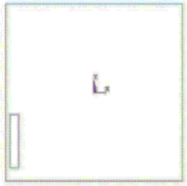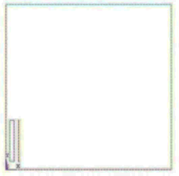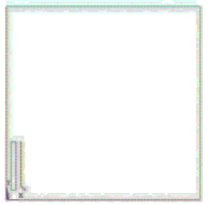

1. b) c)

**Fig. 2.** Diagram of the analyzed problem; a) heater without cover, b) heater with vertical plate, c) heater with de Laval nozzle

Boundary conditions were:

* wall temperature – 20°C,
* heater temperature constant along the height of heater – 60°C,
* the size of the mesh elements for the analysis – 0.0035.

Based on the analysis, the following temperature fields (Fig. 3a, 4a, 5a) and air velocity (Fig. 3b, 4b, 5b) were obtained.

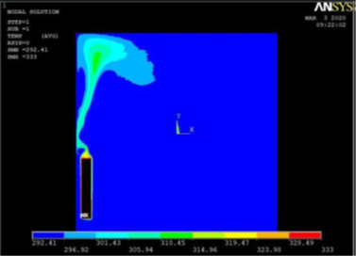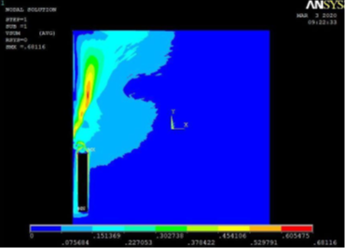

a) b)





**Fig. 3.** a) Air temperature fields with heater only, b) Air velocity fields with heater only; axes: upper – temperature, K and lower – speed, m/s

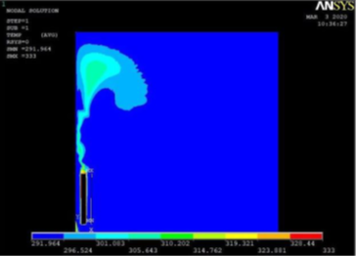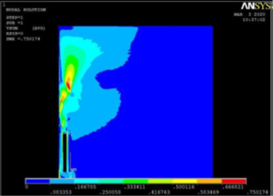

a) b)





**Fig. 4.** a) Air temperature fields with system heater – vertical plate, b) Air velocity fields with system heater – vertical plate; axes: upper – temperature, K and lower   
– speed, m/s

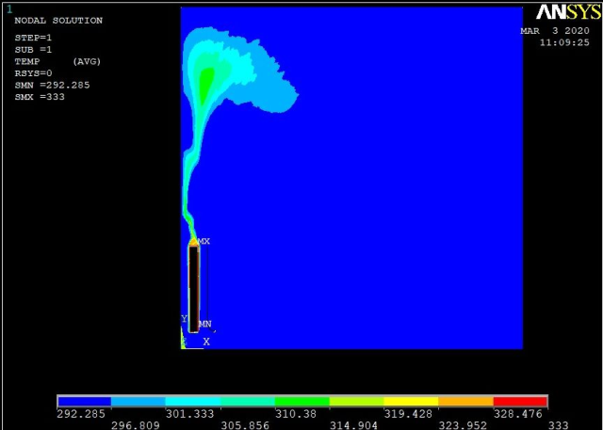

a) b)





**Fig. 5.** a) Air temperature fields with system de Laval nozzle, b) Air velocity fields with system de Laval nozzle; axes: upper – temperature, K and lower – speed, m/s

The measure of heat transfer intensity in convection is the heat transfer coefficient α. Fig. 6 shows the relationship between the value of the heat transfer coefficient (determined along the height of the heater on the room side) and the height of the heater.

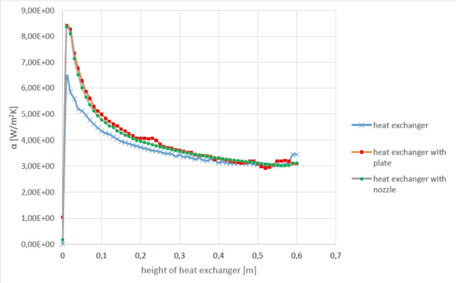

**Fig. 6.** Heat transfer coefficient α as a function of radiator height in selected systems geometric

In the future, experimental tests can be performed to verify the behaviour of the fluid under given boundary conditions. The article provides many valuable tips and advice regarding heater housing. We often do it thoughtlessly, guided more by appearance than practicality. Curtains, curtains, and covering radiators with perforated wooden housings are all in the living room. Depending on the season, we also rearrange the furniture in the rooms. For example, with the central heating turned on and the radiators working, we prefer not to have beds next to heaters, while in the summer, one can try to rearrange our interior design due to the lack of a heating season.

5. Conclusion

The highest average values of the heat transfer coefficient α were recorded in the case of a radiator system with a plate attached to it. It may be due to the chimney draft effect in the airtight between the hob and the radiator. Slightly lower values of the α coefficient were obtained in the system with the nozzle. The gentle inlet reduced the airflow resistance but, at the same time, introduced a certain amount of room-temperature air not yet heated from the radiator into the gap. The worst thermal effect occurs in the case of a radiator without a nozzle or plate. The non-monotonicity of the curves is emphasized in Fig. 6. Hence the decrease in the α coefficient value on the initial in-run along the height of the radiator, as compared to the system with the plate or nozzle, is visible in Fig. 6. The average value of α in a system with a gap of 4.00 W/m2K, in a system with a nozzle 3.91 W/m2K, while in a system without a plate 3.63 W/m2K. On this basis, it should be stated that the surface formation around the heater has a sense and impact on the heat transfer intensity.

References

Czapp, S., Czapp, M., Orłowska, M. (2016). *Numerical and Experimental Investigation of Thermal Convection near Electric Devices with Vertical Channels*, Proceedings of the International Conference on Information and Digital Technologies (IDT). 54-58.

Lahmer, K., Bessaďh, R. (2014). Numerical simulation of cooling electronic components mounted in a vertical wall by natural convection. *Mechanics & Industry*, *15*, 89-98.

Tăcutu, L., Năstase, I., Bode, F., Verona Croitoru, C., Dogeanu, A., Sandu, M. (2019). Experimental and numerical investigation on the convective thermal plume around the head of the standing and lying human body, *E3S Web of Conferences*, *85*, Article Nr 02016.

Orłowska, M. (2018). Study of the Influence of Window Thermal Properties on Radiator Work in the Room – Numerical Research. *Rocznik Ochrona Środowiska*, *20(*2), 1699-1709.

Orłowska, M., Szkarowski, A., Mamedov, S. (2019). Numerical Analysis of Influence of the Angel of Inclination of the Screen on the Intensity of Heat Exchange from a Flat Heat Exchanger in a Partially Limited Space. *Rocznik Ochrona Środowiska*, *21*(1), 728-737.

Orłowska, M. (2017). Numerical analysis of the heat exchanger energy efficiency depending on location from the floor. *E3S Web of Conferences*, *17*, Article Nr 00068.

Orłowska, M. (2018). Numerical analysis of a heat exchanger with differentiated temperatures surface at varying distances from the wall. *E3S Web of Conferences*, *30*, Article Nr 03006.

Pukhkal, V., Bulgakov, V. (2017). Generation of natural convective air flows in rooms with the use of in-floor convectors with natural circulation. *Architecture and Engineering*, *2*(4), 42-47.

Pukhkal, V. (2016). Studies of application conditions of in-floor convectors with natural air circulation in water heating systems. *Architecture and Engineering*, *1*(2), 49-52.

Purusothaman, A., Murugesan, K., Chamkha, Ali J. (2019). 3D modeling of natural convective heat transfer from a varying rectangular heat generating source. *Journal of Thermal Analysis and Calorimetry*, *138*(1), 597-608.

Staniszewski, B. (1978). *Termodynamika.* PWN, Warszawa, Poland.

Wiśniewski, S., Wiśniewski, T. (2017). *Wymiana Ciepła*. PWN, Warszawa, Poland.