 | Rocznik Ochrona Środowiska
 | Volume 24 | Year 2022 ISSN 2720-7501 | pp. 97-109
 | https://doi.org/10.54740/ros.2022.008 open access
 | Received: 11 July 2022 Accepted: 18 July 2022 Published: 14 November 2022
Innovative Method of Forecasting the Generator Gas Composition after the Process of Pyrolysis and Gasification
Anna Maria Slowak
Kielce University of Technology, Poland
corresponding author’s e-mail: anmarii@windowslive.com
Abstract: The article presents a new approach to forecasting producer gas composition. Thermochemical treatment of biomass was presented as an effective method of producing flammable gas. The methods of predicting the gas composition of the generator are described, and then its efficiency depends on the device’s parameters. In order to create a method for forecasting gas composition, the authors’ works were used as the basis on which the energy characteristics of the gases obtained were assessed. It was assumed in this paper that it is essential to understand the influence of each parameter on the energy characteristics of the gas. It made it possible to optimize the composition and predict thermal characteristics. This article presents the results of experimental studies on biomass gasification and a mathematical model based on Gibbs free energy.
Keywords: gasification, pyrolysis, biomass, regenerative energy, synthetic gas, mathematical modeling, Gibbs energy
1. The main goal
Research in this work aims to increase the efficiency of gasification processes (biomass, household waste, garbage, car tires) and develop methods for using generator gas in heating plants, processing synthesized gas into liquid hydrocarbons, hydrogen, fertilizers, and other products.
The efficiency of processes may be improved, providing optimal technological modes for synthesized gas production with a predicted composition of chemical components. Therefore, the project’s primary goal is to create a mathematical model for predicting the components of synthesized gas using the method of minimizing the system’s free energy.
The following tasks are defined according to the purpose:
- to study heat transfer and physico-chemical processes in biomass pyrolysis of different types;

- to develop a mathematical model of pyrolysis, making it possible to analyze the gasification process with the dependence of change of its parameters (process temperature, biomass moisture content, coefficient of excess gasification air) and predict the synthesized gas composition;
- to perform experimental studies of gasification to develop technological bases for processing the synthesis gas into gaseous and liquid hydrocarbons and hydrogen;
- study and develop recommendations on using generator gas in heat-generating plants.
1.1. The main hypothesis
The main project hypothesis is that simulation of the thermodynamic equilibrium state in the gasification process makes it possible to determine synthesis gas composition and temperature in the process when the system’s thermodynamic potential (Gibbs free enthalpy) has minimal importance. In this work, unlike most studies on gasification process simulation, carbon conversion rate, a yield of C₂H₄, C₆H₆, and CH₄ is proposed to be determined using empirical dependencies determined based on experimental studies. Material and energy balance equations for the elements involved in the gasification process make it possible to calculate the process of synthesis gas or its combustion products recirculation. The mathematical model will make it possible to determine the generator gas composition and temperature during the process depending on biomass characteristics and other parameters of the gasification process. Due to the predicted non-adiabaticity of the model, it is possible to maintain a constant temperature during the process by modeling the energy supply to the reactor. It allows for studying the independent effect of the main parameters of the gasification process, such as air excess factor, biomass moisture content, and reactor temperature, on synthesis gas composition and yield. Thus, depending on raw material composition and synthesized gas purpose, we can perform the pyrolysis process to obtain the predicted composition of chemical substances in the gas and implement the best possible process of pyrolysis gas conversion into required products. The main problem of combined tasks of pyrolysis and pyrolysis gas processing is that currently, it is impossible to predict the synthesized gas composition since raw materials will always have different chemical compositions. If we determine the chemical composition of the raw material (at least, averaged) before heat treatment, then quantitative parameters of the effect on raw material to obtain the required composition of the pyrolysis gas can be adjusted using control functions, integrating technological modes and kinetic parameters of the main reactions. In order to accomplish these tasks, it is planned to develop a prediction method for gas composition based on experimental data and previous theoretical knowledge. The method shall include the minimization of the free energy system and processed data on the kinetics of thermochemical transformations of raw material components and processing temperatures.
2. The importance of the work
According to the requirements of current guiding documents, a significant increase of renewable energy sources share, including non-fossil fuels, in the general energy balance of the country is planned. This decision is appropriate at the current stage of the country’s transition to a more balanced and rational use of natural resources. In order to achieve desired results, specific technical solutions and significant investments are required. Combustion gas production technologies through biomass or solid waste gasification are considered the most acceptable way of renewable energy use for energy purposes, but they shall be improved due to a lack of process efficiency. A method for predicting synthesis gas composition and its basic physico-chemical properties shall be further developed to study the gasification processes of the resulting synthesis gas and heat exchange in the heat-generating equipment.
3. Actual methods of the gasification process
Modern methods of theoretical description of the gasification process do not allow accurate results prediction and do not reflect the effect of various parameters on the synthesis gas composition and overall process efficiency. Most known models are based on experimental data and are correct only for specific process conditions. The actual gasification process depends on many factors. Different process simulation methods consider only certain factors, despite their relatively low accuracy. All mathematical modeling methods of the gasification process can be divided into the following types:
1) those using basic kinetic laws,
2) those based on thermodynamic equilibrium,
3) methods based on hydrodynamics calculation,
4) empirical simulation methods,
5) combined models.
3.1. Kinetic models
In kinetic models, the chemical reaction rate is crucial, depending mainly on factors such as carbon residue reactivity of gasified fuel and temperature in the reactor. Often, kinetic models use the same gasification reactions as thermodynamic ones, adding the equations and characterizing the rate of selected reactions. In order to solve this model, it is necessary to know the reactivity value of the gasified fuel carbon residue, as well as the rate of main gasification reactions of the process. Considerable complexity of processes, exacerbated by secondary combustion processes and carbon dioxide reduction; the carbon residue reactivity depends on gasification conditions and source fuel characteristics; due to these facts, most authors recommend using experimental studies results instead of theoretical data. The kinetic model may be appropriate for designing low-temperature gasification processes when the rate of essential reactions is not high, but at temperatures above 750°С, the reaction rate significantly increases, complicating this model’s use. Unlike homogeneous reactions, the rate of carbon combustion reactions or reduction reactions on its surface depends mainly on gas diffusion to the interfacial surface of solid particles of the carbon residue, gas supply rate, that is, hydrodynamic factors to be studied in practice. We set such tasks at the project’s initial stage in the Pyrolysis Laboratory of the Kielce University of Technology.
3.2. Hydrodynamic models
Hydrodynamic models allow the calculation of temperature distribution and concentration of generator gas components in a reactor, but they require careful study of gasification process hydrodynamics in a specific reactor type, thus, depriving them of a versatile function. To summarize such processes, we already have a large amount of data on heat and mass transfer in different media: in emulsions (for gasification of liquid media) and solid dispersed materials in stable or fluidized layers. The results of empirical models are sufficiently precise, but only for researched equipment and a range of values that are absolutely unacceptable for other cases. Therefore, this simulation method is not universal.
3.3. The thermodynamic equilibrium method
The methods using a thermodynamic equilibrium state during the gasification process make it possible to predict the maximum yield of main generator gas components. However, they are not used to predict carbon residue or gasification liquid products yield, which is why specific reductions shall be used. The thermodynamic equilibrium method demonstrates more accurate results during gasification process simulation for dense gas generators because, due to high temperature and long reaction time, the equilibrium state is reached faster than in other gas generators (Azzone et al. 2012, Jarungthammachote & Dutta 2008). The absence in the binding model to features of heat and mass transfer in the gasified fuel layer (blast velocity, layer density, material porosity, heat and mass transfer intensity, etc.) makes it possible to study the complex effect of main gasification parameters on synthesis gas composition and yield. It makes the thermodynamic simulation method the most versatile one. Some conditions, when equilibrium state between all gas components is achieved more rapidly, such as high reactor temperatures, small particle sizes, and long-time of system components in the reactor, can be easily implemented in the gas generating process, which will not only improve the simulation accuracy of this process but also increase its efficiency. The type of gas generator also affects the duration of the equilibrium state period. Many authors have used and refined the thermodynamic equilibrium method for gasification process simulation (Melgar et al. 2007, Nemanova & Engvall 2014, Silva et al. 2019, Wan et al. 2018, Zevenhoven-Onderwatet et al. 2001). In some works (Pepiot et al. 2010, Puig-Arnavat et al. 2012, Samuelsson et al. 2015, Sieradzka et al. 2020), the dependence of the carbon residue yield on the excess air ratio has been proposed. In most works (Koshlak & Pavlenko 2020, Koukkari & Pajarre 2011, Lee et al. 2007, Liliedahl et al. 2011), this value is neglected, thus, reducing simulation accuracy. The yield of resins (hydrocarbons with high condensation temperature) at high gasification temperature is relatively insignificant, and therefore most researchers neglect this value. For lower temperatures, the average yield of resins formed during the gasification process shall be considered (Nemanova et al. 2014, Nemanova et al. 2011, Pavlenko & Klas 2020, Pavlenko & Koshlak 2019, Ahmadi et al. 2013, Dahlquist et al. 2013, FakhrHoseini & Dastanian 2013.) The analytical simulation methods were used in the project; they are based on our experimental studies of heat and mass transfer (Pavlenko & Koshlak 2021, Pavlenko et al. 2014), gasification, reaction kinetics, and thus combine advantages of these prediction methods (Pavlenko & Koshlak 2021, Babler et al. 2017, Barman et al. 2012). In theoretical studies, we use a Gibbs free energy minimization approach that does not require the selection of specific gasification reactions and considers only the initial and final states of the system and its components. It makes our method more appropriate for complex systems with a significant number of reactions. All existing mathematical models are designed for stationary gasification conditions at atmospheric pressure. As one of the research tasks, we envisage the implementation of experimental and theoretical studies, considering the unsteadiness and different pressures in the gasification chamber.
4. Gasification of biomass with minimum energy
The thermodynamic potential of the system is the main idea. It goes to the minimum value under its equilibrium. The idea of setting the composition of a synthetic gas with an equilibrium state of the system drives to the composition that agrees with the minimum value of the function (Gtot → min) shown by equation (1) under particular conditions. The conditions for this method are the equations of the mass and energy balances. The w_{air} is the total water mass per kg of dry fuel (2). The amount of non-gasified carbon residue is presented by equation (3). the molar yield of CH₄ is represented by equation (4). The gasification process is shown in equation (5). The expanded form is equation (6). The energy of formation and the physical heat is presented by equation (7). The Lagrange multiplier link all the conditions in equation (8). The partial derivatives for each component (9).

The general equation is:
$$\left.\begin{aligned}G_{tot}=\sum{x_{i}∙\left(H_{fi}^{0}-TS_{i}^{0}\right)+RT\sum{x_{i}ln\frac{x_{i}}{\sum{x_{i}}}}} (1) \\ { w}_{air}=\frac{d_{air}α_{bio}m_{bio}\left(M_{O_{2}}+3,76M_{N_{2}}\right)}{M_{H_{2}O}1000} (2) \\ γ=1-\left\{0,63\left(0,589α_{bio}+0,641\right)\left(0,001T+0,51\right)\left(0,0003W^{'}+0,963\right)\right\} (3) \\ CH_{4}=0,0678\left(0,0722-0,0314α_{bio}\right)\left(23,34-0,0097T\right)\left(0,0003W^{'}+0,9626\right) (4) \\ CH_{b}O_{c}N_{d}+α_{bio}m_{bio}\left(O_{2}+3,76N_{2}\right)+wH_{2}O+qV_{SG}+f\left\{V_{FG}+\left(α_{sg}-1\right)m_{sg}\left(O_{2}+3,76N_{2}\right)\right\}= \\ =γC+x_{1}H_{2}+x_{2}CO+x_{3}{CO}_{2}+x_{4}H_{2}O+x_{5}CH_{4}+x_{6}C_{2}H_{4}+x_{7}C_{6}H_{6}+zN_{2} (5) \\ H_{bio}^{in}=w_{bio}H_{w_{bio}}^{in}+w_{air}H_{w_{air}}^{in}+w_{steam}H_{w_{steam}}^{in}+α_{bio}m_{bio}\left(H_{O_{2}}^{in}+3,76H_{N_{2}}^{in}\right)+ \\ +qH_{SG}^{in}+fH_{FG}^{in}+Q_{ex}= \\ =γH_{C}^{out}+x_{1}H_{H_{2}}^{out}+x_{2}H_{CO}^{out}+x_{3}H_{{CO}_{2}}^{out}+x_{4}H_{H_{2}O}^{out}+x_{5}H_{{CH}_{4}}^{out}+ \\ +x_{6}H_{{C_{2}H}_{4}}^{out}+x_{7}H_{{C_{6}H}_{6}}^{out}+zH_{N_{2}}^{out}+{Q^{'}}_{ach}+Q_{loss} (6) \\ H_{i}=∆H_{fi}^{0}+{Q^{'}}_{i} (7) \\ L=G_{tot}-\sum_{j=1}^{M}{λ_{j}\left(\sum_{i=1}^{N}{h_{ji}x_{i}^{out}+A_{j}^{out}-\sum_{i=1}^{N}{h_{ji}x_{i}^{in} -}}A_{j}^{in}\right) }\left(8\right)\end{aligned}\right.$$

$$\left.\begin{matrix}\begin{matrix}\frac{∂L}{∂x_{1}}=RT∙ln\left(\frac{x_{1}}{\sum{x_{i}+z}}\right)+G_{fH_{2}}^{0}+λ_{H}\left(2q-2\right)=0; \\ \frac{∂L}{∂x_{2}}=RT∙ln\left(\frac{x_{2}}{\sum{x_{i}+z}}\right)+G_{fCO}^{0}+λ_{C}\left(q-1\right)+λ_{O}\left(q-1\right)=0; \\ \begin{matrix}\frac{∂L}{∂x_{3}}=RT∙ln\left(\frac{x_{3}}{\sum{x_{i}+z}}\right)+G_{f{CO}_{2}}^{0}+λ_{C}\left(q-1\right)+λ_{O}\left(2q-1\right)=0; \\ \frac{∂L}{∂x_{4}}=RT∙ln\left(\frac{x_{4}}{\sum{x_{i}+z}}\right)+G_{fH_{2}O}^{0}+λ_{H}\left(2q-1\right)+λ_{O}\left(q-1\right)=0; \\ \begin{matrix}1-γ+q\left(1-γ\right)+f\left(1-γ\right)=x_{2}+x_{3}+x_{5}+{2x}_{6}+6x_{7}; \\ \left(b+2w\right)\left(1+q+f\right)={2x}_{1}+2x_{4}+4x_{5}+{4x}_{6}+6x_{7}; \\ c+2α_{bio}m_{bio}+w+q\left(c+2α_{bio}m_{bio}\right)+f\left(c+2α_{bio}m_{bio}+w+2α_{sg}m_{sg}\right)=\end{matrix} \end{matrix}\end{matrix} \\ {=x}_{2}+2x_{3 }+x_{4}. \end{matrix}\right.(9)$$

where:
G_{tot} – the Gibbs energy of the system, kJ/kmol,
µ_{i} – the chemical potential of the component of the system, kJ/kmol,
P_{i} – the partial pressure of the ith component of the system, Pa,
R – the universal gas constant, kJ/(kmol ∙ °C),
Т – the temperature of the system, K,
G_{fi}⁰ – the standard free Gibbs energy of the formation of the component, kJ/kmol,
Н⁰_{f i} – enthalpy of formation of the i-th component of the system, kJ/kmol,
S⁰_{i} – entropy of the i-th component of the system, kJ/(kmol ∙ K),
d_{air} – moisture content of air, g/kg,
α_{bio} – coefficient of excess air in the process of gasification,
m_{bio} – the amount of oxygen for stoichiometric combustion of 1 km of biomass, kmol,
M_{i} – molecular mass of the i-th component, kg/kmol,
$W^{'}$– the total mass of H₂O is given by 1 kg of dry gasified fuel, kg (H₂O)/kg
(dry biomass),
γ – the amount of carbon that remained in the ash residue, kmol,
х₁, х₂, х₃, х₄, х₅, х₆, х₇, z – coefficients of predicted yield H₂, CO, CO₂, H₂O, CH₄, C₂H₄, C₆H₆, N₂,
V_{SG} – total yield of volatile components in the gasification process, kmol,
q – Synthesis gas recycling ratio in the gas generator, units,
m_{sg} – the amount of oxygen for stoichiometric combustion of 1 kmol of generator gas, kmol,
V_{FG} – the amount of combustion products during stoichiometric combustion of 1 kmol of synthesis gas, kmol,
w – total H₂O entering the gas generator, kmol,
h_{ji} – the number of atoms of the j-th element in the i-th gas or liquid component of the system,
$n_{i}^{in}$, $n_{i}^{out}$ – the amount of substance of the i-th gas or liquid component at the entrance to the system and at the output from the system, kmol,
$A_{j}^{in}$, $A_{j}^{out}$ – the number of atoms of the j-th element in the solid form, per 1 kmol of biomass at the entrance to the system at the output of the system, respectively,
$Q_{i}^{in}$ – energy flow at the entrance to the gasification plant, W,
$Q_{i}^{out}$ – energy flow at the outlet from the gasification unit, W,
$H_{bio}^{in}$ – total energy of the dry part of the biomass, kJ,
$H_{w_{bio}}^{in}$ – total energy of moisture of biomass, kJ,
$H_{w_{air}}^{in}$– the total energy of the water of the blown air supplied to the gas generator kJ,
$H_{w_{steam}}^{in}$ – total energy of water vapor for gasification, kJ,
$H_{O_{2}}^{in}$, $H_{N_{2}}^{in}$ – total energy O₂ and N₂ of air, kJ,
$H_{SG}^{in}$ – total energy of the recycled generator gas, kJ,
$H_{FG}^{in}$ – the total energy of the combustion products entering the gas generator, kJ,
$Q_{ex}$ – additional energy entering the gas generator from external sources, kJ,
$H_{C}^{out}$ – the total energy of the carbon residue, kJ,
$H_{H_{2}}^{out}$, $H_{CO}^{out}$, $H_{{CO}_{2}}^{out}$, $H_{H_{2}O}^{out}$, $H_{{CH}_{4}}^{out}$, $H_{{C_{2}H}_{4}}^{out}$, $H_{{C_{6}H}_{6}}^{out}$ – total energy Н₂, СО, СО₂, H₂O, СH₄, С₂H₄, С₆H₆ as gasification products, kJ,
${Q'}_{ach}$ – loss of heat with ash, kJ,
$Q_{loss}$ – loss of heat to the environment (from the body of the gas generator), kJ,
$∆H_{fi}^{0}$ – standard enthalpy of formation of 1 kmol of the i-th component, kJ/kmol. Standard enthalpy of substance formation,
${Q'}_{i}$ – physical heat of 1 kmol of the i-th component of the system, kJ/kmol,
L – the Lagrange function of the system,
λ_{j} – the Lagrange multiplier at the j-th element.
5. Innovativeness of the developed forecasting method
In the existing models, the authors propose assumptions that, in our opinion, result in significant calculation errors. The first mistake is assuming that the pyrolysis reaction time tends to infinity – such conditions are impossible. During the time-limited reaction, many different carbon and hydrogen compounds are formed that must be taken into account. Another misconception is that the process is isothermal, which is impossible to implement. Atmospheric pressure is assumed in all existing prediction methods of pyrolysis gas composition. In order to optimize the technological parameters of the gas composition, it will be necessary to test the process under various pressure conditions, i.e., under negative- and overpressure conditions. The authors of the cited works believe that carbon conversion is 100% – it is impossible to achieve in reality. Another erroneous assumption repeated in the previous research is the omission of tars and not considering the humidity. The carbon conversion rate increases with increasing humidity. We take into account all these parameters in our work. The reaction time is specified, the process is not isothermal, and the carbon conversion is not 100%. We take into account the humidity, pressure in the reaction zone, and the amount of tars, and we determine the percentage of conversion experimentally. We consider all of these empirical equations in our mathematical model presented below. When analyzing the type of dependence of the factors affecting the optimization parameter, it was found that the second-order equation most accurately reflects this relationship. Therefore, such a model is chosen as the basis. The experiment got set in a generator with a fluid bed. Figures 1, 2, and 3 show the results. The lines with “S” picture the material’s humidity of 14%, “S +” – humidity of 35%. The lines indicate calculated data, and the points indicate the experiment.

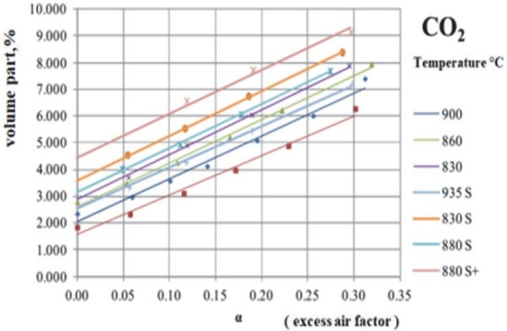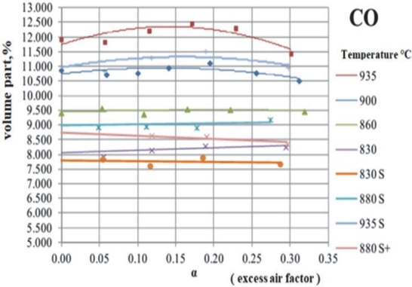
Fig. 1. Graphs for the CO₂ emission  in the synthesized gas | Fig. 2. Graphs for the CO emission  in the synthesized gas

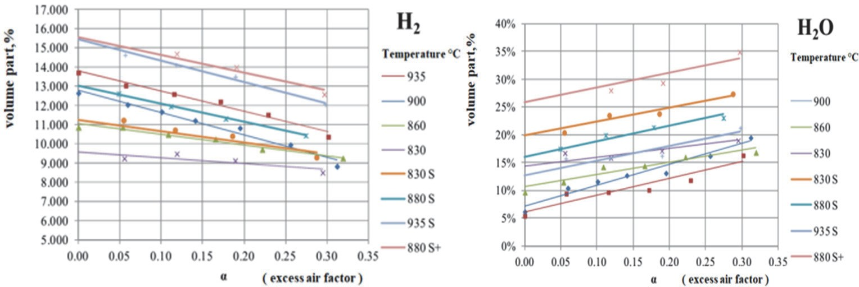
Fig. 3. Graphs for the H₂ emission  in the synthesized gas | Fig. 4. Graphs for the H₂O emission in the synthesized gas

As seen above, the mathematical model simulation is almost identical to the experiment’s results for the yield of carbon dioxide, methane, and hydrogen.
Below we present a diagram of the experimental installation.

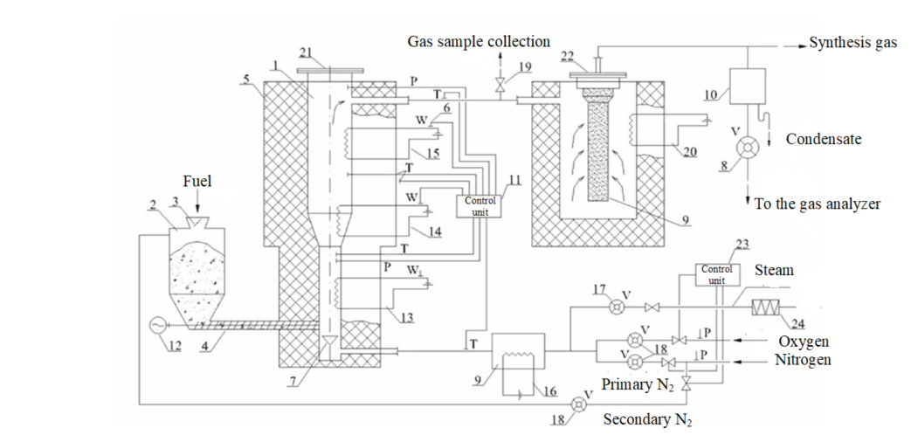
Fig. 4. Scheme of experimental gasification plant: 1 – biomass gasification reactor,
2 – solid fuel chamber, 3 – gate valve, 4 – screw transporter for fuel transport, 5 – reactor thermal insulation, 6 – installation places for pressure and temperature measuring instruments, electricity consumed, 7 – blowing distribution system,
8 – generator gas flow meter, 9 – graphite gas filter, 10 – cooling and condensing unit, 11 – control and data collection assembly, 12 – screw motor of the fuel transfer system; 13, 14, 15 – electric heaters of different reactor zones (lower, middle with the upper respectively); 16 – electric heater of the pre-heating system; 17 – jet flow meter of steam water; 18 – oxygen and nitrogen flow meter; 19 – tap for sampling gas to the filter; 20 – filter assembly heater; 21 – reactor cover; 22 – filter chamber cover;
23 – blowing control unit; 24 – steam superheater
6. Optimization of gasifier operation

The optimization is shown by equation (10):

η = 0.5923 ∙ (-2.5822 ∙ α²bio + 1.5792 ∙ αbio + 0.833) ∙ (-0.000137 ∙ W^{p2} + 0.00605 ∙ W^{p} + 0.9801) ∙ (0.0000005 ∙ $t_{react}^{2}$ + 0.0010706 ∙ t_{react} + 0.4778)

where:
η – process optimization parameter,
α_{bio} – excess air coefficient,
W^{p} – of biomass moisture changes,
t_{react} – range of process temperature changes.

A more accurate assessment of the impact of gasification parameters on the efficiency of this process is possible after performing an extended computational experiment and processing the obtained data.
The extended experiment was conducted under the following conditions:
- range of changes in the excess air coefficient: α_{bio} = 0.01-0.5,
- range of biomass moisture changes: W_{р} = 5-50%,
- process temperature variation range: t_{react} = 800-1000°C,
- biomass consumption: B_{bio} = 100 g/h,
- the reactor has a cylindrical shape and dimensions d_{react} = 1.5 m, h_{react} = 3.0 m,
- the efficiency of using the produced gas for own needs η_{sg} = 80%.

The obtained results are presented in Table 1.

Table 1. Characteristics of the factors of experiment 2³
Characteristics of factors | Factors
 | Х₁ (α_{bio}) | Х₂ (t_{react}, °C) | Х₃(W_{bio}, %)
Basic level | 0.275 | 900 | 27.5
Variation range | 0.225 | 100 | 22.5
Maximum factor level | 0.500 (+1) | 1000 (+1) | 50.0 (+1)
Minimum factor level | 0.050 (-1) | 800 (-1) | 05.0 (-1)

The coefficients’ value characterizes the factors’ influence on the optimization parameter. The analysis shows that the excess air coefficient (α) has the most significant impact. An increase in the value of α leads to an increase in the thermodynamic efficiency of the gasifier. The temperature coefficient, common humidity coefficient, and excess air coefficient have a similar, directly proportional effect. The biomass humidity and the common factors of the excess air and temperature, temperature and humidity coefficient, and the common factor of all parameters have an inversely proportional effect. The influence of the fuel moisture coefficient is relatively insignificant, which during the operation of the gasifier may manifest itself both as a result of the natural moisture of the fuel and the steam blowing. In addition, the increase in fuel humidity following the mathematical model obtained leads to a decrease in the efficiency of the gasifier’s operation. The influence of temperature in the reaction zone is also unequivocal, although insignificant - the increase in temperature in the reaction zone increases the efficiency of the gasifier’s operation.
7. Conclusions
After conducting the experiment on the pyrolysis installation, it was found that the proposed method of predicting the producer gas composition is correct. The results of the mathematical modeling and the experiment coincide. This experiment is closest to the actual conditions of the gasification and pyrolysis technological process and opens the way to further research on the even more effective yield of the gas we desire. The experience allowed us to understand the gasification and pyrolysis processes. Thanks to the combination of model and experimental research, we could accurately understand the influence of all parameters on the process characteristics. The synergy of gas generator operation optimization and using a mathematical model changes the approach to producing gas depending on the needs.
References
Ahmadi, M., Elm Svensson, E., Engvall, K. (2013). Application of solid-phase microextraction (SPME) as a tar sampling method. Energy & fuels, 27(7), 3853-3860.
Azzone, E., Morini, M., Pinelli, M. (2012). Development of an equilibrium model for the simulation of thermochemical gasification and application to agricultural residues. Renewable energy, 46, 248-254.
Babler, M.U., Phounglamcheik, A., Amovic, M., Ljunggren, R., Engvall, K. (2017). Modeling and pilot plant runs of slow biomass pyrolysis in a rotary kiln. Applied energy, 207, 123-133.
Barman, N.S., Ghosh, S., De, S. (2012). Gasification of biomass in a fixed bed downdraft gasifier – A realistic model including tar. Bioresource technology, 107, 505-511.
Dahlquist, E., Mirmoshtaghi, G., Larsson, E.K., Thorin, E., Yan, J., Engvall, K., ... Lu, Q. (2013, September). Modelling and simulation of biomass conversion processes. In 2013 8th EUROSIM Congress on Modelling and Simulation, 506-512. IEEE.
FakhrHoseini, S.M., Dastanian, M. (2013). Predicting pyrolysis products of PE, PP, and PET using NRTL activity coefficient model. Journal of Chemistry, 2013.
Jarungthammachote, S., Dutta, A. (2008). Equilibrium modeling of gasification: Gibbs free energy minimization approach and its application to spouted bed and spout-fluid bed gasifiers. Energy Conversion and Management, 49(6), 1345-1356.
Koshlak, H., Pavlenko, A. (2020). Mathematical Model of Particle Free Settling in a Vortex Apparatus. Rocznik Ochrona Środowiska, 22.
Koukkari, P., Pajarre, R. (2011). A Gibbs energy minimization method for constrained and partial equilibria. Pure and Applied Chemistry, 83(6), 1243-1254.
Lee, D.H., Yang, H., Yan, R., Liang, D.T. (2007). Prediction of gaseous products from biomass pyrolysis through combined kinetic and thermodynamic simulations. Fuel, 86(3), 410-417.
Liliedahl, T., Sjöström, K., Engvall, K., Rosén, C. (2011). Defluidisation of fluidised beds during gasification of biomass. Biomass and bioenergy, 35, S63-S70.
Melgar, A., Pérez, J.F., Laget, H., Horillo, A. (2007). Thermochemical equilibrium modelling of a gasifying process. Energy conversion and management, 48(1), 59-67.
Melgar, A., Pérez, J.F., Laget, H., Horillo, A. (2007). Thermochemical equilibrium modelling of a gasifying process. Energy conversion and management, 48(1), 59-67.
Nemanova, V., Engvall, K. (2014). Tar variability in the producer gas in a bubbling fluidized bed gasification system. Energy & fuels, 28(12), 7494-7500.
Nemanova, V., Abedini, A., Liliedahl, T., Engvall, K. (2014). Co-gasification of petroleum coke and biomass. Fuel, 117, 870-875.
Nemanova, V., Nordgreen, T., Engvall, K., Sjöström, K. (2011). Biomass gasification in an atmospheric fluidised bed: Tar reduction with experimental iron-based granules from Höganäs AB, Sweden. Catalysis Today, 176(1), 253-257.
Pavlenko, A.M., Koshlak, H. (2021). Application of Thermal and Cavitation Effects for Heat and Mass Transfer Process Intensification in Multicomponent Liquid Media. Energies, 14(23), 7996. https://doi.org/10.3390/en14237996
Pavlenko, A.M., Koshlak, H. (2021). Intensification of Gas Hydrate Formation Processes by Renewal of Interfacial Area between Phases. Energies, 14(18), 5912.
Pavlenko, A.M., Koshlak, H.V., Usenko, B.O. (2014). Heat and mass transfer in fluidized layer. Metallurgical and Mining Industry, 6(6), 96-100.
Pavlenko, A., Klas, E. (2020). Hydrocarbon Synthesis During Methane Pyrolysis. Rocznik Ochrona Środowiska, 22.
Pavlenko, A., Koshlak, H. (2019). Heat and mass transfer during phase transitions in liquid mixtures. Rocznik Ochrona Środowiska, 21.
Pepiot, P., Dibble, C.J., Foust, T.D. (2010). Computational fluid dynamics modeling of biomass gasification and pyrolysis. In Computational modeling in lignocellulosic biofuel production, 273-298. American Chemical Society.
Puig-Arnavat, M., Bruno, J.C., Coronas, A. (2012). Modified thermodynamic equilibrium model for biomass gasification: a study of the influence of operating conditions. Energy & Fuels, 26(2), 1385-1394.
Samuelsson, L.N., Moriana, R., Babler, M.U., Ek, M., Engvall, K. (2015). Model-free rate expression for thermal decomposition processes: the case of microcrystalline cellulose pyrolysis. Fuel, 143, 438-447.
Sieradzka, M., Rajca, P., Zajemska, M., Mlonka-Mędrala, A., Magdziarz, A. (2020). Prediction of gaseous products from refuse derived fuel pyrolysis using chemical modelling software-Ansys Chemkin-Pro. Journal of Cleaner Production, 248, 119277.
Silva, I.P., Lima, R.M., Silva, G.F., Ruzene, D.S., Silva, D.P. (2019). Thermodynamic equilibrium model based on stoichiometric method for biomass gasification: A review of model modifications. Renewable and Sustainable Energy Reviews, 114, 109305.
Wan, W., Engvall, K., Yang, W. (2018). Novel model for the release and condensation of inorganics for a pressurized fluidized-bed gasification process: effects of gasification temperature. ACS omega, 3(6), 6321-6329.
Zevenhoven-Onderwater, M., Backman, R., Skrifvars, B.J., Hupa, M. (2001). The ash chemistry in fluidised bed gasification of biomass fuels. Part I: predicting the chemistry of melting ashes and ash-bed material interaction. Fuel, 80(10), 1489-1502.

