 | Rocznik Ochrona Środowiska
 | Volume 24 | Year 2022 ISSN 2720-7501 | pp. 83-96
 | https://doi.org/10.54740/ros.2022.007 open access
 | Received: 22 April 2022 Accepted: 11 July 2022 Published: 14 November 2022
Influence of Abrasive Treatment of Steel Fibers on the Effectiveness of Anchoring in Concrete
Dorota Janikowska
Koszalin University of Technology, Poland
https://orcid.org/0000-0001-5861-8530
corresponding author’s e-mail: dorota.janikowska@tu.koszalin.pl
Abstract: The article presents an original proposal to improve the efficiency of anchoring steel fibers in fibroconcrete mixtures. The expected effect was obtained by developing the surface of the fibers by mechanical abrasive treatment with electrocorundum. The main part of the work presents the results of the conducted experimental studies. The effect of the surface treatment of the fibers was investigated through metallographic techniques, using a metallographic microscope and equipment to determine the surface roughness. On the other hand, the direct method of assessing the effectiveness of fiber anchoring in the concrete was determined using the pull-out test. The results of these studies were subjected to detailed analysis and statistical processing. The results of metallographic and pull-out tests indicate that the proposed method of treating the fibers significantly affects their anchoring efficiency in the concrete matrix. According to the author, this may be of great practical importance because the discussed method of treating the fibers can significantly improve the general properties of fibrocomposite mixtures.
Keywords: steel fiber, pull-out test, concrete, bond characteristics, roughness, fiber surface
1. Introduction
Concrete is one of the most popular materials constructing the basis of modern civil engineering worldwide. It gained popularity mainly due to accessibility, low price, ease of shaping, high strength, and durability. Over the years, concrete recipes have been improved to obtain a composite distinguished by the best physical and mechanical parameters.
Concrete is a brittle material, and its tensile strength is about 12-15 times lower than the compression strength (PN-EN 1992-1-1). A standard method of improving the tensile strength parameters of concrete is the use of reinforcement. It can take the form of both reinforcing bars and dispersed reinforcement in the form of fibers.
Using such reinforcement allows to take over tensile stresses and minimize the propagation of cracks (Beglarigale et al. 2015, Alwan et al. 1993, Alwan et al. 1991). In the last twenty years, mainly steel fibers have been used as dispersed reinforcement, but polypropylene, glass, and carbon fibers are also used (Zych 2010). The combination of concrete with appropriate fibers is called fiber concrete.
The efficiency of the fibers in the concrete matrix depends on many factors (Beglarigale et al. 2015, Alwan et al. 1993, Alwan et al. 1991, Kim et al. 2011, Soulioti et al. 2011, Nataraja et al. 2000, Katzer et al. 2012, Abdallah et al. 2016, Zile et al. 2013, Cunha et al. 2008, Abdallah et al. 2016, Jamroży 1985, Won et al. 2013), of which the most important are: their length, a cross-section (type of the cross-section and its surface area), a longitudinal shape, a percentage in the mixture as well as the orientation of the fiber axis in relation to the direction of the acting stresses.
The first of the mentioned features – fiber length – was studied and discussed, among others, in the works (Cunha et al. 2008, Abdallah et al. 2016, Markovic 2016), while the influence of the cross-section and longitudinal shape of the fibers on the mechanical properties of the fibrocomposite mixtures was widely analyzed in the works (Kim et al. 2011, Soulioti et al. 2011, Nataraja et al. 2000, Katzer et al. 2012, Abdallah et al. 2016, Zile et al. 2013, Cunha et al. 2008, Abdallah et al. 2016).
Based on the tests and the analyses of the adhesion of the straight fiber to the concrete matrix, it was found that the actual distribution of the shear stresses τ at the interface between the steel and the concrete is nonlinear (Cunha et al. 2008, Naaman et al. 1991, Gray 1983, Sujivorakul et al. 2000). The distribution of these stresses along the reinforcement is presented in Figure 1, in the form of the characteristic τ(x). Due to difficulties in accurately determining the nonlinear stress distribution, in the analysis of steel adhesion to concrete, stress characteristic has a form of constant function τ(x)= τ₁.

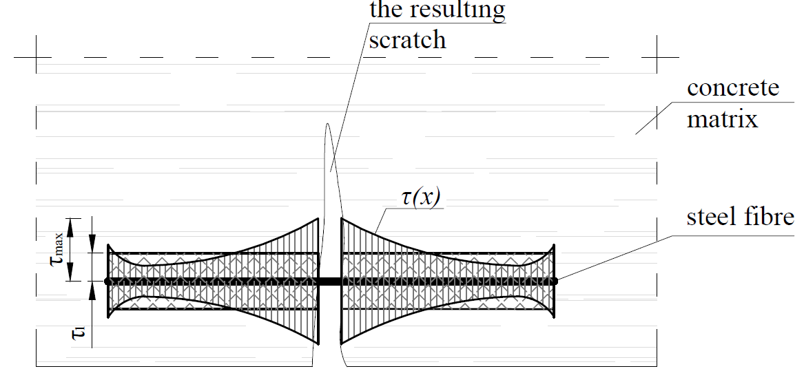
Fig. 1. The tangential stress distribution along the fiber axis
Assuming a simplified, constant distribution of the tangential stresses τ₁, the relationship can be easily determined.
$P_{max}=τ_{1}∙A$, (1)
where A is a sidewall field of the fiber constrained (fixed) in the concrete. Based on this condition, it is possible to obtain a force P_{max} causing debond of the fiber from the matrix.
Assuming that the diameter and anchored length of the fiber are constant, the effectiveness of the anchoring can be increased by modifying its surface or shape with chemical or mechanical treatment. The use of chemical methods to improve the adhesion of fibers to the concrete has been widely studied and discussed, e.g. (Wiemer et al. 2020, Zhu et al. 2020, Oh et al. 2021, Liu et al. 2020, Chun et al. 2021, Tattersall et al. 1974, Pi et al. 2019). In the mentioned works, these methods included, among others, surface cleaning with acetone, galvanizing, applying a nanosilicate, brassed or ethylenediaminetetraacetic acid (EDTA) electrolyte solution treatment, as well as zinc phosphate treatment.
The mechanical methods of improving the anchoring of the concrete’s fibers consist mainly of giving them the appropriate shape. These modifications may concern the longitudinal profile of the whole fibers, their parts, or their edges. Many research works have been done on this subject, among which one can mention (Zile et al. 2013, Won et al. 2013, Cunha 2010, Chun et al. 2020, Yoo et al. 2020, Holschemacher et al. 2010, Kim et al. 2010, Maage 1977, Domski et al. 2017).
Increasing the anchoring effect of the fibers in the concrete matrix can also be achieved by developing their surface, i.e., increasing the roughness of the fibers surfaces. It can be done by treating fibers surfaces with a sharp-edged abrasive material with an appropriate hardness. As a result, the surface of the fibers should have greater roughness and, consequently, greater adhesion to the concrete matrix than in the case of fiber with a smooth surface.

2. Materials and methods
Based on the preliminary conclusions resulting from the literature study, the effectiveness of the anchorage of the mechanically treated steel wire was tested. This treatment consisted of mixing the steel fibers with the abrasive for 1 hour. For this purpose, a mixture of fibers and corundum in the proportions of 1 to 9, with a total weight of 2.1 kg, was prepared. The mixture was placed in a mixing machine nominally used for the Los Angeles Abrasion Test. The fibers’ treatment was performed without steel balls, assuming a rotational speed of approx. 32 rpm. Then, after cleaning the fibers from fine impurities and degreasing, metallographic tests were carried out. In the second phase of laboratory tests, the pull-out test was performed.
2.1. Materials – steel fiber
A steel wire with a diameter of 1.3 mm was used for the tests. The strength parameters, i.e., yield stress (350 MPa) and ultimate strength (475 MPa), were determined by the tension of the fibers in a testing machine. Figure 2 shows the example of the stress-strain (σ – ε) characteristic obtained during the tests performed. On the other hand, the photograph (Fig. 3) shows the test method.

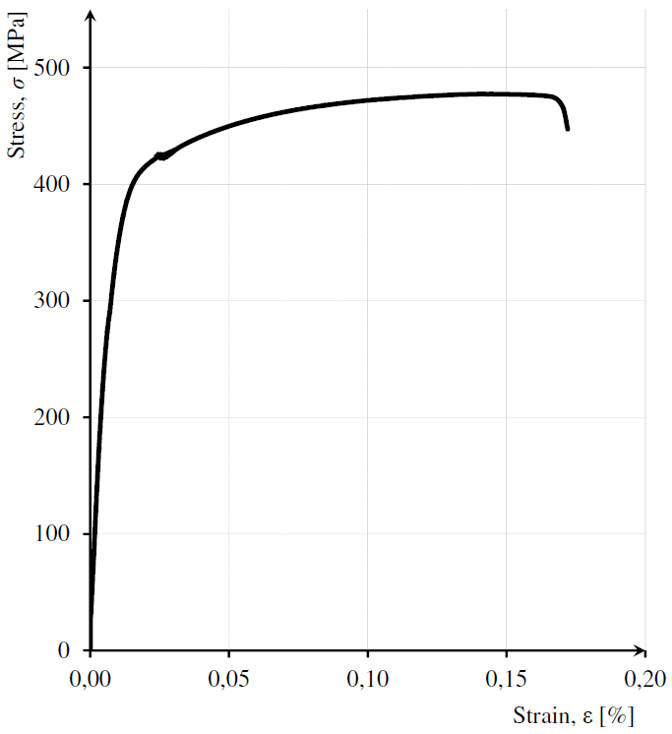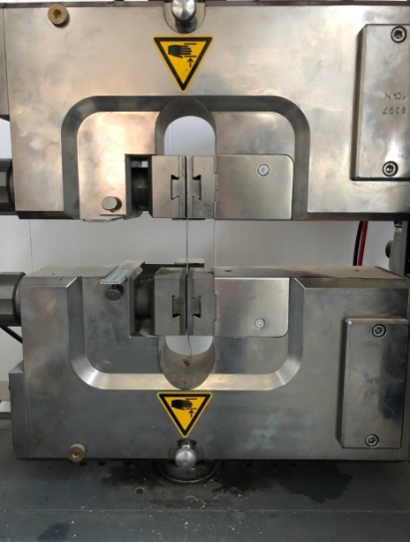
Steel fiber

Fig. 2. An example of the stress-strain Fig. 3. View of the tested fiber subjected
characteristic (σ – ε) to the breaking test
2.2. Materials – corundum
From the abrasive materials that are most often used in abrasive blasting, it was decided to use electrocorundum. This material was chosen because it is a synthetically produced form of the corundum, whose hardness reaches nine on the Mohs scale. In addition, it is an abrasive that self-sharpens during use so that it can be recovered and reused. The combination of three fractions with characteristic grain sizes of 0.55 mm, 1.29 mm, and 1.85 mm was selected in equal proportions for the experiment.
2.3. Materials – concrete
The sand concrete samples were made of a sand concrete mix according to the proportions: 1: 3: 0.5, corresponding to 450 g of CEM I 42.5R Portland cement, 1350 g of standard sand, and 225 cm³ of water. In the process of making the samples, steel fibers were embedded, protecting them appropriately for the time of concrete curing. Then, the formed specimens were subjected to wet curing for 28 days under the standard conditions
2.4. Methods
2.4.1. Metallographic research
The two tests were performed as part of the laboratory tests in the field of metallographic measurements. The first test was to obtain an image of the sample in the light reflected from its surface with a magnification of 200x using the Nikon MA 200 metallographic microscope equipped with the NIS Elements software. With the help of this study, it was possible to reveal the surface on a micro-scale and identify surface changes due to mechanical treatment that are invisible to the unaided eye.
The second metallographic study was to define the roughness of the steel fibers’ surface using the Hommel-Etamic apparatus for a contact unevenness measurement equipped with the TurboWave V7.42 program. Again, three randomly selected fibers were tested, the surface of which was measured in 5 different places.
2.4.2. Pull-out test
The laboratory tests included, among other things, the pull-out method. This test consisted of removing the bar (fiber) with a diameter of 1.3 mm from the concrete block with dimensions of 40x40x80 mm. The assumed depth of the fiber embedding in the concrete of 30 mm is 60% of the total length, at which the fiber anchoring resistance amounts to the tensile resistance of the fiber steel cross-section.
During the pull-out test, the value of the P force was recorded with the simultaneous measurement of the displacements s of the pulled-out fiber from the concert block. A constant force increase of 10 N/s was taken, and the measurements for each sample were recorded until the fiber wrested from the matrix.

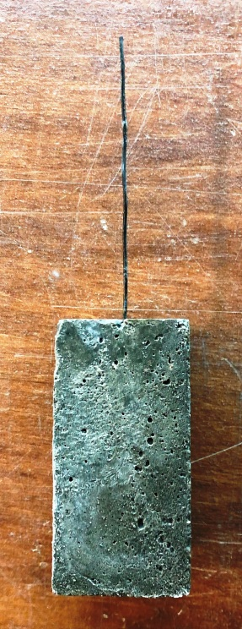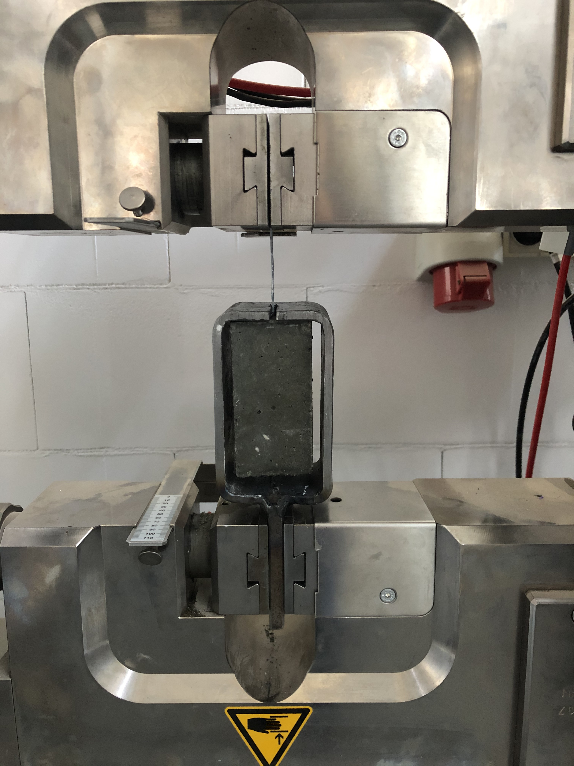
mounting bracket
concrete block
Steel fiber

Fig. 4. Molded sample Fig. 5. View of the test sample
After curing, the samples were tested. A total of 26 tests were performed: 13 for the samples with unmodified surface fibers (series I) and 13 for the samples with developed surface fibers (series II). During the test, in the testing machine, the samples were placed in a specially prepared mounting holder so that the lower jaws of the machine do not grip the concrete element directly and do not cause additional compressive stresses in them, which could disturb the measurement or damage the samples (Fig. 5). Jaws with fine notches were used to grasp the steel fibers.

3. Results and discussion
3.1. Metallographic research
The first test results are photographs, two examples of which are shown in Figure 6. It is easy to see that photo 6a) shows the surface of the fiber before treatment – it is relatively smooth with fine, irregularly distributed indentations (“tears”). On the other hand, photo 6b) shows the surface of the fiber that has been developed. It can be seen that this surface is much more irregular. Since the entire fibers have been subjected to that abrasive treatment, the resulting cracks are distributed randomly over their entire surface.

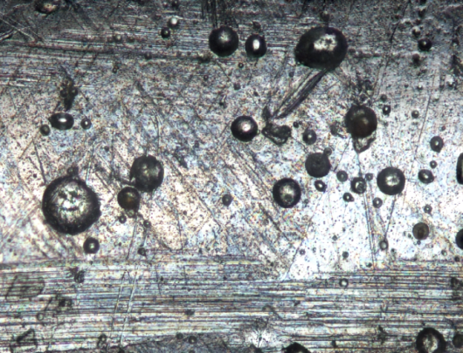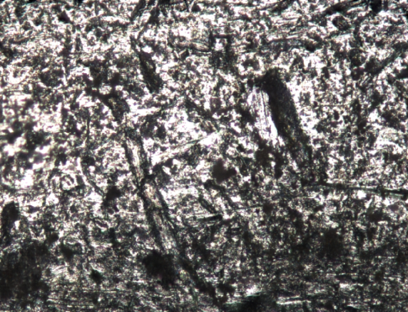
b)
a)
Fig. 6. The surface of the fiber: a) before processing, b) after mechanical processing

With the help of the second metallographic test, the arithmetic mean values of the ordinates of the Ra profile and the highest roughness height Rz were determined. The test was performed on a measuring section of 1.50 mm and at a preset feed speed of the measuring tip equal to 0.05 mm/s. Table 1 summarises the mean values of the readings recorded for smooth (series I) and mechanically treated (series II) fibers.

Table 1. Tabular list of mean roughness measurements
Series number | Ra [µm] | Rz [µm]
Series I | 0.170 | 1.075
Series II | 0.539 | 3.357

It can be concluded that the fibers subjected to abrasive treatment with the use of the electrocorundum will have better adhesion to the concrete than fibers that have not been subjected to that type of treatment, comparing both the surfaces presented in Figure 6 and the results of roughness measurements.
3.2. Pull-out test
During the tests of the first series of samples, all the fibers were pulled out (none of the steel fiber was damaged in its cross-section), while in the second series, 4 of the 13 fibers were damaged by tension (full anchorage of the fiber in the concrete was achieved).
Moreover, during the testing of the samples, no slippage was noted in the upper and lower jaws of the testing machine. The fibers in the upper jaws or directly in their vicinity were not cracked either.
The values of the maximum forces obtained during the pull-out test for each sample in both series (I and II) are presented in Table 2. (the underlined numbers in the series II correspond to the forces at which the fibers were broken).

Table 2. Tabular summary of the maximum forces P_{max}
Series number | Maximum force P_{max} [N]
 | 1. | 2. | 3. | 4. | 5. | 6. | 7. | 8. | 9. | 10. | 11. | 12. | 13.
Series I | 286 | 471 | 298 | 265 | 329 | 315 | 346 | 429 | 340 | 397 | 395 | 308 | 436
Series II | 597 | 596 | 556 | 448 | 511 | 612 | 534 | 591 | 616 | 590 | 526 | 368 | 449

Furthermore, the average distribution of the force-displacement (P – s) characteristics was obtained, respectively, for the samples with the smooth surface of the fibers (determined based on the results from 13 tests) and for the samples with fibers whose surfaces were modified (specified based on the results from 9 tests – Fig. 7). Figure 7 also shows the average course of the P – s characteristics obtained in series II for the samples that cracked in the measurement base.
The average value of the maximum force P_{max} for series I equals 355 N. Whereas for series II – 538 N. The difference is significant and amounts to about 52%. The mean values of the forces in both series for the suitable displacements given in Table 3 were also compared.

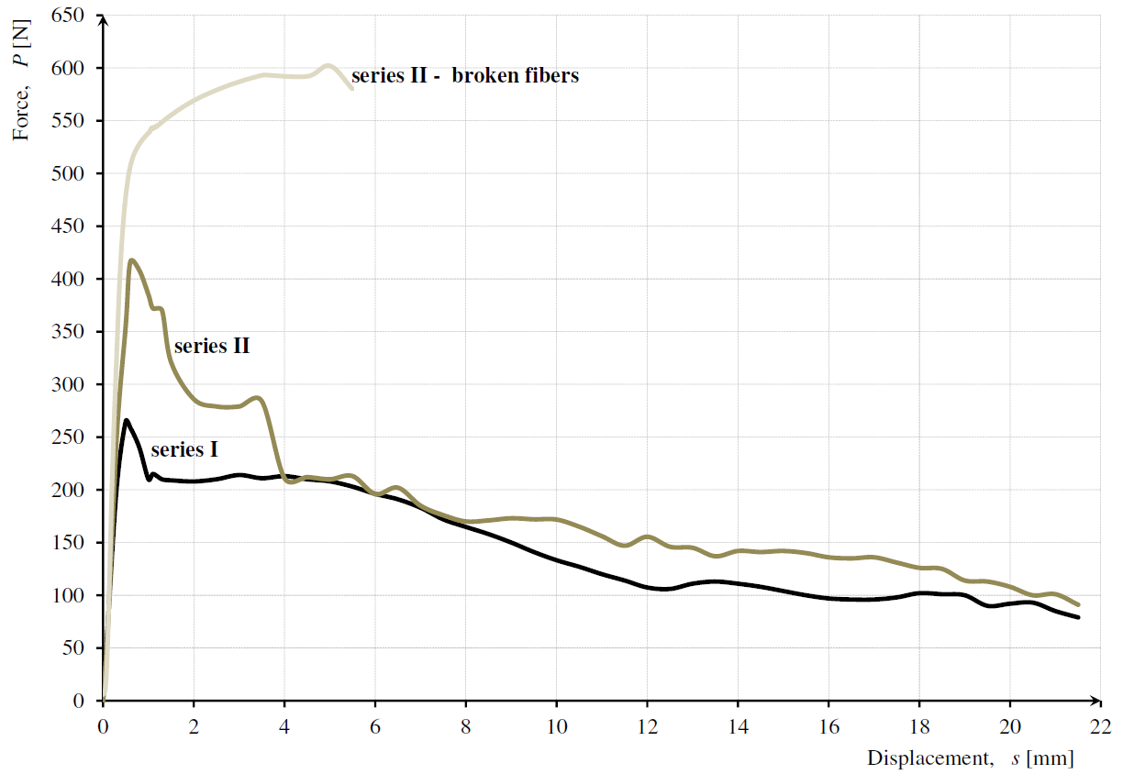
Fig. 7. Average distribution of the characteristics P – s

Table 3. Summary of force values for both series
 | The mean maximum value of the force P_{max} [N] | Displacement s [mm]
 |  | 2 | 4 | 6 | 8 | 10 | 12
 |  | Mean value of the force P [N]
Series I | 355 | 207,95 | 212,93 | 196,16 | 164,81 | 133,23 | 107,37
Series II | 538 | 368,64 | 280,34 | 275,35 | 240,10 | 171,78 | 155,44
Differences | 52%↑ | 77%↑ | 32%↑ | 40%↑ | 46%↑ | 29%↑ | 45%↑

Within the scope of the analysis of the obtained results, the energy E needed to pull the wire out of the matrix was also determined (the area under the P – s characteristic). The average maximum energy value for both series was determined, and the average values for displacements amount respectively: 2, 4, 6, 8, 10, and 12 mm. In the case of series II, those samples with cracked fibers were omitted from determining the energy value. Table 4 summarises the mean values for both series and shows the percentage relationship between them. It can be seen that the energy required to pull out the wire from the concrete is more significant in the case of mechanically modified fibers.
Table 4. Summary of energy values for both series
 | Average maximum energy value E [J] | Displacement s [mm]
 |  | 2 | 4 | 6 | 8 | 10 | 12
 |  | Average energy value E [J]
Series I | 2.58 | 0.41 | 0.83 | 1.24 | 1.61 | 1.91 | 2.15
Series II | 3.39 | 0.64 | 1.15 | 1.56 | 2.05 | 2.42 | 2.74
Differences | 22%↑ | 36%↑ | 28%↑ | 21%↑ | 21%↑ | 21%↑ | 22%↑

Based on the analysis of the obtained results, it can be concluded that the proposed method of fiber surface modification significantly improves its efficiency in the concrete matrix. It is evidenced by the greater energy required to pull the fibers out of the concrete block. An extensive statistical analysis was carried out for the results obtained during the research. Based on the representativeness of the samples, it was found that 13 samples in each series were sufficient. Additionally, using the Dixon method, it was proved that there is no reason to reject the extreme values in both series.
Moreover, the discrepancy between the average values of the forces causing pulling out of the wire from the concrete matrix (according to the Student’s t distribution) for the fibers with a smooth and developed surface was checked. Therefore, with the assumed significance level α = 5% (a trust level: 100% – α = 95%) and a number of freedom degrees k = 24, the theoretical value of a statistic (t_{t} = 2.0639) was compared with an empirical value (t_{e} = 6.603). Demonstrating the fulfillment of the inequality t_{t} < t_{e} means that the differences between the considered average values of the forces F_{max}, respectively, for the two series, are significant enough that the sets of results should be treated as belonging to different populations.
In the scope of the statistical analysis, the lower estimation of the force value causing the fiber to debond from the concrete was also determined according to the relationship (2), where ${\overline{P}}_{min}$ is the average value for a given series, t is a parameter for the significance level α = 5% for the t – Student distribution, and υ is an index of volatility. The results are summarised in Table 5.
${ P}_{min}={\overline{P}}_{min} ∙ \left(1-t∙υ\right).$ (2)

Table 5. Estimated lower strengths for breaking the fiber from the concrete
Series number | Volatility index υ [%] | The value of strength P_{min} [N]
Series I | 18.14 | 214.68
Series II | 14.20 | 371.53

It can be seen that the variation index is lower in the case of fibers with a developed surface when analyzing the obtained values. It is, therefore, possible to predict with greater probability the nature of the behavior of this type of fibers in the matrix.

4. Conclusions
The article presents an author’s proposal to improve the effectiveness of dispersed reinforcement by abrasive treatment with electrocorundum.
The effect of abrasive treatment on the surface of steel fibers was determined by metallographic tests using the metallographic microscope and roughness measuring equipment. On the other hand, the influence of surface development with the use of electrocorundum on the effectiveness of anchoring the fibers in the concrete was determined directly by performing the pull-out test.
Based on the collected and developed results, the following conclusions can be drawn:
1. the photos taken of the steel surfaces of the fibers at a magnification of 200x visually show a clear difference between the surface condition before and after treatment;
2. the differences observed during the roughness measurement between the samples belonging to two different series prove a significant development of their surface and the increase in roughness;
3. based on the analysis of the pull-out tests, it was proved that the fibers with a developed surface have better adhesion to the concrete than the “smooth” fibers. The results clearly show that both the maximum force P_{max} and the pull-out work of the fibers from the concrete are much more significant in the case of the abrasive-treated fibers. Moreover, the results obtained during the pull-out tests for the fibers with a developed surface are characterised by a smaller spread;
4. It is seen that fibers with a developed surface are characterized by greater anchorage in the concrete matrix than fibers with a smooth surface. On average, the increase in anchorage strength is approximately equal to 45%;

5. the proposed method of modifying the surface of steel fibers is economical. Both the costs of the abrasive and the possibility of its multiple uses, as well as the technological process of treating the fibers (mixing the steel fibers with the abrasive), is not complicated.

Based on the obtained test results, it can be assumed that the proposed method of treating the surface of the fibers has a beneficial effect on the effectiveness of anchoring the fibers in the concrete.
For this reason, the next stage of research has been planned. In the adopted research program, the effectiveness of the abrasive-treated fibers will be assessed based on the bending tensile tests of the fiber concrete.
References
Abdallah, S., Fan, M., Zhou, X. (2016). Effect of Hooked-End Steel Fibres Geometry on Pull-Out Behaviour of Ultra-High Performance Concrete. Construction and Architectural Engineering, 10(12), 1594-1599.
Abdallah, S., Fan, M., Zhou, M., Le Geyt, S. (2016) Anchorage Effects of Various Steel Fibre Architectures for Concrete Reinforcement. International Journal of Concrete Structures and Materials, 10(3), 325-335. DOI: 10.1007/s40069-016-0148-5
Alwan, J.M., Naaman, A.E., Guerrero, P. (1993). Effect of mechanical clamping on the pull-out response of hooked steel fibers embedded in cementitious matrices. Concrete Science and Engineering, 1, 5-25.
Alwan, J.M., Naaman, A.E., Hansen, W. (1991). Pull-Out Work of Steel Fibers From Cementitious Composites: Analytical Investigation. Cement & Concrete Composites, 13, 247-255.
Beglarigale, A., Yazici, H. (2015). Pull-out behavior of steel fiber embedded in flowable RPC and ordinary mortar. Construction and Building Materials, 75, 255-265. DOI: 10.1016/j.conbuildmat.2014.11
Chun, B., Kim, S., Yoo, D.-Y. (2021). Benefits of chemically treated steel fibers on enhancing the interfacial bond strength from ultra-high-performance concrete. Construction and Building Materials, 294, DOI: 10.1016/j.conbuildmat.2021.123519
Chun, B., Yoo, D.-Y., Banthia, N. (2020). Achieving slip-hardening behavior of sanded straight steel fibers in ultra-high-performance concrete. Cement and Concrete Composites, 113, DOI: 10.1016/j.cemconcomp.2020.103669
Cunha, V.M. C.F., Barros, J.A.O., Sena-Cruz, J.M. (2008). Bond-Slip Mechanisms of Hooked-End Steel Fibers in Self-Compacting Concrete. Materials Science Forum, 587-588, 877-881. DOI: 10.4028/www.scientific.net/msf.587-588.877
Cunha, V.M.C.F. (2010). Steel Fibre Reinforced Self-Compacting Concrete (from Micro-Mechanics to Composite Behaviour). Portugal: Minho's University.
Domski, J., Katzer, J., Zakrzewski, M., Ponikiewski, T. (2017). Comparison of the mechanical characteristics of engineered and waste steel fiber used as reinforcement for concrete. Journal of Cleaner Production, 158, 18-28. DOI: 10.1016/j.jclepro.2017.04.165
Gray, R.J. (1983). Experimental techniques for measuring fibre/matrix interfacial bond shear strength. International Journal of Adhesion and Adhesives, 3, 197-202.
DOI: 10.1016/0143-7496(83)90094-5
Holschemacher, K., Mueller, T., Ribakov, Y. (2010). Effect of steel fibres on mechanical properties of high-strength concrete. Materials and Design, 31, 2604-2615. DOI: 10.1016/j.matdes.2009.11.025
Jamroży, Z. (1985). Fibre reinforced concrete. Kraków: Cracow University of Technology Publishing House (in Polish).
Katzer, J., Domski, J. (2012). Quality and mechanical properties of engineered steel fibres used as reinforcement for concrete. Construction and Building Materials, 34, 243-248. DOI: 10.1016/j.conbuildmat.2012.02
Kim, D.J., Park, S.H., Ryu, G.S., Koh, K.T. (2011). Comparative flexural behavior of Hybrid Ultra High Performance Fiber Reinforced Concrete with different macro fibers. Construction and Building Materials, 25, 4144-4155. DOI: 10.1016/j.con-buildmat.2011.04
Kim, D.J., El-Tawil, S., Naaman, A.E. (2010). Effect of Matrix Strength on Pullout Behavior of High-Strength Deformed Steel Fibers. ACI Special Publication, 272, 135-150. DOI: 10.14359/51664089
Liu, T., Wei, H., Zhou, A., Zou, D., Jian, H. (2020). Multiscale investigation on tensile properties of ultra-high performance concrete with silane coupling agent modified steel fibers. Cement and Concrete Composites, 111, DOI: 10.1016/j.cemconcomp. 2020.103638
Maage, M. (1977). Interaction between steel fibers and cement based matrixes. Matériaux et Construction, 10(59), 297-301. DOI: 10.1007/bf02478831
Markovic, I. (2006). High-Performance Hybrid-Fibre Concrete. Netherlands: DUP Science.
Naaman, A.E., Namur, G.G., Alwan, J.M., Najm, H.S. (1991). Fiber Pull-out and bond slip. I: analytical study. Journal of Structural Engineering, 117, 2769-2790.
Nataraja, M.C., Dhang, N., Gupta, A.P. (2000). Toughness characterisation of steel fiber-reinforced concrete by JSCE approach. Cement and Concrete Research, 30, 593-597. DOI: 10.1016/s0008-8846(00)00212-x
Oh, T., You, I., Banthia, N., Yoo, D.-Y. (2021). Deposition of nanosilica particles on fiber surface for improving interfacial bond and tensile performances of ultra-high-performance fiber-reinforced concrete. Composites Part B, 221, DOI: 10.1016/j. compositesb.2021.109030
Pi, Z., Xiao, H., Du, J., Liu, M., Li, H. (2019). Interfacial microstructure and bond strength of nano-SiO2-coated steel fibers in cement matrix. Cement and Concrete Composites, 103, DOI: 10.1016/j.cemconcomp.2019.04.025
PN-EN 1992-1-1:2008. Projektowanie konstrukcji z betonu. Reguły ogólne i reguły dla budynków.
Soulioti, D.V., Barkoula, N.M., Paipetis, A., Matikas, T.E. (2011). Effects of Fibre Geometry and Volume Fraction on the Flexural Behaviour of Steel-Fibre Reinforced Concrete. Strain, 47, 535-541. DOI: 10.1111/j.1475-1305.2009. 00652.x
Sujivorakul, C., Waas, A.M., Naaman, A.E. (2000). Pull-out response of a smooth fiber with an end anchorage. Journal of engineering mechanics, 126, 986-993.
DOI: 10.1061/(asce)0733-9399(2000)126:9(986)
Tattersall, G.H., Urbanowicz, C.R. (1974). Bond strength in steel-fIbre-reinforced concrete. Magazine of Concrete Research, 26(87), 105-113.
Wiemer, N., Wetzel, A., Schleiting, M., Krooß, P., Vollmer, M., Niendorf, T., Böhm, S., Middendorf, B. (2020). Effect of Fibre Material and Fibre Roughness onthe Pull-out Behaviour of Metallic Micro Fibres Embedded in UHPC. Material, 13. DOI: 10.3390/ma13143128
Won, J.-P., Hong, B.-T., Lee, S.-J., Choi, S.J. (2013). Bonding propertiesofamorphousmicro-steelfibre-reinforced cementitious composites. Composite Structures, 102, 101-109. DOI: 10.1016/j.compstruct.2013.02.015
Yoo, D.-Y., Chun, B., Kim, J.-J. (2020). Bond performance of abraded arch-type steel fibers in ultra-high-performance concrete. Cement and Concrete Composites, 109, DOI: 10.1016/j.cemconcomp.2020.103538
Zhu, Y., Zhang, Y., Qu, S., Kumar, A. (2020). Flexural and Tensile Strength of Ultra-High-Performance Concrete with ZnPh-Treated Steel Fibers. Journal of Materials in Civil Engineering, 32, 06020013-1 - 06020013-8. DOI: 10.1061/ (asce)mt.1943-5533.0003372
Zile, E., Zile, O. (2013). Effect of the fiber geometry on the pull-out response of mechanically deformed steel fibers. Cement and Concrete Research, 44, 18-24.
DOI: 10.1016/j.cemconres.2012.10.014
Zych, T. (2010). Contemporary fibre reinforced concrete – possibility of forming of structural elements and architectural forms. Architektura Czasopismo Techniczne, 18, 371-386 (in Polish).

