 | Rocznik Ochrona Środowiska
 | Volume 24 | Year 2022 ISSN 2720-7501 | pp. 54-73
 | https://doi.org/10.54740/ros.2022.005 open access
 | Received: 04 April 2022 Accepted: 06 June 2022 Published: 14 November 2022
Influence of Railroad Infrastructure on Residential Property Prices on the Example of Kórnik Municipality
Cyprian Chwiałkowski*
Department of Land Improvement, Environmental Development
and Spatial Management, Poznań University of Life Sciences, Poland
https://orcid.org/0000-0002-7073-4216
Adam Zydroń
Department of Land Improvement, Environmental Development
and Spatial Management, Poznań University of Life Sciences, Poland
https://orcid.org/0000-0002-5894-0412
*corresponding author's e-mail: cyprian.chwialkowski@up.poznan.pl
Abstract: The study's primary objective was to analyse how railroad infrastructure affects residential property prices on the example of the municipality of Kórnik. The analysis includes 737 transactions, which were concluded in 2019-2021. Input data forming the basis of the study were obtained from the District Surveying and Cartographic Documentation Centre in Poznań. The most important part of the analyses conducted was performed using the Ordinary Least Squares (OLS) method and the Geographically Weighted Regression (GWR) method. The analysis helped to identify the attributes that had the most significant impact on price. The statistical tools showed that a railroad line in the vicinity of residential properties negatively affected transaction prices. A unique role in the study is also played by spatial analyses, whose priority is to increase transparency in describing phenomena occurring within the real estate market.
Keywords: railroad infrastructure, property prices, Geographically Weighted Regression
1. Introduction
Sustainable, properly implemented transport infrastructure development brings many benefits to local communities, among which we should mention factors such as reduction of traffic congestion, levelling social differences resulting from mobility restrictions or improvement of the quality of life (Hayashi et al. 2020, Podawca &Staniszewski 2019). An important issue is also the nature of the impact of adequately operating transport on the environment, which, rationally managed, can eliminate negative aspects of its impact on the environment (Eckersten et al. 2021). On the other hand, the intensification of transport sector activities may lead to the occurrence of many negative phenomena resulting from, among others, pollutants emitted into the environment or noise generated (Vijay et al. 2015). As a result, factors related to transport infrastructure play an essential role in describing phenomena occurring within the real estate market, as they rank high in the hierarchy of features important to potential buyers (Liang et al. 2021).
In the context of the influence of rail transport on the real estate market, it is worth emphasising that convenient access to this type of transport can lead to an improvement in the mobility of residents, which in turn can result in greater demand for apartments located near railway halts (Yang et al. 2020). As a result of this phenomenon, with constant supply, properties of this type may reach a much higher price in market transactions. On the other hand, dwellings situated close to railroad lines, due to inconvenient noise generated by trains, may very often not be of interest to market participants, which usually results in a lower transaction price (Andersson 2010). The issue of how rail transport affects the value of the real estate is ambiguous and difficult to interpret straightforwardly, but due to its importance, it has been the subject of many research works and especially in recent years, it has clearly gained in importance (Berawi et al. 2020, Yang, Chen et al. 2020, Cohen et al. 2017, Debrezion et al. 2011).
It is worth emphasising that rail transport in Poland is essential for passenger and freight transport. Among the available means of transport, rail is in second place in terms of importance in transportation services (after road transport). The characteristics of transportation services provided by railroads make it a highly competitive means of transportation compared to other forms. A significant influence on the rating of railroads is the safety resulting from the low number of accidents in relation to, for example, car transport. In addition, convenient accessibility is crucial, being at a much higher level in relation to, for example, sea or air transport. Furthermore, rail transport is much cheaper for individual passengers than services provided on identical routes by other means of transport (Behrends 2012, Zielińska 2017).
The primary objective of this study is to identify how the proximity of a railroad line affects the transaction prices of residential units in the municipality of Kórnik. The real estate sector is an example of an imperfect market within which a property (land, buildings, premises) is a unique commodity characterised by individual features. These factors can usually be grouped into economic, physical, environmental and that conditioning the immediate surroundings (Chwiałkowski & Zydroń 2022). Comprehensive analyses related to the real estate market should consider the features of each of the mentioned groups. The price of property results from its physical conditions, such as the shape of the plot, the number of rooms or the height of the building. Nowadays, the attribute that takes into account the condition of the nearest neighbourhood is gaining in importance, including, among others, issues related to air pollution, accessibility of areas intended for tourism and recreation or proximity of airports inconvenient for the owners of neighbouring properties (Batóg et al. 2019). Accessibility and proximity to transport infrastructure are among the priority characteristics of this group of factors (Lieske et al. 2018, Liang et al. 2021).
2. Area and material of the study
2.1. Area of the study
The urban-rural municipality of Kórnik is located in central-eastern Poland, in the central part of the Wielkopolskie Province and borders its capital city, Poznań. There are 25 surveying districts in the municipality, two of which are urban areas – Bnin and Kórnik, and the remaining ones are rural areas (Fig. 1). According to the Central Statistical Office data, the municipality is inhabited by 31,451 people (as of August 2021), and its area is 186.6 km². The Kórnik municipality borders the following municipalities: Poznań, Kleszczewo, Środa Wielkopolska, Zaniemyśl, Śrem, Brodnica and Mosina.

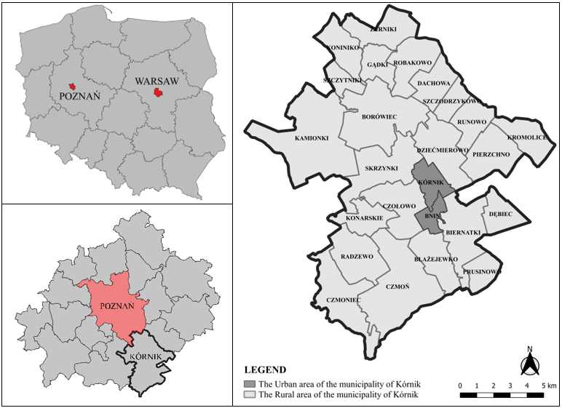
Fig. 1. Location of the study area

One railroad line no. 272 Kluczbork – Poznań Główny crosses the municipality of Kórnik. The intensity of train traffic on the line is moderate. During the week (Monday-Friday), there are, on average, 23 runs between Kórnik and Poznań, and at weekends the intensity is lower (17 runs). The line is managed by PKP Polskie Linie Kolejowe (Polish Railways), and its route is 200.90 km long and runs through two provinces: Opolskie and Wielkopolskie. It is worth noting that it is a fully electrified, double-track line with a width of 1435 mm, and the maximum speed for passenger trains on particular sections of the route is 120 km/h. In the study area, the line runs in the northern part of the municipality through the cadastral precincts: Pierzchno, Runowo, Szczodrzykowo, Borówiec, Robakowo, Gądki and Koninko (Fig. 2).
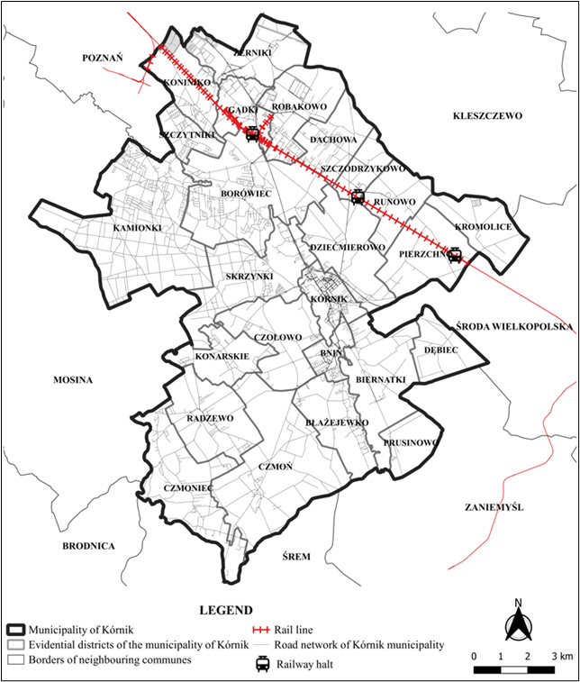
Fig. 2. Location of railroad infrastructure in Kórnik municipality
There are three halts in the Kórnik municipality: Pierzchno (passenger stop and branch station), Kórnik (passenger stop), and Gądki (station). It is worth noting that a part of the line's route runs short distances from nearby buildings, which may directly affect the local real estate market (Fig. 3).
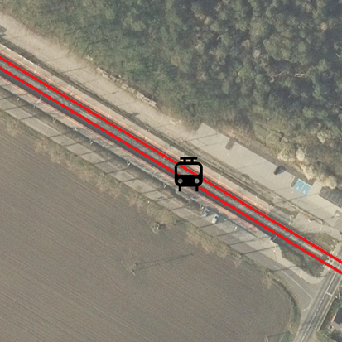  Kórnik halt (A) | 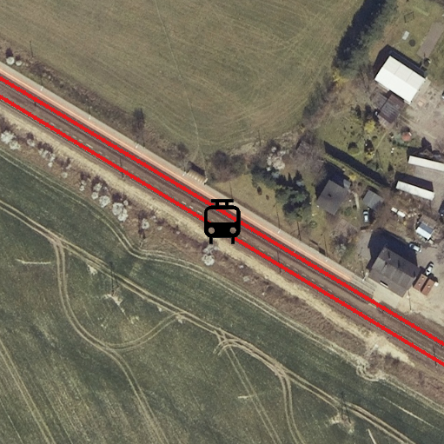  Pierzchno halt (B)
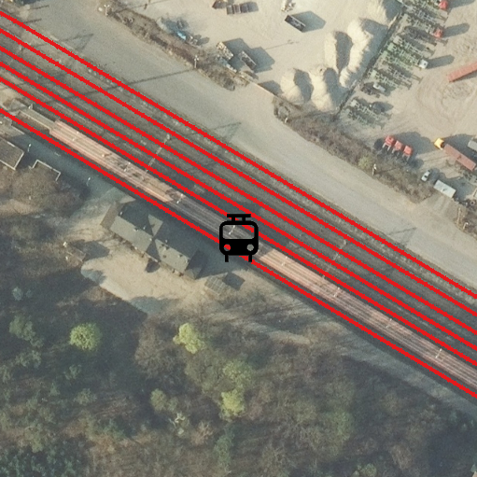  Gądki halt (C) | 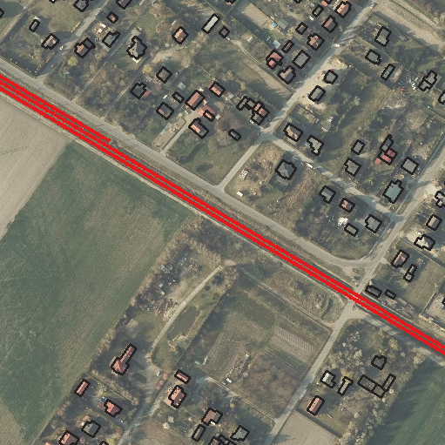  Buildings – Robakowo (D)
Fig. 3. Railway halts– Kórnik municipality
2.2. Study material
The study was conducted based on source data from the District Surveying and Cartographic Documentation Centre in Poznań. Collected data directly refer to market transactions of residential units, which were concluded in the area of Kórnik municipality in 2019-2021 – 737 transactions (Fig. 4). The information collected in the database in question formed the basis for the analyses performed to identify how rail transport affects the prices of residential properties. The structure of the database in question makes it possible to gather information on the essential characteristics associated with each listed property. It is, first of all, necessary for defining conditions of concluding transactions information connected with price and date of transaction, area of the apartment including an area of auxiliary rooms, location of the apartment on a floor in a building and function performed by a given housing unit.
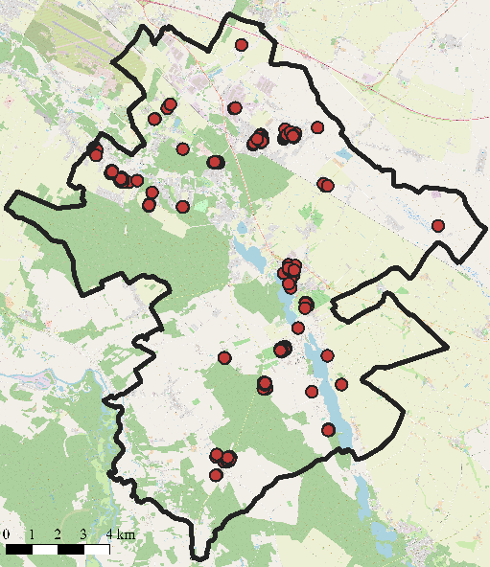  (a) | 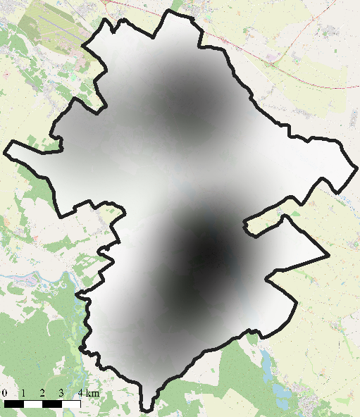  (b)
Fig. 4. (a) Location of housing units analysed. (b) Transaction density for the study area
The initial stage of analysis, carried out immediately after obtaining the source material, consisted of verification of the usefulness of the transaction data in terms of their applicability in the conducted research. As part of this process, properties whose sales transactions were carried out under non-market conditions were excluded from the database in question. In the analysed data group, this problem was most frequently related to transactions carried out for bailiff auctions and sales as part of enforcement proceedings.
The main advantage of such data recorded by public offices, such as PODGiK, is the fact that the information gathered in them comes directly from the real estate market. As a result, transactions recorded in appropriate registers based on notarial deeds constitute a reliable source of information on the mechanisms occurring within the given real estate market. The structure and characteristics of this type of data make it widely used in real estate market analyses, and, what is extremely important, its specificity makes it much more useful than the data coming from the offer market. However, a significant drawback of this database is the lack of complementarity in terms of precise characteristics of basic attributes influencing the apartment price. Factors such as the nearest environment's condition, the building's age or the apartment's finishing standard are not included in the register, which may lead to severe errors when formulating conclusions based only on information from the database in question. Concerning the presented problem, the analyses constituting the basis for the conducted research were supplemented with information related to, among others, the characteristics of the nearest neighbourhood obtained from other types of source materials (e.g. cadastral or topographic maps).
3. Research methodology
The innovative concept related to determining the influence of selected factors on the real estate price, the foundation of which is the hedonic pricing method (HPM), originated at the beginning of the 20th century. The first documented research based on HPM method concerned the modelling of agricultural land prices and was conducted according to G.A. Hass in 1922 (Colwell & Dilmore 1999). Over time, the method has become an increasingly popular tool in various real estate market analyses. It has been applied, among others, in the characterisation of the relationship between the price of residential property and the quality of the air (Coulson 2008). In the 20th century, the theoretical scope of this method was developed in a detailed and precise manner and formulated by subsequent authors (Lancaster 1966, Rosen 1974, Maclennan 1977).
According to the most critical assumption of the HPM method, the most essential task of the estimated model is to formulate an answer to the question: how do the attributes adopted for the model influence the real estate price? The assumption that several adopted attributes define the real estate price is the fundamental essence of HPM models. The model obtained based on the statistical procedure allows for defining the values of analysed explanatory variables, such as location or the floor, which, as a result, are the components of the explained variable (price). Finally, according to the presented assumptions, the price of the apartment can be presented in the form of a standard regression equation:
P = f(LN, T, H, e) (1)
where:
P – the equal price of the sold apartment,
LN – a combination of locational and neighbourhood characteristics,
T – a combination of characteristics related to transport characteristics,
H – a combination of characteristics related to the features of the dwelling,
e – standard error.
Additionally, in models of this type, the dependent variable, which is the unit price of the property, is usually defined by a standard logarithmic variable ln(cena). This change is necessary because of the need to satisfy the normality requirement of the distribution of the dependent variable. Given the above proviso, the estimated model can be specified by a multiple regression equation in the following form:
ln(cena) = β₀ + β₁ * X₁ + … +β_{n} * X_{n} + e (2)
where:
β₀ – fixed element, point of intersection of the regression line,
β_{1,} …, β_{n} – regression coefficients,
X₁, …, X_{n} – the value of selected attributes.
This study was carried out according to a specific methodology divided into seven basic stages.
- Selection of independent variables based on information obtained from real estate agencies.
- Initial characteristics of the observation.
- The final selection of the variables included in the analysis.
- Model estimation using global regression (Ordinary Least Squares).
- Identification of spatial autocorrelation of observations.
- Model estimation using local regression (Geographically Weighted Regression).
- Formulation of conclusions based on statistical analysis.
3.1. Ordinary Least Squares – Global Regression Analysis
One of the most frequently used regression techniques in real estate analysis is the Ordinary Least Squares (OLS) method. This technique is the basic method of linear modelling. According to the theoretical assumptions of this method, the relation between the explained variable and the explanatory variables can be presented with an ordinary straight line for which y values are estimated by x. According to the most essential assumption of the OLS method in the predicted model, the sum of squares of the errors of the estimated parameters should be as small as possible (Hutcheson 2019)., the global regression model can be presented in the following form, taking into account the above assumptions:
ln(Cena) = β₀ +$\sum_{i=1}^{K}{βi}Xi$ + e (3)
where:
ln(Cena) – the logarithmic unit price of the sold dwelling,
β – regression coefficient,
X – the value of the analysed characteristic,
e – standard error.
Typical statistical analysis methods, including the OLS regression technique, aim to define common relationships between the variables under study in different locations (Cao et al. 2019). However, it is essential to note that location-representative analyses cannot be performed using conventional methods, and typical OLS regression may not be sufficient to identify the determinants of real estate sales prices. An important issue is that the results obtained using the OLS method may be biased due to the heterogeneity of spatial relationships. Moreover, housing prices may be autocorrelated spatially in many cases. This feature is directly related to the standard behaviour of real estate market participants who, when putting an apartment up for sale, take into account transaction prices of similar dwelling units in the nearest neighbourhood. In addition, spatial autocorrelation may result from the fact that location and features related to the nearest neighbourhood may, in an analogous way, affect the prices of real estate in selected areas (Tomal 2020). The relationships defined in this way are confirmed in the case of the analysed data by the value of Moran's I test, which is statistically significant. The test value and the p-value indicate that real estate prices are spatially clustered and characterised by positive spatial autocorrelation (Table 1).

Table 1. Measures of spatial autocorrelation for the dwellings prices
Moran's Index | 0.508215
Expected Index | -0.001359
Variance | 0.000457
z-score | 23.825619
p-value | 0.000000

3.2. Geographically Weighted Regression – Local Regression Analysis
The geographically weighted regression (GWR) method was proposed in 1996 to address the problem arising from spatial dependence effects (Brunsdon et al. 1996). The GWR technique can be interpreted as an extension of the OLS global regression method with the proviso that GWR allows local parameter estimation based on samples within the bandwidth of a local location. As a result, the GWR model can be represented by the formula:
ln(Cena) = β₀ (x_{i},y_{i}) +$\sum_{i=1}^{K}{βi(xi,yi)}Xi$ + e (4)

where:
x_{i}, y_{i} – geographical coordinates of i^{th} point,
β₀(x_{i}, y_{i}) – site-specific intersection point,
β_{i}(x_{i}, y_{i}) – the location-specific coefficient for point i,
X_{i} – variable related to $βi(xi,yi)$,
K – number of estimated parameters,
e – standard error.
From the presented equations related to OLS and GWR regressions, the global model can be interpreted as a specific case of a local model. The main difference is the assumption that in the global model, the parameters are taken as constant, while the model based on GWR recognises the spatial variation of these parameters. A significant step in GWR regression execution is equation calibration, during which an assumption is made that data observed near the location of a given point have a more significant influence on the estimation of specific coefficients concerning observations located at a longer distance. The parameters of the estimated model using the GWR technique are estimated locally using the weighted least squares method, resulting in closer data being more significant concerning further observations (Fotheringham et al. 2003, Lin & Wen 2011). In conclusion, it can be said that the fundamental difference between OLS and GWR techniques is that the coefficients in the global model are fixed, whereas the coefficients in the local model are variable and depend on the location.
4. Results
In the first research stage, the independent variables accepted for analysis based on information obtained from real estate agencies were subjected to preliminary analysis. A prevalent problem in analyses of this type is the occurrence of multicollinearity between the adopted characteristics and skewness, which is a measure of the asymmetry of the analysed observations. In this study, attributes with a skewness value more significant than three were logarithmically transformed (Yang 2014). Next, OLS regression was estimated using which VIF (Variance Inflation Factor) values were calculated for the analysed attributes. Attributes with a VIF value greater than 7.5 were excluded from the final part of the analysis (Table 2).
In the initial stage, basic descriptive statistics such as mean, standard deviation, median, maximum and minimum values were defined for the general characterisation of the observations. Then, these statistics were formulated for both the dependent and explanatory variables (Table 3).

Table 2. Characteristics of qualitative and quantitative variables applied in the model
Feature | Symbol | Feature Description | Form
Price | P | Housing price (PLN/m²) | Logarithmic
Rooms | NR | Number of rooms | Standard
Water | DW | Distance to surface water (m) | Standard
Shop | DS | Distance to stores (m) | Variable deleted due to high VIF value
Forest | DF | Distance to a forest (m) | Standard
Center | DC | Distance to the centre of the Kórnik municipality (m) | Variable deleted due to high VIF value
School | DS | Distance to schools (m) | Standard
Poznań | DP | Distance to Poznań (m) | Variable deleted due to high VIF value
Park | DPark | Distance to parks (m) | Variable deleted due to high VIF value
Roads | DR | Distance to nearest main  or secondary road (m) | Standard
Rail | DRail | Distance to the railroad (m) | Standard
Busstop | DBS | Distance to a bus stop (m) | Standard
Surface | SA | Apartment surface (m²) | Logarithmic
Basement | BT | Accessible amenity space  (0 – no access,1 – access) | Standard
Age of building | AoB | Building age  (0 – building over 5 years,  1 – building less than 5 years) | Standard

Table 3. Descriptive statistics of dependent and independent variables
 | Mean | Median | Standard deviation | Max | Min
P (PLN/m²) | 5493.31 | 5486.25 | 484.39 | 6438.17 | 4447.07
NR (number of rooms) | 2.56 | 3.00 | 1.34 | 6.00 | 1.00
DW (m) | 464.84 | 483.82 | 247.56 | 953.54 | 23.66
DS (m) | 1660.81 | 689.53 | 1821.77 | 6069.35 | 13.05
DF (m) | 438.78 | 460.01 | 322.85 | 2329.12 | 0.00
DC (m) | 4938.38 | 5787.10 | 2469.75 | 9589.55 | 63.08
DS (m) | 593.98 | 420.98 | 535.45 | 4597.37 | 7.14
Table 3. cont.
 | Mean | Median | Standard deviation | Max | Min
DP (m) | 7332.98 | 8812.95 | 3897.31 | 13093.26 | 653.32
DPark (m) | 2682.09 | 2025.16 | 1882.03 | 6869.76 | 29.04
DR (m) | 350.00 | 255.02 | 315.57 | 1109.63 | 4.99
DRail (m) | 5045.59 | 4083.85 | 3579.19 | 11599.06 | 88.22
DBS (m) | 499.69 | 357.78 | 442.90 | 2094.62 | 1.45
SA (m²) | 190.56 | 70.89 | 2318.81 | 44666.00 | 14.49
BT (0 or 1) | 0.28 | 0.00 | 0.45 | 1.00 | 0.00
AoB (0 or 1) | 0.03 | 0.00 | 0.17 | 1.00 | 0.00

Based on the results obtained from the OLS global regression model, it can be concluded that most of the variables are statistically significant at p-value = 1%. The variables that are not statistically significant are NR, DW, DS and DR. The obtained model explains slightly more than 55% of the variability of the observed phenomenon. Generally, it should be remembered that negative values of coefficients (e.g. for the feature distance from surface waters – DW) in the case of attributes defined by distance measurements indicate a positive influence of a given feature on the price of analysed properties. Based on the coefficient for the attribute that is the most important from the point of view of the defined objective of the study, DRail (0.000053), we may conclude that the prices of properties located at a closer distance from the railroad line are relatively more minor concerning the prices of comparable properties located at a greater distance to this attribute (Tab. 4). In percentage terms, however, the price difference due to the change in the distance from the railroad line is small and amounts to 0.5% (the value of the DRail attribute changes by 0.5% with a change of 1.0 m).

Table 4. Summary of ordinary least squares (OLS) regression results
 | Coefficient | Standard error | T-value | P-value | VIF
Intercept | 8.678457 | 0.026777 | 324.101372 | 0.000000* | –
NR | - 0.000582 | 0.001840 | -0.316334 | 0.751851 | 1.256349
DW | -0.000011 | 0.000012 | -0.919074 | 0.358348 | 1.712105
DF | 0.000024 | 0.000008 | 2.909802 | 0.003734* | 1.400698
DS | -0.000005 | 0.000005 | -1.150948 | 0.250130 | 1.231048
DR | -0.000002 | 0.000009 | -0.227415 | 0.820165 | 1.823361
DRail | 0.000053 | 0.000010 | 5.555327 | 0.000000* | 3.652521

Table 4. cont.
 | Coefficient | Standard error | T-value | P-value | VIF
DBS | -0.000009 | 0.000001 | -5.911264 | 0.000000* | 5.865754
SA | -0.020480 | 0.005904 | -3.468595 | 0.000569* | 1.175111
BT | 0.115040 | 0.006268 | 18.354615 | 0.000000* | 1.616779
AoB | 0.066150 | 0.014016 | 4.719699 | 0.000004* | 1.118002
Number of Observations |  |  |  | 737
Multiple R-Squared |  |  |  | 0.5631
Adjusted R-Squared |  |  |  | 0.5571
AICc |  |  |  | -2045.25
* indicates p < 0.01
The results obtained from using geographically weighted regression (GWR) indicate a slight difference in the global regression (OLS) results. For the analysed research group in the case of GWR regression, the value of adjusted
R-Squared is 0.5724 (OLS: 0.5571), and the value of AICc is equal to -2068.15 (OLS: -2045.25) (Table 5). Based on these values, we can conclude that GWR for the analysed data group is characterised by minimally more efficient modelling quality.
The indisputable advantage of GWR regression over OLS regression is the ability to estimate variable coefficients both at the location of the observations themselves and at any other arbitrary location in the study area, even when no data are recorded there. The local coefficients of the DRail trait estimated for the properties analysed range from 0.000020 to 0.000054. Overall, the results confirm the negative impact of noise on housing prices. However, it is worth noting that the nature of noise pollution in different areas cannot be unambiguous, as the results of three research facilities located in Great Britain confirm (Blanco & Flindell 2011). It is worth noting that a different way of noise impact may occur mainly in the case of larger cities, where, despite the noise generated by transport infrastructure, the prices of dwellings located near railway stations or railway lines may be higher due to more convenient transport accessibility, which is confirmed by the results obtained, among others, in Hamburg (Brandt & Maennig 2012). Generally, with a few exceptions, observations located in the northern part of the community and those located near the railroad route had smaller coefficient values for DRail (Fig. 5).

Table 5. Summary of Geographically Weighted Regression (GWR) regression results
– regression coefficients
Variable | Mean | SD | Min | Max | Median | Mean Standard error
Intercept | 8.588652 | 0.017314 | 8.566629 | 8.621381 | 8.582384 | 0.015376
NR | -0.000685 | 0.001050 | -0.003259 | 0.000577 | -0.000830 | 0.002147
DW | -0.000015 | 0.000028 | -0.000053 | 0.000024 | -0.000010 | 0.000014
DF | 0.000017 | 0.000003 | 0.000009 | 0.000020 | 0.000018 | 0.000009
DS | -0.000011 | 0.000012 | -0.000026 | 0.000009 | -0.000016 | 0.000006
DR | 0.000009 | 0.000008 | -0.000005 | 0.000025 | 0.000014 | 0.000011
DRail | 0.000044 | 0.000008 | 0.000020 | 0.000054 | 0.000046 | 0.000001
DBS | -0.000007 | 0.000001 | -0.000008 | -0.000005 | -0.000007 | 0.000002
SA | 0.000001 | 0.000000 | 0.000000 | 0.000001 | 0.000001 | 0.000011
BT | 0.119689 | 0.013177 | 0.096406 | 0.139174 | 0.120963 | 0.007405
AoB | 0.067219 | 0.004199 | 0.057741 | 0.072577 | 0.068634 | 0.017513
Number of Observations |  |  |  | 737
Multiple R-Squared |  |  |  | 0.5841
Adjusted R-Squared |  |  |  | 0.5724
AICc |  |  |  | -2068.15

GWR analysis also allows us to determine a continuous surface within the examined area for which the values of particular coefficients can be estimated, as confirmed, i.a., by a study carried out in Olsztyn, a city in north-eastern Poland (Cellmer 2011). As a result of this phenomenon, it is possible to create complex maps that can provide valuable information for making critical decisions related to the development of housing infrastructure in a given region. In the next part of the paper, a thematic map was prepared, which includes local coefficients for Drail feature for the whole area, estimated based on GWR regression analysis results (Fig. 6).

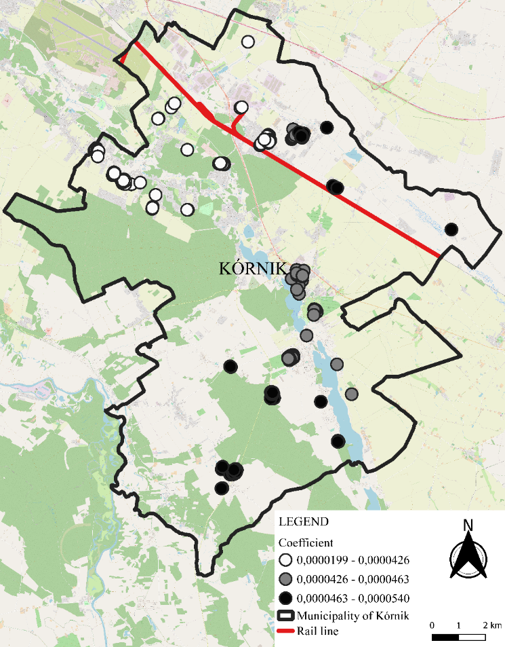
Fig. 5. Local coefficient estimates for Drail

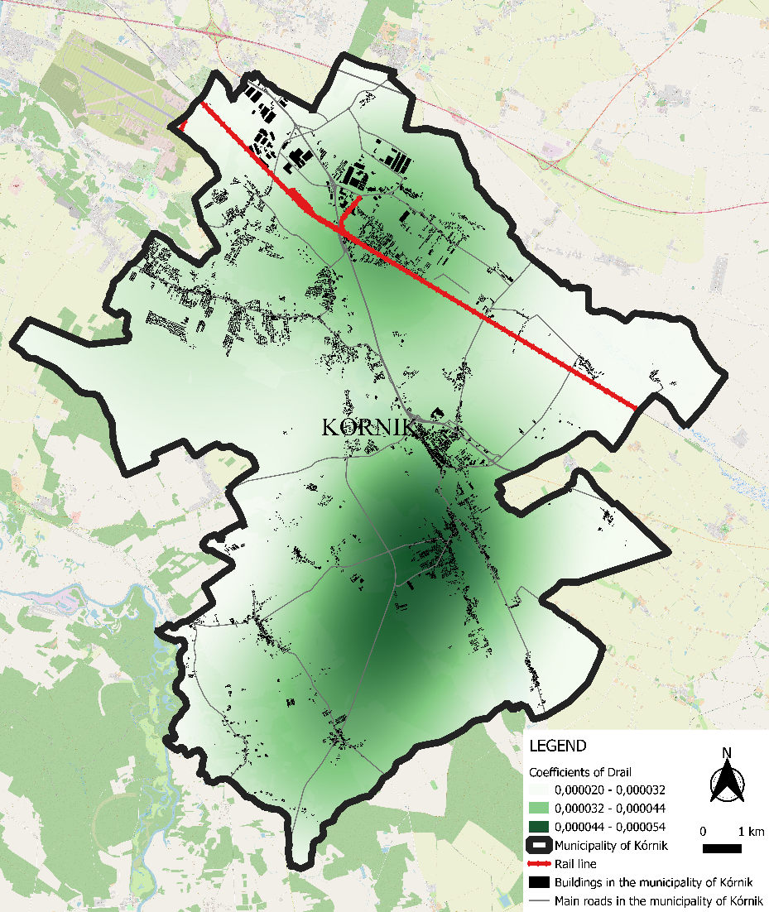
Fig. 6. Maps of local coefficient estimates of explanatory variables DRail
Within the study area, the effects of the feature under investigation are different and comparable to the effects of aircraft noise in the Polish capital Warsaw (Cellmer et al. 2019). The spatial distribution pattern of the Drail feature within the Kórnik municipality indicates a more substantial negative impact of this attribute on housing prices (lower coefficient value) in the municipality's northern part, situated close to the railroad line. For the central part of the gmina, where e.g. the town of Kórnik is located, the value of the coefficient is considerably higher, which proves that an increase in the distance from the railroad line to the other areas of the Kórnik municipality has a much stronger effect on the increase of residential property prices.
5. Discussion of the results
In our study, we applied the HPM method using OLS and GWR techniques. The study's most important objective was to examine how the proximity of a railroad line affects the prices of residential properties in the municipality of Kórnik, located within the boundaries of the Poznań district. Due to its location, issues related to the transport sector are of particular importance for the municipality of Kórnik from the point of view of both socio-economic development and increasing accessibility to efficient public transport. The total number of properties accepted for the analysis included 737 transactions, which were concluded between 2019 and 2021.
It is worth emphasising that the observations used in this study have the character of spatial data, which is extremely important in the context of the characteristics of issues related to the location defined, among others, by analysing spatial autocorrelation (Getis 2007). This problem is often not considered in preparing analyses, which can lead to an incorrect definition of local spatial dependencies. Spatial regression models (e.g. GWR), in comparison to standard regressions (OLS) take into account local spatial relationships, which consequently results in a much higher level of detail of results at the local level (Sheehan et al. 2013). Our findings directly confirm that the DRail feature coefficients are differentiated and non-uniform for the whole municipality area. Despite minor differences, it is worth noting that the analysed case study GWR model, compared to the OLS model, was characterised by higher accuracy, evidenced by the value of adjusted R2 and AICc. The obtained results confirm that rail transport can influence the mechanisms within the real estate market within certain limits. The results formulated in this study may indicate and set perspectives for developing public transport services and directions for housing intensification. It is also vital to emphasise that the conclusions resulting from this analysis may be applied not only to the commune of Kórnik itself but also to other administrative units comparable in socio-economic terms.
Despite the presented advantages of this study, it has, obviously, some limitations. Firstly, the analysis could be performed more comprehensively by collecting more precise information on the analysed properties. The inclusion in the study of additional characteristics related primarily to physical factors such as, among others, the standard of housing or the use of other types of methods could lead to a better fit of the built model (Manasa et al. 2020). Additionally, comparing the results with previous work from a comparable area and the determination of time series could enrich the obtained results with information about changes over time, which would contribute directly to the determination of changes in housing preferences among the population. In this context, the study is critical and constitutes a kind of reference point for future analyses.
6. Conclusions
- The results we obtained for the analysed area show that the presence of a railroad line negatively affects the prices of properties located in the immediate vicinity, most likely due to the emission of excessive communication noise.
- Due to spatial autocorrelation, the Geographically Weighted Regression (GWR) method has a legitimate application in real estate research.
- The method presented in the study may have some limitations due to, among other things, how the selected attributes interact with each other. For example, the way the attributes interact may be different due to the type and spatial extent of the real estate market. In addition, the impact of factors on price may vary over time due to a particular market's social and economic conditions.
References
Hayashi, Y., Ram, K.S., Bharule, S. (2020). Evaluation of Transport Infrastructure Impacts and their Implications for Quality of Life. Handbook on High-Speed Rail and Quality of Life, 527.
Podawca, K. & Staniszewski, R. (2019). Impact of Changes of the Permissible Railway Noise Levels. Rocznik Ochrona Środowiska, 21(2), 1378-1392.
Eckersten, S., Balfors, B., Gunnarsson-Östling, U. (2021). Challenges and opportunities in early stage planning of transport infrastructure projects: environmental aspects in the strategic choice of measures approach. Sustainability, 13(3), 1295. DOI: 10.3390/su13031295
Vijay, R., Sharma, A., Chakrabarti, T., Gupta, R. (2015). Assessment of honking impact on traffic noise in urban traffic environment of Nagpur, India. Journal of environmental health science and engineering, 13(1), 1-10. DOI: 10.1186/s40201-015-0164-4
Liang, J., Koo, K.M., Lee, C.L. (2021). Transportation infrastructure improvement and real estate value: impact of level crossing removal project on housing prices. Transportation, 48(6), 2969-3011. DOI: 10.1007/s11116-020-10157-1
Yang, L., Chau, K.W., Szeto, W.Y., Cui, X., Wang, X. (2020). Accessibility to transit, by transit, and property prices: Spatially varying relationships. Transportation Research Part D: Transport and Environment, 85, 102387. DOI: 10.1016/j.trd.2020.102387
Andersson, H., Jonsson, L., Ögren, M. (2010). Property prices and exposure to multiple noise sources: Hedonic regression with road and railway noise. Environmental and resource economics, 45(1), 73-89. DOI: 10.1007/s10640-009-9306-4
Berawi, M.A., Miraj, P., Saroji, G., Sari, M. (2020). Impact of rail transit station proximity to commercial property prices: utilising big data in urban real estate. Journal of Big Data, 7(1), 1-17. DOI: 10.1186/s40537-020-00348-z
Yang, L., Chen, Y., Xu, N., Zhao, R., Chau, K. W., Hong, S. (2020). Place-varying impacts of urban rail transit on property prices in Shenzhen, China: Insights for value capture. Sustainable Cities and Society, 58, 102140. DOI: 10.1016/j.scs.2020.102140
Cohen, J. P. & Brown, M. (2017). Does a new rail rapid transit line announcement affect various commercial property prices differently? Regional Science and Urban Economics, 66, 74-90. DOI: 10.1016/j.regsciurbeco.2017.05.006
Debrezion, G., Pels, E., Rietveld, P. (2011). The impact of rail transport on real estate prices: an empirical analysis of the Dutch housing market. Urban Studies, 48(5), 997-1015. DOI: 10.1177/0042098010371395
Behrends, S. (2012). The significance of the urban context for the sustainability performance of intermodal road-rail transport. Procedia-Social and Behavioral Sciences, 54, 375-386. DOI: 10.1016/j.sbspro.2012.09.757
Zielińska, E. (2017). Analiza rynku usług kolejowych w Polsce. Autobusy: technika, eksploatacja, systemy transportowe, 18.
Chwiałkowski, C. & Zydroń, A. (2022). The Impact of Urban Public Transport on Residential Transaction Prices: A Case Study of Poznań, Poland. ISPRS International Journal of Geo-Information, 11(2), 74. DOI: 10.3390/ijgi11020074
Batóg, J., Foryś, I., Gaca, R., Głuszak, M., Konowalczuk, J. (2019). Investigating the impact of airport noise and land use restrictions on house prices: Evidence from selected regional airports in Poland. Sustainability, 11(2), 412. DOI: 10.3390/su11020412
Lieske, S.N., van den Nouwelant, R., Han, H., Pettit, C. (2018). Modelling value uplift on future transport infrastructure. In Real Estate and GIS, 80-98. Routledge.
Liang, J., Koo, K.M., Lee, C.L. (2021). Transportation infrastructure improvement and real estate value: impact of level crossing removal project on housing prices. Transportation, 48(6), 2969-3011. DOI: 10.1007/s11116-020-10157-1
Colwell, P.F., & Dilmore, G. (1999). Who was first? An examination of an early hedonic study. Land Economics, 620-626. DOI: 10.2307/3147070
Coulson, E. (2008). Monograph on Hedonic Estimation and Housing Markets; Penn State University: State College, PA, USA.
Lancaster, K.J. (1966). A new approach to consumer theory. Journal of political economy, 74(2), 132-157. DOI: 10.1086/259131
Rosen, S. (1974). Hedonic prices and implicit markets: product differentiation in pure competition. Journal of political economy, 82(1), 34-55. DOI: 10.1086/ 260169
Maclennan, D. (1977). Some thoughts on the nature and purpose of house price studies. Urban Studies, 14(1), 59-71. DOI: 10.1080/00420987720080061
Hutcheson, G. (2019). GLM models and OLS regression.
Cao, K., Diao, M., Wu, B. (2019). A big data-based geographically weighted regression model for public housing prices: A case study in Singapore. Annals of the American Association of Geographers, 109(1), 173-186. DOI: 10.1080/24694452.2018.1470925
Tomal, M. (2020). Modelling housing rents using spatial autoregressive geographically weighted regression: A case study in Cracow, Poland. ISPRS International Journal of Geo-Information, 9(6), 346. DOI: 10.3390/ijgi9060346
Brunsdon, C., Fotheringham, A.S., Charlton, M.E. (1996). Geographically weighted regression: a method for exploring spatial nonstationarity. Geographical analysis, 28(4), 281-298. DOI: 10.1111/j.1538-4632.1996.tb00936.x
Fotheringham, A.S., Brunsdon, C., Charlton, M. (2003). Geographically weighted regression: the analysis of spatially varying relationships. John Wiley & Sons.
Lin, C.H. & Wen, T.H. (2011). Using geographically weighted regression (GWR) to explore spatial varying relationships of immature mosquitoes and human densities with the incidence of dengue. International journal of environmental research and public health, 8(7), 2798-2815. DOI: 10.3390/ijerph8072798
Yang, W. (2014). An extension of geographically weighted regression with flexible bandwidths (Doctoral dissertation, University of St Andrews).
Blanco, J.C. & Flindell, I. (2011). Property prices in urban areas affected by road traffic noise. Applied Acoustics, 72(4), 133-141. DOI: 10.1016/j.apacoust.2010.11.004
Brandt, S. & Maennig, W. (2012). The impact of rail access on condominium prices in Hamburg. Transportation, 39(5), 997-1017. DOI: 10.1007/s11116-011-9379-0
Cellmer, R. (2011). Spatial analysis of the effect of noise on the prices and value of residential real estates. Geomatics and Environmental Engineering, 5(4), 13-28.
Cellmer, R., Bełej, M., Konowalczuk, J. (2019). Impact of a vicinity of airport on the prices of single-family houses with the use of geospatial analysis. ISPRS International Journal of Geo-Information, 8(11), 471. DOI: 10.3390/ijgi8110471
Getis, A. (2007). Reflections on spatial autocorrelation. Regional Science and Urban Economics, 37(4), 491-496. DOI: 10.1016/j.regsciurbeco.2007.04.005
Sheehan, K.R., Strager, M.P., Welsh, S.A. (2013). Advantages of geographically weighted regression for modeling benthic substrate in two Greater Yellowstone ecosystem streams. Environmental Modeling & Assessment, 18(2), 209-219. DOI: 10.1007/s10666 -012-9334-2
Manasa, J., Gupta, R., Narahari, N. S. (2020). Machine learning based predicting house prices using regression techniques. In 2020 2nd International Conference on Innovative Mechanisms for Industry Applications (ICIMIA), 624-630. IEEE. DOI: 10.1109/ ICIMIA48430.2020.9074952

