 | Rocznik Ochrona Środowiska
 | Volume 24 | Year 2022 ISSN 2720-7501 | pp. 41-53
 | https://doi.org/10.54740/ros.2022.004 open access
 | Received: 20 April 2022 Accepted: 26 May 2022 Published: 14 November 2022
Identification of Environmental Pollution Sources
in a Selected Town in the Podlasie Region
Marta Iwona Bolińska*
Faculty of Construction and Environmental Sciences,
Białystok University of Technology, Poland
Anna Siemieniuk
Faculty of Construction and Environmental Sciences,
Białystok University of Technology, Poland
https://orcid.org/0000-0003-4005-4065
*corresponding author’s e-mail: bmarta275@gmail.com
Abstract: The environment is considered an ideal machine, a system in which nothing happens without reason. Every transformation, action and stimulus has consequences that are not always immediately plain to see. It is because the environment is like communicating vessels, or a complex organism, in which everything is interdependent, and the organs work together. Despite the processes’ complexity and intricate yet logical correlations between the elements, it is not a perfect system. Examples are weather anomalies and, in extreme cases, cataclysms. The problem arises when man interferes with the environment. By polluting almost every possible place, he initiates irreversible changes, degrading the environment. This paper presents an analysis of atmospheric air pollution in the town of Supraśl, surface water from the Supraśl river, and soil samples from a selected area.
Keywords: air pollution, surface water pollution, soil pollution
1. Introduction
Despite cataclysms, destruction and pollution of natural origin in the environment, life has survived and adapted to changing conditions. Plants have adapted to new atmospheric and soil conditions, waters, especially flowing waters, have self-cleaned, and animals have adapted to the new state of affairs to re-establish habitats. This is the result of evolution. When something is destroyed, its place is taken by more durable, intelligent individuals with better adaptive abilities. However, this takes place over hundreds of thousands of years. The problem arises when this time is taken away from the environment. This is due to human beings. They mark the places they have been. Plants do not grow on contaminated, dried-up soils, rivers are so polluted that they are closer to sewage than water, and lakes dry up and disappear. However, it is essential to know that these changes can be stopped or, at least, slowed down significantly. The basis for this is public education, monitoring and remedial action based on research findings.
2. Air pollution
The energy used in the environment to carry out life processes almost in one hundred per cent comes from the sun, from electromagnetic radiation (Juraszka & Dąbrowski 2011). Among them, we can distinguish ultraviolet radiation, which is harmful to human health – it can lead to skin changes and, consequently, to skin cancer (Falkowska & Korzeniewski 1995). We are protected from that by the ozonosphere, i.e. the ozone layer, which is constantly being depleted by anthropogenic activities, mainly by the emission of pollutants. However, ozone located in the troposphere is an air pollutant. It is found there due to the transformation of introduced pollutants such as carbon monoxide, methane and volatile organic compounds into the atmosphere under UV radiation (Seigneur 2019). Thus, air pollutants can be categorised into two groups (Juraszka & Dąbrowski 2011):
- primary – entered the atmospheric air directly from the source where they originated and have not changed their form; these include methane, sulphur dioxide, nitrogen oxide, or carbon monoxide;
- secondary – formed already in the atmosphere as a result of chemical reactions, e.g. reactions of analysis, synthesis, oxidation or reduction; as a general rule, they are more harmful than primary pollutants; they are formed as a result of interactions with atmospheric elements, such as moisture and sometimes through a mutual contact with one another; we may mention ozone, nitrogen dioxide or compounds of acidic nature formed after contact of nitrogen and sulphur oxides with water droplets.
3. Surface water pollution
The scale of the water pollution problem is significantly underestimated, especially considering essential statistical data. Fresh water is used for industrial, technical and household purposes. Animals and plants also consume it. However, only 2.5% of the hydrosphere’s water is fresh. In addition, some places and geographical areas are rich in freshwater, while others have widespread scarcity. For example, in Norway, there are 74.4 thousand m³ of water per capita; in Russia, 30 thousand m³ and in Poland, it is only about 1.5 thousand m³ (Wójcik 2020).
Contamination of surface water may be of natural and anthropogenic origin (Maciak 2003). However, drawing a specific, rigid border between them is much more difficult. Pollutants of anthropogenic origin can be directly introduced into receiving reservoirs through discharges, and can flow as leachate from landfills (Szyc 2003) or as leachate from agricultural fields (Wójcik 2020). In order to increase efficiency, a range of artificial fertilisers are used, as well as manures and slurry.
It is worth noting that surface water can become naturally polluted. Examples include soil and rock erosion, storms, tornadoes, and other phenomena (Maciak 2003). Unfortunately, their scale is microscopic compared to the damage caused by humans. Thus, anthropogenic sources can be divided into (Wójcik 2020): household and economic, industrial, precipitation and agricultural.
The most critical and common water pollutants include carbon dioxide, sulphur, nitrogen, phosphorus, mercury, lead, aluminium, iron, manganese, chlorine, calcium, magnesium, petroleum and petroleum-derived substances, pesticides, and phenols (Elbanowska et al. 1999).
4. Soil contamination
Soil consists of a combination of fractions with different particle diameters and organic matter, which is the basis of its fertility. It also contains water, many minerals, and organic substances, forming its crumbling structure (Paluch et al. 2001, Wójcik 2020). In addition, there are free spaces, so-called pores, which, depending on the soil, atmospheric conditions or geographical location, can be filled with air and water, which can contain pollutants. It also has sorption complexes, i.e. highly fragmented solid parts of the soil. These are mineral and organic particles, including humus, aluminosilicate minerals and metal hydroxides, primarily aluminium and iron. They give the soil its sorption properties, i.e. its ability to retain and absorb chemical substances, which may be pollutants such as nitrogen, phosphorus, calcium, magnesium, and potassium compounds, as well as pesticides, petroleum-derived and carcinogenic substances, sulphur compounds and lead, cadmium, copper, zinc, mercury or nickel (Paluch et al. 2001, Wójcik 2020).
5. Characteristics of the Supraśl township
The studies on air, water and soil were conducted in the town of Supraśl. It is a small town in Podlaskie Voivodeship. It is located on the North Podlasie Lowland (Kozłowska-Szczęsna 1995).
Supraśl is a small town of about 5,000 inhabitants (Walkowiak et al. 2009). It has a history of over 500 years. Initially, it was a monastery settlement where life revolved around an Eastern Orthodox church that had been built. Over time it grew, transformed into a village and then into a town of cloth-makers (Maroszek 2013), where the historic Weaver’s Houses can now be seen.
The primary source of air pollution on the territory of the town and municipality of Supraśl are residential buildings heated by solid fuels. Due to the town’s age and the fact that it is surrounded by rural and non-urbanised areas, old coal and wood cookers are very common. Incineration of waste paper and sometimes ordinary rubbish, including plastics, is a regular practice. However, the situation has improved over the years.
The Supraśl River is a source of drinking water for Białystok and the surrounding towns. The water is collected at the water treatment plant in Jurowce as infiltration water (from infiltration ponds, which are currently being modernised) and surface water (direct intake from the river).
6. Research methodology
6.1. Air testing methodology
In order to measure the PM10 and PM2.5 particulate matter concentrations in the air in Supraśl, five measurement locations were determined at the following places (Figure 1):
- point no. 1 – on Karola Chodkiewicza Street near the health resort hospital,
- point no. 2 – on Spółdzielcza Street where three ponds and a fishery are located,
- point no. 3 – at the corner of Majowa and Lewitówka streets;
where many buildings are before modernisation,
- point no. 4 – on Kościelna Street,
- point no. 5 – on Nowy Świat Street, on the edge of Supraśl, surrounded by forest.

Measurements of dust concentrations were conducted using a CEM DT-96 dust meter, model DT-96. Each measurement lasted 30 seconds and consisted of suction of air by the device from approximately 160 cm above ground level. The research was carried out in October and November 2021.

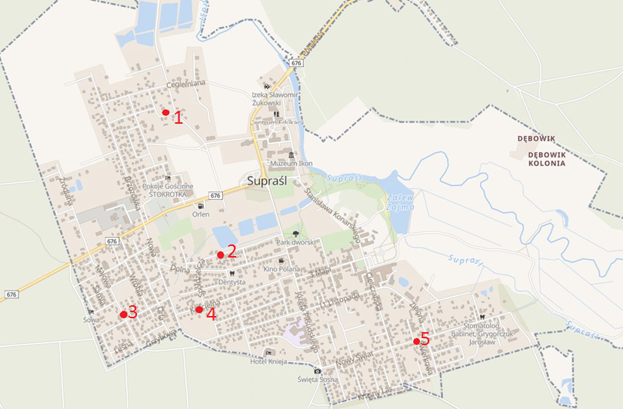
Fig. 1. Location of measurement and control points on the territory of the town of Supraśl; own study based on source (suprasl.e-mapa.net)

6.2. Water testing methodology
The source of surface water sampling was the Supraśl River flowing through the town of Supraśl. In order to take samples, three measurement points were determined following the course of the river (Figure 2):
- point no. 1 – located in the area before the water damming device on the river in front of the boulevard area,
- point no. 2 – located behind the bathing area,
- point no. 3 – located behind the boulevard area, under the bridge leading to Podsupraśl.

From each of them, 1.5 litres of water was sampled on 13 December 2021. The water was taken from places as close as possible to the centre of the riverbed, from a depth close to 0.5 m. This was done using a mounted container on a rigid boom, allowing the water to be drawn steadily and poured into 1.5-litre plastic bottles. The bottles were previously washed with water from the intake points. After filling them with water to the required volume and ensuring that no air bubbles had formed, the bottles were sealed by screwing on the cap.

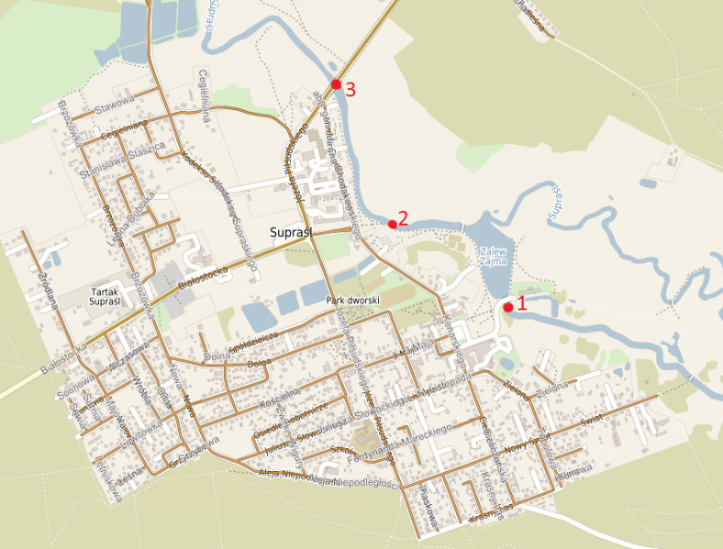
Fig. 2. Location of measurement points on the Supraśl River; own study based on source (polska.e-mapa.net)

The soil was collected from sampling point No. 2 in Spółdzielcza Street by manually uncovering the soil with a gardening shovel, with which the top layer of soil was removed and a sample weighing close to 100 g was dug out. The soil sample was prepared for analysis by shaking it in water, i.e. making an aqueous extract from the fragmented soil, under PN-EN 12457-4:2006 (Król 2012). First, the soil sample was shredded into grains with diameters less than 10 mm, which were then shaken with water for 24 hours, with a water-to-soil ratio of 10:1. This was done at room temperature, using a shaker that ensured constant movement of the mixture and prevented sedimentation of the soil particles at the bottom of the vessel by adjusting the speed accordingly. After shaking, the flask was removed from the shaker set aside for 15 min to allow the agitated soil particles to sediment to the bottom of the container. The resulting extract was filtered twice through a membrane filter with a pore size of 0.45 μm.
The resulting eluate was analysed in which colour, turbidity, conductivity, total hardness, calcium, magnesium, ammonium nitrogen, nitrate nitrogen, phosphates, iron, manganese and sulphates were determined using methods analogous to those used in the study of water from the Supraśl river.
7. Analysis of test results
7.1. Air tests results
Daily results of air quality tests were averaged for analysis and are illustrated in Figure 3. The lowest average value of particulate matter concentrations was recorded at point no. 1 on Chodkiewicza Street; it oscillated at 12 µg/m³ for PM2.5 and 27 µg/m³ for PM10. Slightly higher values were recorded at points no. 4 and 5. However, points no. 2 and no. 3 stood out against them. At point no. 3 at the corner of Majowa and Lewitówka Streets, regular exceeding of daily PM10 concentration was observed, according to the “Regulation of the Minister of Environment of 24 August 2012 on the level of certain substances in the air” amounts to 50 µg/m³. This resulted in an average concentration. The highest average concentration of dust was recorded at point 2 on Spółdzielcza Street. It results from the observed one-time very high result of the research (on 02.11.2021), where the concentration of PM2.5 dust was 398 µg/m³ and PM10 dust – 622 µg/m³.

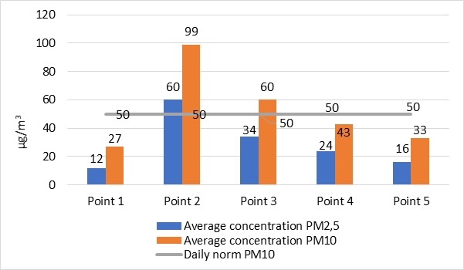
Fig. 3. Average concentrations of particulate matter in measurement points, own study
7.2. Supraśl River water tests results
Figures 4-6 present some of the tested parameters of water from the Supraśl River. They have been compared to the limit values defined in the “Regulation of the Minister of Maritime Economy and Inland Navigation of 11 October 2019 on the classification of ecological status, ecological potential and chemical status and the method of classifying the status of surface water bodies, as well as environmental quality standards for priority substances” for a lowland sandy stream, as the town of Supraśl is located on the North Podlasie Lowland and the bottom of the river is covered with sand.

The results of all water determinations made are presented in Table 1.

Table 1. Summary of analytical results of water samples from the Supraśl river
Determined parameter | Unit | Point 1 | Point 2 | Point 3
Colour | mg Pt/l | 47.00 | 45.00 | 54.00
Turbidity | NTU | 0.00 | 0.00 | 7.31
Dissolved oxygen | mg O₂/l | 8.86 | 8.10 | 7.70
Conductivity | µS/cm | 370.00 | 370.00 | 370.00
Reaction | pH | 7.92 | 7.90 | 7.83
Alkalinity | mg CaCO₃/l | 210.17 | 210.18 | 210.16
General water hardness | mg CaCO₃/l | 500.40 | 460.37 | 560.45
Calcium | mg Ca/l | 153.60 | 179.2 | 164.00
Magnesium | mg Mg/l | 28.41 | 3.14 | 36.68
Ammonium nitrogen | mg N-_{NH4}/l | 0.35 | 0.19 | 0.30
Nitrate nitrogen | mg N-_{NO3}/l | 3.00 | 7.50 | 17.00
Phosphates | mg PO₄/l | 6.40 | 5.50 | 4.40
Iron | mg Fe/l | 1.30 | 0.64 | 0.56
Manganese | mg Mn/l | 0.20 | 0.60 | 0.30
Sulphates | mg SO₄/l | 19.00 | 18.00 | 18.00
Source: Own study

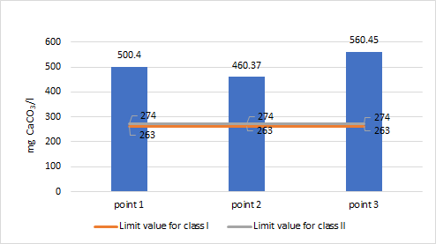
Fig. 4. Results of general water hardness tests at individual measurement points;
own study

Figure 4 shows that the lowest value of general water hardness was observed in point no. 2, reaching 460.37 mg CaCO₃/l. There is a significant difference between the previous point no. 1, where the total hardness was approximately 40 mg CaCO₃/l higher. The highest hardness value was measured at point no. 3, which was as high as 560.45 mg CaCO₃/l. The limit values were significantly exceeded at all points and at the last point, even doubled. It proves the high hardness of water, which is certainly reflected in its treatment at the water treatment plants in Wasilków and Pietrasze.

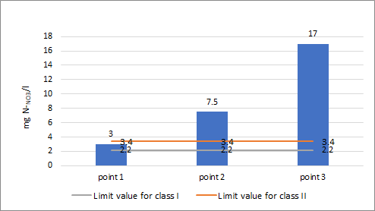
Fig. 5. Results of studies on nitrate nitrogen content in individual measurement points; own study

In the case of nitrate nitrogen results, a clear difference can be observed between measurement points. The lowest content was observed at point no. 1, equal to 3 mg N-_{NO3}/l. It is also the only point from which water samples qualify for water quality class II. In other cases, the values exceed the limits specified by the regulation. They are 7.5 mg N-_{NO3}/l at point 2 and the highest at point 3, as much as 17 mg N-_{NO3}/l. The marked increase in nitrate nitrogen may be related to the slowing river current and its slow accumulation. Above all, however, it indicates contamination of the river, probably by run-off from fields and its gradual eutrophication.

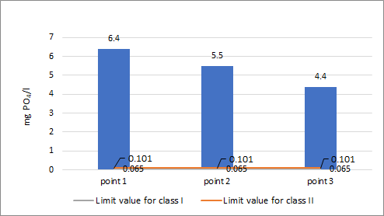
Fig. 6. Results of phosphates content in individual measurement points; own study

The results of phosphates content in the studied samples exceed the limiting values forty times for the lowest observed concentration for point no. 3 equal to 4.4 mg PO₄/l. In point no. 2 the content of phosphates is 5.5 mg PO₄/l, and in point no. 1 its highest concentration of 6.4 mg PO₄/l was found, which exceeds the limit value for class II by over 60 times. It is a clear signal of the eutrophication of the watercourse and its pollution. The decrease in phosphate content at each of the subsequent points is due to a decrease in water velocity in the river, which allows phosphates to precipitate into insoluble forms and to fall so that they can settle and accumulate in bottom sediments.
7.3. Soil test results
The soil was analysed from air quality measurement and control point no. 2 on Spółdzielcza Street. To discuss the results and for clarity and differentiation of measurement points, the soil sampling point was named point 2’. Figures 7-8 show the selected parameters tested. The results of all performed soil determinations are presented in Table 2.

Table 2. Summary of soil analysis results from the measurement point on Spółdzielcza Street, own study
Determined parameter | Unit | Point 2’
Colour | mg Pt/l | 850.00
Turbidity | NTU | 0.00
Conductivity | µS/cm | 260.00
Reaction | pH | 8.05
General eluate hardness | mg CaCO₃/l | 420.34
Table 2. cont.
Determined parameter | Unit | Point 2’
Calcium | mg Ca/l | 167.82
Magnesium | mg Mg/l | 15.74
Ammonium nitrogen | mg N-_{NH4}/l | 1.34
Nitrate nitrogen | mg N-_{NO3}/l | 11.90
Phosphates | mg PO₄/l | 32.60
Iron | mg Fe/l | 2.83
Manganese | mg Mn/l | 1.30
Sulphates | mg SO₄/l | 22.00

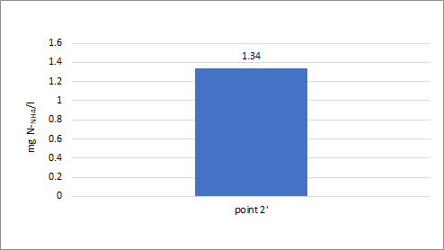
Fig. 7. Results of ammonium nitrogen content in a soil sample; own study

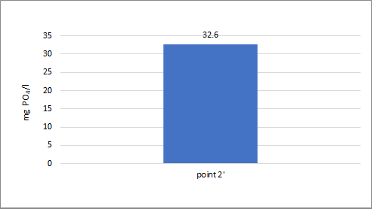
Fig. 8. Results of phosphate content in a soil sample; own study
The eluate had a total ammonia nitrogen content of 1.34 mg N-_{NH4}/l. Such value may be caused by a lack of fresh organic matter, which would be subjected to the processes of decay and rotting by microorganisms, or to the inhibition of this process in late autumn, with a significant drop in temperature.
A significant phosphate content characterised the soil sample. It was equal to 32.6 mg PO₄/l. It is a consequence of using “Polifoska” fertiliser in granules, which is popular among the Supraśl residents and contains mainly phosphorus, as the name suggests. As compared to unfertilised soils, an increased level of phosphates indicates that this fertiliser was used in excessive quantities, which accumulated instead of being absorbed by plants (grass).
8. Conclusions
The presented results of the study show that the Supraśl River is in bad condition. Alarming signals were found, which are, first of all, very high general water hardness, which is connected with exceeding the calcium and magnesium content and alarming amounts of nitrate nitrogen and phosphates. It seems to confirm widespread rumours of the river being polluted by run-off from agricultural fields at the level of the town of Gródek. It is alarming that increased levels of the above substances persist long after the end of the vegetation period. It means that there is a real risk of the situation related to the summer oxygen deficiency in 2021 repeating itself. On the other hand, significantly increased amounts of nitrate nitrogen and phosphates indicate the beginning of the eutrophication of the river. If run-off from fields and high temperatures in summer will happen again on a similar scale, the vision of further degradation of the watercourse is realistic.
Soil taken from the measuring point on Spółdzielcza Street is in a similar condition. A severe problem observed is probably improper, excessive fertilisation. It is indicated by the high total hardness of the eluate, high calcium, nitrate nitrogen, phosphate and sulphate content. Therefore, soil fertilisation practices should be changed, i.e. the use of ‘NPK’ fertilisers should be reduced, and some chelate fertilisers containing iron and manganese should be introduced. It would ensure the rich, dark green grass desired by the inhabitants of Supraśl.
In the case of air, its best quality was observed at measuring point no. 1 on Chodkiewicza Street, and regularly the worst at point no. 3 on Lewitówka Street. Since Supraśl has the status of a health resort and there is a health resort hospital, educational activities should be intensified among the residents of the town of Supraśl and the entire commune. Furthermore, information campaigns and subsidies for renewable energy sources should also be resumed, which could further improve the inhabitants’ air quality and environmental awareness.

Printing of the article was financed by the project: “PB2020 – Integrated Development Programme of Bialystok University of Technology”. – POWR.03.05-00-00-Z220/17
Project co-financed by the European Union under the European Social Fund as part of the Operational Programme Knowledge, Education and Development 2014-2020.
References
Elbanowska, H., Zerbe, J., Siepak, J. (1999). Physical and chemical testing of water. (Fizyczno-chemiczne badania wód). Wydawnictwo naukowe UAM. Poznań.
Falkowska, L., Korzeniewski, K. (1999). Chemistry of the atmosphere (Chemia atmosfery). Wydawnictwo Uniwersytetu Gdańskiego. Gdańsk.
Juraszka, B., Dąbrowski, T. (2011). Fundamentals of atmosphere protection (Podstawy ochrony atmosfery). Wydawnictwo Uczelniane Politechniki Koszalińskiej, Koszalin.
Kozłowska-Szczęsna, T., Krawczyk, B., Błażejczyk, K. (1995). Bioclimatic conditions of Supraśl (Warunki Bioklimatyczne Supraśla). Zeszyty Instytutu Geografii i Przestrzennego Zagospodarowania, 33. Instytut Geografii i Przestrzennego Zagospodarowania PAN.
Król, A. (2012). Release of heavy metals from mineral composites with consideration of environmental impact. (Uwalnianie metali ciężkich z kompozytów mineralnych z uwzględnieniem oddziaływania środowiska). Studia i Monografie, 314. Politechnika Opolska.
Maciak, F. (2003). Protection and reclamation of the environment (Ochrona i rekultywacja środowiska). Wydawnictwo SGGW, Warszawa.
Maroszek, J. (2013). Monograph of the town and commune of Supraśl (Monografia miasta i gminy Supraśl). Urząd Miasta Supraśl.
Paluch, J., Pulikowski, K., Trybała, M. (2001). Water and soil protection (Ochrona wód i gleb). Wydawnictwo Akademii Rolniczej we Wrocławiu. Wrocław.
Seigneur, C. (2019). Air Pollution. Concepts, Theory, and Applications. Cambridge University Press.
Szyc, J. (2003). Leachate from municipal waste landfills (Odcieki ze składowisk odpadów komunalnych). Monografia Instytut Ochrony Środowiska, Warszawa.
Walkowiak, K., Grabowska-Szaniec, A., Śmielecka, M., Bartłomiejczak, W., Piecuch, N., Smakulski, J., Smakulski, B., Jęścko, M. (2009). Health Resort Operation of the Supraśl Municipality (Operat Uzdrowiskowy Gminy Supraśl). Poznań.
Wójcik, J. (2020). Anthropogenic changes in the Earth's environment (Antropogeniczne zmiany środowiska przyrodniczego Ziemi). PWN. Warszawa.

