 | Rocznik Ochrona Środowiska
 | Volume 25 | Year 2023 ISSN 2720-7501 | pp. 374-382
 | https://doi.org/10.54740/ros.2023.038 open access
 | Received: December 2023 Accepted: December 2023 Published: December 2023
Transformation of Municipal Waste Management in Poland Towards a Circular Economy
Józef Ciuła¹, Wioletta Bajdur², Anna Gronba-Chyła^{3*}, Paweł Kwaśnicki⁴
¹Faculty of Engineering Sciences, State University of Applied Sciences in Nowy Sącz, Poland
https://orcid.org/0000-0002-9184-9282
²Department of Innovation and Safety Management Systems Faculty of Management,
Czestochowa University of Technology, Poland
https://orcid.org/0000-0003-4328-6099
³Faculty of Natural and Technical Sciences, John Paul II Catholic University of Lublin, Poland
https://orcid.org/0000-0002-0976-7553
⁴Faculty of Natural and Technical Sciences, John Paul II Catholic University of Lublin, Poland
https://orcid.org/0000-0002-2103-0917
*corresponding author's e-mail: amgronba@kul.pl
Abstract: Municipal waste management in Poland has continuously changed over the past years regarding collection systems and disposal processes. After joining the EU, the approach to waste management changed dramatically, intensifying selective collection and implementing recovery and treatment processes. Recent years have shown that a further fundamental overhaul in the waste sector is needed to convert the sector to a closed-loop economy. These challenges are appearing in Poland, forcing actions in which the efficiency of the waste stream management system should generate added value in the form of sourced raw materials, materials and products. The waste generated should be managed following the waste hierarchy, in which disposal is the least desirable process. The work aims to analyse the current state of municipal waste management in Poland concerning applicable legal requirements, waste management hierarchy and the use of the best available technologies. The data from the analysis was used to determine where Poland is currently, heading towards transforming to a circular economy in the technological, social, environmental and economic areas. The research results showed the need to reduce the waste generated, including a significant reduction in the amount of waste stored in landfills and a significant increase in the recycling rates of municipal waste. In this context, supporting the transition to a closed-loop economy is essential in creating a low-carbon, recycling and innovative waste management, implementing EU strategies.
Keywords: municipal waste, bio-waste, packaging waste, waste incineration, waste recycling, circular economy
1. Introduction
Waste generation is an intrinsic feature of human economic activity, while its collection and processing is becoming a major challenge for individual societies and economies. The need for comprehensive waste management arising from implementing a closed-loop economy has emerged responding to the need to save resources and reduce the space required for waste disposal and processing (Marques & Teixeira 2022). European Union directives on municipal waste implemented into the Polish legal system define municipal waste as waste generated in households, as well as non-hazardous waste from other waste generators, which, due to its nature or composition, is similar to waste generated in households (Act 2013, Directive 2008). Depending on where it is generated, municipal waste is characterised by different morphology, accumulation rate and quality. Waste generated in rural areas and urban fringe regions shows a higher content of mineral fractions than in urban agglomerations (Przydatek & Basta 2019, Prędecka 2019). Biodegradable waste, on the other hand, dominates the composition of waste from urban areas, where there is also a greater amount of potential recyclable materials collected selectively as material for recycling (Sláviková et al. 2022, Ciuła et al. 2023).
The main goal in municipal waste management is the absolute application of the waste hierarchy, in which the most important is the prevention and minimisation of waste generation, followed by design with recycling, recovery of qualitatively valuable secondary use materials and, as a last resort, disposal safe for health and the environment (Kang et al. 2023, Kwaśnicki et al. 2023). A modern approach to municipal waste management requires a comprehensive treatment of the issue, considering economics, ecology, and the conditions of local communities (Su et al. 2023, Wiewiórska 2023a). The comprehensiveness of solutions should characterise the handling of municipal waste. These wastes have material and energy value, which should be utilised without fail, determining the choice of methods for their treatment and disposal, considering ecological, economic and social conditions (Bajdur et al. 2017, Senetra et al.2019). All these activities should be aimed at achieving the goal of shifting national economies in the European Union towards a Green Deal, promoting the reduction of greenhouse gas emissions, mainly methane and carbon dioxide, by optimising waste management and the waste supply chain (Oukili &Chhiba 2023, Mihaliková et al. 2020). Reducing waste generation seems potentially the most effective way to address the problem of the amount of municipal waste generated. Currently, this trend is limited to consumer behaviour at the level of households and other waste generators. In contrast, to a limited extent, it concerns the production process of the finished product itself, which should implement innovative material technologies (He et al. 2022, Wiewiórska 2023b). These activities in municipal waste management have been an area of particular interest to Europeans for years, in the context of transforming the economies of individual countries, including Poland, towards a closed-loop economy (Kowalski et al. 2022).
The European Union is pursuing a closed-loop economy model, which concerns the negative environmental impact of municipal waste and the need to find new raw materials for the primary production of products and packaging. It directly correlates with recycling and reusing waste for production, reducing current material resources (Generowicz et al. 2023, Gronba-Chyła et al. 2022). Municipal waste contains different amounts of bio-waste depending on where it is generated. Bio-waste appears as a potential material for biological recycling through aerobic and anaerobic processes (Graz & Kwaśny 2021). The resulting products of these processes, i.e. compost and biogas, close the waste loop in terms of material (organic fertiliser) and energy (energy generation from biogas) (Sendilvadivelu et al. 2022, Makara et al., 2016; Makara et al. 2021). Municipal waste is also a valuable fuel source for power and heat generation facilities for municipal utility systems, complementing the existing volume. The waste generated in this process (ash and dust) is used in the recycling process to produce construction materials or the reclama brownfield sites (Kumar & Singh 2023). Thermal conversion of municipal waste on a massive scale is currently one of the most important technologies used in municipal waste management in the world's most industrialised countries (Kowalski et al. 2010, Pavliuk et al. 2022). New plants being built will replace those that are outdated and do not meet the conditions of the Industrial Emissions Directive (IED), the Medium Combustion Plants Directive (MCPD), and the BAT Conclusions for coal-fired boilers (Włodarczyk-Makuła et al. 2021, Voss et al. 2021). The least desirable process in the hierarchy of handling municipal waste is its disposal by landfilling in landfills of a particular type. It includes waste with no value as a potential recycling material and no energy value as a fuel source (Oukili et al. 2022). Landfilling is potentially associated with negative environmental impacts of the landfill as a waste disposal facility (Ciuła 2022). In this process, wastewater is generated, requiring intake and treatment to protect groundwater and surface water, and greenhouse gas emissions (carbon dioxide and methane) from the landfill surface occur. Biogas should be captured, purified and used for energy purposes in cogeneration systems, powering gas engines that drive generators (Balcerzak et al. 2014, Wysowska et al. 2022). The waste hierarchy implementation aims to direct waste from lower levels in the hierarchy (such as landfilling) to higher levels, such as energy recovery and recycling (Generowicz et al. 2011, Gaska et al. 2021). Performed analyses of municipal waste management methods in selected European Union countries have shown that the ban on landfilling, introduced in these countries, translates directly into the amount of waste incinerated with energy recovery and recycling. These activities are part of realising a closed-loop economy and waste-free technologies (Malek et al. 2023).
This article aims to analyse the current state and prospects of waste management in Poland towards a closed-loop economy by examining documents including statistical data, local databases, market research reports, strategies, forecasts and waste management plans.
2. Materials and Methods
A study of documents, including statistical data, local databases, market research reports, strategies, forecasts and waste management plans, was applied to analyse the current state and prospects of waste management in Poland towards a closed-loop economy. A review of current legal acts at the European Union level, national level, and local laws was performed. Based on available publications, a literature review of applied technologies, processes and trends in waste management was performed, analysing the latest publications of the last 4 years.
Poland's municipal waste management system is based on the principles set forth in the Act on Maintaining Cleanliness and Order in Municipalities (Act 1996). According to this law, municipalities ensure cleanliness and order on their territory and create the conditions necessary for their maintenance. The municipality organises and controls the waste management system on its territory, being equipped with a financial instrument in the form of a fee paid by the resident for waste management. It considers the costs of waste collection, transportation, recovery (including recycling) and disposal of municipal waste following the waste hierarchy (Regulation 2018). In 2021, Poland generated 13,673.6 thousand tons of municipal waste, 4.2% more than the previous year. On average, there were 360 kg of generated municipal waste per Polish resident (16 kg more than the previous year), with 409 kg in cities (17 kg more than the previous year) and 288 kg in rural areas (16 kg more than the previous year) (Statistic 2021). Waste disposal by residents in European Union countries is shown in Figure 1 (Statistic 2022).

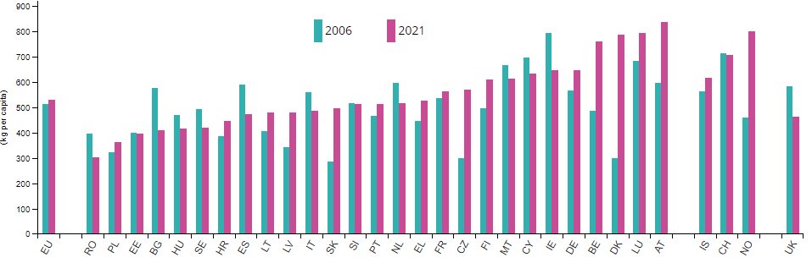
Fig. 1. Municipal waste generated per capita in the EU in 2006 and 2021

The leader in the amount of waste generated per capita in Europe is Austria, with a result of 834 kg per capita, against the EU average value of 530 kg (Eurostat 2023). Against these figures, Poland's amount of waste generated per capita is among the lowest, which does not translate into segregated waste collection levels. The generation of mixed and segregated municipal waste in Poland per capita in 2010-2021 is presented in Figure 2 (Statistic 2022).

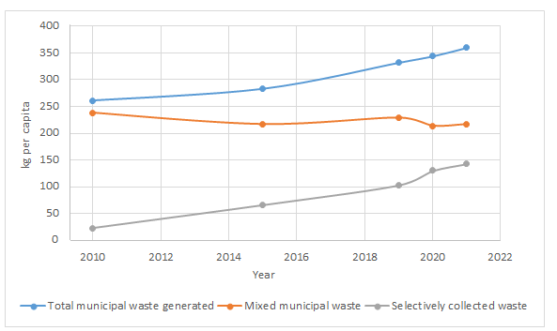
Fig. 2. Generation of municipal waste in Poland per capita in 2010-2021

In 2021, there was an increase in the share of waste collected and collected selectively in the total amount of municipal waste generated to 39.8% from 37.9% in 2020. The total weight of selectively collected waste increased from about 4,975 thousand tons in 2020 to about 5,440 thousand tons in 2021. (o 9,3%). There were about 143 kg of selectively collected municipal waste per capita in Poland (130 kg a year earlier), with 158 kg in urban areas and 122 kg in rural areas (145 kg and 109 kg, respectively, a year earlier).
More than half (60.0%) of the municipal waste generated in 2021 was destined for recovery 8,207.0 thousand tons), of which about 3,680.7 thousand tons of municipal waste was destined for recycling (26.9% of the amount of municipal waste generated). A total of 1,824,300 tons of municipal waste was directed to biological treatment processes (composting or digestion). These were mainly green waste from gardens, parks and cemeteries, marketplaces, biodegradable kitchen and food service waste (Statistic 2021, Waste plan 2023). 2,702.0 thousand tons of municipal waste, accounting for 19.8% of the total amount of municipal waste, were sent for thermal conversion with energy recovery. In 2020, 2,656.2 thousand tons of municipal waste generated were directed to this recovery form. A total of 5,466.6 thousand tons of municipal waste (40.0% of the total amount of municipal waste generated) were directed to disposal processes, of which 5,295.8 thousand tons (38.7% of total waste generated) were sent to landfills, and 170.8 thousand tons (1.2% of total waste generated) were sent to thermal conversion without energy recovery. In 2020, waste disposed of by landfilling accounted for 39.8% of total municipal waste generated (Waste plan 2023, Szczepański et al. 2022, Report 2022). Processing of municipal waste in Poland from 2010 to 2012, is shown in Table 1 (Statistic 2021).

Table 1. Municipal waste treatment processes
Type of process | 2010 | 2015 | 2019 | 2020 | 2021
 | [thous. Mg]
Materials recycling | 1783 | 2867 | 3192 | 3499 | 3681
Organic recycling (composting and fermentation) | 181 | 661 | 1153 | 1578 | 1824
Thermal processing with energy recovery | - | 1318 | 2742 | 2656 | 2702
Landfilling | 8037 | 5897 | 5487 | 5218 | 5296
Thermal processing without energy recovery | 39 | 121 | 179 | 166 | 171

Sorting (treatment) municipal waste from the selective collection included processing paper, plastics, metals, and multi-material waste. It was carried out in 285 installations with a total capacity at two-shift operation of about 300 thousand Mg annually. On the other hand, with regard to the processing of selectively collected bio-waste, in 2021 220 installations were processing green waste and other bio-waste in aerobic processes, with a total capacity of 1803 thousand Mg. In 2021, 9 bio-waste digestion installations were in operation, with a capacity of about 210 thousand Mg per year and an installed electrical capacity of generators of 7.7MWh. 8 installations process the separated fraction from non-segregated (mixed) municipal waste. The capacity for the fraction separated from non-segregated (mixed) municipal waste is currently 180 thousand Mg/year. For one installation dedicated to selectively collected bio-waste, it is 30 thousand Mg/year. The average sieve composition of municipal waste processed by MBP plants is presented in Figure 3.

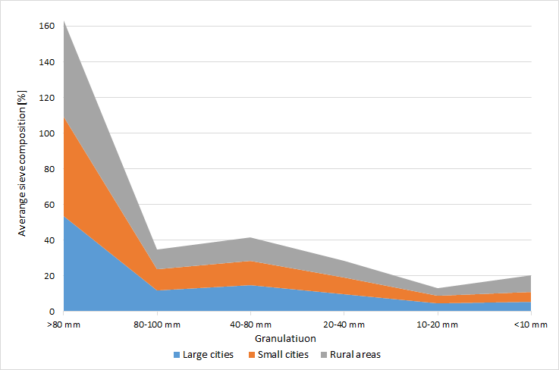
Fig. 3. The average sieve composition of municipal waste processed by MBP plants in 2021 year in Poland

Mixed municipal waste collected from the generating entity must be subjected to mechanical-biological processing in installations dedicated to this process. In 2021, 174 installations for mechanical-biological processing of non-segregated (mixed) municipal waste were in operation in Poland. The national capacity allows for treating mixed waste of 8,521 thousand Mg/year. The capacity for the biological part of the MBP is, according to integrated permits, about 5,300 thousand Mg/year, which makes it possible to process the 0-80 mm fraction stream from mixed waste (defined in the assumptions as 50% of the mixed waste stream) (Waste plan 2023, Szczepański et al. 2022). In recent years, there has been a dynamic increase in the amount of mixed municipal waste processed thermally with energy recovery due to the construction of new incineration facilities co-financed by the European Union under operational programs. Currently, 8 installations are in operation for the thermal processing of non-segregated (mixed) municipal waste and municipal waste processing residues, with a total capacity of 1,185,000 Mg annually. At the end of 2021, 265 active landfills were accepting municipal waste. These landfills covered a total area of 1,667.2 hectares. Waste collected selectively and cleaned through sorting is the primary input material for material recycling. This waste is processed at 14 paper waste recycling facilities, 17 glass waste recycling facilities, 22 metal waste recycling facilities and more than 400 plastic recycling facilities. The total capacity of plastic waste recycling facilities in 2021 was about 2.0 million Mg of waste per year. These are the processing capacity figures included in waste recovery permits (Waste plan 2023, Statistic 2021, Szczepański et al. 2022).
3. Results and Discussion
In the coming years, municipal waste management in Poland will be forced to undergo a thorough transformation towards a closed-loop economy (CE), resulting in changes in the existing waste handling, especially in the technological, social, environmental, and economic areas. Creating an economy that fully implements the GOZ approach will require intensifying waste prevention efforts and managing as much municipal waste as possible through recycling processes. The latter, in turn, requires that waste be collected selectively and be of good quality. Table 2 shows the forecast of waste generation in Poland from 2025 to 2030, based on the National Waste Management Plan (Szczepański et al. 2022).

Table 2. Forecast of waste generation in Poland in 2025-2030
Year | Population [thous.] | Total mass of waste  [thousand Mg/year] | Unit rate per capita [kg∙year⁻¹]
2025 | 38,073.9 | 15,538.0 | 408.1
2030 | 37,640.4 | 16,998.4 | 451.6
2035 | 37 046,5 | 18 052,8 | 487.3
2040 | 36,402.7 | 19,020.4 | 522.5

The quality of municipal waste consists particularly of its cleanliness, understood as not being contaminated with other types of waste. However, the need to achieve very high levels in this regard, resulting from the amendments to the 3 waste directives adopted in 2018, requires further systemic changes. Therefore, an assessment and proposals for changes in the system in operation will be required. Reducing the level of waste landfills could be one of the flywheels for the development of the Polish economy, especially from the point of view of reducing the demand for primary raw materials in favour of greater use of secondary raw materials (Roadmap 2019). The issued amendments result from implementing EU legal acts into the Polish legal system. It includes, in particular, three directives: the Directive of the European Parliament and the Council (EU) 2018/851 of May 30, 2018 on waste (Directive 2018a), the Directive of the European Parliament and the Council (EU) 2018/850 of May 30, 2018 on the landfill of waste (Directive 2018b), and the Directive of the European Parliament and the Council (EU) 2018/852 of May 30, 2018 on packaging and packaging waste (Directive 2018c). Regarding recycling levels for packaging waste, minimum values and dates for achieving these targets have been set. Summaries, including specific dates, are shown in Table 3 (Directive 2018c).
The emerging need for optimal management of municipal waste resulting from the implementation of legal requirements for packaging and packaging waste provides for a significant increase in recycling levels of packaging waste. It applies to waste with a significant share of municipal waste, from 2025 to 50% by weight for plastic waste, 70% for glass and 75% for paper, and 2030 to 55% for plastic waste, 75% for glass and 85% for paper. The recycling levels required to be achieved, presented in Figure 4, appear to be a serious challenge for the Polish packaging waste recovery and processing sector.

Table 3. Types of packaging waste and dates of achievement of required recycling levels
Type  of waste | Minimum value of all types  of packaging waste by weight in % | Date of achievement of minimum values | Minimum recycling targets for the following materials contained in packaging waste specified by weight in %
 |  |  | Plastics | Wood waste | Ferrous metals | Aluminium | Glass | Paper and cardboard
Recycled packaging waste | 65 | until December 31, 2025 | 50 | 25 | 70 | 50 | 70 | 75
 | 70 | until December 31, 2030 | 55 | 30 | 80 | 60 | 75 | 85

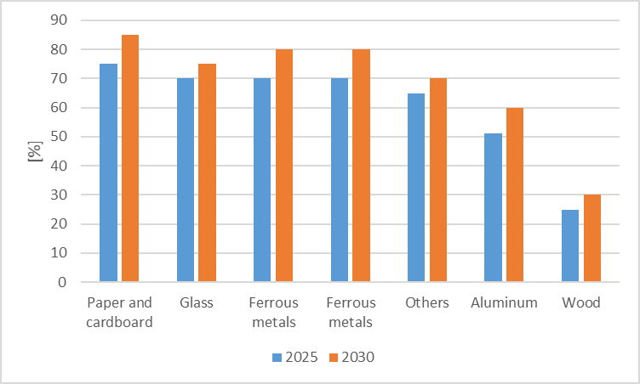
Fig. 4. Required levels and deadlines for material waste

It is mainly related to the need to optimise the selective waste collection system, implement a deposit return system, and other measures to encourage the efficient collection of used products and reusable materials. A tool that can support the above activities is the need to effectively enforce extended producer responsibility for various types of waste and implement measures to improve their efficiency, profitability and management (Roadmap 2019).
Alongside the increase in the amount of waste recycled is the need to reduce the amount of waste disposed in landfills. The increase in landfill fees and restrictions on using these processes should encourage waste prevention and recycling while maintaining landfilling as the least desirable method of municipal waste management. Provisions of the Act on Maintaining Cleanliness and Order in Municipalities (Act 1996), require Municipalities, as waste owners, not to exceed landfilling levels of up to 30% by weight – for each year in 2025-2029, 20% by weight – for each year in 2030-2034, and 10% by weight – in 2035 and for each subsequent year after that. Reducing the amount of municipal waste landfilled will indirectly contribute to reducing the negative impact of landfills on the environment and will increase the potential stream of municipal waste that can be used not for disposal but for recovery. For the challenges identified above to be realised, the determination of all participants in this process is needed, starting with the legislative bodies, municipalities, entrepreneurs and waste generators, who should change their consumption habits.
Undoubtedly, the key activities initiating the implementation of the closed-loop economy (CE) in the waste sector will fall on the central government bodies. In this regard, there will be a need to monitor the effectiveness and efficiency of current regulations and develop recommendations, adjustments, and amendments to national municipal waste regulations. To this end, an analysis of the effectiveness of the current municipal waste collection and management system should be carried out, taking into account, in particular, the demand for raw materials that are key to the Polish economy and the barriers to municipal waste collection and management. The result of this analysis should be proposals for regulatory changes necessary to make the CE concept of municipal waste a reality. Authorities responsible for municipal waste management should identify all municipal waste streams, including post-consumer waste, not yet recorded but of economic importance, and in achieving recovery and recycling targets in waste management. A significant portion of municipal waste already undergoes preparation for reuse or recycling processes without being included in official records (e.g. kitchen and garden waste managed in home composters). Identifying all streams will also make it easier for the waste industry, including recyclers, to reach new materials that can be recycled (Act 1996, Roadmap 2019).
4. Summary and Conclusion
Municipal waste management is economically and environmentally crucial, and its main goal should be to use waste as potential raw materials for producing products and energy. The intensive development of industry and recent decades has changed waste management strategies from simple disposal methods (landfilling) to advanced technological processes for recovering and processing mainly recyclable materials. The economies of EU member states differ, and as a result, each country, based on strategic documents, is developing national programs for transformation to a closed-loop economy. Also, for waste management in Poland, this challenge will spread over the next decade to meet the requirements and achieve appropriate levels of waste recovery. The transformation to CE requires taking action at all life cycle stages, starting with product design, raw material acquisition, processing, production, consumption, waste collection and management. The realisation of this goal will be possible due to the development of innovation and the creation of new business models, increasing the environmental awareness of society. These activities should contribute to stimulating effective waste management, increasing the competitiveness of the Polish raw material economy, and aiming to build a "recycling society".

The scientific research was funded by the statute subvention of Czestochowa University of Technology,
Faculty of Infrastructure and Environment
References
Act of 13 September 1996 on maintaining cleanliness and order in communes Dz. U. 1996 Nr 132 poz. 622. (in Polish)
Retrieved from: https://isap.sejm.gov.pl/isap.nsf/DocDetails.xsp?id=WDU19961320622, 2023 (accessed 18 July 2023).
Act of 14 December 2012 on waste, Dz.U. 2013, poz. 21. (in Polish) Retrieved from: https://isap.sejm.gov.pl/isap.nsf/download.xsp/WDU20130000021/U/D20130021Lj.pdf, 2023 (20 June 2023)
Bajdur, W., Henclik, A., Grabowska, M., Scurek, R., Sikorova, K. (2017). Use of LCA for assessment of environment al impast of newly synthesised polymeric flocculants. Przemysł Chemiczny, 96(12), 2561-2566.
Balcerzak, W., Generowicz, A., Mucha, Z. (2014). Application of a multi-criteria analysis for selection of a method of reclamation method of a hazardous waste landfill. Pol. J. Environ. Stud., 23(3), 983-987.
Ciuła, J. (2022). Analysis of the effectiveness of wastewater treatment in activated sludge technology with biomass recirculation. Architecture Civil Engineering Environment, 15(2), 123-134. https://doi.org/10.2478/acee-2022-0020
Ciuła, J., Kowalski, S., Wiewiórska, I. (2023). Pollution Indicator of a Megawatt Hour Produced in Cogeneration – The Efficiency of Biogas Purification Process as an Energy Source for Wastewater Treatment Plants. Journal of Ecological Engineering, 24(3), 232-245. https://doi.org/10.12911/22998993/158562
Directive (EU) 2018/850 of the European Parliament and of the Council of 30 May 2018 amending Directive 1999/31/EC on the landfill of waste. Retrieved from: https://eur-lex.europa.eu/legal-content/EN/TXT/?uri=CELEX:32018L0850, 2023 (accessed 18 July 2023)
Directive (EU) 2018/851 of the European Parliament and of the Council of 30 May 2018 amending Directive 2008/98/EC on waste. Retrieved from:https://eur-lex.europa.eu/legal-content/PL/TXT/?uri=CELEX:32018L0851, 2023 (accessed 18 July 2023)
Directive (EU) 2018/852 of the European Parliament and of the Council of 30 May 2018 amending Directive 94/62/EC on packaging and packaging waste. Retrieved from: https://eur-lex.europa.eu/legal-content/EN/TXT/?uri=CELEX:32018L0852, 2023 (accessed 17 July 2023)
Directive 2008/98/EC of the European Parliament and of the council of 19 November 2008 on waste and repealing certain Directives, L 312/3. Retrieved from:https://eur-lex.europa.eu/legal-content/EN/TXT/PDF/?uri=CELEX:32008L0098, 2023 (accessed 21 June 2023)
Environment 2022. Statistic Poland. Retrieved from: https://stat.gov.pl/obszary-tematyczne/srodowisko-energia/srodowisko/ochrona-srodowiska-2022,1,23.html, 2023 (accessed 6 June 2023). (in Polish)
Gaska, K., Generowicz, A., Ocłoń, P., Stelmach, S. (2021). Location of the waste incineration plant with particular emphasis on the environmental criteria. Journal of Cleaner Production, 303, 126887. https://doi.org/10.1016/j.jclepro.2021.126887
Generowicz, A., Gronba-Chyła, A., Kulczycka, J., Harazin, P., Gaska, K., Ciuła, J., Ocłoń, P. (2023). Life Cycle Assessment for the environmental impact assessment of a city' cleaning system. The case of Cracow (Poland). Journal of Cleaner Production, 382, 135184. https://doi.org/10.1016/j.jclepro.2022.135184
Generowicz, A., Kulczycka, J., Kowalski, Z., Banach, M. (2011). Assessment of technological solutions of municipal waste management using technology quality indicators and multicriteria analysis. Przemysł Chemiczny, 90(5), 747-752. https://doi.org/10.1016/j.jenvman.2010.12.016
Grąz, K., Kwasny, J. (2021). Microplastics in Composts as a Barrier to the Development of Circular Economy. Architecture, Civil Engineering, Environment, 14(4) 137-144. https://doi.org/10.21307/acee-2021-037
Gronba-Chyła, A., Generowicz, A., Kwaśnicki, P., Cycoń, D., Kwaśny, J., Grąz, K., Gaska, K., Ciuła, J. (2022). Determining the Effectiveness of Street Cleaning with the Use of Decision Analysis and Research on the Reduction in Chloride in Waste. Energies, 15, 3538. https://doi.org/10.3390/en15103538
He, R., Sandoval-Reyes, M., Scott, I., Semeano, R., Ferrão, P., Matthews, S., Small, M.J. (2022). Global knowledge base for municipal solid waste management: Framework development and application in waste generation prediction. Journal of Cleaner Production, 377, 134501. https://doi.org/10.1016/j.jclepro.2022.134501
Housing and municipal infrastructure in 2021. Statistic Poland. Retrieved from: https://stat.gov.pl/publikacje/publikacje-a-z/szukaj.html?letter=G, 2023 (accessed 6 June 2023). (in Polish)
Implementation report national plan waste management 2022. (2023). Retrieved from: https://bip.mos.gov.pl/fileadmin/user_upload/bip/strategie_plany_programy/DGO/Sprawozdanie_z_KPGO_2017-2019/SPRAWOZDANIE_Kpgo_2017-2019.pdf (accessed 10 June 2023). (in Polish)
Kang, Y.O., Yabar, H., Mizunoya, T., Higano, Y. (2023). Environmental and economic performances of municipal solid waste management strategies based on LCA method: A case study of kinshasa. Heliyon, 9(3). https://doi.org/10.1016/j.heliyon.2023.e1437
Kowalski, S., Opoka, K., Ciuła, J. (2022). Analysis of the end-of-life the front suspension beam of a vehicle. Eksploatacja i Niezawodnosc-Maintenance and Reliability, 24(3), 446-454, http://doi.org/10.17531/ein.2022.3.6
Kowalski, Z., Makara, A., Banach, M., Kowalski, M. (2010). Zastosowanie preparatów nanosrebra do oczyszczania powietrza z instalacji klimatyzacyjnej zakładów mięsnych. Przemysł Chemiczny, 89(4), 434-437.
Kumar, S. Singh, D. (2023). Prediction of UCS and CBR behavior of fiber-reinforced municipal solid waste incinerator bottom ash composites using experimental and machine learning methods. Construction and Building Materials, 367, 130230. https://doi.org/10.1016/j.conbuildmat.2022.130230
Kwaśnicki, P., Gronba-Chyła, A., Generowicz, A., Ciuła, J., Wiewiórska, I., Gaska, K. (2023). Alternative method of making electrical connections in the 1st and 3rd generation modules as an effective way to improve module efficiency and reduce production costs. Archives of Thermodynamics, 44(3), 179-200. https://doi.org/10.24425/ather.2023.147543
Malek, W., Mortazavi, R., Cialani, C. Nordström, J. (2023). How have waste management policies impacted the flow of municipal waste? An empirical analysis of 14 European countries. Waste Management, 164, 84-93. https://doi.org/10.1016/j.wasman.2023.03.040
Makara, A., Kowalski, Z., Radomski, P., Olczak, P. (2022).Treatment of wastewater from the production of meat and bone meal by the Fenton process and coagulation. Polish Journal of Chemical Technology, 24(4), 51-60. https://doi.org/10.2478/pjct-2022-0028
Makara, A., Kowalski, Z., Sówka, I., (2016). Possibility to eliminate emission of odor from pig manure treated using AMAK filtration method. Desalination and Water Treatment, 57(3), 1543-1551.
Marques, A.C., Teixeira, N.M. (2022). Assessment of municipal waste in a circular economy: Do European Union countries share identical performance?, Cleaner Waste Systems, 3, 100034. https://doi.org/10.1016/j.clwas.2022.100034
Mihaliková, M., Čulková, E., Stehlíková, K., Tauš, B., Kudelas, P., Štrba D., Domaracká, L. (2020). Analysis of Municipal Waste Development and Management in Self-Governing Regions of Slovakia. Sustainability, 12, 5818. https://doi.org/10.3390/su12145818
Oukili, A.I, Mouloudi, M., Chhiba, M. (2022). LandGEM Biogas Estimation, Energy Potential and Carbon Footprint Assessments of a Controlled Landfill Site. Case of the Controlled Landfill of Mohammedia-Benslimane, Morocco. Journal of Ecological Engineering, 23(3), 116-129. https://doi.org/10.12911/22998993/145410
Oukili, A.I., Chhiba, M. (2023). Evaluation of the Energy Capacity of the Controlled Landfill from Mohamedia Benslimane by Three Theoretical Methods – Land Gem, IPCC, and TNO. Journal of Ecological Engineering, 24(2), 19-30. https://doi.org/10.12911/22998993/156624
Pavliuk, N., Sigal, O., Safiants, A., Plashykhin, S. (2022). The Use of Residual Municipal Solid Waste as an Alternative Fuel. Architecture, Civil Engineering, Environment, 15(4), 147-158. https://doi.org/10.2478/acee-2022-0045
Prędecka, A., Biedugnis, S., Zmysłowski, A. (2019). Waste Management in the Region of Płock – Declarations of Residents. Rocznik Ochrona Środowiska, 12(1), 481-492.
Przydatek, G., Basta, E. (2019). Systemic Efficiency Assessment of Municipal Solid Waste Management in the Suburban Municipality. E3S Web of Conferences 154, 03001. https://doi.org/10.1051/e3sconf/20201540300
Regulation of the Minister of the Environment of December 28, 2018 amending the regulation on the detailed method of selective collection of selected fractions of waste, Dz.U. 2018, poz. 2482. Retrieved from: https://isap.sejm.gov.pl/isap.nsf/download.xsp/WDU20180002482/O/D20182482.pdf, 2023
(accessed 4 July 2023). (in Polish)
Roadmap towards a circular economy transformation, 2019. Retrieved from: https://gozwpraktyce.pl/regulacja/mapa-drogowa/, 2023 (accessed 14 June 2023). (in Polish)
Sendilvadivelu, A., Dhandapani, B., & Vijayasimhan, S. (2022). A Short Review on Feedstock Characteristics in Methane Production from Municipal Solid Waste. Architecture, Civil Engineering, Environment, 15(3) 75-85. https://doi.org/10.2478/acee-2022-0032
Senetra, A., Krzywnicka, I., Duyet, M. (2019). The Analysis and the Evaluation of Municipal Waste Management in Voivodship Cities in Poland. Rocznik Ochrona Środowiska, 12(2), 1076-1097. Retrieved from: https://ros.edu.pl/images/roczniki/2019/066_ROS_V21_R2019.pdf
Sláviková, M., Báreková, A., Tátošová, L., Ducsay, L. (2022). Phytotoxicity Testing of Composts from Biodegradable Municipal Waste. Journal of Ecological Engineering, 23(12), 83-88. https://doi.org/10.12911/22998993/154774
Su, M., Yang, Z., Abba,s S., Bilan, Y., Majewska, A. (2023). Toward enhancing environmental quality in OECD countries: Role of municipal waste, renewable energy, environmental innovation, and environmental policy. Renewable Energy, 211, 975-984. https://doi.org/10.1016/j.renene.2023.05.044
Szczepański, K., Waszczyłko-Miłkowska, B., Kamińska-Borak, J. (2022). Morphology of municipal waste generated in Poland. Instytut Ochrony Środowiska – Państwowy Instytut Badawczy. Poland, Warszawa, (accessed 5 June 2023), (in Polish)
Total waste generation, Eurostat Statistics Explained. Retrieved from: https://ec.europa.eu/eurostat/statistics-explained/index.php?title=Waste_statistics#Total_waste_generation, 2023 (accessed 6 June 2023)
Voss, R., Lee, R.P., Seidl, L., Keller, F., Fröhling, M. (2021). Global warming potential and economic performance of gasification-based chemical recycling and incineration pathways for residual municipal solid waste treatment in Germany. Waste Management, 134, 206-219. https://doi.org/10.1016/j.wasman.2021.07.040
Waste management plan 2028. (2023). Retrieved from:https://bip.mos.gov.pl/strategie-plany-programy/krajowy-plan-gospodarki-odpadami/projekt-uchwaly-rady-ministrow-w-sprawie-krajowego-planu-gospodarki-odpadami-2028/ (accessed 10 June 2023). (in Polish)
Wiewiórska, I. (2023a). Impact of Variable Technological and Quality Factors on the Efficiency of Filtration Processes Using Dynasand Filters and Lamella Separator. Architecture, Civil Engineering, Environment, 16(2), 177-187. https://doi.org/10.2478/acee-2023-0027
Wiewiórska, I. (2023b). The Role of Selected Technological Processes in Drinking Water Treatment. Architecture, Civil Engineering, Environment, 16(2), 189-200. https://doi.org/10.2478/acee-2023-0028
Włodarczyk-Makuła, M., Popenda, A., Wiśniowska, E. (2021). Removal of emerging contaminants and endocrine disrupting compounds from wastewater in the aspect of water protection. International Journal of Conservation Science, 12(1), 731-744. Retrieved from: 731-744. https://ijcs.ro/public/IJCS-21-54_Wlodarczyk.pdf
Wysowska, E., Wiewiórska, I. Kicińska, A. (2022). Minerals in tap water and bottled waters and their impact on human health. Desalination Water Treatment, 259, 133-151. https://doi.org/10.5004/dwt.2022.28437

