 | Rocznik Ochrona Środowiska
 | Volume 25 | Year 2023 ISSN 2720-7501 | pp. 215-221
 | https://doi.org/10.54740/ros.2023.021 open access
 | Received: May 2023 Accepted: September 2023 Published: October 2023
Discrete-Pulsed Energy Input Based Method for Neutralisation of the Acidic Condensate
Bogdan Tselen^{1*}, Georgiy Ivanitsky², Oleksandr Obodovych³,
Nataliya Radchenko⁴, Anna Nedbailo⁵, Liubov Gozhenko⁶
¹Institute of Engineering Thermophysics of NAS Ukraine, Ukraine
https://orcid.org/0000-0001-5213-0219
²National Technical University of Ukraine "Igor Sikorsky Kyiv Polytechnic Institute", Ukraine,
Institute of Engineering Thermophysics of NAS Ukraine, Ukraine
https://orcid.org/0000-0002-0486-2359
³Institute of Engineering Thermophysics of NAS Ukraine, Ukraine
https://orcid.org/0000-0001-7213-3118
⁴Institute of Engineering Thermophysics of NAS Ukraine, Ukraine
https://orcid.org/0000-0002-5315-1609
⁵Institute of Engineering Thermophysics of NAS Ukraine, Ukraine
https://orcid.org/0000-0002-8590-5823
⁶Institute of Engineering Thermophysics of NAS Ukraine, Ukraine
https://orcid.org/0000-0002-8999-1917
*corresponding author's e-mail: ittf_tds@ukr.net
Abstract: The article's authors analysed the most perspective and widely known methods of neutralising the acidic condensate, which is a by-product of natural gas combustion. Among them, the hydrodynamic cavitation method was the most effective. In this regard, it was proposed to improve this method by using the method of discrete-pulsed energy input, which involves neutralisation due to the degassing process. Based on the mathematical model of the bubble ensemble dynamics, a numerical simulation of the formation and growth of vapour-gas bubbles in the process of cavitation boiling of condensate was carried out. Also, an analytical study of the evolution of the vapour-gas bubble population and changes in the current vapour content of the condensate during its boiling was investigated under different values of the initial size of gas micronuclei. The results of the experimental study also confirmed the effectiveness of this method and showed that almost complete removal of carbonic acid from condensate occurs during the first two minutes of processing. That is evidenced by the increased pH values of condensate, which corresponds to the range of permissible pH values of distilled water. Therefore, the carbonic acid in the condensate is absent. Using this method will significantly reduce the environmental effect and the amount of harmful emissions.
Keywords: hydrodynamic cavitation, acidic condensate, neutralisation, numerical modelling, experimental studies, environmental protection
1. Introduction
The daily increase in wastewater emissions from various enterprises significantly affects the environment. One such polluting source is municipal energy companies, whose wastewater, after treatment, enters the general sewage system and is no longer reused. Such wastewater also includes acidic condensate from burning natural gas in municipal boilers. It is dangerous because of its acidic properties; the pH is about 3.8...4.9, caused by a significant concentration of carbonic acid up to 70 mg/l of carbon dioxide. For carbonic acid extraction, several chemical reagents are used, or various mass exchange processes are involved.
The analysis of scientific publications showed that carbonic acid removal occurs in equipment using solid and liquid chemical reagents based on neutralising amines (Akolzin 1998, Zhuk 1996).
Equipment with the operational cycle using solid reagents involves the removal of carbonic acid by passing the treated liquid through the bulk layer of the solid reagent. However, a drawback is associated with the complexity of controlling stable indicators. Therefore, as an alternative, it is often proposed to add a small number of liquid reagents to condensate with a metered machine and improve the stability of pH final values accordingly. However, the main disadvantage of using chemical reagents based on neutralising amines remains their high cost.
Chemical methods for protecting power equipment from corrosion and scale formation provide, on the one hand, the removal of corrosive agents from water, i.e. oxygen (up to 0.015 mg/kg) and free carbon dioxide (up to 3-7 mg/l), and the use of volatile inhibitors on the other hand. Film-forming amines and a mixture of fatty acid amines (C₁₇-C₂₁) are used as inhibitors. They protect against oxygen and carbon dioxide corrosion of equipment and pipelines used for pumping industrial condensate (Akolzin 1998, Zhuk 1996, Galustov 2004). The main reason for restrictions on the use of chemical reagents is the significant contamination of condensate with residual by-products of the reaction, and, accordingly, it is unable to reuse this condensate. Neutralisation using mass transfer processes involves removing carbon dioxide from contact with air and is implemented in absorbent-type equipment. According to several researchers, thermal deaeration of water is and will probably be for a long time, one of the main means of ensuring the reliability of heat supply systems and their heat sources, which contributes to the effective use of fuel heat during its combustion in industrial boilers (Bukowska et al. 2017, Sharapov 2008, Yefimov et al. 2017, Zaporozhets & Babak 2020). For example, the solubility of carbon dioxide in water varies at different temperatures, as in the case of the decarbonisation process (Zhuk 1996, Rozenberg 1973).
Corrosive gases, as well as gases that impede heat transfer, are removed from the heat carrier during the preparation of feeding water in calciners and deaerators at atmospheric pressure. In some cases, deaeration is also necessary in the thermal schemes of power units operating at supercritical live steam parameters, in which oxidative water-chemical regimes are implemented with oxygen or air dosing into the feeding water. In this case, during deaeration, both acidic volatile products of thermolysis and gases that interfere with heat transfer are removed from the heat carrier. In water treatment technologies for the needs of heat and power engineering, the stage of neutralisation of acidic condensate is the most difficult due to the peculiarities of the mass exchange processes (Galustov 2004, Sharapov 2008, Yefimov et al. 2017, Sharapov & Syvukhyna 2002).
According to the design features, decarbonisers are divided into countercurrent and direct-flow types. The first type is a nozzle with an air supply from below. It is quite common; however, it has several disadvantages, including the high cost of manufacturing and significant overall dimensions (Sharapov & Syvukhyna 2002).
Direct-flow ejectors and direct-flow heat and mass exchange devices are common among decarbonisers with unidirectional movement of heat carriers (Galustov 2004, Sharapov & Syvukhyna 2002). Direct-flow ejectors are complicated due to the limitations of the permissible range of carbon dioxide concentrations up to 20 mg/kg. Among the main disadvantages, there are also impressive overall dimensions.
Traditional mass exchange processes, which include decarbonisation deaeration (vacuum and thermal) today, are practically not used to neutralise acidic condensate because they do not allow a sufficient degree of carbon dioxide removal and are often accompanied by increased energy consumption. At the same time, the volumes of acidic condensate are quite significant and can reach 140 l/h from 1 MW of thermal power of the boiler unit. In this regard, it is worth considering the possibility of neutralising it to further return the condensate into the feeding system of the boiler unit. Solving this problem will allow us to reduce the consumption of natural water and reduce the effect on the environment.
Considering alternative carbon dioxide removal methods, it is worth stopping on acoustic ones. Their principle is built on the use of ultrasonic generators (Carpenter et al. 2016, Rozenberg 1973, Brennen 1995, Rooze 2012, Eskin 2017). Their advantage is that they ensure the fastest removal of free gas in bubbles. The liquid's degassing occurs because, under the influence of ultrasound, most of the dissolved gas moves inside the bubbles due to "rectified mass diffusion" (Brennen 1995). The growing bubbles float up and further exit the liquid. The advantage of acoustic methods is the possibility of neutralising any liquid. Nonetheless, despite their high efficiency, today, they are used mainly in laboratory research and have not been widely used in industry due to relatively high specific energy consumption.
Recently, the number of scientific works devoted to the study of the prospects for using the method of hydrodynamic cavitation has been increasing (Brennen 1995, Rooze 20, Carpenter et al. 2016). In particular, this is confirmed by many researches and in various production spheres. Therefore, for the further development of this direction, it is necessary during research to pay special attention to the parameters of increasing productivity and reducing energy consumption.
The purpose of this work is a comprehensive experimental and analytical study of the process of liquid degassing by using hydrodynamic cavitation methods and substantiation of the effectiveness of such methods compared to the neutralisation of acidic condensate of boilers. The research direction consisted of the analytically determining dependence of vapor content in the liquid at the outlet of the cavitation device on the current bubble growth radius and time, and the experimentally determining dependence of pH of acidic condensate and model liquid on the duration of treatment.
2. Problem Formulation
Liquid degassing methods using acoustic or hydrodynamic cavitation are applied when it is necessary to remove gas, which is always present in any liquid in the form of free micro-bubbles. Gases that are contained in the liquid, such as O₂, CO₂, H₂S, are chemically more aggressive than the same gases in a dissolved state (Akolzin 1998, Zhuk 1996, Rozenberg 1973, Brennen 1995, Carpenter et al. 2016). Being present in ordinary water, they act as catalysts for corrosion processes. The efficiency of the methods increases with the degassing of supersaturated liquids when the amount of free gas in bubble form exceeds the equilibrium concentration of the gas dissolved in the liquid.
Recently, many articles have been dedicated to studying the cavitation degassing of liquids. As well as, patents have been issued for the method and design of cavitation degassers. An analysis of these publications indicates the absence of generally accepted clear ideas about the physical nature and mechanisms of cavitation phenomena occurring on the micro-level and a general approach to analysing the results obtained.
This article briefly considers the main problems and tasks associated with studying the mechanisms and processes of hydrodynamic cavitation for liquid degassing and discusses possible solutions.
The authors developed an alternative method of removal of aggressive gases, which are contained in a liquid in the form of gas micronuclei. The method is reagent-free and involves only physical effects on the liquid; therefore, its advantage is significant savings on chemical reagents and the possibility of reducing specific energy consumption. It was developed within the scientific direction of discrete-pulse energy input (DPEI) and today has a wide range of applications. (Dolinskiy & Ivanitsky 2008, Ivanitsky et al. 2020). The main prerequisites of this method are as follows.
The treated acidic condensate is initially in a tank where a vacuum pump maintains a constant low pressure of 0.02 bar. With the help of a centrifugal pump, the condensate is fed to the inlet of the cavitating device (cavitation reactor), in which, due to a sharp decrease of the pressure, the liquid boils up intensively with the formation of large vapour-gas bubbles. At the outlet of the cavitating device, the boiling flow in the form of a spray enters the vacuum tank, where phase separation occurs. The vapor-gas mixture is removed from the container by the vacuum pump. Afterwards, the spray droplets return to the liquid volume inside the tank, and the deaerated liquid is again fed to the inlet of the cavitating device with the help of the centrifugal pump. The related fact that micro-bubbles containing free CO₂ are the centres of formation of the vapour-gas phase, the processing of condensate in a closed circuit in the recirculation mode allows the activation of gas nuclei of any size and thus the removal of aggressive gases from the liquid.
This method, which combines thermo-vacuum treatment of liquid with the significant effect of cavitation mechanisms, will allow obtaining degassed fresh water, which can be used in the future to prepare heat carriers for boiler feeding.
3. Materials and Methods
The basis for carrying out numerical calculations was the scientific work of our institute, in particular, mathematical models of the dynamics of ensemble and single steam-gas bubbles developed in previous works (Dolinskiy & Ivanitsky 2008). The models within a unified system of equations describe the behaviour of bubbles in boiling processes and in the processes of hydrodynamic and acoustic cavitation in the entire temperature range of a liquid phase existence, up to the critical point, without introducing additional assumptions. A feature of the models is the description of interfacial heat and mass transfer within the framework of the molecular-kinetic theory, as well as the analytical representation of the temperature dependencies of the main physical characteristics of both phases. To determine the dynamics of steam-gas bubbles, it is necessary to analytically present the equation for changing the external pressure in a liquid, which determines the number of activated bubbles, their growth rate, and the amount of vapour content in the liquid flow. This equation, specific for each individual problem, is the basic equation of the cavitation degassing models (Dolinskiy & Ivanitsky 2008, Ivanitsky et al. 2019).
During experimental studies, the following research objects were used: acidic condensate from a municipal boiler and, for comparison, a model liquid, which was a mixture of carbon dioxide in distilled water with a pH value close to condensate.
For the experimental part of the research, a laboratory stand was created Fig. 1. Its main components were a rotary-pulsation apparatus (RPA) with a specially designed design of working bodies and a unit of the thermal vacuum processing chamber.
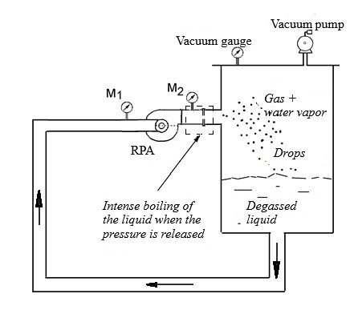
Fig. 1. Scheme of the laboratory stand

According to the developed experimental methodology, the test liquid of 30 litres was treated in the recirculation mode in a closed-loop RPA – Thermovacuum Treatment Container for 10 minutes. Samples were carried out every minute using a special pipe, which is located on the container of the thermo-vacuum processing unit. During the experiments, the treated liquid's pH and temperature were measured. The pH values of each selected sample, both acidic condensate and a model liquid, were measured three times – before processing, immediately after sampling and after 7 hours of sample exposure. The EZODO PCT-407 multifunctional device was used to measure the pH value and analyse water parameters. The concentration of dissolved carbon dioxide was determined by the known dependence of the pH of water on the concentration of carbon dioxide calculated using dissociation constants.
4. Results and Discussions
Based on the mathematical model of bubble ensemble dynamics (Dolinskiy & Ivanitsky 2008, Ivanitsky et al. 2019, Ivanitsky et al. 2020), a numerical simulation of the vapor-gas bubble growth during cavitation boiling of the condensate has been carried out. Analytical analysis of the evolution of the bubble population and changes in the current vapor content of the liquid β(τ) (the ratio of the disperse gas phase volume to the liquid volume) was investigated under different initial radii R_{g0} of gas micronuclei. Fig. 2 presented the pattern of change in the vapour content in the liquid flow at the outlet from the cavitating device depending on the current radius of the growing vapour-gas bubbles in the monodisperse ensemble.

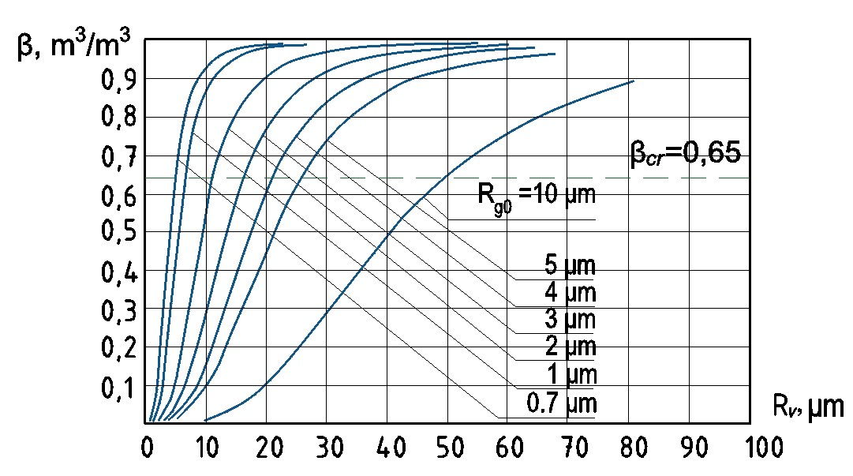
Fig. 2. The pattern of the change in the vapour content β in the liquid flow at the outlet from the cavitating device depending on the current radius of the growing vapour-gas bubbles R_{g0} in the monodisperse ensemble (at an initial concentration of carbon dioxide of 70 mg/l and the liquid temperature of 25°C)

Monodisperse aggregates of gas bubbles in water for different initial radii of micronuclei of free carbon dioxide were analysed. The horizontal line (β_{cr} = 0.65) in Fig. 2 corresponds to the critical value of the vapour content. For any initial radius of the micro-nuclei, the radius of the vapour-gas bubbles, reaching a critical value, increases significantly (almost five times), and the volume of the bubble phase is more than two orders bigger. Segments 1-7, located higher than the dashed line, do not show the real course of the process because, due to phase inversion, there are no more bubbles in this zone, but a continuous vapour-gas phase with water droplets is created.
Fig. 3 shows the pattern of change in time of the vapour content of the CO₂ mixture in the water for monodisperse totality of bubbles with a range of initial radius of gas micronuclei from 0.5 μm to 5.0 μm at the same values of concentration and liquid temperature. In Fig. 3, it can be observed that bubbles with all initial sizes 0.7 ≤ R_{g0} ≤ 5 µm reach the critical gas content in almost the same time interval from 115 to 140 µs, while small gas nuclei with initial R_{g0} < 0.6 µm were not activated at all. Also, it can be seen that for most of the nuclei of CO₂ with R_{g0} > 2 μm, the vapour content of the liquid increases rather slowly. At the same time, the vapour content of the liquid containing nuclei with R_{g0} < 1 μm increases instantly. It shows that the increase in the vapour content of the water, which initially contained a monodisperse set of relatively large gas nuclei (R_{g0} ≥ 2 μm) occurs slowly, while in the water, which initially contained small gas nuclei (R_{g0} ≤ 1 μm), the vapor content increases almost instantly.

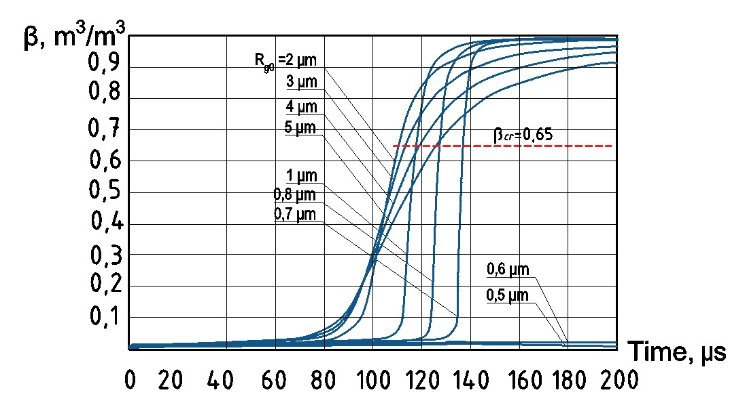
Fig. 3. Change over time in the vapour content of a carbon dioxide solution in water at different initial values of the radius of gas micronuclei R_{g0}

The above results of the study show that small bubbles with R_{g0} < 0.6 μm do not increase even in conditions of significant pressure drops while it is impossible to achieve their further shredding. At the same time, when passing through the RPA channels of the gas-liquid flow of the bubble structure, several powerful hydrodynamic mechanisms are launched, resulting in the liquid being intensively affected. In the liquid space between the bubbles, several effects arise – intense high-frequency pressure drops, as well as shear rates that can reach 2,5.10⁵ s⁻¹, abnormal accelerations that periodically change in direction and magnitude and, etc. (Dolinskiy & Ivanitsky 2008, Ivanitsky et al. 2020). Due to the combined effect of these factors, the bubbles collide, merge and, as a result, are converted into larger bubbles. Consequently, large gas-vapor bubbles are already formed in RPA channels.
The obtained data shows that the intensity of extraction of carbon dioxide dissolved in water from condensate droplets during their stay in a vacuum tank is much less than the rate of desorption of free carbon dioxide from condensate, which is the main advantage of the proposed method.
To verify the reliability of the results of the numerical calculation of the CO₂ removal process, experimental measurements of the pH value of acidic condensate from the municipal boiler were carried out. For comparison, the experiment also examined the pH value of a model solution of carbon dioxide in water under the same processing conditions.
Fig. 4 shows the change of pH values of acidic condensate (curve 1) and model liquid (curve 2) during the treatment, as well as the pH value after 7 hours of exposure of each sample of treated acidic condensate (curve 3) and model liquid (curve 4). Dotted line 5 corresponds to the standard pH value of degassed distilled water, which should be strived when neutralising acidic condensate.
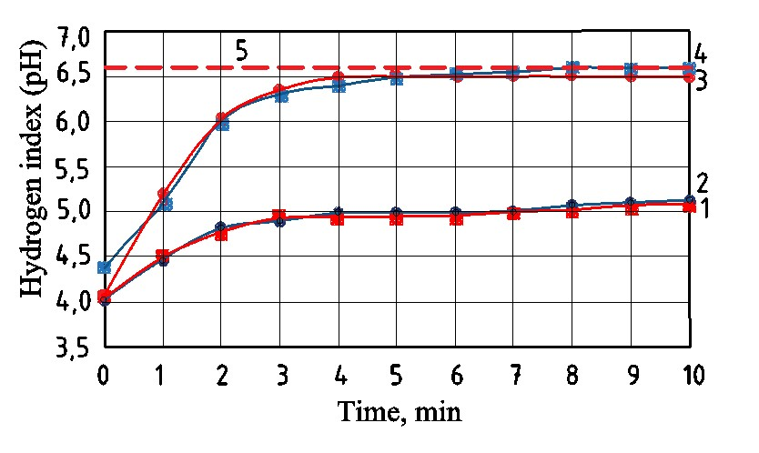
Fig. 4. Pattern of change pH of condensate and model liquid on the duration of cavitation treatment immediately after sample removal (1, 2) 7 hours after sampling (3, 4): 1 and 3 – acidic condensate; 2 and 4 – model liquid;
5 – the standard pH value of degassed distilled water

The vast majority of CO₂ is extracted after 2 minutes of processing, which is clearly visible in the graphs. From the 4th minute, the pH curves reach a plateau and their changes insignificantly, which indicates the inexpediency of further processing. It was revealed that the pH of condensate samples continues to increase for some time after the completion of the processing process, which indicates an unstable state of the liquid and the beginning of the process of its smoothing (relaxation). It was established that within 7 hours of sample storage, pH indicators stabilise, reaching 6.5, which is included in the standard limits of the pH range of distilled degassed water.
The results of measuring the pH values indicate that after treatment, one may get a neutralised condensate, according to fresh water's physics-chemical properties.
5. Conclusions
The authors present a concise analysis of the state of the problem of wastewater neutralisation in municipal energy and consider traditional and alternative approaches to their neutralisation, highlighting their main advantages and disadvantages. Based on the analysed data, the expedience of using hydrodynamic cavitation has been proven to remove any free aggressive gases from the liquid contained in it in the form of gas micro-bubbles. Based on complex theoretical and experimental studies, the possibility of using this method to neutralise acidic condensate, one of the types of wastewater of municipal enterprises, was considered.
Within the previously developed mathematical model of the bubble ensemble dynamics, a numerical simulation of the process of cavitation boiling of aqueous solution of CO₂ with a given initial concentration was carried out. It was found that bubbles increase with an initial radius of 0.7-5.0 μm, and the liquid flow reaches a critical gas content after 115-140 μs. Bubbles with an initial radius of up to 0.6 μm in this mode of liquid treatment do not increase. It is shown that increasing the vapour content in the liquid up to a critical value ensures the effectiveness of this degassing method.
Experimental studies have shown that after two minutes of exposure to the effects of hydrodynamic cavitation on the treated liquid, almost complete removal of carbonic acid is achieved (it decreases to 0.03 mg/l of carbon dioxide 7 hours after sampling).
Regarding further research and implementation perspectives, this neutralisation method can be usefully implemented in wastewater treatment technologies of municipal enterprises. The effect of the use will allow for a reduction in the volume of emissions of harmful wastes and a reduction in the consumption of freshwater due to the return of neutralised condensate to the feeding system of the municipal boiler.
References
Akolzin, P.A. (1998). Prevention of corrosion of technical water and heat supply equipment. Moscow: Metallurgy.
(in Russian)
Brennen, Ch.E. (1995). Cavitation and Bubble Dynamics. New York: Oxford University Press.
Bukowska, M., Nowak, K., Proszak-Miąsik, D., Rabczak, S. (2017). Concept of heat recovery from exhaust gases.
IOP Conference Series: Materials Science and Engineering, 245(5), 052057.
https://doi.org/10.1088/1757-899X/245/5/052057
Carpenter, J., Badve, M., Rajoriya, S., George, S., Saharanand, V., Pandit, A.B. (2016). Hydrodynamic cavitation: an emerging technology for the intensification of various chemical and physical processes in a chemical process industry. Review in Chem. Engineering, 33(5), 1-36. https://doi.org/10.1515/revce-2016-0032
Dolinskiy, A.A., Ivanitsky, G.K. (2008). Heat and mass transfer and hydrodynamics in vapor-liquid dispersed media. Physical foundations of discrete-pulse energy input. Kiev: PH “Naukova dumka”. (in Russian)
Eskin, D.G. (2017). Overview of ultrasonic degassing development. Light Metals, in.: The Minerals, Metals & Materials Series. Springer, Cham. 1437-1443, https://doi.org/10.1007/978-3-319-51541-0_171
Galustov, V.S. (2004). About water decarbonisation. Аkva-Term, 5(21), 76-79.
Ivanitsky, G.K., Tselen, B.Ya., Nedbaylo, A.E., Konyk, A.V. (2019). Modeling the kinetics of cavitation boiling up of liquid. Physics of aerodisperse systems, 57, 136-146. http://dx.doi.org/10.18524/0367-1631.2019.57.191970
Ivanitsky, G.K., Tselen, B.Ya., Nedbaylo, A.E., Gozhenko, L.P. (2020). The ways of producing an unified mathematical model for the cavitating flow in hydrodynamic cavitation reactors. Thermophysics and Thermal Power Engineering, 42(2), 31-38. https://doi.org/10.31472/ttpe.2.2020.3
Rooze, J. (2012). Cavitation in gas-saturated liquids. [Dissertatie 1 (Onderzoek TU/e / Promotie TU/e), Chemical Engineering and Chemistry]. Technische Universiteit Eindhoven. http://doi.org/10.6100/IR732583
Rozenberg, L.D. (1973). Liberation of Free Gas from a Liquid. In: Rozenberg, L.D. (eds), Physical Principles of Ultrasonic Technology. Ultrasonic Technology, 1. (422-443). Springer, Boston, MA. https://doi.org/10.1007/978-1-4684-8217-1_20
Sharapov, V.I. (2008). Problems of thermal deaeration of water for heat supply systems. Heat Supply News, 94(6),
46-53. (in Russian)
Sharapov, V.Y., Syvukhyna, M.A. (2002). Calciners for water treatment plants of heat supply systems. Moscow: PH ACB. (in Russian)
Zaporozhets, A.O., Babak, V.P. (2020). Control of fuel combustion in small and medium power boilers. Kyiv: Akademperiodyka.
Zhuk, N.P. (1996). Course of corrosion and protection of metals. Moscow: Metallurgy. (in Russian)
Yefimov, A.V., Goncharenko, A.L., Goncharenko, L.V., Yesipenko, T.A. (2017). Modern technologies of deep cooling combustion products fuel in boiler installations, their problems and solutions. Kharkov: Kharkov Technical University "KhPI", Ukraine. http://repository.kpi.kharkov.ua/handle/KhPI-Press/32826 (in Russian)

