 | Rocznik Ochrona Środowiska
 | Volume 25 | Year 2023 ISSN 2720-7501 | pp. 188-197
 | https://doi.org/10.54740/ros.2023.018 open access
 | Received: June 2023 Accepted: August 2023 Published: September 2023
Selected Properties of Reinforcing Composite Bars for Concrete Elements
Prepared from Waste Polyethylene Terephthalate (PET) Bottles
Jacek Katzer¹, Paweł Grzybowski², Janusz Kobaka^{3*}
¹Faculty of Geoengineering, University of Warmia and Mazury in Olsztyn, Poland
https://orcid.org/0000-0002-4049-5330
²Stanisław Staszic State University of Applied Sciences in Piła, Poland
https://orcid.org/0000-0002-9115-7622
³Faculty of Geoengineering, University of Warmia and Mazury in Olsztyn, Poland
https://orcid.org/0000-0002-3596-3187
*corresponding author's e-mail: janusz.kobaka@uwm.edu.pl
Abstract: A concept of producing reinforcing bars for concrete elements from waste polyethylene terephthalate (PET) bottles is presented in the paper. The proposed technology of production harnesses strips of PET cut from bottles and thermal treatment. Finally, a sand-resin coating is applied to the composite bars. Produced bars can be differentiated by utilising different numbers of strips influencing the diameter of a bar. The key mechanical properties of the bars containing 3 to 8 strips were tested during the research program. Maximum loadings and displacements were established. Problems regarding the future application of the bars in question were discussed. Areas of need for further research were pointed out.
Keywords: concrete, waste, polyethylene terephthalate, PET, reinforcement
1. Introduction
Plastic pollution is a global environmental problem of our time (Cai et al. 2022) that poses a huge threat to the health of people and marine ecosystems worldwide (Salazar et al. 2022, Valentin & Hechanova 2023). In 2022, the resumed session of the United Nations Environment Assembly (UNEA) adopted a resolution to initiate an international law-making process to combat global plastic pollution by 2024 (Walker 2022, Wang 2023), yet the implementation may take up to 8-10 years to address plastic pollution (Walker 2022). The construction industry has great potential in the field of management and utilisation of waste. Concrete is a commonly used material in construction worldwide (Desta & Jun 2018, Kadir & Hassan 2014, Kobaka 2021, Rumman et al. 2020) with significant capability of utilising waste materials. The examples of using waste materials for concrete production range from replacing aggregate with waste ceramics (Wang et al. 2023), waste sand (Jeyanthi et al. 2023, Katzer & Kobaka 2009), alkali-activated slag (Kocot et al. 2021), PET flakes (Kocot et al. 2021), sintered fly ash (Jayadurgalakshmi et al. 2023) to slag (Wang et al. 2023) and metallurgical sludge (Lehner et al. 2022). For over a dozen years, research has been conducted on using synthetic plastic recyclates as substrates in the production technology of mortars and concrete mixes. The strength, water tightness and frost resistance of concrete are based on its internal structure, aggregate composition, content and properties of a used binder. It is not easy to successfully apply waste materials to concrete. The key issue is to maintain the compressive strength of concrete. On the other hand, almost all cast concrete elements are reinforced by steel bars, stirrups, meshes or fibre. The authors proposed viable steel bar replacement based on one of the most commonly used plastics (PET). It seems to be a promising material to substitute fully or at least partially stell, which is the most expensive component of reinforced structural concrete. So far, some research tests show that the addition of plastic affects the workability, compressive strength (Ahdal et al. 2022), split tensile strength (Thomas & Moosvi 2020), thermal conductivity and slightly enhances the abrasion and flexural strength (Alani et al. 2022, Borg et al. 2016, Sharma & Bansal 2016) of concrete. There were attempts to produce ecological concrete using fibres from discarded PET bottles as concrete aggregate (Gu & Ozbakkaloglu 2016, Pereira et al. 2017). Such concrete is characterised by increased ductility compared to conventional concrete (Foti 2011, Khalid Ali et al. 2022, Kim et al. 2010, Mustafa Abdullah & Haido 2022).
Considering the above facts, the authors decided to use waste PET to produce flaccid, capable of carrying tensile forces, reinforcing bars. PET is a common polyester plastic used for the production of packaging, notably plastic bottles. Currently, most PET bottles are produced from fossil fuel-derived feedstocks (Benavides et al. 2018) like crude oil or natural gas. PET is strong, lightweight, and cheap, making it a great material for packaging and making all sorts of plastic utility items. In 2015, global plastic waste output was approximately equal to 141 million tons (Geyer et al. 2017). In the European Union in 2019, 34.4 kg of plastic packaging waste was generated per EU inhabitant. At the same time, on average, the recycling rate of 41% (14.1 kg) per inhabitant is achieved in the EU. Thus, large amounts of packaging waste are buried in landfills, contributing to air, water, and soil pollution (Benyathiar et al. 2022). Therefore, utilising this waste, which can naturally decompose for many decades, is an ecological necessity.
For the purpose of the research program, it was hypothesised that reinforcement bars made of PET strips would be characterised by sufficient mechanical properties to at least partially replace traditional steel reinforcement in structures of less importance and low internal stresses, e.g. lintel beams.
2. Materials and Methods
2.1. Used Materials and Preparation Process of PET Reinforcement
Waste PET bottles (previously containing mineral water) with a volume of 1.5 dm³ were used to make the reinforcing bars. The first step of production of a reinforcing bar was cleaning a bottle from a label and other residues. Subsequently, it was cut into three parts: top, middle and bottom. Only the uniform (in a cylindrical shape) middle part of a bottle (80 mm high without embossing and narrowing) was used for the bar production. Long 8 mm wide strips were then cut from the middle part of a bottle. The strips were spirally wrapped over a steel wire (1 mm in diameter). The tightly wrapped and stretched strips formed the first layer of the reinforcing bar (see Figure 1), which was subjected to a short thermal treatment.
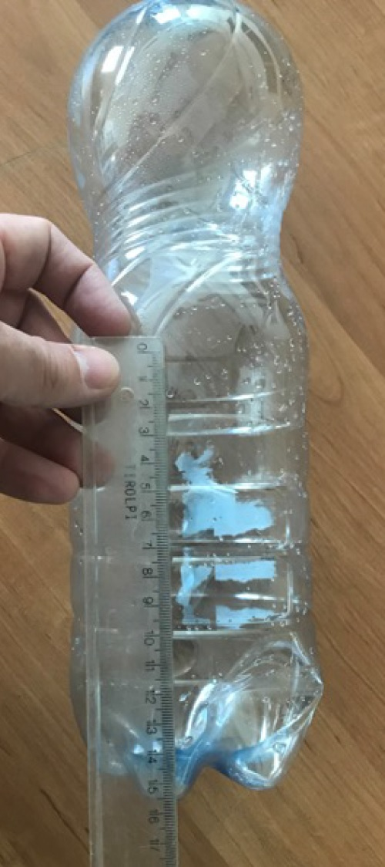
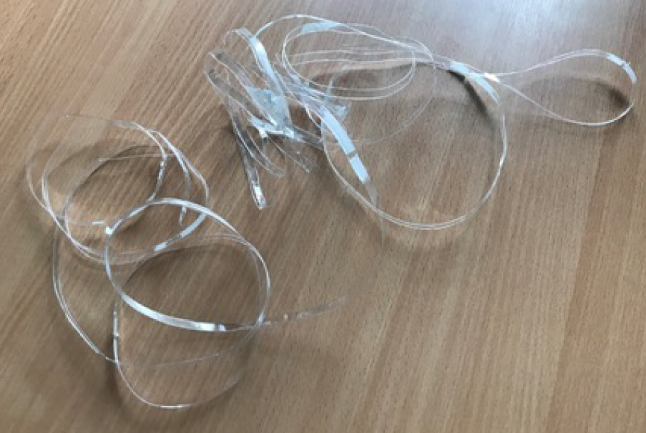  a) | b)
c) | d)
Fig. 1. Key stages of the creation of PET reinforcing bars: PET strips (a) cut from the middle part of a bottle
(b) are spirally wrapped on a steel wire (c) and form a reinforcing bar (d) after thermal treatment

Thermal treatment was executed (for several seconds) by a stream of hot air (+350°C), generated by an electric heat gun placed about 5 cm away from the bar. The high temperature caused shrinkage, stiffening and tight connection of the spirally wrapped PET strips. A coating was formed on a steel wire. The edges of the adjoining strips formed ribs were embossed at regular distances (see Figure 1).
After thermal treatment, another layer of strips was applied. Successive layers were wrapped on each other in opposite directions to obtain a homogeneous weave. Depending on the diameter of the bar to be obtained, the application of layers and thermal treatment was repeated (from 3 to 8 times). After all layers were made, the steel wire was pulled out of the PET reinforcing bar. Finally, the bars were surface-protected with epoxy resin and covered by sand with particles up to 1 mm (see Figure 2). Thanks to the resin, the PET bar is connected with the sand, forming an external, irregular, rough layer. Therefore, the sand-resin coating enables better concrete interaction with the reinforcing bar. The coating also protects the PET core against depolymerisation in the alkaline environment of the cement matrix (Silva et al. 2005, Wiliński et al. 2016). The coating also improves mechanical properties due to the higher bonding between concrete-coated PET and uncoated PET (Salhotra et al. 2021, Salhotra et al. 2022).
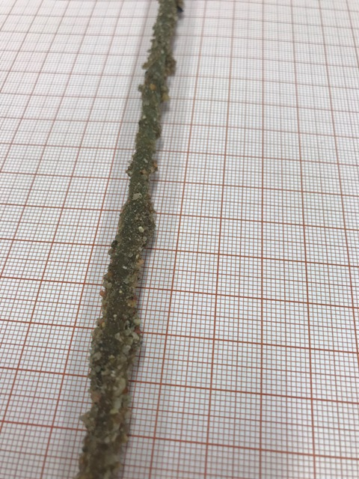 | Fig. 2. Sand-resin coating on the PET reinforcing bar
2.2. Measurements Methods
A variable diameter of a cross-section characterises PET bars with a resin-sand coating. To determine the basic characteristics of the bars, such as diameter, weight, and density, specimens without an outer resin-sand coating were used. 6 bars for each type (made out of 3, 4, 6 and 8 layers of PET strips) characterised by length of 600 mm were prepared for the tests. Since the bars along their entire length have regular thickening (the effect of applying successive layers of strips), the method of measuring the diameter had to be chosen wisely. A direct measurement method using an electronic calliper was selected for the prepared PET bars. To accurately determine the diameter, 100 readings were taken along the entire length of each bar (Figure 3). On this basis, the arithmetic mean and standard deviation were determined, and a constant value was assigned, identifying bars made of 3, 4, 6 and 8 layers of PET strips. All bar samples were weighed in the next stage, and their length was measured. Since each bar is characterised by an internal air void formed after removing the steel wire, the density of PET was used to determine the properties of the material forming the PET bars.

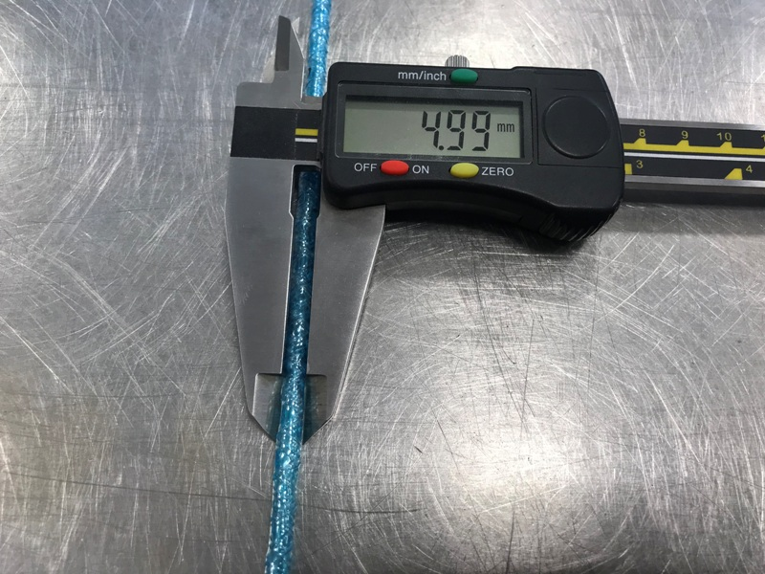
Fig. 3. Determination of a PET bar diameter using an electronic calliper
2.3. Tensile Test Method
6 PET bars without a resin-sand coating were prepared for each number of layers (see Table 1) to determine the strength characteristics of PET reinforcing bars subjected to axial tensile forces until breaking.

Table 1. Designation of the tested PET reinforcing bars
Number of layers | Designations of the tested bars
3 | 1/(3), 2/(3), 3/(3), 4/(3), 5/(3), 6/(3)
4 | 1/(4), 2/(4), 3/(4), 4/(4), 5/(4), 6/(4)
6 | 1/(6), 2/(6), 3/(6), 4/(6), 5/(6), 6/(6)
8 | 1/(8), 2/(8), 3/(8), 4/(8), 5/(8), 6/(8)

The minimum length of the tested bars was based on the requirements for non-metallic bars of the American Concrete Institute (ACI) standard (ACI 2012):
$L≥40∙d_{b}$ (1)
where d_{b} is a bar diameter.

Since PET bars, like all non-metallic bars, have a relatively low compressive strength, each end was embedded in a protective sleeve with a diameter of 12 mm to securely fix it in the jaws of the testing machine (see Figure 4). The space between the bar and the walls of the sleeves was afterwards filled with epoxy resin. The prepared bars were next placed in the jaws of the Zwick/Roell Z010 universal testing machine to be subjected to a tensile test.

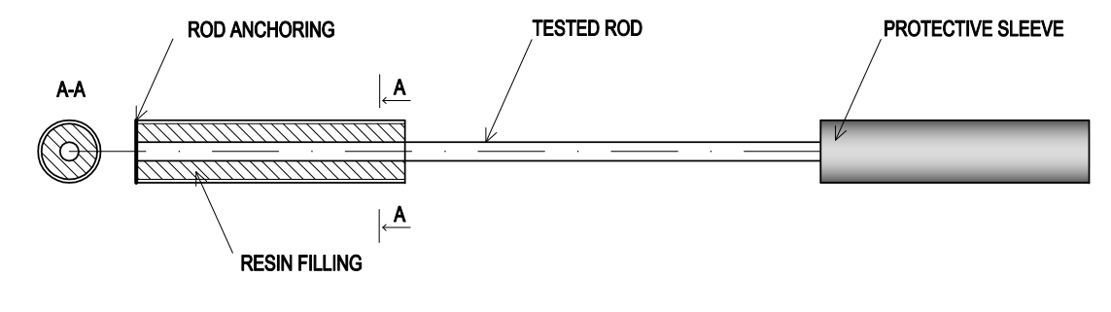
Fig. 4. Anchoring of the tested bars in protective sleeves
3. Research Tests Results
3.1. Dimensional Measurement Results
Basic characteristics such as diameter d_{b} and apparent density ρ of the tested PET bars are presented in Table 2. The apparent density was calculated using only the volume of PET (without the central hollow space left by the removal of the steel wire used for its formation). The average cross-sectional area of PET in a reinforcing bar (A_{b}) was used for these calculations. Values of standard deviation (SD) for d_{b} and ρ are also presented there. The obtained average apparent density of 1.11 g/cm³ significantly differs from the density of PET, which for a homogeneous material, determined following the German DIN standard, is equal to 1.38 g/cm³ (DIN 1976). This phenomenon is a consequence of the technology of the bars' production described above.

Table 2. Basic characteristics of the tested PET bars
Specimen | d_{b} [mm] | Average d_{b} [mm] | Average A_{b} [mm²] | ρ  [g/cm³] | Average ρ [g/cm³] | SD of ρ | Average ρ  for all specimens/SD
1/(3) | 2.74 | 2.70 | 4.94 | 0.99 | 1.07 | 0.04 | 1.11 / 0.06
2/(3) | 2.81 |  |  | 1.07
3/(3) | 2.73 |  |  | 1.06
4/(3) | 2.65 |  |  | 1.10
5/(3) | 2.65 |  |  | 1.07
6/(3) | 2.62 |  |  | 1.10
1/(4) | 3.09 | 3.17 | 7.10 | 1.07 | 1.08 | 0.01
2/(4) | 3.24 |  |  | 1.08
3/(4) | 3.17 |  |  | 1.09
4/(4) | 2.98 |  |  | 1.06
5/(4) | 3.28 |  |  | 1.06
6/(4) | 3.24 |  |  | 1.09
1/(6) | 3.96 | 3.98 | 11.65 | 1.26 | 1.14 | 0.06
2/(6) | 3.73 |  |  | 1.16
3/(6) | 3.66 |  |  | 1.11
4/(6) | 4.29 |  |  | 1.09
5/(6) | 4.06 |  |  | 1.11
6/(6) | 4.17 |  |  | 1.11
1/(8) | 4.90 | 4.73 | 16.78 | 1.13 | 1.17 | 0.03
2/(8) | 4.81 |  |  | 1.16
3/(8) | 4.82 |  |  | 1.13
4/(8) | 4.41 |  |  | 1.20
5/(8) | 5.00 |  |  | 1.17
6/(8) | 4.42 |  |  | 1.20

3.2. Tensile Strength Tests Results
The relationships between tensile axial load and axial displacement (see Figs. 5-8) show that all the tested bars behaved quite similarly when the loading force was applied. Three stages in the displacement process can be distinguished when analysing the values of axial displacement attributable to the relevant forces.
In the first stage, regardless of the diameter of the bars, a linear-elastic relationship can be observed, and (according to Hooke's law) the longitudinal modulus of elasticity of the bars can be determined. This stage corresponds to 8 mm displacement (4%) of the tested bars.
In the second stage, the bars are significantly deformed until they break. At this stage of work of the loaded bars their strength decreases significantly. Longitudinal deformation increases much faster than in the first stage. This proves the plastic form of deformation resulting in PET bars' axial displacement ranging from 8 to 100 mm (from 4% to 50%).

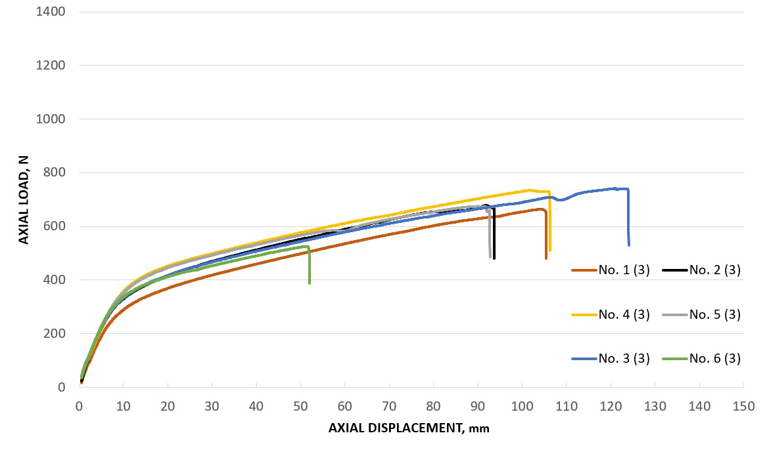
Fig. 5. Relationship between load and axial displacement for PET bars made of 3 strips

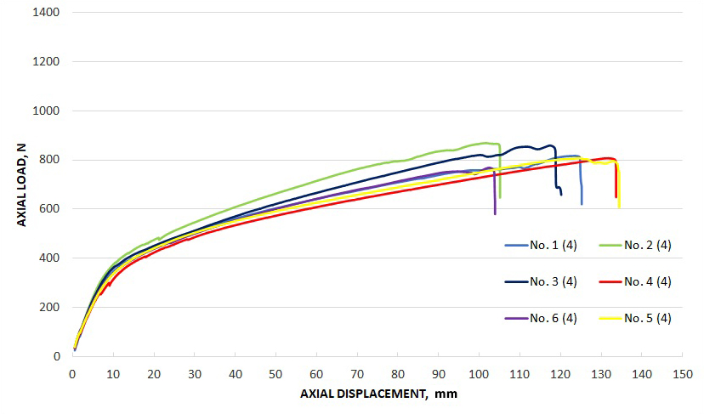
Fig. 6. Relationship between load and axial displacement for PET bars made of 4 strips

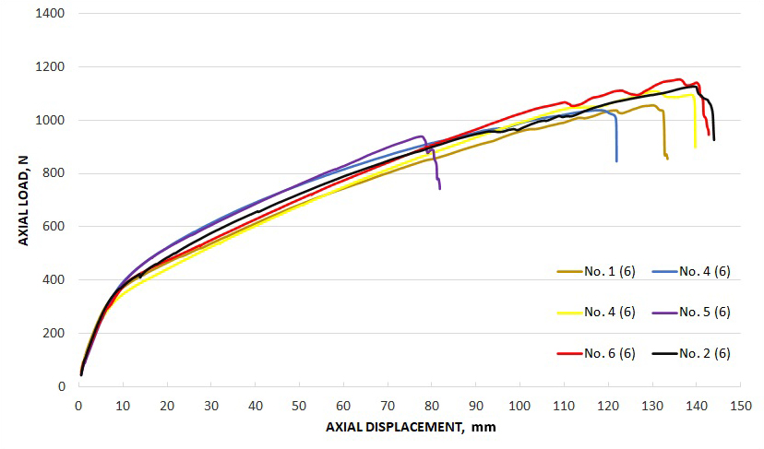
Fig. 7. Relationship between load and axial displacement for PET bars made of 6 strips

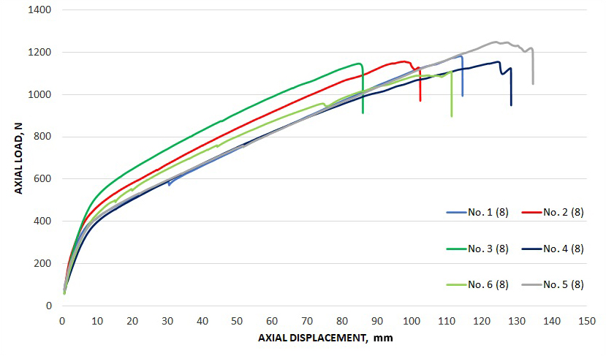
Fig. 8. Relationship between load and axial displacement for PET bars made of 8 strips

In the third stage, a significant decrease in strength can be observed, and the bars break due to the loss of strength of individual strips. Depending on the number of strips, the process is characterised by their gradual breaking (see Figure 9). It can be argued that the load capacity in the elastic range (first stage) of deformation is higher the more PET strips the tested bar consists of (see Table 3) when analysing the tensile test results. All tested bars were of the same length, therefore, the displacement parameter was used for the comparison.

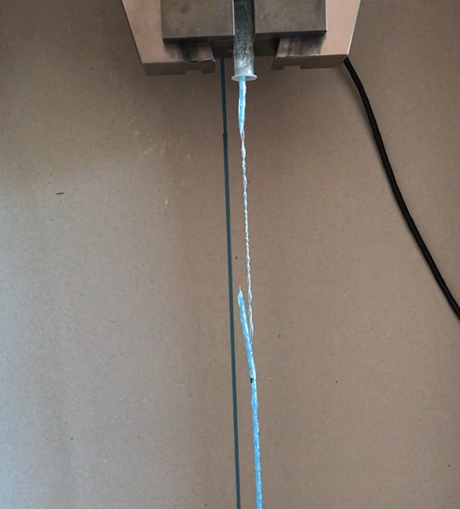 | Fig. 9. Destruction of the strips of the tested PET bar

Table 3. Average values of load corresponding to 8 mm displacement of PET bars
PET bars (number of strips) | Load corresponding to 8 mm displacement [N]
3 | 299
4 | 308
6 | 338
8 | 409

Analysing the maximum displacement and forces, one can also notice the dependence on the cross-section size (number of strips forming a particular PET bar). The results are presented in Table 4.

Table 4. Average values of maximum force and displacement for the tested PET bars
Number of strips | Maximum load [N] | Maximum displacement [mm] | Maximum displacement [%]
3 | 669 | 131 | 65
4 | 818 | 138 | 69
6 | 1070 | 165 | 83
8 | 1166 | 175 ¹ | 88 ¹
¹ One result was removed as an outlier
4. Discussion
The applied method of producing PET bars showed a promising potential in achieved strength characteristics. Some inconsistencies in achieved strength results were noted, but the authors believe they result from currently underdeveloped technological aspects of prepared PET bars. In comparison with the pultrusion method (FRP fibre reinforcement polymer composite bar production technology), which involves dragging the fibre wound on a spool sequentially through the thermosetting resin impregnation system and the shaping element, giving the element the desired form, the proposed approach is less effective from strength and uniformity points of view. Nevertheless, the proposed approach to PET bar production has a large room for improvement associated with homogenisation and automation of the production process. In the pultrusion method, the bars are made of fibres bonded with resin. Therefore, the estimated fibre content in the composite is defined as 40-70% (by volume). This process of bonding all the layers together ensures the homogeneity of the material throughout its cross-section, while PET bars do not have this uniformity. The spotted weaknesses of the proposed approach can be eliminated in the future.
In the case of using PET strips, the process of shaping the bars is based on applying successive layers using only means of pre-stretching and basic thermal treatment. When reaching maximum tensile forces, the PET bars gradually break, enabling greater axial displacement of the bars compared to FRP composite. Non-metallic bars based on glass, carbon and aramid fibres are characterised by a lower value of the modulus of elasticity in relation to steel reinforcing bars. In addition, they show a linear-elastic nature of work in the entire range of strength and are capable of significant linear deformation. PET bars could replace steel reinforcement in low-stress structures (e.g. prefabricated lintels). The flexibility of PET bars allows their easy shaping and placement in formworks. The advantage of non-metallic bars over steel bars is their lack of corrosive capacity, electromagnetic neutrality, and very low specific gravity. Another essential feature of PET bars is their production technology, which is significantly less environmentally harmful than steel bars. The production process of proposed PET bars is not associated with large amounts of carbon dioxide emissions, which are so characteristic of steel production. Moreover, a vast potential for effective recycling of PET bottles is enabled. Future research should also focus on other non-metallic waste materials with higher (in comparison to PET) tensile strength. Polypropylene (PP), which is characterised by tensile strength equal to 150 MPa (Mohammed
& Karim 2023) is one of the possible solutions. Moreover, one can also conceptualise modifying the proposed PET reinforcing bars by waste glass or carbon fibres characterised by tensile strength equal to 1900 MPa and 2900 MPa, respectively (Ho et al. 2023, Zhu et al. 2022). Different shapes and sizes of created and tested reinforcing bars should also be considered to define much more general relationships characterising their properties.
References
ACI. 2012. 440.3R Guide Test Methods for Fiber-Reinforced Polymer (FRP) Composites for Reinforcing or Strengthening Concrete and Masonry Structures.
Ahdal, A.Q., Amrani, M.A., Ghaleb, A.A.A., Abadel, A.A., Alghamdi, H., Alamri, M., Wasim, M., Shameeri, M. (2022). Mechanical Performance and Feasibility Analysis of Green Concrete Prepared with Local Natural Zeolite and Waste PET Plastic Fibers as Cement Replacements. Case Studies in Construction Materials, 17, e01256. https://doi.org/10.1016/j.cscm.2022.e01256.
Alani, A.H., Johari, M.A.M., Noaman, A.T., Bunnori, N.M., Majid, T.A. (2022). Effect of the Incorporation of PET Fiber and Ternary Blended Binder on the Flexural and Tensile Behaviour of Ultra-High Performance Green Concrete. Construction and Building Materials, 331, 127306. https://doi.org/10.1016/j.conbuildmat.2022.127306.
Benavides, P.T., Dunn, J.B., Han, J., Biddy, M., Markham, J. (2018). Exploring Comparative Energy and Environmental Benefits of Virgin, Recycled, and Bio-Derived PET Bottles. ACS Sustainable Chemistry and Engineering, 6(8). https://doi.org/10.1021/acssuschemeng.8b00750.
Benyathiar, P., Kumar, P., Carpenter, G., Brace, J., Mishra, D.K. (2022). Polyethylene Terephthalate (PET) Bottle-to-Bottle Recycling for the Beverage Industry: A Review. Polymers, 14(12), 2366. https://doi.org/10.3390/polym14122366.
Borg, R.P., Baldacchino, O., Ferrara, L. (2016). Early Age Performance and Mechanical Characteristics of Recycled PET Fibre Reinforced Concrete. Construction and Building Materials, 108, 29-47. https://doi.org/10.1016/j.conbuildmat.2016.01.029.
Cai, W., Tremblay, L.A., An, L. (2022). Enhancing Consumption Responsibility to Address Global Plastic Pollution. Marine Pollution Bulletin, 183, 114089. https://doi.org/10.1016/J.MARPOLBUL.2022.114089.
Desta, E., Jun, Z. (2018). A Review on Ground Granulated Blast Slag GGBS in Concrete. 5-10. In: Kuala Lumpur, Malaysia: Institute of Research Engineers and Doctors.
DIN. 1976. 53479 Testing of Plastics and Elastomers; Determination of Density.
Foti, D. (2011). Preliminary Analysis of Concrete Reinforced with Waste Bottles PET Fibers. Construction and Building Materials, 25(4), 1906-15. https://doi.org/10.1016/j.conbuildmat.2010.11.066.
Geyer, R., Jambeck, J.R., Law, K.L. (2017). Production, Use, and Fate of All Plastics Ever Made. Science Advances 3(7). https://doi.org/10.1126/sciadv.1700782.
Gu, L., Ozbakkaloglu, T. (2016). Use of Recycled Plastics in Concrete: A Critical Review. Waste Management, 51,
19-42. https://doi.org/10.1016/J.WASMAN.2016.03.005.
Ho, H., Nguyen, H.C., Dinh, H.T., Ngo, D.Q., Le, D.D. (2023). Experimental Study on the Tensile Strength Degradation of Curved Alkali Resistant Glass and Carbon Textile as Concrete Reinforcement under Complex Loading. Case Studies in Construction Materials, 18, e01947. https://doi.org/10.1016/J.CSCM.2023.E01947.
Jayadurgalakshmi, M., Suganya, N., Udhaya Kumar T. (2023). A State-of-the-Art Review – Mechanical Properties of Light Weight Concrete by Utilising Sintered Fly Ash Aggregate. Materials Today: Proceedings. https://doi.org/10.1016/J.MATPR.2023.05.511.
Jeyanthi, J., Karthikeyan, U., Raj, M.M., Raj, M.K. (2023). Study of Concrete with Partial Replacement of Waste Foundry Sand for Fine Aggregate and Granite Waste for Coarse Aggregate. Materials Today: Proceedings. https://doi.org/10.1016/J.MATPR.2023.06.412.
Kadir, A.A., Hassan, M.I.H. (2014). An Overview of Fly Ash and Bottom Ash Replacement in Self Compaction Concrete. 465-70. In: Key Engineering Materials. Vols. 594-595.
Katzer, J., Kobaka, J. (2009). Influence of Fine Aggregate Grading on Properties of Cement Composite. Silicates Industriels, 74(1-2).
Khalid A., Ismail Al-Hadithi, O.A., Tareq Noaman, A. (2022). Flexural Performance of Layered PET Fiber Reinforced Concrete Beams. Structures, 35, 55-67. https://doi.org/10.1016/J.ISTRUC.2021.11.007.
Kim, S.B., Yi, N.H., Kim, H.Y., Kim, Jang-Ho J., Song, Young-Chul. (2010). Material and Structural Performance Evaluation of Recycled PET Fiber Reinforced Concrete. Cement and Concrete Composites, 32(3), 232-40. https://doi.org/10.1016/j.cemconcomp.2009.11.002.
Kobaka, J. (2021). Principal Component Analysis as a Statistical Tool for Concrete Mix Design. Materials, 14(10), 2668. https://doi.org/10.3390/ma14102668.
Kocot, A., Ćwirzeń, A., Ponikiewski, T., Katzer, J. (2021). Strength Characteristics of Alkali-Activated Slag Mortars with the Addition of Pet Flakes. Materials, 14(21). https://doi.org/10.3390/ma14216274.
Lehner, P., Horňáková, M., Pizoń, J., Gołaszewski, J. (2022). Effect of Chemical Admixtures on Mechanical and Degradation Properties of Metallurgical Sludge Waste Concrete. Materials, 15(23), 8287. https://doi.org/10.3390/ma15238287.
Mohammed, A.A., Karim, S.H. (2023). Impact Strength and Mechanical Properties of High Strength Concrete Containing PET Waste Fiber. Journal of Building Engineering, 68, 106195. https://doi.org/10.1016/J.JOBE.2023.106195.
Mustafa Abdullah, Q., Haido, J.H. (2022). Response of Hybrid Concrete Incorporating Eco-Friendly Waste PET Fiber: Experimental and Analytical Investigations. Construction and Building Materials, 354, 129071. https://doi.org/10.1016/J.CONBUILDMAT.2022.129071.
Pereira, E.L., de Oliveira Junior, A.L., Fineza, A.G. 2017. Optimisation of Mechanical Properties in Concrete Reinforced with Fibers from Solid Urban Wastes (PET Bottles) for the Production of Ecological Concrete. Construction and Building Materials, 149. https://doi.org/10.1016/j.conbuildmat.2017.05.148.
Rumman, R., Bari, M.S., Manzur, T., Kamal, M.R., Noor, M.A. (2020). A Durable Concrete Mix Design Approach Using Combined Aggregate Gradation Bands and Rice Husk Ash Based Blended Cement. Journal of Building Engineering, 30. https://doi.org/10.1016/j.jobe.2020.101303.
Salazar, C., Jaime, M., Leiva, M., González, N. (2022). From Theory to Action: Explaining the Process of Knowledge Attitudes and Practices Regarding the Use and Disposal of Plastic among School Children. Journal of Environmental Psychology, 80. https://doi.org/10.1016/j.jenvp.2022.101777.
Salhotra, S., Khitoliya, R.K. Kumar Arora, S. (2022). Assessing the Enhanced Concrete-Properties Induced by Sugarcane Bagasse Ash-Coated PET-Fibers. Materials Today: Proceedings, 48, 994-1000. https://doi.org/10.1016/j.matpr.2021.06.319.
Salhotra, S., Khitoliya, R.K., Kumar, S. (2021). Comparative Study of Uncoated and Coated Waste PET Fiber for Sustainable Concrete. Materials Today: Proceedings. https://doi.org/10.1016/j.matpr.2021.06.060.
Sharma, R., Bansal, P.P. (2016). Use of Different Forms of Waste Plastic in Concrete – a Review. Journal of Cleaner Production, 112, 473-82. https://doi.org/10.1016/J.JCLEPRO.2015.08.042.
Silva, D.A., Betioli, A.M., Gleize, P.J.P., Roman, H.R., Gómez, L.A., Ribeiro, J.L.D. (2005). Degradation of Recycled PET Fibers in Portland Cement-Based Materials. Cement and Concrete Research, 35(9). https://doi.org/10.1016/j.cemconres.2004.10.040.
Thomas, L.M., Moosvi, S.A. (2020). Hardened Properties of Binary Cement Concrete with Recycled PET Bottle Fiber: An Experimental Study. Materials Today: Proceedings, 32, 632-37. https://doi.org/10.1016/j.matpr.2020.03.025.
Valentin, A.P.M., Hechanova, M.R.M. (2023). Addressing Plastic Pollution through Green Consumption: Predicting Intentions to Use Menstrual Cups in the Philippines. Journal of Retailing and Consumer Services, 71, 103204. https://doi.org/10.1016/J.JRETCONSER.2022.103204.
Walker, T.R. (2022). Calling for a Decision to Launch Negotiations on a New Global Agreement on Plastic Pollution at UNEA5.2. Marine Pollution Bulletin, 176, 113447. https://doi.org/10.1016/J.MARPOLBUL.2022.113447.
Wang, F., Meng, F., Feng, T., Wang, Y., Jiang, J., Shi, J. (2023). Effect of Stone Powder Content on the Mechanical Properties and Microstructure of Tunnel Slag Aggregate-Based Concrete. Construction and Building Materials, 388, 131692. https://doi.org/10.1016/J.CONBUILDMAT.2023.131692.
Wang, S. (2023). International Law-Making Process of Combating Plastic Pollution: Status Quo, Debates and Prospects. Marine Policy, 147, 105376. https://doi.org/10.1016/J.MARPOL.2022.105376.
Wang, Y, Huang, H., Zeng, J., Hu, W., Cheng, Y. (2023). Axial Compressive Behavior of Recycled Ceramic Coarse Aggregate Concrete-Filled Steel Tubular Columns. Journal of Constructional Steel Research, 210, 108040. https://doi.org/10.1016/J.JCSR.2023.108040.
Wiliński, D., Łukowski, P., Rokicki, G. (2016). Application of Fibres from Recycled PET Bottles for Concrete Reinforcement. J. Build. Chem, 1.
Zhu, L., Wen, T., Tian, L. (2022). Size Effects in Compressive and Splitting Tensile Strengths of Polypropylene Fiber Recycled Aggregate Concrete. Construction and Building Materials, 341, 127878. https://doi.org/10.1016/J.CONBUILDMAT.2022.127878.

