 | Rocznik Ochrona Środowiska
 | Volume 25 | Year 2023 ISSN 2720-7501 | pp. 141-147
 | https://doi.org/10.54740/ros.2023.014 open access
 | Received: June 2023 Accepted: July 2023 Published: July 2023
Cold Plasma Surface Modification of PLA and LDPE Polymer Plastics
Karol Leluk
Faculty of Environmental Engineering, Wrocław University of Science and Technology, Poland
https://orcid.org/0000-0002-1992-7477
corresponding author's e-mail: karol.leluk@pwr.edu.pl
Abstract: Low-density polyethylene (LDPE) and polylactic acid (PLA) plastic films were subjected to modification using different plasma sources. Argon, nitrogen, air and oxygen were used as a gas phase throughout the process, and their impact on the material's surface properties was verified. The surface activation rate was measured via atomic force microscopy regarding the porosity factor and using the water contact angle technique. The last method – being feasible, agile and of high sensitivity to alternating physicochemical surface character – was utilised to verify the post-process stability of the modified surface. Those tests were performed extensively, up to 160 hours (contact angle) and 240 hours (atomic force microscopy).
Keywords: packaging plastic, plasma modification, wetting, surface properties
1. Introduction
It has been widely observed that biopolymers – polymer plastics of sustainable origin- are increasingly used in many industrial branches. Although their world production rate is still relatively marginal (Plastics Europe – a Report. Plastics – the Facts 2022 2022) as well as abundance in end-products far from frequent, one can no longer neglect their presence in the polymer processing world (Rosenboom et al. 2022). Most commonly known bioplastic is polylactic acid (PLA) (Ali et al. 2023, Patel et al. 2022, DeStefano et al. 2020), which has been produced for years by many manufacturers like NatureWorks LLC, NaturePlast, Sybra Technology or Total Corbion to name only few most recognisable ones. However physicomechanical properties of PLA are, to say at least, not entirely satisfactory for an overwhelming variety of demandful industrial products (Oksiuta et al. 2020, Ebadi-Dehaghani et al. 2015). This is why many manufacturers decided to produce bioplastics which, in fact, are blends (Mater-Bi™, Novamont) and/or copolymer plastics (like Ecoflex™, BASF) not so rarely being composed of non-sustainable constituents (Reimer et al. 2008, Moshood et al. 2022). A much easier and cost-effective way is to modify bioplastic matrix by addition of specific filler leading to improvement in barrier (Singha & Hedenqvist 2020, Yuniarto & Welt 2017, Pan et al. 2021), mechanical (Wang et al. 2019, Asadollahi et al. 2022) or biostatic (Liu et al. 2022) properties. It is a much more flexible way of modifying bioplastic properties compared to chemical processing related to the molecular structure of the polymer chain. However, the limits to which such a modification can be carried out are reached much earlier. On the other hand, bioplastic materials are not always mandatory to reveal their high-performance properties during the product's whole life cycle (Starkova et al. 2022). When it comes to common customer-related products, not only the material's performance has to be emphasised and its appearance (White et al. 2016, Astvansh 2021). This issue is of great importance when discussing packaging materials, especially those designed for end-user (individual clients). Apart from protecting the goods from the external environment, those products also play a crucial role in marketing-related issues. The product to be sold has to be of the finest quality itself but, not less importantly: being eye-catching and attractive is a key factor when discussing increasing the selling rate. That is why packaging manufacturers also focus on surface printability as a crucial parameter for the materials designed for packaging (Pankaj et al. 2014, Ozdemir et al. 1999). Foils, plastic bags and containers are much less attractive if they are only transparent or colourless. Besides the commonly met process of introducing crucial data to the packaging surface, like bar code, ingredient list, expiration date or even LOT number, product's name and/or glossy, vivid colours covering the packaging foil always grab customers' attention.
The surface of most polymer materials has to be activated via different methods before being covered with ink (Non-Thermal Plasma Technology for Polymeric Materials 2019, Fard et al. 2017, Matsunaga & Whitney 2000). Corona discharge, plasma or chemical activation are the most commonly used methods for activating the polymer plastic surface just before printing, thus allowing the ink to cover the plastic surface and bond to it much more tightly. In industrial plants, the process is mainly held by corona discharge (Božović et al. 2023, Lee et al. 2017) due to its relative simplicity in conducting the process as well equipment construction.
Although plasma treatment has to be conducted in a much more demandful environment (for instance: very low pressure induces non-continuous treatment of the objects of finite geometry), it allows to variably modify the structure by simply alternating process parameters. That high-energy treatment leads to the modification of a complicated mechanism of chemical transformation, leading to many by-products and, to some extent – uncontrolled processes. The modification has a short-lasting effect; however, the time frame is adequate for modifying industrial processes. The paper comes with a quantitative data discussion relating to the plasma-type impact on each polymer and the decay rate after the modification process. Simultaneously, the effect of surface morphology alteration is discussed basing on AFM images and, more importantly, absolute values allowing to compare plasma type impact on different polymer films.
2. Materials and Methods
In the study, two commercially available materials were chosen. Low-density polyethylene (LDPE) - Basell-Orlen, Malen E FGAN 23-D003, and polylactic acid (PLA) – NatureWorks 3052D, both in the granular form. Their principal physical properties are listed in Table 1. The first one represents the most abundant material in the polymer plastic packaging industry, and PLA is a commonly recognisable representative of sustainable plastic. Both were used to manufacture rectangular films with 100 cm² area and 0.15 mm thickness, from which smaller samples were cut out (20x20 mm) and later used for plasma processing purposes. Rectangular-shaped film samples were made in a press moulding process (LabTech press) under typical process conditions: LDPE – 150°C, 20 bar, 3 minutes, PLA – 185°C, 20 bar, 3 minutes. Preheating time was set to 2 minutes regardless of polymer plastic type.

Table 1. Physical properties of LDPE and PLA granulate used in the study
Parameter | Unit | Value
 |  | LDPE | PLA
Density | g/cm³ | 0.924 | 1.24
MFR | g/10 min | 0.28/190°C, 2.16 kg | 14/210°C, 2.16 kg
Melting temperature | °C | 114 | 145-160
Glass transitom temperature | °C | – | 55-60
Vicat/HDT | °C | 96 | 55
Processing temperature | °C | 170-220 | 165-205

Samples were subjected to a radio frequency plasma source, where the parameter to be changed was the gas type: argon, nitrogen, oxygen and air. Modification time (5.0 min), power of the source (50 W), gas pressure (10 Pa) and flow (7 cm³/min), as well as experimental set-up geometry – the sample distance from the electrode, remain unchanged. After modification, samples were left in the sealed plasma chamber for 20 minutes and then transported to the container (air atmosphere) to prevent the material from the accidental excessive influence of ambient factors like sunlight or contamination by dust and left there for further characterisation.
Materials were characterised via atomic force microscopy (AFM – Qscope Quesant) and water contact angle (wetting). Both techniques were applied before and after sample modification to verify the process impact on the surface morphology and the chemical structure. AFM measurements were performed on areas of different dimensions: 19x19 µm and 10x10 µm with RMS [µm] and its mean deviation as a result. RMS (root mean square) is related to the height alteration along the specified sampling length, which position was set invariably regardless of the sample type. Additionally, to estimate the modification decay time frame, water contact angle testing was repeated in specific time frames to acquire results in the most comparable manner and post-modification conditions. The first measurement (after the modification) was performed 5-15 minutes after plasma treatment, depending on the experiment conditions.
The plasma reactor and contact angle measuring unit were custom-made by the Department of Mathematics and Physics, Faculty of Physics of Polymers, Charles University, Prague, Czech Republic. The access was kindly allowed to perform experiments. The software code for contact angle calculations was written and compiled by mgr Pavel Solar affiliated.

3. Results and Discussion
Before modification, both materials' surfaces were characterised using AFM. According to calculated RMS values (Tables 1 and 2 – first row) and presented graphical representation presented on Figs. 1 and 2, it is clearly visible that surfaces may be described as "smooth" irrespective of the characterised area.

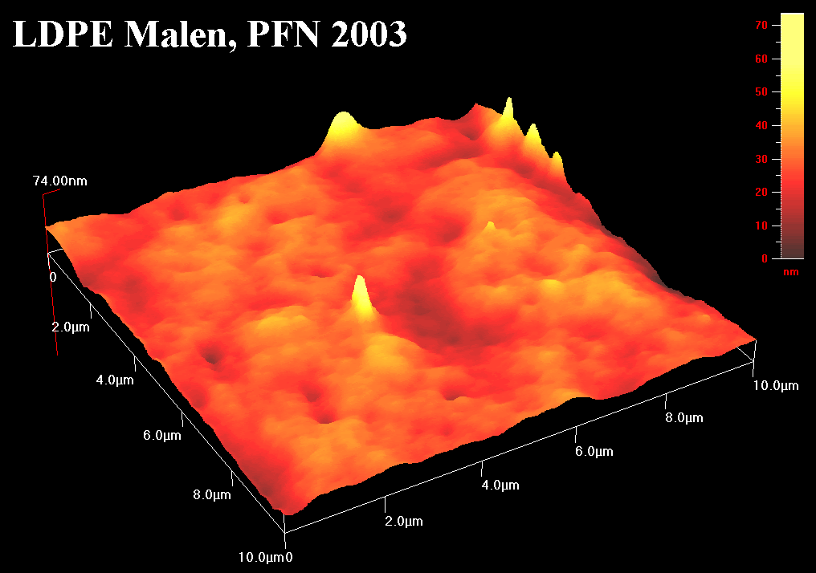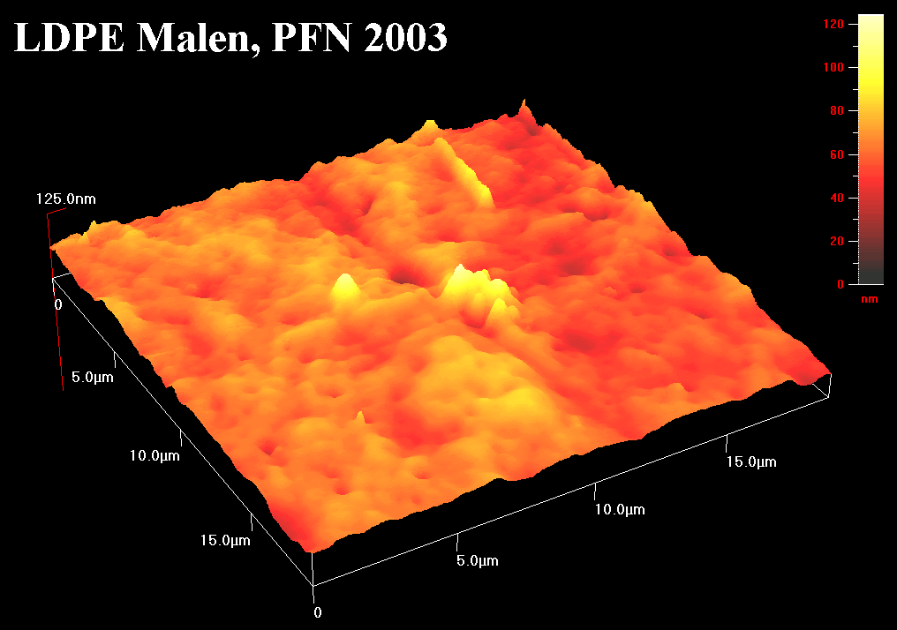
Fig. 1. Captured images of unmodified LDPE sample surface: 10x10 µm (left) and 19x19 µm (right)

It has to be taken into consideration that neat samples (before modification) were manufactured by the press moulding technique without any further surface processing, possibly leading to a decrease in roughness. Visible on captured images (Figs. 1 and 2) high peaks and low funnel cones should be assigned as a side effect of the press moulding process, which was not prioritised for the production of a "low roughness surface" but to achieve a sample in the conditions in a most likely industrial environment. Considering this, it is much more likely that the mean deviation of the calculated RMS value for untreated samples was relatively high.

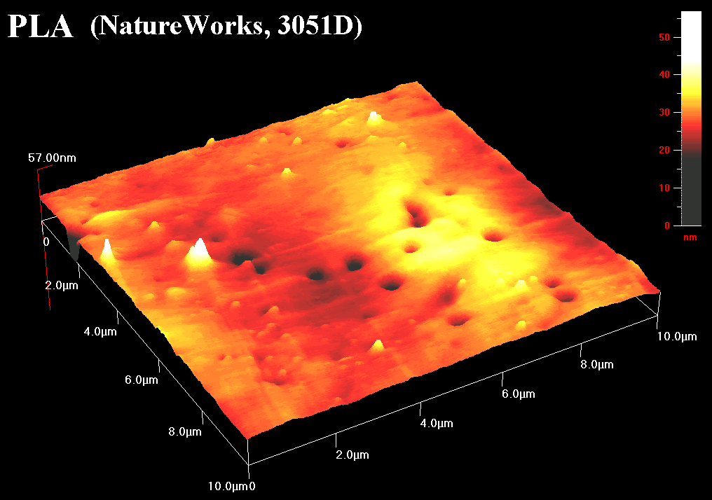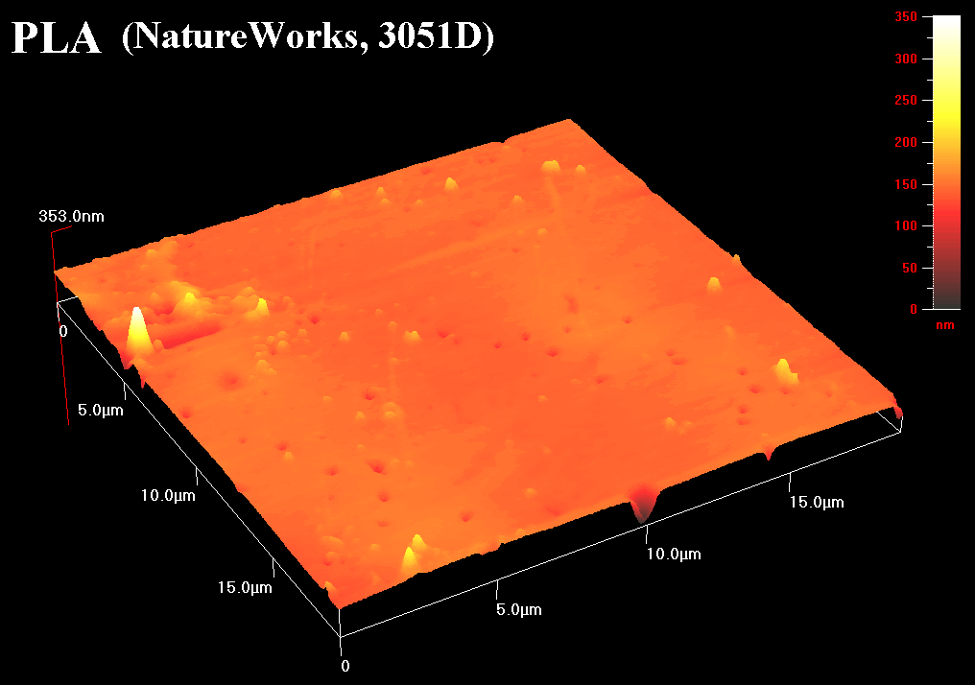
Fig. 2. Captured images of unmodified PLA sample surface: 10x10 µm (left) and 19x19 µm (right)

Applying different plasma treatments (various gases in particular) led to huge discrepancies among treated materials of the same polymer type. According to the data presented for LDPE in Table 2, the most effective (in terms of highest impact on increasing surface roughness) plasma type was the one using inert gas – argon and nitrogen. The relative increase of RMS is almost twice as much as the initial value, irrespective of characterised surface area. The alteration of the surface roughness ratio in time is worth noting, represented in the third and fifth columns of Table 2. Numbers after a hyphen indicate the time frame (in hours) after modification when the final measurement was made. In all samples, RMS decreased its value (please compare values in columns fourth and fifth in Table 2) but still, differences remained among the samples treated by different plasma types. After over a week, RMS measured for argon and air plasma treated samples was found to be 8.8 and 9.9 (respectively), almost equal to that recorded for unmodified LDPE (9.1). RMS was considerably higher in nitrogen and oxygen plasma-treated samples, preserving elevated RMS at more than 150% of its initial value. What is more, oxygen plasma-treated LDPE seems to be highly resistant to decay processes, with roughness ratio (RMS) being in its peak value (14.2) and preserving almost unchanged value after 10 days (14.0).

Table 2. RMS values and their mean deviation calculated for the LDPE sample
Gas type | RMS (mean dev) – 10 x10 µm |  | RMS (mean dev) – 19 x19 µm
Unmodified | 5.8 (4.4) |  | 9.1 (6.9)
Ar | 11.4 (7.7) | 6.3 (4.6) – 210h | 15.4 (11.26) | 8.8 (6.5) – 210h
Air | 5.2 (3.3) | 6.3 (4.7) – 192h | 14 (8.5) | 9.9 (6.7) – 192h
N₂ | 11 (7.9) | 10.2 (7.7) – 187h | 22.3 (14.8) | 16.8 (10.9) – 187h
O₂ | 9.6 (7.1) | 6.6 (4.6) – 240h | 14.2 (10.3) | 14.0 (10.2) – 240h

Similar divagations may be carried out on PLA-modified samples. As reported in Table 3, each modification process led to a remarkable effect, mostly increasing RMS to at least one order of magnitude. Also, contrary to LDPE, the decay is not a straightforward process leading to only a slight decrease in RMS. Referring to Table 3, only the sample subjected to nitrogen-assisted plasma irradiation revealed a 15-20% loss in RMS. All other materials showed increasing RMS value with time which may be explained by some post-treatment processes modestly increasing surface roughness ratio. By analysing the mean deviation value (refer to Table 3, columns fourth and fifth), it may also be considered that the dimension diversity of surface peaks and funnel cones has considerably increased after plasma processing.

Table 3. RMS values and their mean deviation calculated for the PLA sample
Gas type | RMS (mean dev) – 10 x10 µm |  | RMS (mean dev) – 19 x19 µm
Unmodified | 3.5 (2.6) |  | 8.3 (4.7)
Ar | 30.4 (14.7) | 44.2 (28.6) – 210h | 53.3 (34.2) | 64.3 (39.1) – 210h
Air | 68.0 (41.7) | 88.6 (48.6) – 192h | 113.9 (65.7) | 121.3 (76.6) – 192h
N₂ | 84.9 (63.0) | 69.1 (54.7) – 187h | 98.4 (78) | 84.9 (60.8) – 187h
O₂ | 71.7 (42.7) | 53.6 (33.1) – 240h | 83.3 (47.1) | 102.5 (63.6) – 240h

When comparing RMS values for LDPE and PLA (columns nos. 2 and 4 in respective Tables 1 and 2), one can easily notice that surface roughness alteration for LDPE was relatively slight. That observation may be easily supported by both polymer plastics' commonly known chemical composition and structure. While LDPE consists of a simple hydrocarbon chain, PLA backbone is of a polyester nature in contrast with many oxygen atoms and double bonding therein. Absence of heteroatoms and double bonds in LDPE results in high resistance to many chemical factors and physical treatment. However, applying a high energy beam on the surface (supported with proper gas – i.e. oxygen) has to affect even the most resistive material, but still, chemical structure alterations were not even expected to occur at the level observed in PLA-modified samples. Interestingly, oxygen-assisted plasma treatment led to a stable structure in LDPE, indicating permanent modification and increased surface activity.
Some general observations can be withdrawn from water contact angle measurements, regardless of the plasma type used. LDPE surface exposed to a high energy source changed its hydrophobic character (contact angle around 90 degrees) to hydrophilic, with a water contact angle around half of the initial value (Figure 3). Subsequent wetting measurements reveal increasing water contact angle with time (asymptotically) but not restoring the initial value even after a considerably long experiment time frame (up to 160 hrs). What is essential, the final value of the water contact angle does not significantly differ, disregarding the plasma type used, and oscillates around 60 degrees indicating turning the surface character to a more hydrophilic one. The discrepancies among them are within the experimental error margin, which is represented by error bars in Figure 3.
A similar tendency (massive decrease of a water contact angle) was observed in PLA-modified samples, presented in Figure 4. The initial value decreased from 60 to around 10 degrees (for argon, air and nitrogen plasma). The only exception was oxygen plasma, where the measured water contact angle after modification decreased only by 10 degrees. Alike for LDPE, a subsequent increase in water contact angle value was observed apart from the fact that the asymptotic characteristic was remarkably steeper and led to the restoration of initial wetting characteristics (the final contact angle was comparable to the initial one). Referring to data presented in Figures 3 and 4 in a more quantitative way, it has to be noted that it took no longer than five hours for PLA samples to restore their wetting character, whereas the LDPE surface became permanently changed. There also exist differences among plasma type influence on PLA surface. The most stable structure (after modification) seems to be revealed for air plasma (4 hours with the lowest contact angle), then nitrogen (2.5 hrs) and argon and oxygen being the least stable. PLA modified with argon plasma sustained its active state (with the lowest contact angle) only up to the first hour after modification as well oxygen modified PLA sample lasted longer, but also the contact angle decreased only by 1/6 of its initial value.
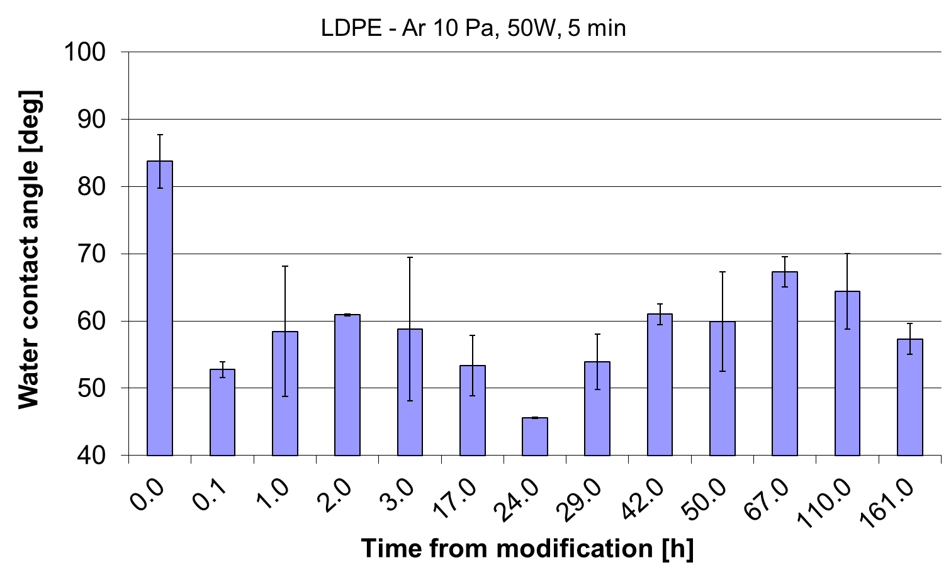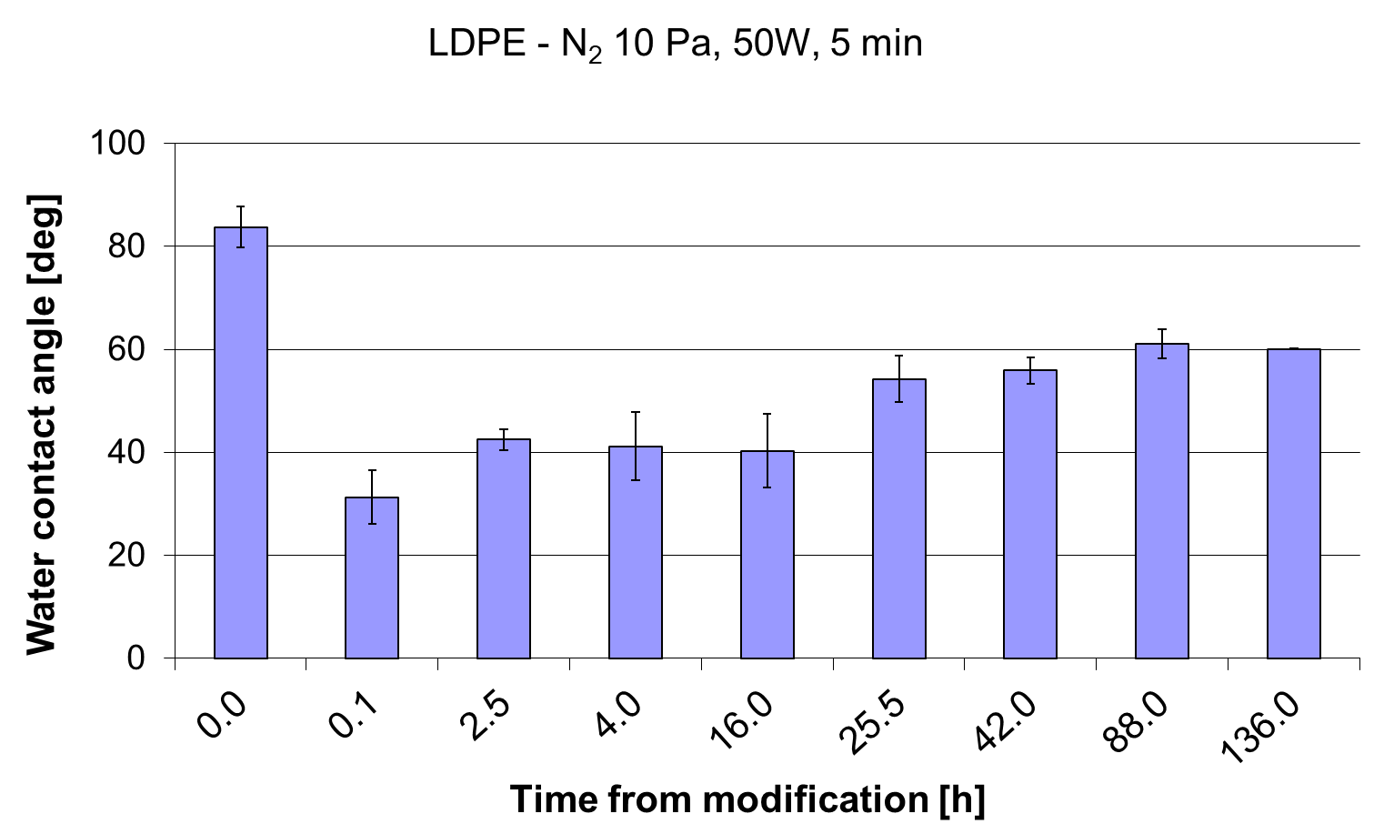
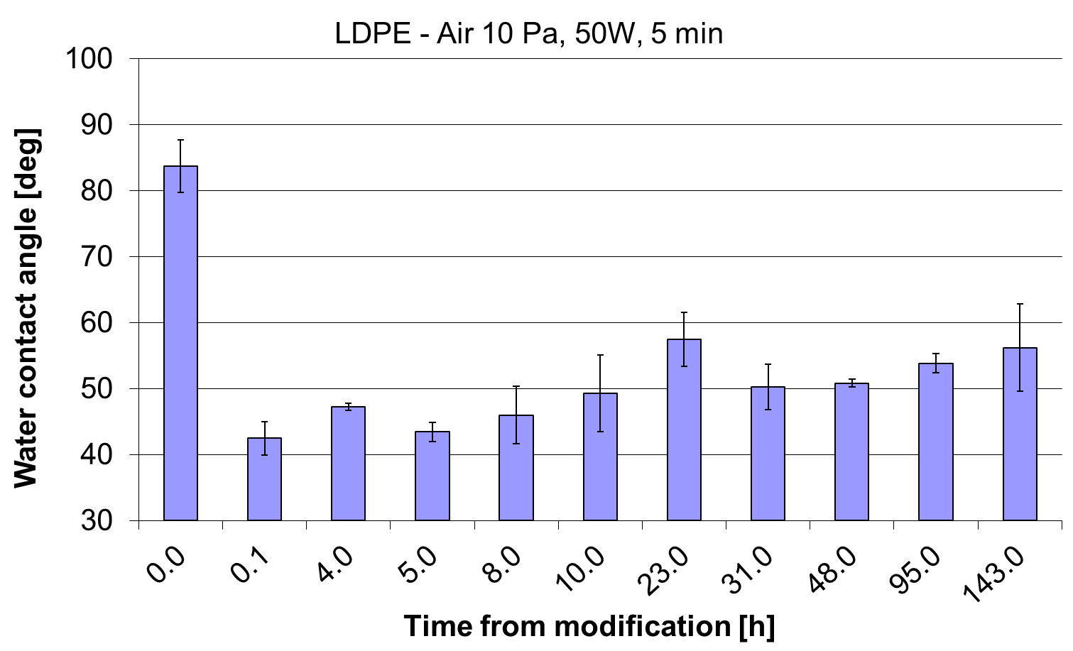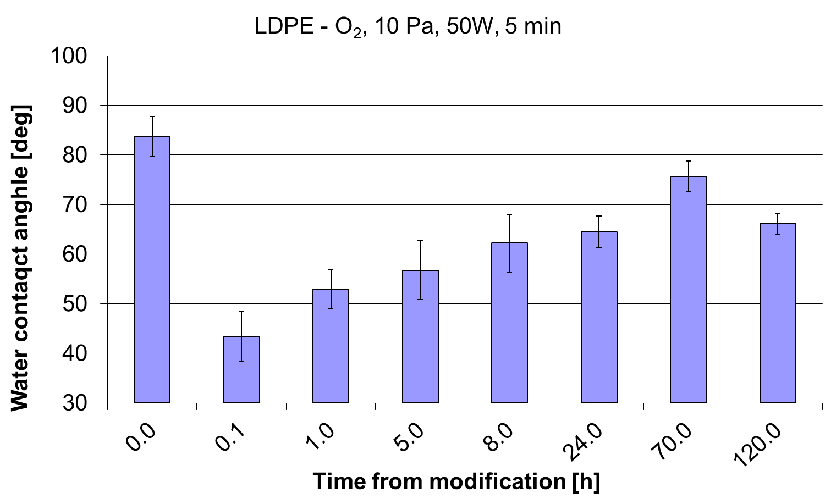
Fig. 3. Water contact angles alternation in the time domain for four different plasma-modified LDPE

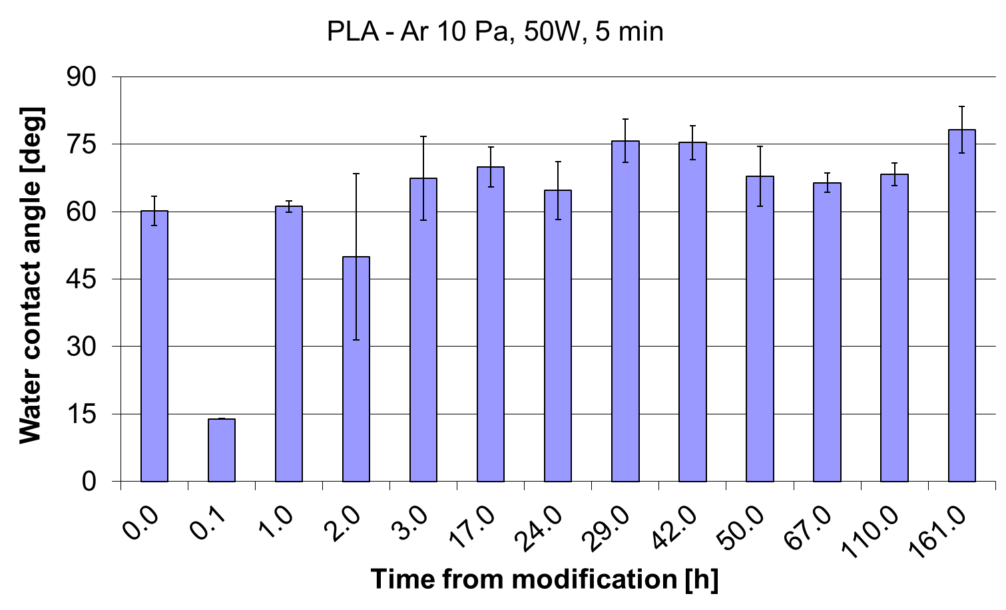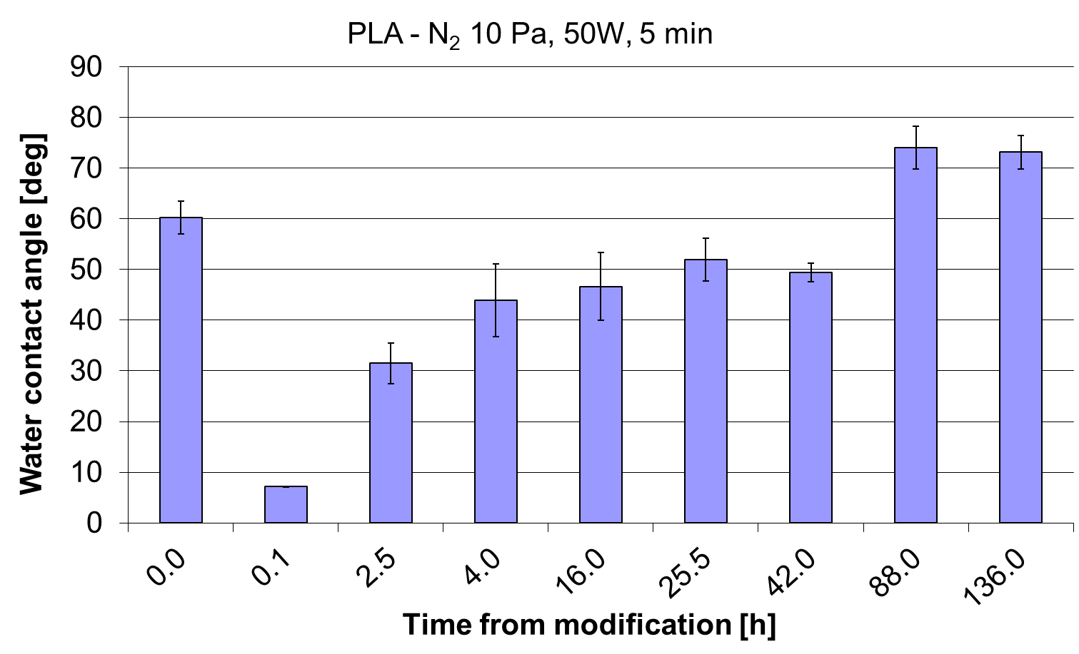
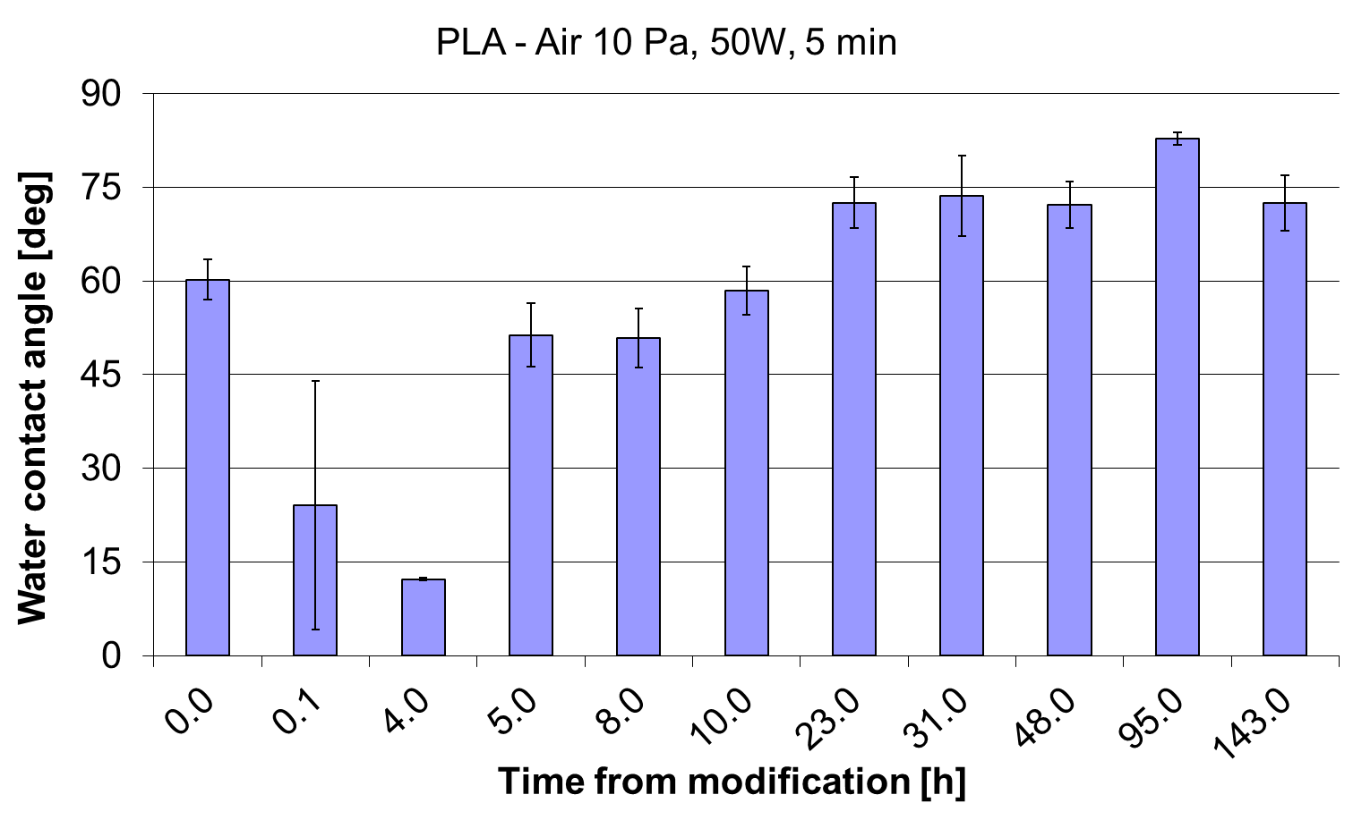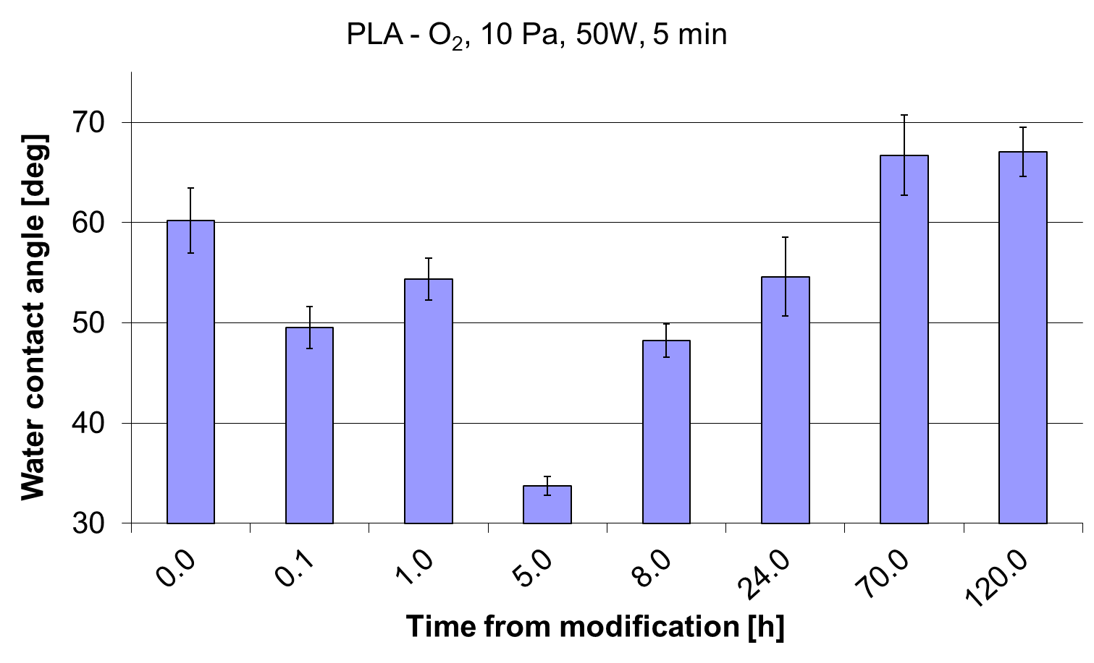
Fig. 4. Water contact angles alternation in the time domain for four different plasma-modified PLA

4. Conclusions
Plasma modification leads to physical and chemical alteration of the modified surface. The differences were observed not only on different impacts on the material type but also among the same polymer material subjected to different inert gases. Surprisingly, air and oxygen plasma do not always lead to modification, with the most remarkably emphasised changes, in terms of time stability or water contact angle.
Although counting on AFM and contact angle measurements, it is pointless to discuss the detailed chemical and physical transformation of the modified surface; those two techniques give sufficient quantitative insight into the modification range (increasing surface activity) and the time when those supreme parameters are sustained. That comparison gives a usable dataset which may be profitable for polymer surface processing techniques from the continuous modification process (applied for industrial scale). It is beneficial to utilise a specific plasma source giving an advantage on the modification degree (the most active surface – with the lowest contact angle) or compromising the activity with the longest modification effect duration, considering printing techniques commonly used in the packaging industry.
On the other hand, verifying plasma impact on the modified surface for two different materials (LDPE and PLA) in the long time frame gave valuable information considering post-processing stability. PLA seems to have a much more diverse surface (high RMS). In contrast, changes in LDPE samples were more of a chemical character with considerably lower final water contact angle but only slightly changed RMS (compared to PLA sample).

The author would like to express his deepest gratitude to Prof. RNDr. Hynek Biederman, DrSc., Head of Group of Thin Films and Surfaces, Department of Macromolecular Physics, Faculty of Mathematics and Physics, Charles University, Prague (Czech Republic), for limitless allowance of the facility allowing to perform the experiment. Measurements were conducted during Short Term Scientific Mission,
Cooperation in Science and Technology (COST action FA0904).

References
Ali, W., Ali, H., Gillani, S., Zinck, P., Souissi, S. (2023). Polylactic acid synthesis, biodegradability, conversion to microplastics and toxicity: A review. Environmental Chemistry Letters, 21(3), 1761-1786. https://doi.org/10.1007/s10311-023-01564-8
Asadollahi, M., Gerashi, E., Zohrevand, M., Zarei, M., Sayedain, S.S., Alizadeh, R., … Atari, M. (2022). Improving mechanical properties and biocompatibility of 3D printed PLA by the addition of PEG and titanium particles, using a novel incorporation method. Bioprinting, 27, e00228. https://doi.org/10.1016/j.bprint.2022.e00228
Astvansh, V. (2021). Winning with Packaging: When Does Repackaging Elevate Sales? SSRN Electronic Journal. https://doi.org/10.2139/ssrn.3984942
Božović, A., Tomašević, K., Benbettaieb, N., Debeaufort, F. (2023). Influence of Surface Corona Discharge Process on Functional and Antioxidant Properties of Bio-Active Coating Applied onto PLA Films. Antioxidants, 12(4), 859. https://doi.org/10.3390/antiox12040859
DeStefano, V., Khan, S., Tabada, A. (2020). Applications of PLA in modern medicine. Engineered Regeneration, 1,
76-87. https://doi.org/10.1016/j.engreg.2020.08.002
Ebadi-Dehaghani, H., Khonakdar, H.A., Barikani, M., Jafari, S.H. (2015). Experimental and theoretical analyses of mechanical properties of PP/PLA/clay nanocomposites. Composites Part B: Engineering, 69, 133-144. https://doi.org/10.1016/j.compositesb.2014.09.006
Fard, M.A., Reid, A.J., Hepburn, D.M. (2017). Analysis of HVDC superimposed harmonic voltage effects on partial discharge behavior in solid dielectric media. IEEE Transactions on Dielectrics and Electrical Insulation, 24(1),
7-16. https://doi.org/10.1109/TDEI.2016.005934
Lee, T., Puligundla, P., Mok, C. (2017). Corona Discharge Plasma Jet Inactivates Food-borne Pathogens Adsorbed onto Packaging Material Surfaces: CDPJ decontamination of packaging material surfaces. Packaging Technology and Science, 30(10), 681-690. https://doi.org/10.1002/pts.2311
Liu, M., Bauman, L., Nogueira, C.L., Aucoin, M.G., Anderson, W.A., Zhao, B. (2022). Antimicrobial polymeric composites for high-touch surfaces in healthcare applications. Current Opinion in Biomedical Engineering, 22, 100395. https://doi.org/10.1016/j.cobme.2022.100395
Matsunaga, M., Whitney, P. J. (2000). Surface changes brought about by corona discharge treatment of polyethylene film and the effect on subsequent microbial colonisation. Polymer Degradation and Stability, 70(3), 325-332. https://doi.org/10.1016/S0141-3910(00)00105-1
Moshood, T.D., Nawanir, G., Mahmud, F., Mohamad, F., Ahmad, M.H., AbdulGhani, A. (2022). Sustainability of biodegradable plastics: New problem or solution to solve the global plastic pollution? Current Research in Green and Sustainable Chemistry, 5, 100273. https://doi.org/10.1016/j.crgsc.2022.100273
Non-Thermal Plasma Technology for Polymeric Materials. (2019). Elsevier. https://doi.org/10.1016/C2016-0-03254-0
Oksiuta, Z., Jalbrzykowski, M., Mystkowska, J., Romanczuk, E., Osiecki, T. (2020). Mechanical and Thermal Properties of Polylactide (PLA) Composites Modified with Mg, Fe, and Polyethylene (PE) Additives. Polymers, 12(12), 2939. https://doi.org/10.3390/polym12122939
Ozdemir, M., Yurteri, C.U., Sadikoglu, H. (1999). Physical Polymer Surface Modification Methods and Applications in Food Packaging Polymers. Critical Reviews in Food Science and Nutrition, 39(5), 457-477. https://doi.org/10.1080/10408699991279240
Pan, Z., Ju, Q., Zhao, D., Shen, Y., Wang, T. (2021). Enhanced oxygen barrier properties of poly(lactic acid) via oxygen scavenging strategy combining with uniaxial stretching. International Journal of Biological Macromolecules, 181, 521-527. https://doi.org/10.1016/j.ijbiomac.2021.03.161
Pankaj, S.K., Bueno-Ferrer, C., Misra, N.N., Milosavljević, V., O'Donnell, C.P., Bourke, P., … Cullen, P.J. (2014). Applications of cold plasma technology in food packaging. Trends in Food Science & Technology, 35(1), 5-17. https://doi.org/10.1016/j.tifs.2013.10.009
Patel, M.K., Hansson, F., Pitkänen, O., Geng, S., Oksman, K. (2022). Biopolymer Blends of Poly(lactic acid) and Poly(hydroxybutyrate) and Their Functionalization with Glycerol Triacetate and Chitin Nanocrystals for Food Packaging Applications. ACS Applied Polymer Materials, 4(9), 6592-6601. https://doi.org/10.1021/acsapm.2c00967
Plastics Europe – A report. Plastics – The facts 2022. (2022). Plastics Europe. Retrieved from https://plasticseurope.org/knowledge-hub/plastics-the-facts-2022/
Reimer, V., Künkel, A., Philipp, S. (2008). An Eco Efficiency Evaluation: Bio-Sense or Nonsesne. Kunstoffe International. Retrieved from https://plastics-rubber.basf.com/global/en/performance_polymers/products/ecoflex.html
Rosenboom, J.-G., Langer, R., Traverso, G. (2022). Bioplastics for a circular economy. Nature Reviews Materials, 7(2), 117-137. https://doi.org/10.1038/s41578-021-00407-8
Singha, S., Hedenqvist, M.S. (2020). A Review on Barrier Properties of Poly(Lactic Acid)/Clay Nanocomposites. Polymers, 12(5), 1095. https://doi.org/10.3390/polym12051095
Starkova, O., Gagani, A.I., Karl, C.W., Rocha, I.B.C.M., Burlakovs, J., Krauklis, A.E. (2022). Modelling of Environmental Ageing of Polymers and Polymer Composites – Durability Prediction Methods. Polymers, 14(5), 907. https://doi.org/10.3390/polym14050907
Wang, S., Daelemans, L., Fiorio, R., Gou, M., D’hooge, D.R., De Clerck, K., Cardon, L. (2019). Improving Mechanical Properties for Extrusion-Based Additive Manufacturing of Poly(Lactic Acid) by Annealing and Blending with Poly(3-Hydroxybutyrate). Polymers, 11(9), 1529. https://doi.org/10.3390/polym11091529
White, K., Lin, L., Dahl, D.W., Ritchie, R.J.B. (2016). When Do Consumers Avoid Imperfections? Superficial Packaging Damage as a Contamination Cue. Journal of Marketing Research, 53(1), 110-123. https://doi.org/10.1509/jmr.12.0388
Yuniarto, K., Welt, B.A. (2017). Morphological, Thermal and Oxygen Barrier Properties Plasticized Film Polylactic Acid. Journal of Applied Packaging Research, 9(3).

