 | Rocznik Ochrona Środowiska
 | Volume 25 | Year 2023 ISSN 2720-7501 | pp. 86-104
 | https://doi.org/10.54740/ros.2023.010 open access
 | Received: May 2023 Accepted: June 2023 Published: June 2023
Geothermal Potential of the Lublin Trough is Low-temperature and North-concentrated. What May Be Environmental Impact of Their Use?
Bartłomiej Ciapała
Department of Energy Resources, Faculty of Geology, Geophysics and Environmental Protection,
AGH University of Krakow, Poland
https://orcid.org/0000-0002-5362-0612
corresponding author's e-mail: bciapala@agh.edu.pl
Abstract: The geothermal potential is challenging to assess, as on the one hand it requires subsurface parametric description; on another – the variable surface influences the potential and geological conditions. In the article, the author presents a novel method for assessing geothermal potential and its environmental impact. The procedure is implemented to evaluate the geothermal potential of the Lublin trough. Geological modelling and GIS analyses are used to determine prospective areas where geothermal water accessibility and sufficient head demand occur in the direct vicinity. Maximal geothermal heat production is estimated, and upon that – possible avoided emissions of air pollutants. The study results indicate that this region's geothermal resources are of low temperature (<50°C), so the only opportunity for exploitation is the direct use of geothermal water in objects or the operation of ultra-low-temperature district heating systems. The main geothermal energy production potential of the Lublin trough is in its northern part, close to the Warszawa trough and nearby main fracture zones. In total, up to 300 GWh of geothermal heat per year might be produced and consumed in the study area if residential and commercial objects could take advantage of ultra-low-temperature district heating system. It would lead to locally significant limitation of air pollutant emissions and decreased fossil fuel consumption.
Keywords: geothermal, district heating, energy, heat, assessment
1. Introduction
One of the most commonly listed ways of reducing air pollution in Poland is the replacement of individual solid-fuel heat sources with other devices or connecting to district heating. Simultaneously, district heating systems face serious challenges in reducing CO₂ emissions, mostly because of the popularity of coal-fired heat plants. One of the most promising ways of phasing out fossil fuels from the heating sector is the use of geothermal energy. Some areas in Poland remain obvious for geothermal heat exploration, like the Podhale region or Central and North-West Poland (Kępińska 2020), yet geothermal heat is also available in other places.
The aim of the present paper is to:
- introduce a methodology for identifying areas with potential for low-temperature geothermal resource exploration that takes into account the practical feasibility of using geothermal heat at the surface rather than solely considering the amount of geothermal energy stored underground;
- indicate what the possible positive environmental impact of low-temperature geothermal resources is.

The chosen method, id est GIS-supported analyses, has already been applied worldwide (Zhang et al. 2020), also considering terrain conditions (Trumpy et al. 2016), yet with a different methodology. Namely, the levelized cost of energy was used as a threshold for assessing prospectivity. There is also an abundant body of articles evaluating the geothermal potential use with heat pumps (Bayer et al. 2019). In the present paper, the surface threshold value is related to energy consumption opportunity, volume and heat capacity, without economic conditions, which change rapidly.

1.1. Geological settings
Structurally, the Lublin trough is an element of a bigger structure called a composite syncline, which extends along the TT line from the Baltic Sea to the south and east of Ukraine.
It lacks clear, tectonically reasoned boundaries, and thus few authors presented their views, both on the extent (Pożaryski 1974, Żelaźniewicz et al. 2011) and type of this structure – whether it is a trough (Ciosmak 2009, Krojewo et al. 1968) or graben (Dziewińska & Jóźwiak 2000, Kozłowska & Kozłowska 2004, Narkiewicz 2003, Pawłowski 1961). Palaeozoic formations are set as a series of tectonic blocks creating a graben, while parts of Mesozoic formations form a syncline. Yet, its step western part and numerous faults may give serious arguments to treat the entire structure as a graben (Pawłowski 1961). Since the present work is focused on post-Palaeozoic layers, the structure extending from Radom and Lublin to the southern-east border of the Republic of Poland will be named through. It remains following recent work of the Polish Geological Institute – National Research Institute (Polish geological survey) (Model Basenu Lubelskiego 2016). In the present work, the extent of the Lublin trough is, as suggested by PGI-NRI in their model, which roughly resembles the boundaries presented by Pożaryski.
Lithologically, the profile is diverse regarding types of rock within a single borehole and laterally, although variability varies depending on the geological era. The area was generally subject to marine sedimentation with some periods of land accumulation and erosion, with a clear tendency to be a more and more shallow part of the ocean (see Fig. 1, Fig. 2).
Also, the range of the subsequent periods varies significantly. Only the NW part of the Lublin trough contains Triassic deposits – sandstone covered with carbonates and clays, locally – terrygenic deposits, locally of significant thickness. Above – carbonates with course clastic interbeds. In Arisian and Ladimian the limestone facies of Muschelkalk (informal unit) were deposited, while over Carmian, Norian and Rheatian clastic facies of fluvial environment were deposited. The marginal character of these deposits makes their modelling challenging for local occurrence and small layers thickness.
The Jurassic period started with deposits continuing Triassic sedimentation in the NW part of the Lublin trough. The range of sea deposition was increasing, and the carbonate deposits of the Upper Jurassic were found in the entire area. Hetttangian sediments are sandstones with heterolytic bedding heterolith and claystone, including sediments of lakes and marshes. Sinemurian-Pliensbachan left noticeable sandstone beds, whilst Toarcian – claystone, mudstone (lower), and fluvial sandstone (upper). Sedimentation of coarse clastic rocks continued to Aalemian and Bajocian, today recognised as layers thick up to 200 m. Sandstones with mudstone and claystone represent Upper Bajocian. Similar deposits were left by the Bathonian age constituting in total – 250 m thick formation. Late Bathonian and entire Callovian sediments are limestones with locally occurring sandstone 5-10 meters thick.
Upper Jurrasic sediments are found throughout the entire considered area, yet various stages are found in parts of the trough. Oxfordian is formed as sandstones-mudstones in the area of Lublin and Krasiczyn, whilst limestones with dolomite are located in the rest of the Lublin trough. Above 100 to 500 m thick Oxfordian are 50 to 300 m sediments of Kimmeridgian. This age range is smaller, and rocks of this age are limestones and dolomites with some anhydrite. Tithonian formations are found only in the SE part of the Lublin trough as limestones of up to 100 m thickness. The rest of the area was subject to regression which lasted to the lower Cretaceous – Valangian. No sediments of Beriasian and lower Valangian are found. The remains of the Upper Valangian are witnesses of transgression (clays-mudstones and carbonates) and regression (sandstones). A similar mix of clastic rocks and marl is found up to Albian. Interesting sediments are calciumless sands found in the vicinity of Annapol and sands with glauconite in the area of Parczew-Zamość.
Over the Upper Cretaceous, 6 cycles of regression and transgression are found. Deposits of different stages are similar – mainly limestones with marls, locally – sandstones, and mudstones.
Palaeocene sedimentation resulted in up to 85 m of sands, sandstones with geza rocks and some marls in the SW part of the Lublin trough. During the Laramide orogeny, the synclinal character of the trough has been consolidated. The limb approximate to Central Poland Anticline is step and with numerous minor folds.

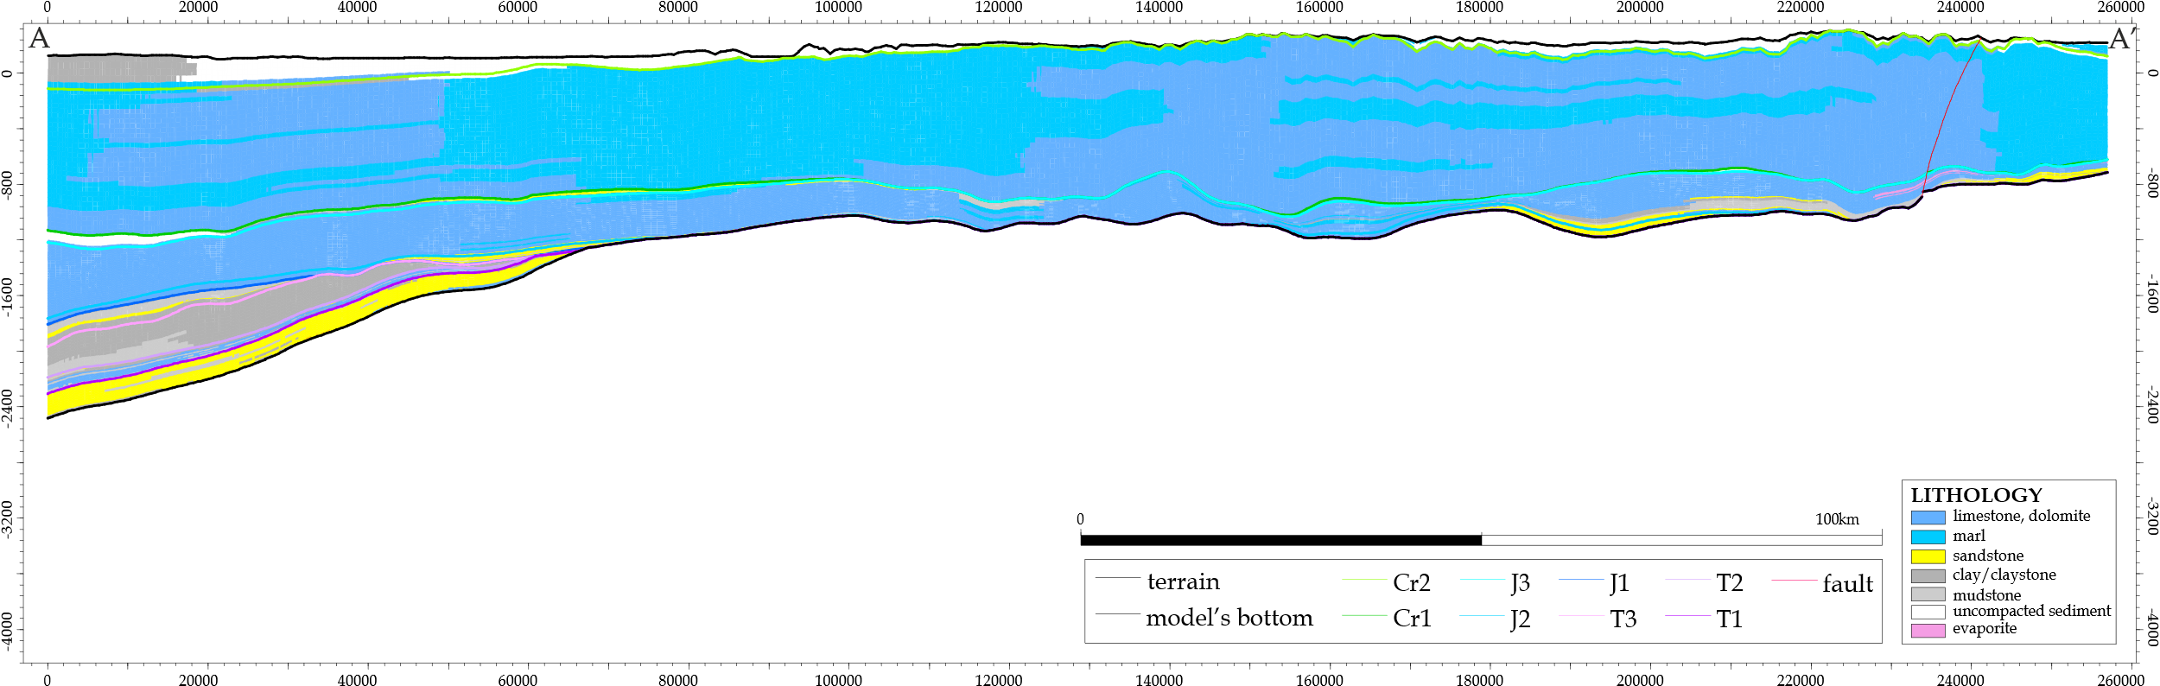
Fig. 1. A-A' lithological cross-section. Carbonate formations are dominating over other rock types. The cross-section shows the modelling results – the data has been generalised, so thin layers remain unnoticed. Cross-section line – see Fig. 4

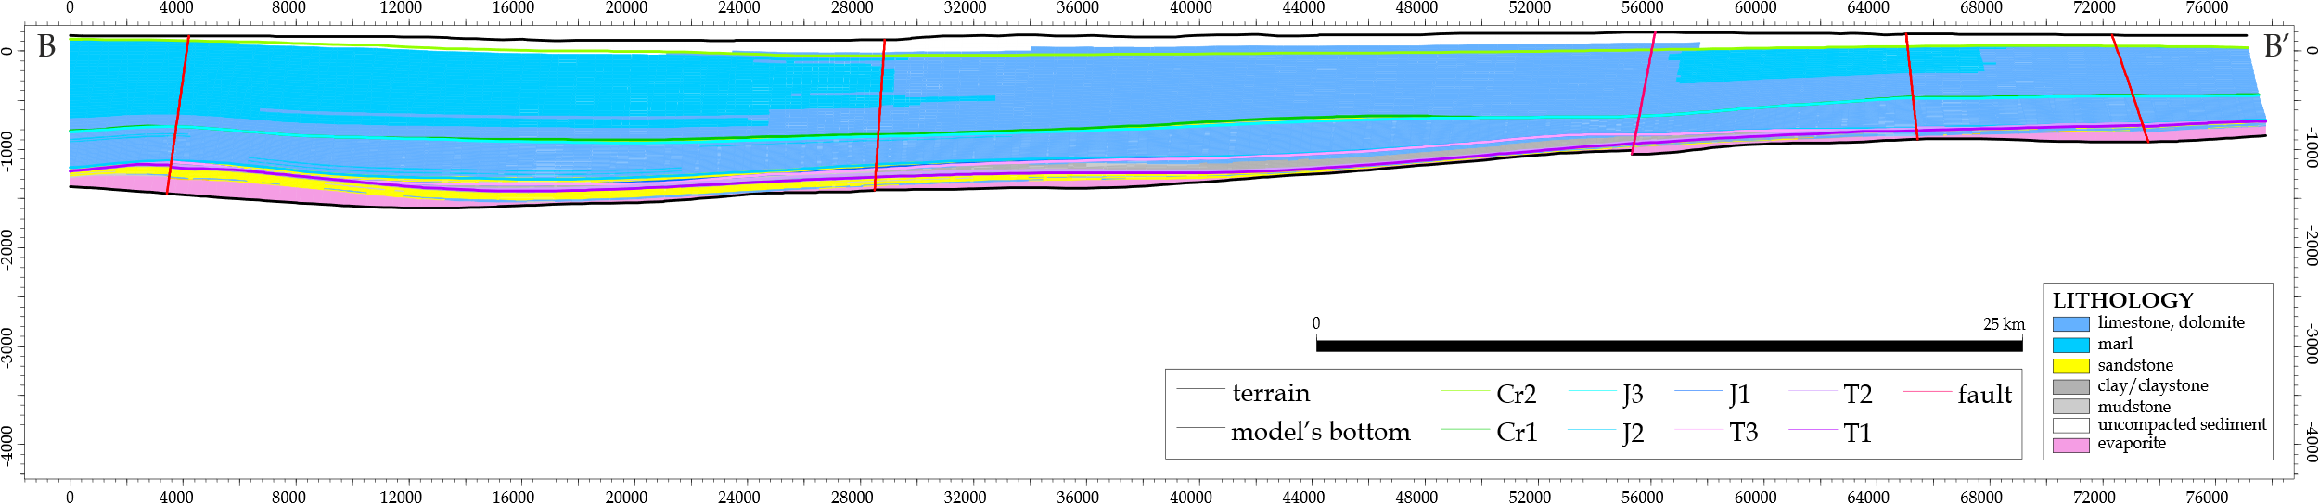
Fig. 2. B-B' lithological cross-section. Cross-section line – see Fig. 4

1.2. Geothermal conditions
The Lublin trough is placed above the old craton, which clearly influences its' thermal conditions by limiting the terrestrial heat flux to 50-70 mW/m² compared to up to 100 mW/m² in regions of western Poland (Górecki et al. 2006, Majorowicz et al. 2009). It makes the conditions favourable for coal mining exploitation (Bogdanka coal mine) and unfavourable for geothermal exploration. Nevertheless, it does not make reaching geothermal water impossible, but rather more challenging to use, especially in high-temperature district heating systems.
Regarding access to water, the literature (Różkowski & Rudzińska 1978) indicates possibly productive horizons within the Lublin trough, consisting of poorly compacted sandstones and carbonate rocks. Also, the substantial density of deep and extended faults creates a promising opportunity for migrating warmer fluids from the lower parts of the Earth's crust. This phenomenon is known from the literature, both as a general remark (Billi et al. 2003, Mitchell & Faulkner 2012, Rotevatn & Bastesen 2014) and locally in the Lublin area (Różkowski & Rudzińska 1978, Zwierzchowski 1989).
1.3. Surface conditions
The considered area is sparsely populated, with a handful of cities. Dominating is a rural landscape with villages consisting of dwellings along the main street, influencing the density of built-up areas. Typically, detached houses in rural areas are heated with individual heat sources, often solid-fuelled, related to significant pollutants and CO₂ emissions. In the cities, district heating systems provide the population with heat, yet according to statistics (Raport Ciepłowniczy 2021), most (about 90%) of heat distributed via district heating systems is produced in coal-fired plants.
2. Methods
2.1. Surface – heat demand
For the calculation of the heat demand, data from the BDOT database was used (Główny Urząd Geodezji i Kartografii 2020). Buildings for each district at least partly overlapping the Lublin trough were extracted from the database, jointed as a single layer, and trimmed afterwards to the extent of the Lublin trough. The next step was to extract the object that creates heat demand; thus, all the objects of a type indicating residential, service and working purposes were selected for the next steps.
The heated area was assessed to be a product of an object's outline area and the number of levels. The heat demand for regional considerations was assumed to be in the energy class D – 100 kWh/m²/yr, and heat capacity was roughly assumed to be 100 W/m²/yr at design conditions.
Afterwards, the Lublin trough was divided into 1 ha areas in longitudinal and latitudinal order, and the starting point of the grid was selected according to the maximal extent of the layer.
The Centroid of each heated building was extracted along with the heated surface to assign the demand to a single hectare univocally.
For every hectare, the sum of heat demand was calculated based on the centroids' locations.
For further consideration, two thresholds were adapted from the literature (Chambers et al. 2019)
– 83 MWh/ha/yr and 138 MWh/ha/yr. These are minimal heat demand density values that allow for considerations of district heating development – low-temperature district heating and high-temperature district heating, respectively. Hectares in which the heat demand excessed these thresholds were selected, and two layers were created for subsequent parallel processing.
The hectares neighbouring areas of sufficient heat demand density were also selected in the next step. It is related to two reasons – first is to tackle the oblique distribution of buildings, which would cause neighbouring dwellings on the same street to be or not be included in the DH prospective area depending on which grid part they were assigned to. Secondly, buildings located in direct proximity to the DH prospective areas are likely to have the opportunity to connect to the pipeline in the main focus area.
In this way, conglomerates of sufficiently densely built-up areas were created. For further processing, they were aggregated and areas in which heat demand was smaller than 1 MW were eliminated. The 1 MW threshold is arbitrary and reflects roughly 50 houses in compact development. Such assumptions align with existing systems described in the literature (Buffa et al. 2019).
It was assumed that geothermal wells might be located not further than 1 kilometre away from the prospective build-up areas, which was applied as creating a 1-kilometre buffer around them. These buffers were used to eliminate parts of the aquifers that are not overlapped by areas of sufficient build-up density. For heat demand capacity and geothermal energy production volume calculation, it was also assumed that geothermal heat might be distributed in the entire built-up area, regardless of the overlap size.
The heat plant operation mode was considered as follows.
Low-temperature district heating (LTDH) – 5th and 6th generation district heating system. Suppose the district heating supply temperature is lower than 50 centigrade (id est DH alone is insufficient for domestic hot water preparation). In that case, the system may also be considered as ultra-low temperature district heating (ULTDH). In the present paper, the temperature drop of the geothermal water is constant and equal to 15K. The heat is calculated as provided to the customer. It is up to the owner's decision whether to use a heat pump or radiators and surface heating of the developed area. The geothermal heat source operates as a base load, and once the demand exceeds 60% of the nominal capacity, the peak source is engaged (Ciapała et al. 2021).
High-temperature district heating (HTDH) – district heating system of 3rd or 4th generation, where the presence of the central heat pump was assumed. The minimal temperature of the geothermal water was assumed to be 42°C which comes from the case study of Mszczonów, where such installation successfully operates.
2.2. Subsurface – geothermal modelling
In the geological modelling, the data from archives of PGI-NRI and AGH Department of Energy Resources were used. The structural model prepared by PGI-NRI was adapted and filled with modelled parameters of temperature, permeability and lithology, which allowed for the calculation of the potential well's volumetric productivity, subsequently, the thermal capacity of the geothermal wells. Upon request, details of the modelling parameters procedure may be provided.
The thresholds applied to indicate prospective aquifers are as follows:
- A temperature of at least 20 centigrade, id est the minimal temperature of water at the wellhead is in Poland, considered geothermal (Ustawa z Dnia 9 Czerwca 2011 r. – Prawo Geologiczne i Górnicze – Prawo Geologiczne i Górnicze z Późniejszymi Zmianami, 2011).
- Permeability of at least 500 mD. The literature suggests this valuas a minimal robust rock's susceptibility to transmit water (Bujakowski & Barbacki 2004, Feldrappe et al. 2007, Schroeder 1976).
- The thickness of at least 20 m. It is the minimum required thickness of the permeable rock layer (Kramers et al. 2012, Markó et al., 2021, Pluymaekers et al., 2012, Rockel et al. 1997, Seibt & Kellner 2003), although some authors use a more restrictive 100 m threshold (Limberger et al. 2018).

Limits were applied to filter out cells satisfying these conditions in 200-metre intervals. Also, the resources and all the analyses were performed in 200-metre intervals measured from the terrain. Three reasons support the use of depth intervals rather than the age of the horizon:
- Depth interval is easily translatable into the drilling depth and, subsequently – drilling cost.
- The depth of the top and bottom of the geological era can vary significantly over large areas such as the entire Lublin trough. Therefore, it is more convenient to compare parameters within specific depth intervals.
- During the modelling, some aquifers were identified to occur at the ages' boundary. If classified by aquifer rock's age, there is a significant probability that such aquifer would be split and often not reach sufficient thickness. This would lead to a systematic error in vast areas, which is possible only in marginal zones in the case of depth intervals.

The volumetric productivity was calculated using a commonly accepted method known from the Geothermal Atlas of the Polish Lowland (Górecki et al. 2006) using the equations 1, 2, 3:
$k=\frac{k_{p}⋅\left(1-0.002⋅M_{s}\right)⋅ρ_{w}⋅9.81}{239.4⋅{10}^{-7}⋅{10}^{\frac{248.37}{T_{s}+133.15}}}$ (1)
$Q=2π⋅k⋅m_{P}⋅\frac{S}{\ln{\frac{R}{r}}}$ (2)
$R=3000⋅S⋅\sqrt{k}$ (3)
where:
$k$ – hydraulic conductivity coefficient [m/s],
$k_{p}$ – permeability coefficient [m²],
$M_{s}$ – TDS of reservoir water [kg/m³],
$ρ_{w}$ – density of reservoir water [kg/m³],

$T_{s}$ – temperature of reservoir water, assumed as average reservoir temperature [°C],
$Q$ – discharge of production well [m³/s],
$m_{P}$ – thickness of groundwater horizon (limited by working length of screen) [m],
$S$ – permissible drawdown [m],
$r$ – radius of production filter [m],
$R$ – radius of depression cone [m].

Based on maps of modelled permeability, the thickness of the permeable bodies and assumed parameters:
- mineralisation not higher than 2.5 g/dm³ (Różkowski & Rudzińska 1978),
- allowable water depression is equal to half of the thickness; it comes from a practical approach popular for unconfined aquifers and regarding pressures reaching 30-60 bars (Różkowski & Rudzińska 1978) seems to be a realistic value, especially assuming full water reinjection,
- well's diameter is 12" (0.305 m).

The maximal heat production rate was calculated, assuming that at least one geothermal doublet may operate in every area. If its surface exceeds 10 km², the number of doublets is equal to the quotient of the area (in km²) and 10, rounded up to an integer number. Heat capacity was calculated with the formula:
$\dot{E}=\dot{m}⋅c_{w}⋅ΔT=Q∙ρ_{w}⋅c_{w}⋅ΔT$ (2)
where $\dot{E}$ is the energy flow rate, $\dot{m}$ is mass flow rate, $c_{w}$ is specific heat and $ΔT$is temperature drop.
When considering the location of only one doublet in the prospective area, its heat capacity was evaluated as the maximum expected in the region. Alternatively, if multiple doublets were possible, the maximum geothermal heat capacity of the area was determined by multiplying the average heat capacity of a geothermal well by the number of potential doublets.
Annual energy production volume was calculated as a proportion to the heated space, which demand may be covered with the geothermal heating plant. The effective heat capacity used in this calculation was the smaller of the following: heating demand capacity and geothermal heat plant capacity.
3. Results and Discussion
The general results of the calculations are presented in the table in Appendix 1.
3.1. Surface research
In total, 40 279 hectares prospective for HTDH were identified in 482 zones of compact development and 119 724 hectares in 3 967 zones of compact development suitable for LTDH. There is almost a 3 times larger area feasible for low-temperature district heating development, resulting from a lower energy demand density threshold. Comparison with the entire area of the study that exceeds 2 million hectares shows that HTDH might be considered in 2% of the study area, whilst LTDH – is in 6% of the Lublin trough.
The buffers in which the geothermal resources might be sought to provide potential LTDH systems exceed 5 100 km², which, compared to more than 20 000 km² of the study area, states 25% in which geothermal prospection is reasoned. The HTDH area of prospection is more than 2 800 km² or 14% of the total area of the study.
The biggest congestion of heated space is Lublin city and its suburbia with accessed heated area of buildings totalling 27.3 km². The smallest considered areas are slightly above the threshold, providing sufficient heat demand – 10 000 m² of heated space (Fig. 3).

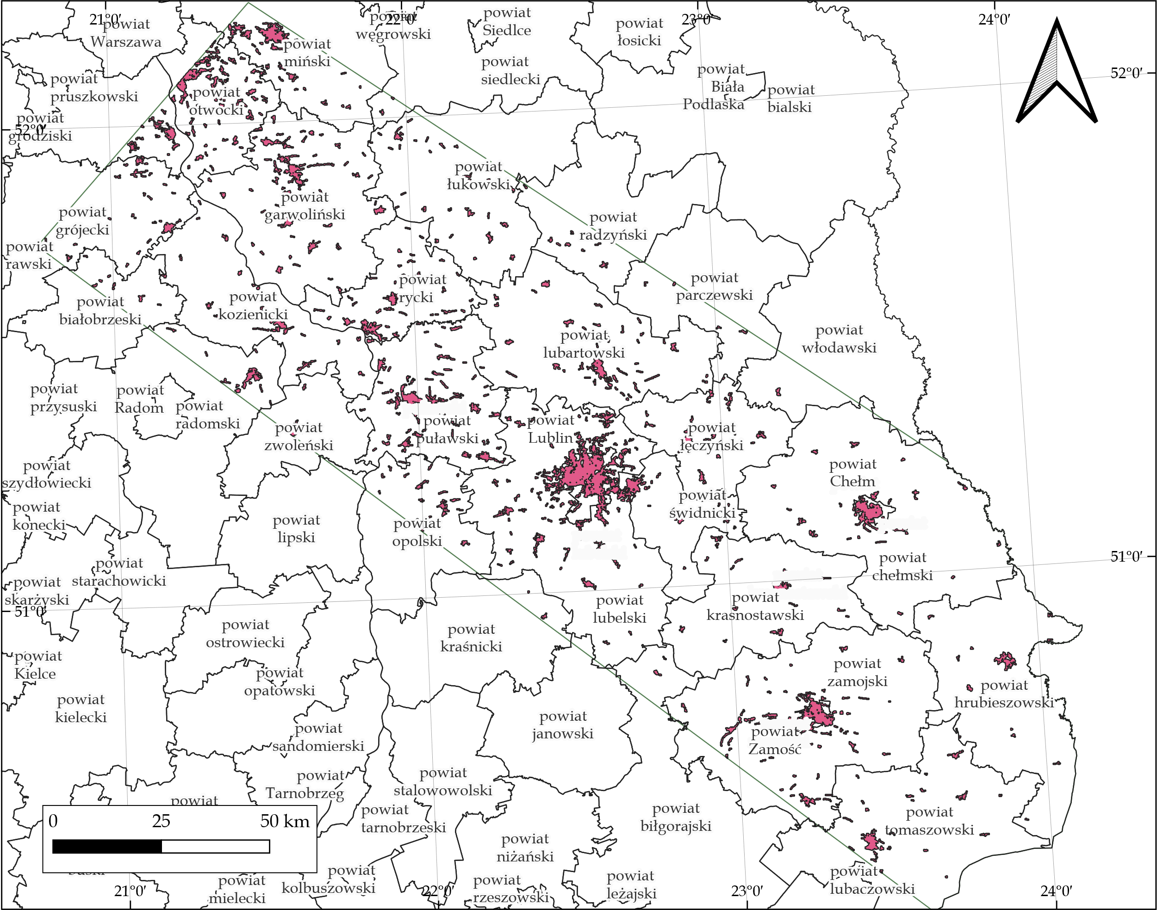
Fig. 3. Map – areas within the model range where heat demand density was above the 83 MWh/ha/yr threshold, and heat demand was above 1 MW_{th}. Visible are administrative districts
3.2. Geological modelling
3.2.1. Lithology
Carbonates, specifically marls, limestones, and dolomites, are the predominant rock types found in the Mesozoic profiles throughout the entire area. This can be attributed to the abundance of thick remains from the Upper Jurassic and Upper Cretaceous periods formed in the shallow and thriving sea. The Upper Cretaceous in the study area is especially interesting for its poorly permeable rocks that, because of their fractures, state precious freshwater aquifer recognised as a main strategic aquifer (GZWP – pol. Główny Zbiornik Wód Podziemnych) that should be specially protected (Główne Zbiorniki Wód Podziemnych – Państwowy Instytut Geologiczny – PIB, 2023). The temperature level in this aquifer is low, suggesting that any potential conflicts with geothermal exploitation are unlikely to arise. Some types of limestones and dolomites may exhibit outstanding permeability properties, yet it remains a matter of their origin and history; thus, they cannot be explicitly marked as permeable or impermeable.
Otherwise – sandstones in the Lublin trough are poorly compacted. In some places, their compaction is so low that they are described as "sand" in the drilling documentation. Lower Cretaceous and Lower Jurassic sandstone horizons are considered the most prospective layers in the Polish Lowlands, exploited in a handful of geothermal heat plants (Kępińska 2005). The difference is that while in the central part of the Polish Lowland, these sandstones are rather coarse, in the Lublin area are more fine-grained. This and their marginal character – limited thickness and poorly permeable mudstone abundance limit permeability.
The Jurassic sandstones tend to create isolated lenses of irregular shape, which is noted by the literature (Różkowski & Rudzińska 1978) and observable in the computer model and influences water resource renewability, but simultaneously – increases suitability for aquifer thermal energy storage.

3.2.2. Temperature
The rock temperature modelling results are described for the areas that offer permeability above 500 mD. Along with modelling results, the resource temperature is discussed against its potential use for energy purposes. The supply temperature is a significant issue in the discussion about developing or retrofitting any district heating system. The general trend is to lower the supply and return temperature, which leads to lower transmission losses. Hence, the literature suggests configurations that make using lower temperatures more convenient (Ciapała et al. 2018, Gong et al. 2023, Guelpa et al. 2023, Østergaard & Svendsen 2016).
The temperatures discussed are average values for all the model cells in a given column falling within the given interval and excessing temperature of 20°C. The assumption is that the temperature of the geothermal water at the surface is similar to that of the reservoir itself, which is supported by two factors. Firstly, the temperatures being exploited are relatively low, which results in a limited temperature difference – a thermodynamic force that causes losses on the way to the surface. Secondly, at lower temperatures, the volumetric production of wells is expected to be high, limiting the time for losses to occur. For low salinity, the water of the shallowest intervals may be provided via pipelines to the receivers without a main heat exchanger. Such a solution, impossible in deeper aquifers, may help give the receivers higher temperatures, increasing the heat pump's efficiency.
Water may be considered geothermal at a minimum depth of 400-600 meters, where temperatures in sufficiently permeable rocks are expected to range between 20-23 degrees Celsius. In other words, wells drilled up to 600 metres in the Lublin trough may provide ULTDH systems – district heating and cooling and any space heating operation requires a heat pump. Also, wells drilled in this depth interval may not produce geothermal water according to Polish law – depending on the pumping rate and heat loss on the water's way to the surface.
Similarly, the deeper interval (600 to 800 m.b.s.) offers temperatures in the range of 20-25 centigrade, suitable for cooling and heating with a heat pump.
At depths ranging from 800 to 1000 meters below the surface, the expected temperature is 21 to 31 degrees Celsius. In areas with the lowest temperature, the water is suitable for cooling and heating using a heat pump. In contrast, direct heating via floor and wall heating systems and warming inlet ventilation air are viable for the most advanced installations in areas with the highest temperature. This way of heating can provide the required internal temperature upon proper design and dimensioning, but not all users may find it entirely comfortable for their personal preferences (Orman et al. 2023, Orman et al. 2023). It is worth noting that a positive thermal anomaly is expected in the vicinity of the Łuków and Łosice faults, which may indicate improved geothermal conditions resulting from the vertical flow of geothermal fluids through fractured rock volumes. The existence of magma intrusions providing additional heat in the fractured zones also may be the case. A similar situation is probably observed west of the Izbica-Zamość fault.
Within the depth interval of 1 000-1 200 meters, the temperature of geothermal water ranges from 24 to 38 degrees Celsius (Fig. 4), making it less suitable for cooling purposes in residential and commercial buildings. Space heating still requires a heat pump, but in buildings that can access geothermal water directly and obtain the highest temperatures. For lower thermal energy use objects, floor heating supplied in this way may suffice throughout the year. A positive thermal anomaly is also visible in the aforementioned fractured zone.
The temperature range of geothermal water within the depth interval of 1 200-1 400 meters is expected to be between 29 and 44 degrees Celsius. Therefore, this water may be appropriate for industrial cooling purposes only. Still, residential and commercial buildings may require only limited support to provide floor heating fully, even if the building is connected to a district heating system without a heat pump. Heat pumps can operate efficiently to provide any space heating installation and domestic hot water throughout the year.
The deeper, 1 400-1 600 metres interval is mainly suited to satisfy the needs of floor heating without heat pump use, as dominant is the range of temperatures between 34 and 48 degrees Celsius. This is also the shallowest depth interval at which temperatures required for a high-temperature district heating configuration with a central heat pump, similar to that of Mszczonów, can be achieved.
Interval 1 600-1 800 metres offers temperatures from 40 to 50°C, so both high-temperature district heating systems with central heat pumps and ULTDH systems may be developed. Heat pumps would not be required, even in instances with traditional radiator space heating installation.

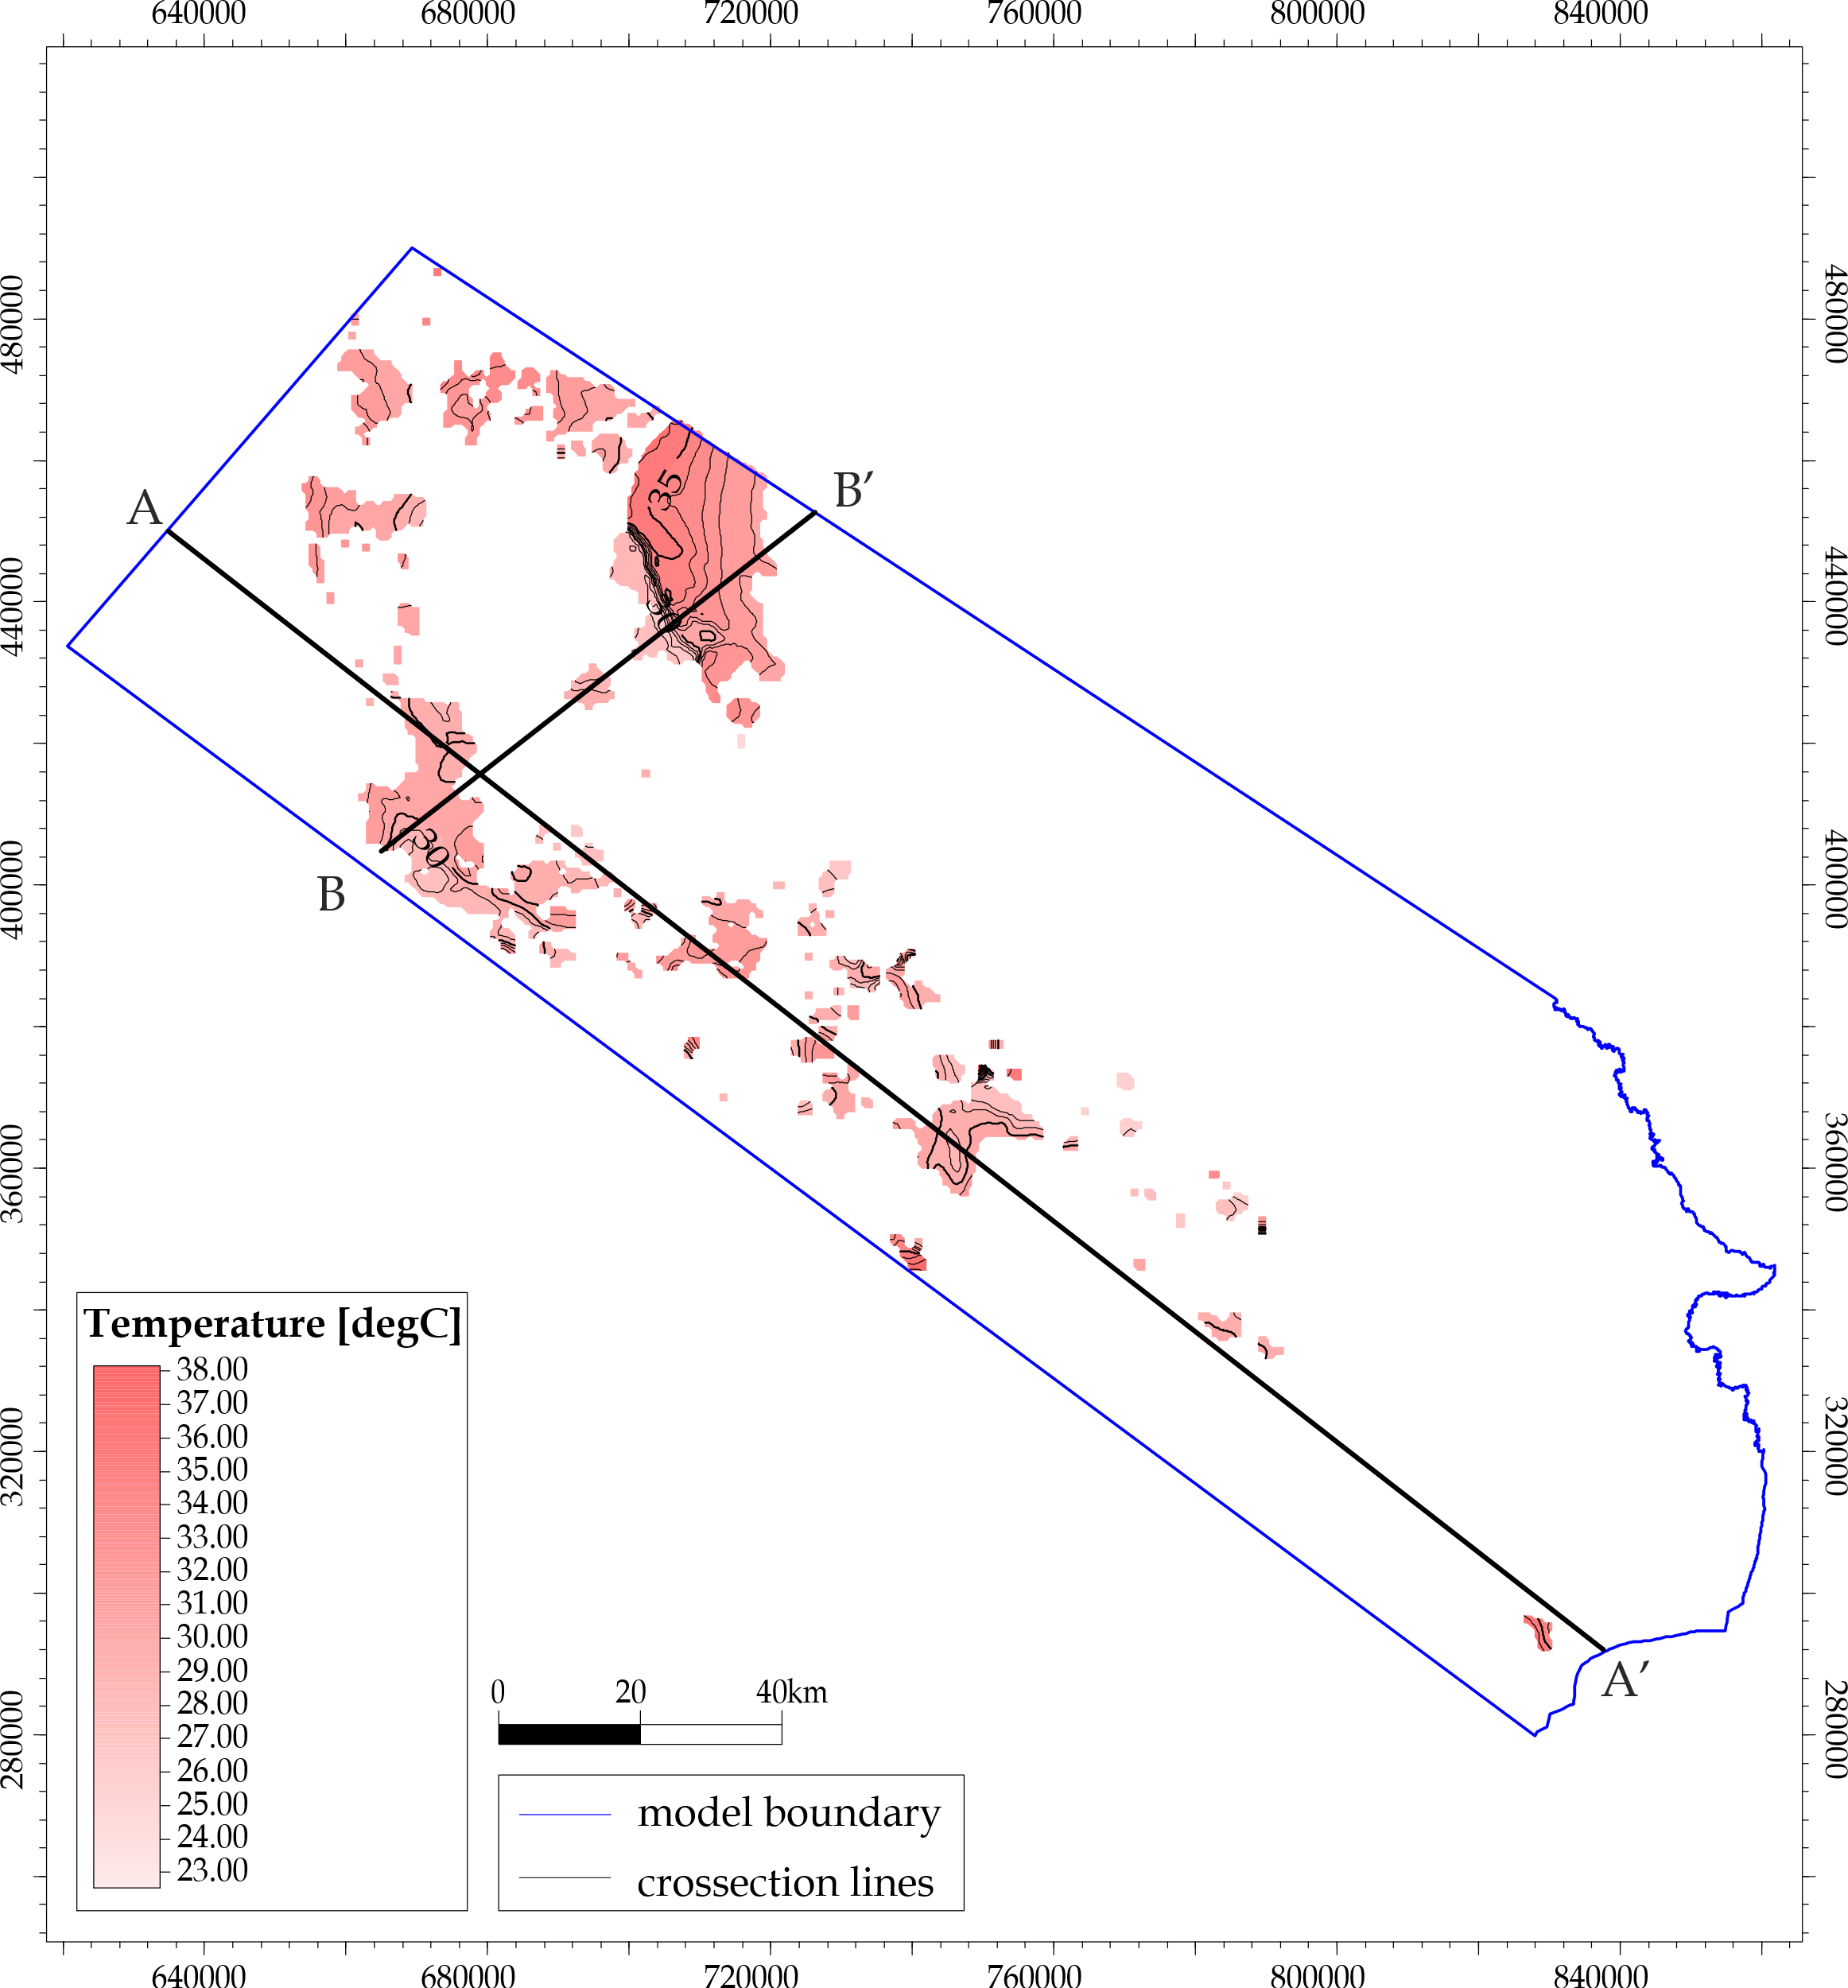
Fig. 4. Map of average temperatures in the 1000-1200 m below surface interval within areas of sufficient permeability. Crossection lines marked with black lines
3.2.3. Wells volumetric productivity
In the depth interval of 400-600 m, there is one area where the productivity may reach up to 300 m³/h. It is related to a thick (>130 m) permeable body placed near Kock and Świecica faults. Other areas are comparatively small and isolated, offering no more than a 25 m³/h water production rate.
The depth interval of 600-800 m, there are several smaller permeable bodies offering up to 25 m³/h and two areas of promising modelled productivity excessing 300 m³/h – the first one in the fractured zone of the mentioned above Łuków and Łosice faults and the second one between Grójec and Góra Kalwaria towns. So high values should be treated as indicators of especially good conditions rather than exact values.
The bottom parts of the outstanding bodies from 600-800 m intervals are also present in the 800-1 000 m depth range offering significant outputs. Beside them, in the northern part of the Ursynów-Kazimierz fault zone, there are bodies up to 50 m thick and of possible productivity reaching 20 m³/h.
The highly permeable zone in Łuków and Łosice fault area continues to the 1 000-1 200 m interval, where productivity excessing 200 m³/h may be expected. In this depth interval, two smaller bodies are placed near faults that offer productivity exceeding 70 m³/h. Both permeable zones are east of the Ursynów-Kazimierz fault zone, with the northern one in its direct vicinity and the southern one halfway to the Wilczopole S fault.
Interval 1 200 to 1 400 m below the surface is devoid of sufficiently thick permeable zones, whilst the 1 600-1 800 and 1 800-2 000 metres intervals probably contain one lens-like body of increased permeability. This body should be treated as low-confidence as it was modelled based on porosity, and actual porosity may be significantly lower than modelled if rocks of non-effective porosity occur. Since the only area in which the aquifer's thresholds for HTDH with central geothermal heat pump are fulfilled is related to this debatable body, this type of geothermal heat distribution is to be considered as not viable in the Lublin trough area.
Visible is a general concentration of useful geothermal resources in the Lublin trough's northern part, regardless of the interval. Only in the deepest one can any geothermal potential for high-temperature district heating systems be considered possible. Values of possible geothermal well capacity and annual geothermal heat production, along with an assumed maximal number of wells in the prospective area, are presented in the table in Appendix 1. Please note that each contains multiple grid nodes (possible calculated wells) for which the statistics (max, average) were presented.
3.2.4. Geothermal heating capacity
For the areas where the rock's temperature, permeability and thickness of the permeable bodies were above thresholds presented in the Methods section, the geothermal heat capacity and maximal geothermal heat production were calculated.
In the 400-600 m depth interval, the rated heat capacity is 3.7 MW_{th} for the most prospective area and 3.2 MW_{th} for the most promising location placed by the faults (Fig. 5 and 6). The usual useful heat capacity for this interval is in the range of 100-400 kW. Geothermal heat production is often limited by receivers' needs, typically between 100 and 300 MWh per year, reaching 1 000 and 6 000 MWh per year in the most promising zones.
The beneficial coincidence exists for the 600-800 m depth interval: there is an area of substantial built-up density and permeable zone with potentially geothermal water. The average geothermal doublet heat capacity may reach 4 MW_{th}, and total energy production – 76 GWh/yr. Of course, it is rather unexpected to develop so tremendous ULTDH yet indicate the importance and potential benefits of exploiting geothermal resources where they are available. In this interval, wells may obtain a capacity of 1 MWth or more. Simultaneously the energy demand density at the surface is high; thus, the potential heat volume sold often may reach a few gigawatt-hours.
Similar results may provide exploitation of geothermal water from the 800-1000 m interval, where the prospective permeable zones are continued. The heat demand is the same as in the case of the previous interval, so geothermal wells of 1-2 MW_{th} capacity might well produce 1-2 GWh of heat per year.
Typical heat capacity of deeper intervals (1 000-1 200 m) are counted in hundreds of kilowatts with a few excessing 1.5 MW_{th}. The vicinity of substantial heat demand allows for possible 1-2 GWh heat production in most of the areas. A similar situation is found in the 1 200-1 400 intervals.
1 600-1 800 metres interval offers heat capacities in 3 areas, where the energy production rate is between 0.5 and 1.7 MW_{th}.
It is observable that the opportunity to receive the heat is a significant limitation of geothermal heat production, as capacity factors usually fall near 20%. Yet it is not the number of receivers but their demand profile that is the most important, as another obvious limitation is the well's heat capacity.

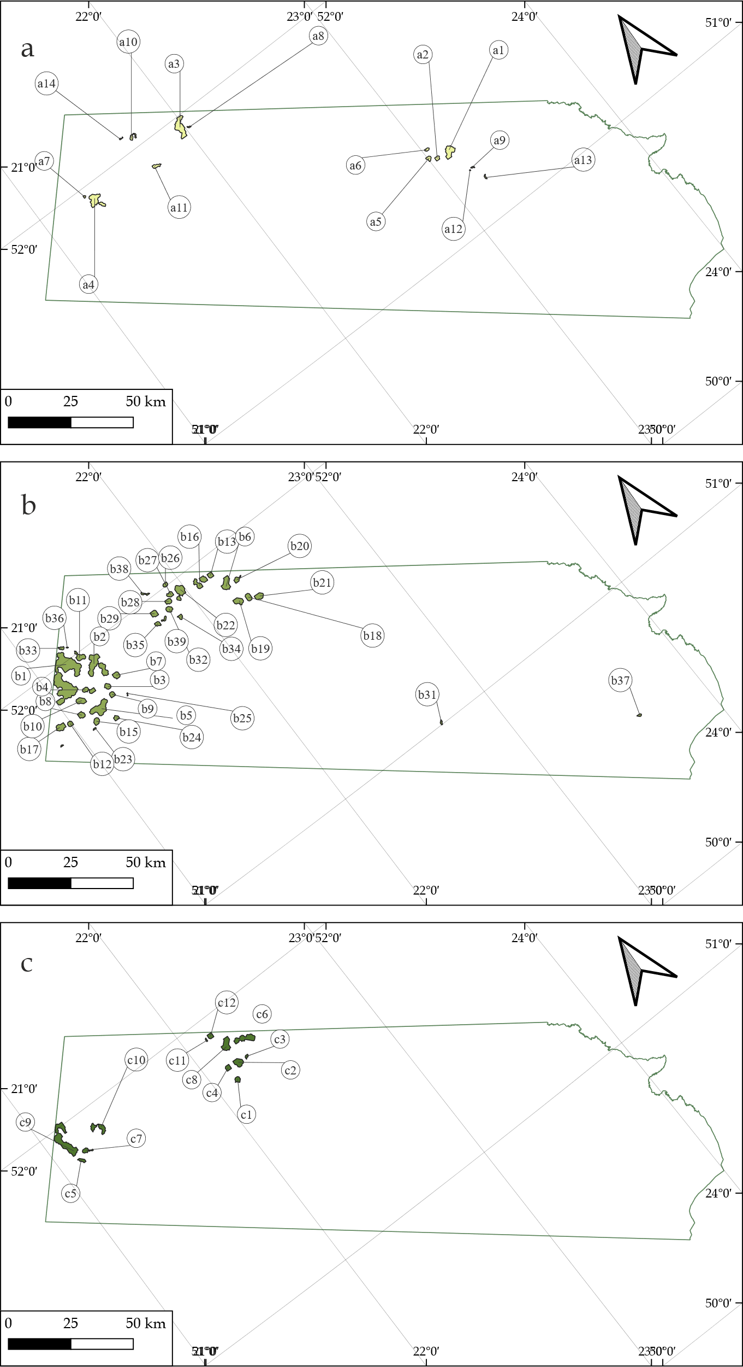
Fig. 5. Location of the prospective areas where both heat demand and opportunity of geothermal heat production occur. Intervals in the following map miniatures are (metres below the surface): a) 400-600, b) 600-800, c) 800-1000

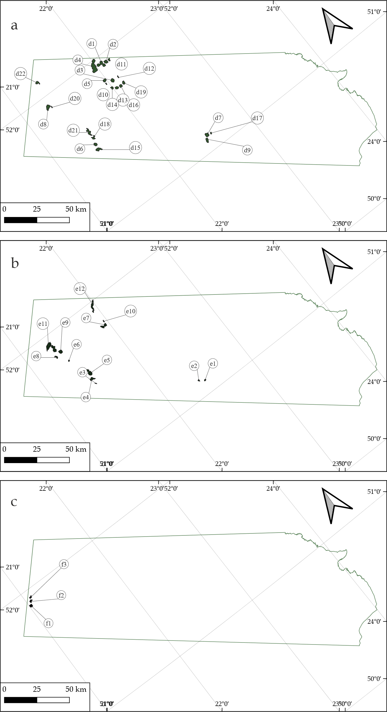
Fig. 6. Location of the prospective areas where both heat demand and opportunity of geothermal heat production occur. Intervals in the following map miniatures are (metres below the surface): a) 1000-1200; b) 1200-1400; c) 1400-1600

3.3. Potential air pollution limitation
Although the Lublin trough is not very fragile regarding air pollution emissions for its scarce population, the environmental impact has been assessed (Table 1). Since the current way of fulfilling heating needs in the prospective areas remains unknown, two extreme scenarios were considered as alternatives: coal combustion in simple devices and natural gas combustion with emissivity factors used following the latest official report regarding small heat sources (Wskaźniki Emisji Zanieczyszczeń ze Spalania Paliw Dla Źródeł o Nominalnej Mocy Cieplnej Do 5 MW, Zastosowane Do Automatycznego Wyliczenia Emisji w Raporcie Do Krajowej Bazy Za Rok 2022, 2023).
It is estimated that avoided emissions might exceed 100,000 metric tonnes of CO₂, 205 tonnes of NO_{x} and 306 tonnes of SO_{x} yearly. On top of that – 800 tonnes of cancerogenic particulate matter and 3 000 tonnes of CO. These values are not so high if compared to natural gas, where it would be 60 000 tonnes of CO₂, 32 tonnes of CO, 500 kg of particulate matter, 42 tonnes of NO_{x} and 400 kg of SO_{x}.
These hypothetical, practically unreachable emission reductions are of minor importance regarding the entire country since, for example, in 2020, all the sectors emitted 430 000 tonnes of SO_{x} (Poland – Air Pollution Country Fact Sheet – European Environment Agency, 2021). Nevertheless, their local impact may be noticeable, and the results of limited emissions remain a part of small improvements that cause major change.
4. Conclusions
Geothermal heat is available in the northern parts of the Lublin trough and near major fault zones. However, the areas where district heating can be developed often do not align with the prospective geological bodies, leaving much of the geological potential hypothetical due to the absence of surface receivers.
Most systems operate on a scale of several megawatts, offering flexibility in district heating operations. It's important to note that systems with a capacity below 5 MW are subject to less strict supervision by the relevant authorities.
Generated maps show neighbourhoods where ultra-low-temperature district heating systems could be developed based on geothermal resources and areas suitable for commercial, recreational, or public service big-scale objects that could be geothermally heated and cooled. Maps also revealed that developing a high-temperature district heating system fed with the central heat pump is unlikely in the Lublin trough.
A methodology must be developed to confirm geothermal water flow and availability in fractured zones. Detailed mapping of faults could lead to discoveries of geothermal resources in the Lublin trough and throughout Poland.
The deployment of ultra-low-temperature district heating systems allows access to the untapped geothermal potential unattainable for medium- and high-temperature district heating systems. To gauge the environmental impact of low-temperature geothermal resources, projects must be broader and include building adjustments for operating with ultra-low-temperature district heating systems.
Although the calculated possible decrease in air pollutant emissions is only of local significance, it remains consistent with modern trends and good practices.
Acknowledgements
The author would like to acknowledge using the geological model prepared by the Polish Geological Institute – National Research Institute under project 3D cyfrowy model geologiczny pokrywy osadowej basenu lubelskiego.
The author would like to express gratitude towards Bartosz Papiernik and Marek Hajto for their kind help and consultancy during the development of the geological model of the Lublin trough.
The author would like to state that the ChatGPT tool was used only to enhance the text's language, which was revised scientifically afterwards.
The paper was prepared under AGH grant No. 16.16.140.315/05
The paper is part of Bartłomiej Ciapała PhD thesis.

Table 1. Potential air pollutant emissions avoided by using geothermal heat
 |  | Potentially Avoided Pollutant Weight (kg/yr)
 | Depth interval (ULTDH) | 400-600 | 600-800 | 800-1000 | 1000-1200 | 1200-1400 | 1600-1800 | sum
Coal | Particulate matter (total) | 30 000 | 470 000 | 100 000 | 110 000 | 70 000 | 20 000 | 800 000
 | Particulate matter PM10 | 30 000 | 420 000 | 90 000 | 100 000 | 60 000 | 20 000 | 710 000
 | Particulate matter PM2.5 | 20 000 | 320 000 | 70 000 | 70 000 | 50 000 | 10 000 | 550 000
 | CO₂ | 4 400 000 | 58 900 000 | 12 800 000 | 13 500 000 | 8 600 000 | 2 300 000 | 100 400 000
 | CO | 150 000 | 1 990 000 | 430 000 | 460 000 | 290 000 | 80 000 | 3 390 000
 | NO_{x} | 10 000 | 120 000 | 25 000 | 30 000 | 15 000 | 5 000 | 205 000
 | SO_{x} | 15 000 | 210 000 | 45 000 | 50 000 | 30 000 | 10 000 | 360 000
 | BaP | 17 | 232 | 50 | 53 | 34 | 9 | 396
Natural Gas | Particulate matter (total) | 25 | 315 | 70 | 70 | 45 | 10 | 535
 | Particulate matter PM10 | 25 | 315 | 70 | 70 | 45 | 10 | 535
 | Particulate matter PM2.5 | 25 | 315 | 70 | 70 | 45 | 10 | 535
 | CO₂ | 2 680 000 | 36 070 000 | 7 820 000 | 8 270 000 | 5 240 000 | 1 390 000 | 61 460 000
 | CO | 1 000 | 19 000 | 4 000 | 4 000 | 3 000 | 1 000 | 32 000
 | NO_{x} | 2 000 | 25 000 | 5 500 | 5 500 | 3 500 | 1 000 | 42 500
 | SO_{x} | 20 | 250 | 55 | 55 | 35 | 10 | 425
 | BaP | 0.00004 | 0.00050 | 0.00011 | 0.00011 | 0.00007 | 0.00002 | 0.00085
.
Appendix 1
Table A-1. Available geothermal productivity in the areas prospective for exploitation
Prospective  area ID | depth interval | thermal capacity (kW) |  | number  of possible wells | geothermal energy  production (MWh/yr)
 |  | max | average
a1 | 400-600 | 3178 | 1879 | 2 | 6140
a2 | 400-600 | 1064 | 851 | 1 | 1165
a3 | 400-600 | 362 | 270 | 3 | 1323
a4 | 400-600 | 398 | 322 | 2 | 1052
a5 | 400-600 | 345 | 268 | 1 | 564
a6 | 400-600 | 251 | 219 | 1 | 410
a7 | 400-600 | 244 | 241 | 1 | 399
a8 | 400-600 | 219 | 204 | 1 | 358
a9 | 400-600 | 209 | 209 | 1 | 341
a10 | 400-600 | 182 | 142 | 1 | 297
a11 | 400-600 | 162 | 141 | 1 | 265
a12 | 400-600 | 138 | 138 | 1 | 225
a13 | 400-600 | 122 | 114 | 1 | 199
a14 | 400-600 | 107 | 105 | 1 | 174
b1 | 600-800 | 9878 | 4253 | 11 | 76406
b2 | 600-800 | 9904 | 4803 | 4 | 17797
b3 | 600-800 | 10171 | 9241 | 1 | 1080
b4 | 600-800 | 9209 | 6435 | 1 | 2287
b5 | 600-800 | 5245 | 2855 | 3 | 13988
b6 | 600-800 | 5385 | 4281 | 2 | 7258
b7 | 600-800 | 6737 | 3657 | 1 | 6904
b8 | 600-800 | 5467 | 5208 | 1 | 2157
b9 | 600-800 | 5272 | 4305 | 1 | 999
b10 | 600-800 | 5121 | 3877 | 1 | 2444
b11 | 600-800 | 4788 | 2326 | 1 | 7820
b12 | 600-800 | 4633 | 3593 | 1 | 1080
b13 | 600-800 | 4279 | 3878 | 1 | 1618
b14 | 600-800 | 4064 | 3120 | 1 | 2617
b15 | 600-800 | 3005 | 1872 | 1 | 1549
b16 | 600-800 | 2514 | 1474 | 1 | 3410
b17 | 600-800 | 2491 | 2332 | 1 | 4069
b18 | 600-800 | 2133 | 1831 | 1 | 1550
b19 | 600-800 | 1952 | 1077 | 1 | 3188
b20 | 600-800 | 1485 | 845 | 1 | 2426
b21 | 600-800 | 1288 | 792 | 1 | 2104
b22 | 600-800 | 748 | 486 | 2 | 1588
b23 | 600-800 | 621 | 603 | 1 | 1014
b24 | 600-800 | 590 | 470 | 1 | 963
b25 | 600-800 | 541 | 541 | 1 | 884
b26 | 600-800 | 481 | 421 | 1 | 786

Table A-2. cont.
Prospective  area ID | depth interval | thermal capacity (kW) |  | number  of possible wells | geothermal energy  production (MWh/yr)
 |  | max | average
b27 | 600-800 | 383 | 304 | 1 | 625
b28 | 600-800 | 379 | 346 | 1 | 619
b29 | 600-800 | 360 | 278 | 1 | 588
b30 | 600-800 | 352 | 352 | 1 | 575
b31 | 600-800 | 330 | 326 | 1 | 539
b32 | 600-800 | 312 | 194 | 1 | 510
b33 | 600-800 | 301 | 251 | 1 | 492
b34 | 600-800 | 296 | 238 | 1 | 483
b35 | 600-800 | 243 | 204 | 1 | 397
b36 | 600-800 | 193 | 184 | 1 | 316
b37 | 600-800 | 186 | 180 | 1 | 304
b38 | 600-800 | 115 | 101 | 1 | 188
b39 | 600-800 | 113 | 99 | 1 | 184
c1 | 800-1000 | 788 | 593 | 1 | 1287
c2 | 800-1000 | 1747 | 1198 | 1 | 2854
c3 | 800-1000 | 517 | 461 | 1 | 845
c4 | 800-1000 | 1713 | 1340 | 1 | 1869
c5 | 800-1000 | 1352 | 816 | 1 | 2208
c6 | 800-1000 | 2162 | 1268 | 2 | 4143
c7 | 800-1000 | 1453 | 801 | 1 | 2287
c8 | 800-1000 | 4366 | 3685 | 2 | 7258
c9 | 800-1000 | 2367 | 1700 | 4 | 11103
c10 | 800-1000 | 565 | 360 | 2 | 1178
c11 | 800-1000 | 619 | 600 | 1 | 1011
c12 | 800-1000 | 2187 | 1509 | 1 | 1618
d1 | 1000-1200 | 3892 | 3710 | 2 | 3410
d2 | 1000-1200 | 3481 | 2722 | 1 | 2617
d3 | 1000-1200 | 1999 | 1674 | 1 | 3265
d4 | 1000-1200 | 3038 | 1644 | 3 | 8058
d5 | 1000-1200 | 2390 | 1499 | 1 | 1348
d6 | 1000-1200 | 1828 | 1485 | 1 | 1619
d7 | 1000-1200 | 1300 | 835 | 1 | 2124
d8 | 1000-1200 | 1095 | 828 | 1 | 1788
d9 | 1000-1200 | 1078 | 816 | 1 | 1761
d10 | 1000-1200 | 850 | 771 | 1 | 1075
d11 | 1000-1200 | 1019 | 750 | 1 | 1618
d12 | 1000-1200 | 817 | 718 | 1 | 1335
d13 | 1000-1200 | 728 | 642 | 1 | 1189
d14 | 1000-1200 | 774 | 622 | 1 | 1187
d15 | 1000-1200 | 980 | 547 | 1 | 1600
d16 | 1000-1200 | 624 | 533 | 1 | 1019
d17 | 1000-1200 | 573 | 497 | 1 | 936

Table A-3. cont.
Prospective  area ID | depth interval | thermal capacity (kW) |  | number  of possible wells | geothermal energy  production (MWh/yr)
 |  | max | average
d18 | 1000-1200 | 572 | 485 | 1 | 934
d19 | 1000-1200 | 547 | 468 | 1 | 894
d20 | 1000-1200 | 463 | 446 | 1 | 757
d21 | 1000-1200 | 539 | 410 | 1 | 880
d22 | 1000-1200 | 272 | 247 | 1 | 444
e1 | 1200-1400 | 558 | 514 | 1 | 911
e2 | 1200-1400 | 398 | 378 | 1 | 650
e3 | 1200-1400 | 529 | 523 | 1 | 864
e4 | 1200-1400 | 1535 | 951 | 1 | 2507
e5 | 1200-1400 | 1097 | 665 | 2 | 2173
e6 | 1200-1400 | 371 | 341 | 1 | 606
e7 | 1200-1400 | 999 | 626 | 1 | 1632
e8 | 1200-1400 | 2390 | 1645 | 1 | 1080
e9 | 1200-1400 | 2648 | 1518 | 1 | 4325
e10 | 1200-1400 | 791 | 787 | 1 | 1292
e11 | 1200-1400 | 3269 | 1661 | 3 | 8137
e12 | 1200-1400 | 648 | 507 | 1 | 1058
f1 | 1600-1800 | 3161 | 1744 | 1 | 3210
f2 | 1600-1800 | 1547 | 1072 | 1 | 2526
f3 | 1600-1800 | 574 | 529 | 1 | 938
f3 (part) | 1600-1800 HTDH | 819 | 815 | 1 | 1338
f1 (part) | 1600-1800 HTDH | 3145 | 2283 | 1 | 1330

References
Bayer, P., Attard, G., Blum, P., Menberg, K. (2019). The geothermal potential of cities. Renewable and Sustainable Energy Reviews, 106, 17-30. https://doi.org/10.1016/J.RSER.2019.02.019
Billi, A., Salvini, F., Storti, F. (2003). The damage zone-fault core transition in carbonate rocks: Implications for fault growth, structure and permeability. Journal of Structural Geology, 25(11), 1779-1794. https://doi.org/10.1016/S0191-8141(03)00037-3
Buffa, S., Cozzini, M., D'Antoni, M., Baratieri, M., Fedrizzi, R. (2019). 5th generation district heating and cooling systems: A review of existing cases in Europe. Renewable and Sustainable Energy Reviews, 104, 504-522. https://doi.org/10.1016/J.RSER.2018.12.059
Bujakowski, W., Barbacki, A. (2004). Potential for geothermal development in Southern Poland. Geothermics, 33(3), 383-395. https://doi.org/10.1016/J.GEOTHERMICS.2003.04.001
Chambers, J., Narula, K., Sulzer, M., Patel, M.K. (2019). Mapping district heating potential under evolving thermal demand scenarios and technologies: A case study for Switzerland. Energy, 176, 682-692. https://doi.org/10.1016/J.ENERGY.2019.04.044
Ciapała, B., Janowski, M., Jurasz, J. (2018). Superniskotemperaturowa sieć ciepłownicza z indywidualnym źródłem szczytowym w kontekście zaopatrzenia w ciepło budynku wykonanego w technologii tradycyjnej. Technika Poszukiwań Geologicznych Geotermia, Zrównoważony Rozwój, 2. (in Polish) https://min-pan.krakow.pl/wydawnictwo/wp-content/uploads/sites/4/2019/01/05-ciepala-i-inni.pdf
Ciapała, B., Jurasz, J., Janowski, M., Kępińska, B. (2021). Climate factors influencing effective use of geothermal resources in SE Poland: the Lublin trough. Geothermal Energy, 9(1). https://doi.org/10.1186/s40517-021-00184-1
Ciosmak, M. (2009). Warunki geotermalne centralnego obszaru niecki lubelskiej oraz możliwości ich wykorzystania na przykładzie gminy Spiczyn. Inżynieria Ekologiczna, 21, 109-120. (in Polish)
Dziewińska, L., Jóźwiak, W. (2000). Zmiany litologiczne w utworach karbonu rowu lubelskiego w świetle interpretacji geofizycznej. Biuletyn Państwowego Instytutu Geologicznego, 392, 5-48. (in Polish)
Feldrappe, H., Obst, K., Wolfgramm, M. (2007). Proceedings European Geothermal Congress. 30.
Główne Zbiorniki Wód Podziemnych – Państwowy Instytut Geologiczny – PIB. (2023). (in Polish) https://www.pgi.gov.pl/psh/psh-2/ochrona-wod-podziemnych.html
Główny Urząd Geodezji i Kartografii. (2020). Baza Danych Obiektów Topograficznych – BDOT10k. (in Polish) https://dane.gov.pl/pl/dataset/2030,dane-obiektow-topograficznych-o-szczegolowosci-zap
Gong, Y., Ma, G., Jiang, Y., Wang, L. (2023). Research progress on the fifth-generation district heating system based on heat pump technology. Journal of Building Engineering, 71. https://doi.org/10.1016/j.jobe.2023.106533
Górecki, W. (ed.), Hajto, M., et al. (2006). Atlas of Geothermal Resources of Mesosoic Formations in the Polish Lowlands (W. Górecki, Ed.).
Guelpa, E., Capone, M., Sciacovelli, A., Vasset, N., Baviere, R., Verda, V. (2023). Reduction of supply temperature in existing district heating: A review of strategies and implementations. Energy, 262. https://doi.org/10.1016/j.energy.2022.125363
Kępińska, B. (2005). Geothermal Energy Country Update Report from Poland, 2000-2004. Proceedings World Geothermal Congress, 24-29.
Kępińska, B. (2020). Geothermal Energy Country Update Report from Poland, 2015-2019. Proceedings World Geothermal Congress 2020 Reykjavik, Iceland, April 26 – May 2, 2020.
Kozłowska, A., Kozłowska, A. (2004). Diageneza piaskowców karbonu górnego występujących na pograniczu rowu lubelskiego i bloku warszawskiego. Biuletyn Państwowego Instytutu Geologicznego, 411(411), 5-86. (in Polish) https://geojournals.pgi.gov.pl/bp/article/view/29581
Kramers, L., Van Wees, J. D., Pluymaekers, M. P. D., Kronimus, A., Boxem, T. (2012). Direct heat resource assessment and subsurface information systems for geothermal aquifers; the Dutch perspective. Netherlands Journal of Geosciences, 91(4), 637-649. https://doi.org/10.1017/S0016774600000421
Krojewo, K., Krojewo, K., Teller, L. (1968). Stratygrafia karbonu zachodniej części niecki lubelskiej. Acta Geologica Polonica, 18(1), 153-178. (in Polish) https://geojournals.pgi.gov.pl/agp/article/view/10160
Limberger, J., Boxem, T., Pluymaekers, M., Bruhn, D., Manzella, A., Calcagno, P., Beekman, F., Cloetingh, S., van Wees, J.D. (2018). Geothermal energy in deep aquifers: A global assessment of the resource base for direct heat utilisation. Renewable and Sustainable Energy Reviews, 82, 961-975. https://doi.org/10.1016/J.RSER.2017.09.084
Majorowicz, J.,Wybraniec, S. (2009). Zmiany strumienia cieplnego Europy w skali regionalnej i głębokościowej i ich wpływ na szacowanie zasobów energii geotermalnej głębokich zamkniętych systemów typu EGS. Przegląd Geologiczny, 57(8). (in Polish)
Markó, Á., Mádl-Szőnyi, J., Brehme, M. (2021). Injection related issues of a doublet system in a sandstone aquifer
– A generalised concept to understand and avoid problem sources in geothermal systems. Geothermics, 97, 102234. https://doi.org/10.1016/J.GEOTHERMICS.2021.102234
Mitchell, T.M., Faulkner, D.R. (2012). Towards quantifying the matrix permeability of fault damage zones in low porosity rocks. Earth and Planetary Science Letters, 339-340, 24-31. https://doi.org/10.1016/j.epsl.2012.05.014
Model basenu lubelskiego. (2016). https://geo3d.pgi.gov.pl/pl/model-basenu-lubelskiego
Narkiewicz, M. (2003). Tektoniczne uwarunkowania rowu lubelskiego (późny dewon-karbon). Przegląd Geologiczny, 51(9), 771-776. (in Polish) https://geojournals.pgi.gov.pl/pg/article/view/14059
Orman, Ł.J., Honus, S., Jastrzębska, P. (2023). Investigation of Thermal Comfort in the Intelligent Building in Winter Conditions. Rocznik Ochrona Środowiska, 25, 45-54. https://doi.org/10.54740/ROS.2023.006
Østergaard, D.S., Svendsen, S. (2016). Theoretical overview of heating power and necessary heating supply temperatures in typical Danish single-family houses from the 1900s. Energy and Buildings, 126, 375-383. https://doi.org/10.1016/j.enbuild.2016.05.034
Pawłowski, S. (1961). Kredowy i jurajski rów lubelski. Geological Quarterly, 5(4), 831-838. https://gq.pgi.gov.pl/article/view/14077
Pluymaekers, M.P.D., Kramers, L., Van Wees, J.D., Kronimus, A., Nelskamp, S., Boxem, T., Bonté, D. (2012). Reservoir characterisation of aquifers for direct heat production: Methodology and screening of the potential reservoirs for the Netherlands. Netherlands Journal of Geosciences, 91(4), 621-636. https://doi.org/10.1017/S001677460000041X
Poland – Air pollution country fact sheet – European Environment Agency. (2021).
https://www.eea.europa.eu/themes/air/country-fact-sheets/2021-country-fact-sheets/poland
Pożaryski, W. (1974). Podział obszaru Polski na jednostki tektoniczne. In Budowa geologiczna Polski. T. 4, Tektonika. Cz. 1. Niż Polski. (in Polish)
Raport ciepłowniczy 2021. (2021). (in Polish)
Rockel, W., Hoth, P., Seibt, P. (1997). Charakteristik und Aufschluß hydrothermaler Speicher. Geowissenschaften: Organ Der Alfred-Wegener-Stiftung, 15(8), 244-252.
Rotevatn, A., Bastesen, E. (2014). Fault linkage and damage zone architecture in tight carbonate rocks in the Suez Rift (Egypt): Implications for permeability structure along segmented normal faults. Geological Society Special Publication, 374(1), 79-95. https://doi.org/10.1144/SP374.12
Różkowski, A., Rudzińska, T. (1978). Model hydrogeologiczny Centralnego i Północnego Okręgu Węglowego w Lubelskim Zagłębiu Węglowym. Geological Quarterly, 22(2), 395-414. (in Polish) https://gq.pgi.gov.pl/article/download/8889/pdf_920
Schroeder, R.C. (1976). Reservoir engineering report for the magma-SDG and E geothermal experimental site near
the Salton Sea, California. https://doi.org/10.2172/7324818
Seibt, P., Kellner, T. (2003). Practical experience in the reinjection of cooled thermal waters back into sandstone reservoirs. Geothermics, 32(4-6), 733-741. https://doi.org/10.1016/S0375-6505(03)00071-3
Trumpy, E., Botteghi, S., Caiozzi, F., Donato, A., Gola, G., Montanari, D., Pluymaekers, M.P.D., Santilano, A., van Wees, J.D., Manzella, A. (2016). Geothermal potential assessment for a low carbon strategy: A new systematic approach applied in southern Italy. Energy, 103, 167-181. https://doi.org/10.1016/J.ENERGY.2016.02.144
Ustawa z dnia 9 czerwca 2011 r. – Prawo geologiczne i górnicze – Prawo geologiczne i górnicze z późniejszymi zmianami, (2011). (in Polish) https://isap.sejm.gov.pl/isap.nsf/DocDetails.xsp?id=wdu20111630981
Wskaźniki emisji zanieczyszczeń ze spalania paliw dla źródeł o nominalnej mocy cieplnej do 5 MW, zastosowane do automatycznego wyliczenia emisji w raporcie do Krajowej bazy za rok 2022. (2023). (in Polish)
Żelaźniewicz, A., Paweł, A., Buła, Z., Karnkowski, P. H., Konon, A., Oszczypko, N., Andrzej, Ś., Żaba, J., Żytko, K. (2011). Regionalizacja tektoniczna Polski (Tectonic subdivision of Poland). June 2015.
Zhang, Y., Zhang, Y., Yu, H., Li, J., Xie, Y., Lei, Z. (2020). Geothermal resource potential assessment of Fujian Province, China, based on geographic information system (GIS) – supported models. Renewable Energy, 153, 564-579. https://doi.org/10.1016/J.RENENE.2020.02.044
Zwierzchowski, A. (1989). Rola tektoniki w kształtowaniu się warunków hydrogeologicznych w obszarze lubelskim. Przegląd Geologiczny, 37(12), 614-623. (in Polish) https://geojournals.pgi.gov.pl/pg/article/view/17201

The following part is based on documentation of the geolocal model of the Lublin trough provided by PGI-NRI (not published).
Geza is Polish name for extremally porous type of modified silicate rock. Characteristic feature is that the pores are closed – devoid of connections between them.
mD – milidarcy, a non-metric unit of permeability. 1 darcy = 9.8697·10⁻¹³ m².

