 | Rocznik Ochrona Środowiska
 | Volume 25 | Year 2023 ISSN 2720-7501 | pp. 01-08
 | https://doi.org/10.54740/ros.2023.001 open access
 | Received: December 2022 Accepted: January 2023 Published: January 2023
Contamination of the Šar Mountains Aquatorium – Kosovo
with Depleted Uranium
Nenad Z. Stanojević¹, Jelena V. Đokić¹,
Đorđe R. Lazarević², Dušan P. Nikezić^{3*}, Predrag V. Osmokrović⁴
¹Faculty of Technical Sciences, University of Priština in Kosovska Mitrovica, Serbia
²Nuclear Facilities of Serbia, Belgrade, Serbia
https://orcid.org/0000-0002-7258-2658
³VINČA Institute of Nuclear Sciences, National Institute of the Republic of Serbia,
University of Belgrade, Belgrade, Serbia
https://orcid.org/0000-0002-8885-2683
⁴Faculty of Electrical Engineering, University of Belgrade, Belgrade, Serbia
https://orcid.org/0000-0001-5781-3334
*corresponding author's e-mail: dusan@vin.bg.ac.rs
Abstract: The main objective of this study was to estimate the environmental and health risk of the Šar Mountains (Kosovo) for depleted uranium contamination. The risk assessment of the contamination is needed since, in the spring of 1999, conflict with bombarding took place in the territory of the Western Balkans, during which depleted uranium ammunition was used. In Serbia and Montenegro, such tests were performed; based on them, some territories were decontaminated. Šar Mountains is particularly important as it is one of the few water-rich areas in Kosovo. Therefore, soil and water samples were taken from characteristic places in the Šar Mountains aquatorium. Tests of the samples were performed under well-controlled conditions. The measurement uncertainty was less than 5%. Based on the obtained results, it was concluded that there was no contamination of the Šar Mountains with depleted uranium. This conclusion can be extended to the broader area around the Šar Mountains, as it is a safe area surrounded by high mountains.
Keywords: environmental risk, health risk assessment, soil contamination, water contamination, depleted uranium, radiation survey, Kosovo
1. Introduction
Kosovo is geographically identified with the two great valleys Metohija (in the west) and Kosovo (in the northwest and east). These valleys are surrounded by mountain massifs above 2000 m above sea level. The climate is moderately continental with steppe features and mountainous on the high mountain rim. Despite several rivers, Kosovo can be considered a water-poor area (Depleted Uranium in Kosovo 2001, Use of depleted uranium weapons in Kosovo 2000).
In March 1999, there was an armed conflict in Kosovo. During this conflict, which lasted for three months, depleted uranium ammunition was used against specific targets. After the end of hostilities in Serbia and Montenegro, extensive testing of depleted uranium soil contamination and searching for depleted uranium missiles were conducted. The obtained results of these researches have been published, and a more significant number of depleted uranium projectiles have been found, Figure 1 (Vukotić et al. 2003, Sahoo et al. 2004, Ninković & Glišić 2005).

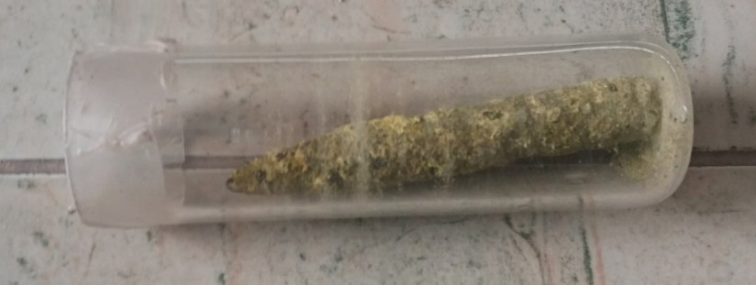
Fig. 1. Depleted uranium projectile (in a bullet shell casing) excavated in Serbia

In the region of Vranje (Serbia) at the location of Pljačkovica, the following samples were analyzed: soil, moss, lichen and water. Samples were taken from areas where there was a reasonable suspicion that depleted uranium munitions had been used. During the research, depleted uranium projectiles were found in this area. Based on physicochemical analyses in the environment, the results confirmed the presence of depleted uranium based on isotope ratios U²³⁴/U²³⁸ and U²³⁵/U²³⁸. Based on the obtained results, the authors concluded that the mobility of depleted uranium is high.
For this reason, the authors, as particularly undesirable, point to the possibility of contamination of the surrounding watercourses. The results show an inhomogeneous distribution of depleted uranium contamination. This result is explained by the fact that the authors did not take samples in the manner prescribed by the standards. Also, sampling followed shortly after depleted uranium munitions were used, so there was not enough time to homogenize the contaminant (depleted uranium) by diffusion in the field being tested.
Detailed investigations were carried out in Cape Arza (Montenegro). 242 depleted uranium projectiles and 49 fragments were found (which shows that the projectile exploded, which is highly unfavourable). The terrain was homogeneously contaminated with depleted uranium. About 7 tons of contaminated soil were removed, reducing radioactivity to below the permitted value. The disadvantage of this procedure is that not all projectiles fired have been removed, and they are still in the ground. It is possible that many of these projectiles lost their shells, and some of them disintegrated into fragments (242 projectiles are only 30% of the projectiles fired in the observed region). For this reason, diffusion of depleted uranium and subsequent contamination can be expected. In this case, the reaction was quick (which was justified), but this missed the examination of the subsequent diffusion of contaminants.
This study aims to examine environmental and health risk assessment by the contamination of the area of Kosovo where there were no previous tests and where was the epicentre of the war. The area study of the Šar Mountains, which is extremely rich in watercourses, was chosen. The previous research monitoring the concentration of tritium in the waters of the Šar Mountains Aquatorium (same authors) (Stanojević et al. 2019, Stanojević et al. 2020) found that the watercourses and lakes of the Šar Mountains are of atmospheric origin. Water from the watercourses of the Šar Mountains is used as drinking water, for irrigating crops and for raising fish for human consumption. It is also an area known for raising domestic animals that spend most of their time outdoors. In addition, in the vicinity of the study area, there is a large ski centre visited by many skiers. For all these reasons, it is crucial to determine whether the site is contaminated and whether the water is safe to use. The research and the obtained results are also valid for the broader area around the Šar Mountains since the study was carried out long enough after possible contamination so that it included the circulation of water in nature for several cycles (Nedić et al. 2021, Kartalović et al. 2021, Antić 2021).
2. Materials and Methods
A sampling of soil and water to determine the presence of radionuclides and measurement of their activity was carried out according to the instructions for sampling by the Public Company "Nuclear Facilities of Serbia", one of the accredited laboratories for gamma spectrometric testing of soil and water. Sampling was performed near watercourses on the Šar Mountains (water and land) from the locations of the Perebes (repeater) (1), Durlov Creek (2) and Berevački Creek (3) marked in Figure 2. According to the instructions, taking a soil sample from the selected depth d is performed without any physical and chemical action to avoid disturbing the existing balance between radionuclides. All the soil and water samples are packed in standard plastic bottles of regular cylindrical geometry (as shown in Figure 3). The soil samples were taken from a depth of 5 cm, and at the Perebes location they were also taken from a depth of 30 cm and 60 cm. The method of soil sampling from depth d is shown in Figure 4.

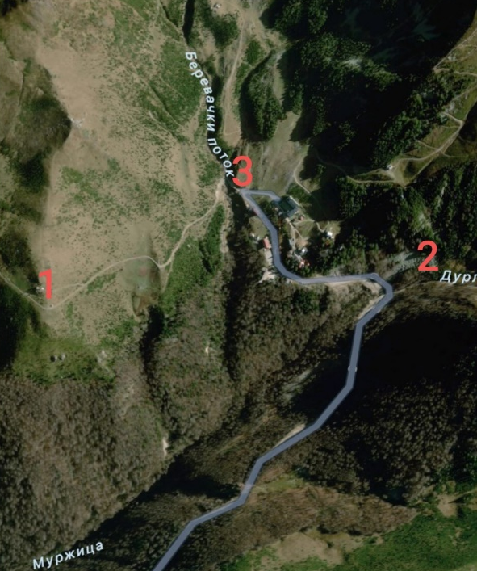 | Fig. 2. Locations of the Perebes (repeater), Durlov Creek  and Berevački Creek on the Šar Mountains
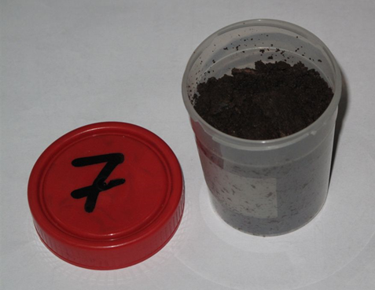 | Fig. 3. Plastic bottle with soil sample
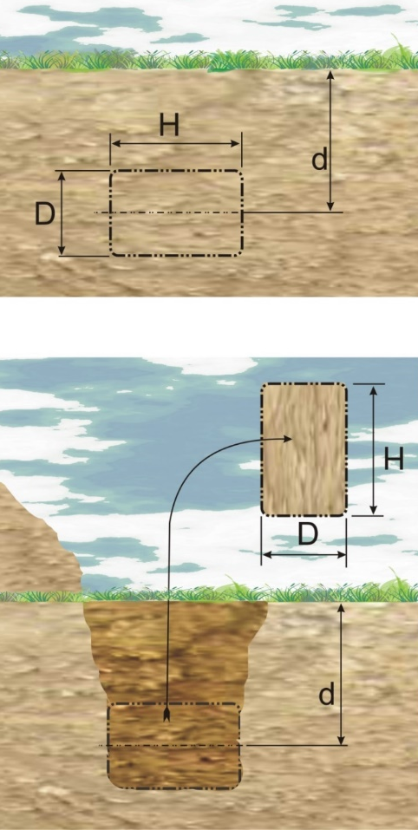 | Fig. 4. Illustration of the soil sampling procedure  from depth d
The samples were analyzed, without any additional treatment, 30 days after collection. Canberra's GX5020 semiconductor Ge detector was used to measure the samples, as well as LabSOCS (Canberra) efficiency software, EFFTRAN to obtain the COI factor for the effects of cascading and subtracting the number of pulses in the Ge detector, and ANGES to determine the peak area of identified radionuclides. Data on the volume and density of the soil samples given in Table 1 were used for numerical calibrations of the Ge detector using LabSOCS software. The expanded measurement uncertainty was less than 5% (Nedić et al. 2021, Kartalović et al. 2021, Antić 2021).
The activity (A) of the radionuclides was determined in a standard way by Eq. (1):
$\text{A = }\frac{\text{C}}{\text{ε ∙ Y ∙ COI}}$ (1)
where:
C – measured peak area for the selected gamma line,
Y – yield for the selected gamma line,
ε – detector efficiency (numerically determined),
COI – factor for the effects of cascading summation and subtraction of the number of pulses in the Ge detector (numerically determined).

The methodology for determining the activity of the identified radionuclides is based on the characteristic lines of gamma radiation with the data given in Table 1. Based on specific values of activity, known values of atomic masses and decay constants for ²³⁵U and ²³⁸U masses m₅ and m₈ for ²³⁵U and ²³⁸U in soil samples are calculated. From the relation, m₅/(m₅ + m₈) enrichment of uranium present in the soil samples is calculated.

Table 1. Data on characteristic lines used to determine radionuclide activity A
Radionuclide | Gamma radiation emitter | Energy [keV] | Yield [%]
²³⁵U | ²³⁵U  ²³⁵U  ²³⁵U | 143.760  163.330  185.715 | 10.96  5.08  57.20
²³⁸U | ²³⁴Th  ^{234m}Pa | 63.290  1001.033 | 3.720  0.842
²³²Th | ²²⁸Ac  ²²⁸Ac | 911.204  968.971 | 25.80  15.80
²²⁶Ra | ²²⁶Ra | 186.211 | 3.64
²⁴¹Am | ²⁴¹Am | 59.537 | 35.90
¹³⁷Cs | ^{137m}Ba | 661.660 | 85.10
⁶⁰Co | ⁶⁰Co  ⁶⁰Co | 1173.237  1332.501 | 99.850  99.983
¹⁵²Eu | ¹⁵²Eu | 344.279 | 26.60
¹⁵⁴Eu | ¹⁵⁴Eu | 591.755 | 4.95
¹³³Ba | ¹³³Ba | 356.013 | 62.05

The levels of exemption from regulatory control (CL) are limit values for individual radionuclides set so that under no circumstances the annual dose for one person of an individual radionuclide exceeds a dose of 10 μSv which is 10 times less than the annual dose of ionizing radiation allowed for the population. CL values are taken from the international standard IAEA BSS 2014.
3. Results and Discussion
The volume of the water sample was 500 mL, and for the soil samples, the values were different, determined over the calculated volume and the measured net mass, and are given in Table 2.
The Minimum Detectable Activity (MDA) for radionuclides that can most often be found in the environment from the group of NORM (Naturally Occurring Radioactive Material – radionuclides from the uranium and thorium decay chain) and the group of artificial (¹³⁷Cs) radionuclides were determined for the time used to measure the samples. No peaks for all three water samples belonging to the NORM group or artificial radionuclides were observed on the energy spectra of gamma radiation, and MDA values are given in Table 3.
Table 2. Data on soil samples taken at locations in the Šar Mountains
Location  of the soil sample | Net mass  of the sample [g] | Height of the sample  in a bottle [cm] | Sample  density [g∙cm⁻³]
Perebes, d = 5 cm | 445.44 | 10.0 | 0.886
Perebes, d = 30 cm | 680.18 | 10.0 | 1.353
Perebes, d = 60 cm | 495.43 | 9.5 | 1.038
Durlov Creek | 526.11 | 10.0 | 1.047
Berevački Creek | 608.95 | 10.0 | 1.211

Table 3. MDA values for NORM and artificial radionuclides in water samples during measurement t = 325,000 s
Radionuclide | MDA [Bq·l⁻¹]
²³⁸U | 0.3
²²⁶Ra | 0.3
²³²Th | 0.5
⁴⁰K | 0.9
¹³⁷Cs | 0.1

In all three water samples, peaks were observed on 139.9 keV and 198.3 keV, which originate from the activation of the Ge nuclides in the detector from nature neutrons. Ge nuclides are very susceptible to activation. In addition, peaks ²¹⁴Pb and ²¹⁴Bi were also observed. No peak has been identified on line 186.2 keV of ²²⁶Ra, so lines of ²¹⁴Pb and ²¹⁴Bi are an obvious consequence of their presence on the outside of the bottle.
The analysis of the energy spectra of gamma radiation from the soil samples revealed the presence of the following radionuclides ²³⁸U and ²³⁵U (with descendants from the uranium decay chain ²³⁴Th, ^{234m}Pa, ²²⁶Ra, ²¹⁴Pb, ²¹⁴Bi and ²¹⁰Pb), ²³²Th (with descendants from the decay chain ²²⁸Ac, ²¹²Pb and ²⁰⁸Tl), ⁴⁰K, and ¹³⁷Cs. Since the spectra from the analyzed soil samples are similar, Figure 5 shows the energy spectrum of gamma radiation for the sample taken from the Perebes location (d = 5 cm).

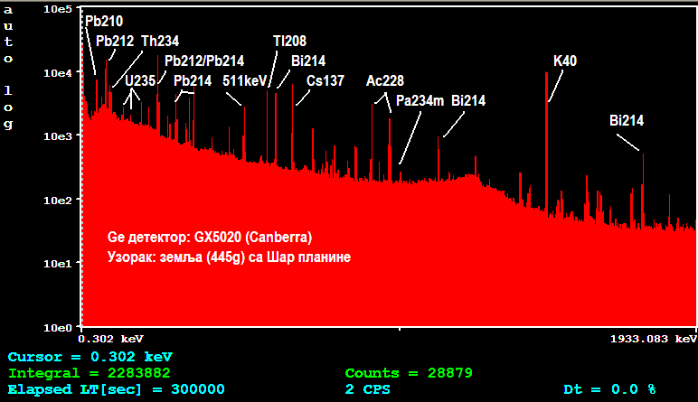
Fig. 5. Energy spectrum of gamma radiation from the tested soil sample taken from the Perebes location (d = 5 cm)

The obtained results for the activity of identified radionuclides, MDA values and the level of exemption from regulatory control (clearance level – CL) in the soil samples (for the measurement time of 250,000 s) from the locations Perebes, Durlov Creek and Berevački Creek on Šar Mountains are shown in Tables 4-8.

Table 4. Activities of radionuclides present in the Perebes soil sample, d = 5 cm
Radionuclide | Activity [Bq·g⁻¹] | MDA value [Bq·g⁻¹] | CL [Bq·g⁻¹]
²³⁵U | 0.0012 ± 0.0001 | 0.0001 | 1
²³⁸U | 0.0258 ± 0.0020 | 0.0010 | 1
²²⁶Ra | 0.0215 ± 0.0013 | 0.0012 | 1
²¹⁴Pb | 0.0236 ± 0.0007 | 0.0002 | 1
²¹⁴Bi | 0.0236 ± 0.0007 | 0.0002 | 1
²¹⁰Pb | 0.1090 ± 0.0060 | 0.0013 | 1
²³²Th | 0.0379 ± 0.0011 | 0.0003 | 1
²¹²Pb | 0.0380 ± 0.0019 | 0.0001 | 1
⁴⁰K | 0.5285 ± 0.0084 | 0.0009 | 10
¹³⁷Cs | 0.0176 ± 0.0084 | 0.0001 | 0.1
Uranium enrichment  $\left(\frac{{\text{m}}_{\text{5}}}{{\text{m}}_{\text{5}}\text{+}{\text{m}}_{\text{8}}}\right)$[%] | 0.7084

Table 5. Activities of radionuclides present in the Perebes soil sample, d = 30 cm
Radionuclide | Activity [Bq·g⁻¹] | MDA value [Bq·g⁻¹] | CL [Bq·g⁻¹]
²³⁵U | 0.0012 ± 0.0002 | 0.0001 | 1
²³⁸U | 0.0271 ± 0.0016 | 0.0010 | 1
²²⁶Ra | 0.0249 ± 0.0014 | 0.0010 | 1
²¹⁴Pb | 0.0260 ± 0.0007 | 0.0001 | 1
²¹⁴Bi | 0.0260 ± 0.0007 | 0.0001 | 1
²¹⁰Pb | 0.0283 ± 0.0021 | 0.0011 | 1
²³²Th | 0.0454 ± 0.0013 | 0.0002 | 1
²¹²Pb | 0.0453 ± 0.0018 | 0.0001 | 1
⁴⁰K | 0.7851 ± 0.0124 | 0.0006 | 10
¹³⁷Cs | 0.0017 ± 0.0001 | 0.0001 | 0.1
Uranium enrichment  $\left(\frac{{\text{m}}_{\text{5}}}{{\text{m}}_{\text{5}}\text{+}{\text{m}}_{\text{8}}}\right)$[%] | 0.7083

Table 6. Activities of radionuclides present in the Perebes soil sample, d = 60 cm
Radionuclide | Activity [Bq·g⁻¹] | MDA value [Bq·g⁻¹] | CL [Bq·g⁻¹]
²³⁵U | 0.0013 ± 0.0002 | 0.0001 | 1
²³⁸U | 0.0282 ± 0.0016 | 0.0010 | 1
²²⁶Ra | 0.0382 ± 0.0023 | 0.0011 | 1
²¹⁴Pb | 0.0330 ± 0.0009 | 0.0002 | 1
²¹⁴Bi | 0.0330 ± 0.0009 | 0.0002 | 1
²¹⁰Pb | 0.0282 ± 0.0030 | 0.0012 | 1
²³²Th | 0.0569 ± 0.0016 | 0.0003 | 1
²¹²Pb | 0.0553 ± 0.0022 | 0.0001 | 1
⁴⁰K | 1.0592 ± 0.0168 | 0.0008 | 10
¹³⁷Cs | 0.0014 ± 0.0001 | 0.0001 | 0.1
Uranium enrichment  $\left(\frac{{\text{m}}_{\text{5}}}{{\text{m}}_{\text{5}}\text{+}{\text{m}}_{\text{8}}}\right)$[%] | 0.7114

Table 7. Activities of radionuclides present in the Durlov Creek soil sample
Radionuclide | Activity [Bq·g⁻¹] | MDA value [Bq·g⁻¹] | CL [Bq·g⁻¹]
²³⁵U | 0.0010 ± 0.0004 | 0.0003 | 1
²³⁸U | 0.0212 ± 0.0008 | 0.0003 | 1
²²⁶Ra | 0.0381 ± 0.0014 | 0.0003 | 1
²¹⁴Pb | 0.0316 ± 0.0010 | 0.0003 | 1
²¹⁴Bi | 0.0316 ± 0.0010 | 0.0003 | 1
²¹⁰Pb | 0.0400 ± 0.0016 | 0.0003 | 1
²³²Th | 0.0336 ± 0.0010 | 0.0003 | 1
²¹²Pb | 0.0336 ± 0.0010 | 0.0003 | 1
⁴⁰K | 0.9338 ± 0.0282 | 0.0009 | 10
¹³⁷Cs | 0.0197 ± 0.0006 | 0.0001 | 0.1
Uranium enrichment  $\left(\frac{{\text{m}}_{\text{5}}}{{\text{m}}_{\text{5}}\text{+}{\text{m}}_{\text{8}}}\right)$[%] | 0.7103

Table 8. Activities of radionuclides present in the Berevački Creek soil sample
Radionuclide | Activity [Bq·g⁻¹] | MDA value [Bq·g⁻¹] | CL [Bq·g⁻¹]
²³⁵U | 0.0017 ± 0.0004 | 0.0003 | 1
²³⁸U | 0.0219 ± 0.0007 | 0.0003 | 1
²²⁶Ra | 0.0237 ± 0.0009 | 0.0003 | 1
²¹⁴Pb | 0.0206 ± 0.0006 | 0.0003 | 1
²¹⁴Bi | 0.0206 ± 0.0006 | 0.0003 | 1
²¹⁰Pb | 0.0238 ± 0.0013 | 0.0003 | 1
²³²Th | 0.0349 ± 0.0011 | 0.0003 | 1
²¹²Pb | 0.0349 ± 0.0011 | 0.0003 | 1
⁴⁰K | 0.7213 ± 0.0218 | 0.0008 | 10
¹³⁷Cs | 0.0041 ± 0.0001 | 0.0001 | 0.1
Uranium enrichment  $\left(\frac{{\text{m}}_{\text{5}}}{{\text{m}}_{\text{5}}\text{+}{\text{m}}_{\text{8}}}\right)$[%] | 0.7110

Similar values of uranium soil concentration obtained here were used by the authors Durante and Pugliese (Durante & Pugliese 2003) in their mathematical calculation model.
4. Conclusion
The presented study, based on a limited number of samples, shows that the presence of uranium from production was not determined, i.e. there is no uranium from depleted uranium ammunition in the samples from the locations Perebes, Durlov Creek and Berevački Creek on Šar Mountains, Kosovo. In the water samples, the activities of uranium radionuclides are below the minimum detectable values that are significantly lower than the CL limit values for these radionuclides. The radionuclides present from the uranium decay chain in all soil samples are in equilibrium. The obtained activity values correspond to the mean value for these radionuclides in the earth's crust, which is about 0.0330 Bq∙g⁻¹ for uranium ²³⁸U. Minor differences between ²³⁸U and ²²⁶Ra are due to differences in these radionuclides' chemical properties in conditions where precipitation is pronounced (primarily from the aspect of solubility in water). Hence, in the soil samples, radionuclides from the thorium decay chain are in equilibrium, and the values obtained correspond to the mean activity value for the presence of ²³²Th in the earth's crust, which is about 0.045 Bq∙g⁻¹. Of the artificial radionuclides, the presence of only ¹³⁷Cs radionuclides was determined at the level of typical values of the activity for this radionuclide in the soil on the territory of the Republic of Serbia, which amounts to 10-20 Bq∙kg⁻¹.
Based on results and the time between the war and sampling, it can be reliably claimed that there is no contamination of land and water with depleted uranium in the broader region of the Šar Mountains, i.e. environmental and health risks are contained to acceptable levels. This can be claimed with some reservations for the parts of the territory of Kosovo that gravitate to the Šar Mountains and its aquatorium.
References
Antić, V.M. (2021). Semi-automatic positioning of the protective screen based on integration with C-arm X-ray device. Nucl Technol Radiat. 36(1), 85-90. https://doi.org/10.2298/NTRP201210002A
Depleted Uranium in Kosovo, Post-Conflict Environmental Assessment, United Nations Environment Programme 2001. (online). (accessed 2022 October 15). https://postconflict.unep.ch/publications/uranium.pdf.
Durante, M., Pugliese, M. (2003). Depleted uranium residual radiological risk assessment for Kosovo sites.
Journal of Environmental Radioactivity, 64(2-3), 237-245. https://doi.org/10.1016/S0265-931X(02)00052-8
Kartalovic, N.M., Djekic, S.D., Djekic, S.B., Nikezic, D.P., Ramadani, U.R. (2021). Possibility of application nuclear magnetic resonance for measurement of fluid-flow. Nucl Technol Radiat. 36(2), 168-173.
https://doi.org/10.2298/NTRP210614017K
Nedic, T.M., Lazarevic, Dj.R., Stankovic, K.D., Kartalovic, N.M. (2021). Optimization of fast three-electrode spark gaps isolated with a SF₆ and He mixture. Nucl Technol Radiat. 36(3), 234-242. https://doi.org/10.2298/NTRP2103234N
Ninković, M.M., Glišić, R. (2005). A critical look at UNEP reports concerning depleted uranium on Yugoslav territory. Nucl Technol Radiat. 20(1), 86-90. https://doi.org/10.2298/NTRP0501086N
Sahoo, S.K., Fujimoto, K., Čeliković, I., Ujić, P., Žunić, Z.S. (2004). Distribution of uranium, thorium, and isotopic composition of uranium in soil samples of south Serbia: Evidence of depleted uranium. Nucl Technol Radiat. 19(1), 26-30. https://doi.org/10.2298/NTRP0401026S
Stanojević, N.Z., Đokić, J.V., Nikezić, D.P., Osmokrović, P.V. (2020). Application of complex statistical distributions and natural isotopes of hydrogen and oxygen for assessment of water origin in Šar mountains aquatorium.
Nucl Technol Radiat. 35(2), 172-180. https://doi.org/10.2298/NTRP2002172S
Stanojević, N.Z., Đokić, J.V., Osmokrović, P.V. (2019). Research on water interconnections within the Šar mountains aquatorium by radioactive hydrogen isotope tritium. Nucl Technol Radiat. 34(4), 392-398.
https://doi.org/10.2298/NTRP191029040S
Use of depleted uranium weapons in Kosovo: map 2. 2000. (Online). (accessed 2022 October 15).
https://mondediplo.com/maps/uakosovo2.
Vukotić, P., Andjelić, T., Zekić, R., Kovačević, M., Vasić, V., Savić, S. (2003). Radiation survey and decontamination of Cape Arza from depleted uranium. Nucl Technol Radiat. 18(2), 51-56. https://doi.org/10.2298/NTRP0302051V

