 | Rocznik Ochrona Środowiska
 | Volume 24 | Year 2022 ISSN 2720-7501 | pp. 404-414
 | https://doi.org/10.54740/ros.2022.029 open access
 | Received: 27 October 2022 Accepted: 28 November 2022 Published: 07 December 2022
Impact of Selected Operating Conditions
on the Optical Properties of Polymer Shields
Agnieszka Ubowska*
Faculty of Maritime Technology and Transport,
West Pomeranian University of Technology in Szczecin, Poland
https://orcid.org/0000-0002-2230-9522
Piotr Zmuda Trzebiatowski
Faculty of Mechanical Engineering, Koszalin University of Technology, Poland
https://orcid.org/0000-0002-1330-4842
*corresponding author’s e-mail: agnieszka.ubowska@zut.edu.pl
Abstract: The optical properties of polymer barriers used as machine covers and eye protection are extremely important for vision quality and user safety. The article presents the influence of liquid chemical substances at room temperature on the transparency of poly(methyl methacrylate) shields. UV/VIS spectroscopy was used to assess the impact of liquid chemical substances on the polymer’s permeability to visible, ultraviolet and infrared radiations. The tests showed that the contact of the poly(methyl methacrylate) sheath with liquid chemicals influences the transmittance of the PMMA surface to a limited extent, without thereby reducing the harmful effects of radiation on humans.
Keywords: operational safety; optical radiation; poly(methyl methacrylate)
1. Introduction
The operation of machinery and equipment is invariably one of the basic sources of threats in the industry. Despite the decrease in the number of persons injured in accidents at work in the manufacturing section (according to The Polish Classification of Activities PKD-2007) in 2020, the number of injured persons is still high (Fig. 1).
In 2020 the injured in this sector accounted for almost 35% of those injured in accidents at work. In the same year, employees were exposed to the following risk factors:
- risks arising from work environment – 260495 persons,
- risks arising from strenuous work – 107575 persons,
- risks arising from mechanical factors – 71558 persons.

Fig. 1. Persons injured in accidents at work
Source: Statistics Poland, Local Data Bank

Moreover, 81315 persons were exposed to mechanical risk factors associated with hazardous machinery (Statistic Poland, 2022). The vast majority of accident causes are directly or indirectly related to the work organisation and safety culture (Fig. 2).
Technical measures for improving occupational safety include solutions produced from polymer materials, i.e., machine guards and eye protection. The quality of these materials significantly influences the safety and comfort of work.
Machine guards form a barrier separating the operator from hazardous and harmful factors in all production and processes. The machine covers are complemented with eye and face shields, which include safety glasses and goggles, face and welding shields. Their basic element, which determines the user’s safety, are visors, protective glass, screens or filters, protecting against impacts, optical radiation, and drops and splashes of liquid substances. The conditions of using guards and protecting shields can result in the materials’ contact with liquid process media, operating fluids, engine fuels and lubricants. Under the influence of those liquids, phenomena such as their absorption by the plastic or extraction of plastic components soluble in a given liquid may occur. In addition, chemical reactions during these processes can cause changes in the usability of the shields, including their transparency, which can affect the transmission of non-laser optical radiation, changing the operator’s working conditions. When determining the impact of UV/VIS radiation on human health, the following radiation ranges are considered:
- 320-380 nm (UV-A): accelerates the skin ageing processes damaging collagen fibres; long-term exposure to high doses of radiation can cause clouding of the eye lens (cataract),
- 280-320 nm (UV-B): produces skin pigmentation,
- 200-280 nm (UV-C): long exposure increases the incidence of skin cancers, e.g. melanoma; this is the most dangerous UV radiation for humans (Kolek 2006, Pawlak 2021).

Fig. 2. Causes of accidents at work in industry (2020)
Source: Statistics Poland, Local Data Bank

Examples of non-laser optical radiation sources in the industry are shown in Figure 3. The presented processes are accompanied by the emission of thermal radiation – IR-A (wavelength 780-1000 nm). Infrared radiation can increase tissue temperature, thus causing discomfort. Its source in processes is, among others, metal parts heated to high temperatures. The visible spectrum of radiation can cause photochemical changes in the retina, which may result in retinitis (blue light hazard). This threat is the effect of artificial optical radiation on employees while constantly staring at the light source, especially in digital device screens (mainly concerned with radiation in the 400-490 nm range). Burns to the skin and retina may result from the thermal effects of visible and near-infrared radiation. Appropriate absorption or absorption-reflection filters like a blue-blocker lenses, amber/yellow filters or blue attenuating anti-reflective lenses could be used to reduce the blue light hazard (Naskręcki & Grzonka 2016).

Fig. 3. Sources of non-laser optical radiations
Source: Pawlak 2020

Requirements for eye guards used at workstations equipped with sources of intense thermal radiation and harmful optical radiation have been specified in the provisions of standards: EN 169, EN 170 and EN 171. In the case of machine shields, the radiation permeability of the shield material is considered in the context of the use of lasers (according to EN 60825-4), while for other cases, general provisions (ISO 14120) apply. Radiation flux emitted by machines can be reduced by attenuation or screening (EN 12198-3).
1.1. Polymer Shields
Polymers are a group of multipurpose materials used in machinery and equipment. Selecting a polymer depends on the work environment and the particular dangers a piece of equipment poses. The most important properties determining the choice of material intended for the cover include impact resistance, stiffness, light transmittance, optical clarity and chemical resistance. The most commonly used materials for polymeric barriers are acrylics [including poly(methyl methacrylate), PMMA], polycarbonates, poly(vinyl chloride) and copolyester PETG.
For both machine guards and eye protection shields, poly(methyl methacrylate) is used. PMMA is characterised by excellent optical properties (visible light transmission of 92%), resistance to weather conditions, low temperature, and low water absorption. In addition, it has good mechanical and electrical insulation properties and a scratch resistance higher than polycarbonates. Among the above-mentioned polymers, PMMA has the lowest impact resistance and stiffness. However, it has the highest light transmittance, giving machine guards the best visual monitoring. Poly(methyl methacrylate) is characterised by high chemical resistance (Table 1) (Sastri 2014, Krala et al. 2014).

Table. 1. Chemical resistance of poly(methyl methacrylate)
Good | Fair | Poor
ethylene oxide  silicones  bleaches  hydrogen peroxide  disinfectants  lipids | dilute acids  dilute bases  saline water  soaps/detergents | tetrahydrofuran  methyl ethyl ketone  methylene chloride  acetone  isopropanol  oils/greases
Source: Sastri 2014

Since the covers are used in all production and processing processes, including the chemical industry, in the conditions of use, they may come into contact with liquid process media, operating fluids, oils and greases. Under the influence of the liquid, phenomena such as its absorption by the plastic or the extraction of components soluble in a given liquid from the plastic can occur. In addition, the chemical reactions that occur during these processes can cause changes in the properties of the material.
2. Materials and Methods
Transparent poly(methyl methacrylate) samples (obtained as described elsewhere (Krala et al. 2014) were exposed to chemicals under ISO 175. To determine the effect of liquid chemicals on the optical properties of polymer sheaths, PMMA was immersed in the following liquids:
- water,
- detergent (10% by weight aqueous solution),
- dilute base: sodium hydroxide (40% by weight aqueous solution) – one of the main components of industrial washing solutions,
- dilute acids: nitric acid (V) (10% by weight aqueous solution), sulfuric (VI) acid (10% by weight aqueous solution) – basic acids of the chemical industry,
- acetone, methanol, toluene – basic industrial solvents,
- extraction gasoline and kerosene – used for degreasing surfaces, cleaning parts, tools and other contaminated elements,
- hydraulic oil – used as a working medium in hydraulic drives and damping systems.

A two-beam UV/VIS UV-9000S spectrophotometer (Shanghai Metash Instruments, China) was used to measure the transparency of materials. Transparency was measured in the 200-1000 nm wavelength range. The camera range contained UV, VIS, and short infrared radiation (IR-A – wavelength 780-1000 nm). The transparency of the samples after contact with chemicals and the reference sample (PMMA not exposed to chemical agents) were assessed. UV/VIS spectra are presented as the dependence of transmittance T on the radiation wavelength. The transmittance (%) is the transmitted intensity ratio over the incident intensity.
3. Results and Discussion
The study confirmed the poor resistance of PMMA to main industrial solvents. The immersion of samples in acetone and toluene for seven days caused their dissolution. Although methanol did not cause this effect, the sample swelled and became milky white after contact with the liquid. Its transmittance in the entire analysed wavelength range was 0% (Table 2).
Contact of poly(methyl methacrylate) with liquids did not affect the permeability of UV-C radiation through the sample. For the 200-280 nm wavelength, the transmission value varied in the range of 0-2% (Fig. 4). Similar transmittance values were recorded for UV-B radiation (Fig. 5). In both cases, PMMA absorbs UV radiation and no additional protection against radiation source is required.
In the case of UV-A radiation, a sharp increase in transmittance value at 370 nm is observed. The spectra of the samples are similar, but it should be noted that the contact of PMMA with hydraulic oil weakens the absorption of UV-A radiation in the range of 350-370 nm (Fig. 6). For 380 nm (Table 2), a significant reduction in transmittance can be seen for samples that have been in contact with diluted base and acids, in particular sulfuric acid (44% reduction in transmittance compared to neat PMMA). This is the effect of the interaction between the polymer and the liquid, leading to a change in structure at the interface.

Table 2. Transmittance values after contact with liquid chemicals for the characteristic wavelength values
Wavelength, nm | Transmittance, %
 | PMMA | PMMA  (water) | PMMA  (detergent) | PMMA  (sodium hydroxide) | PMMA  (sulfuric acid) | PMMA  (nitric acid) | PMMA  (methanol) | PMMA  (extraction gasoline) | PMMA  (hydraulic oil) | PMMA  (kerosene)
200 | 1 | 0 | 0 | 0 | 0 | 1 | 0 | 1 | 0 | 0
280 | 1 | 0 | 0 | 0 | 0 | 2 |  | 1 | 0 | 0
320 | 2 | 2 | 2 | 2 | 1 | 2 |  | 2 | 2 | 2
380 | 60 | 61 | 62 | 47 | 34 | 51 |  | 50 | 62 | 57
400 | 88 | 91 | 91 | 79 | 61 | 85 |  | 83 | 90 | 90
490 | 90 | 93 | 92 | 86 | 70 | 88 |  | 89 | 92 | 92
780 | 90 | 93 | 93 | 87 | 76 | 85 |  | 89 | 92 | 92
1000 | 87 | 90 | 90 | 86 | 73 | 81 |  | 87 | 89 | 89

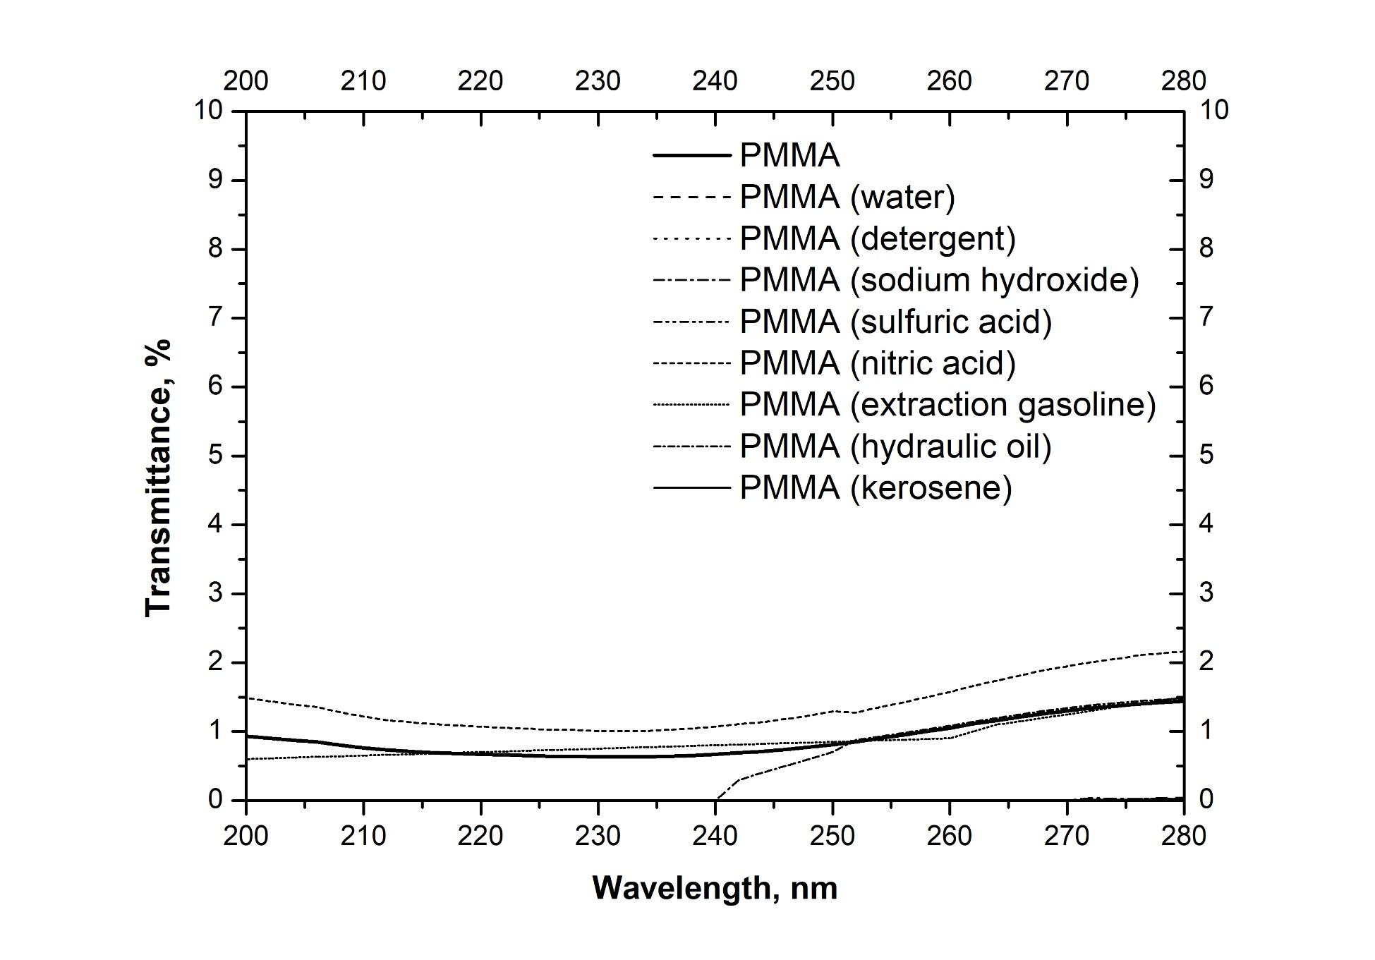
Fig. 4. UV-C spectra of PMMA after contact with liquid chemicals

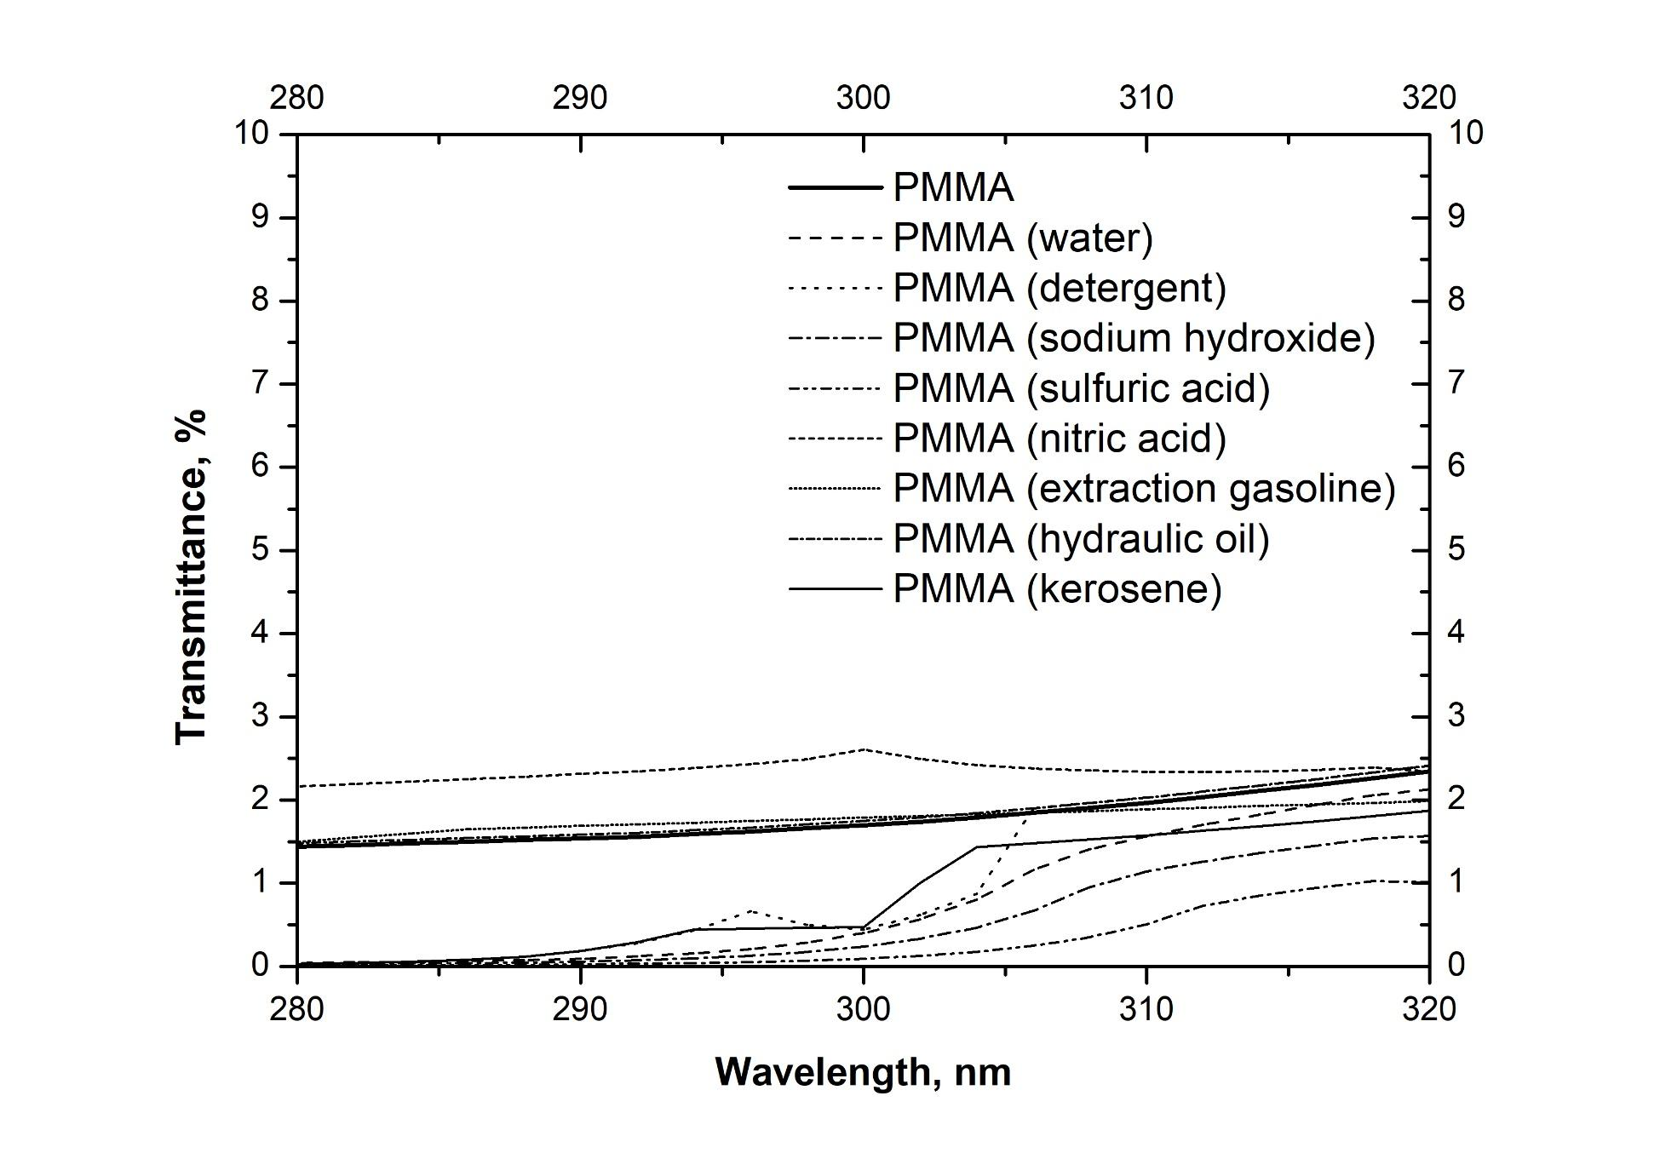
Fig. 5. UV-B spectra of PMMA after contact with liquid chemicals

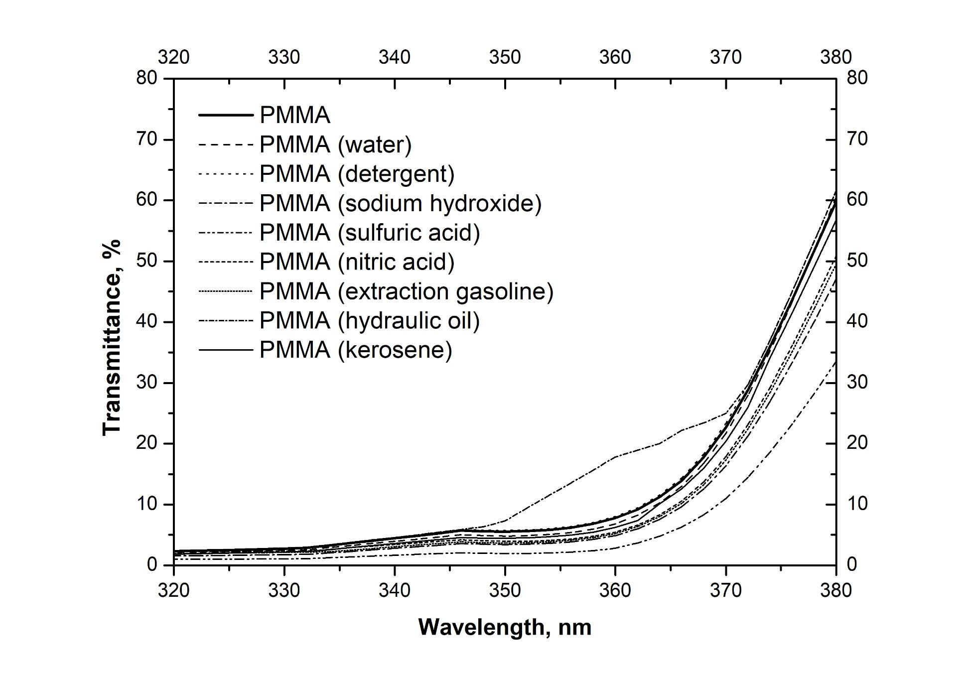
Fig. 6. UV-A spectra of PMMA after contact with liquid chemicals

Absorbed UV radiation can cause photochemical transformation and lead to damage to the cornea and the lens. Therefore, in case of long-term exposure to high doses, additional eye protection should be introduced. PMMA contact with selected chemicals does not contribute to the reduction of visible transmittance; almost the whole range is at about 85% and above (Fig. 7). Significant deterioration in optical properties is only observed for the sample that was in contact with a solution of sulfuric acid. Therefore, in areas where this acid is used, and there is a possibility of splashing the cover, a material other than PMMA should be used. Due to the high UV transmittance for all other samples at the workplace where a blue light hazard may occur, the additional solutions mentioned at the beginning of the article should be introduced.
Similar results as for visible radiation can be observed for infrared radiation (IR-A, Fig. 8). A decrease in transmittance for a wavelength of 780-1000 nm was noted for PMMA samples that had contact with acid solutions. Therefore, to eliminate the influence of infrared radiation on the employee, other solutions should be used, such as screening or visors equipped with appropriate filters.

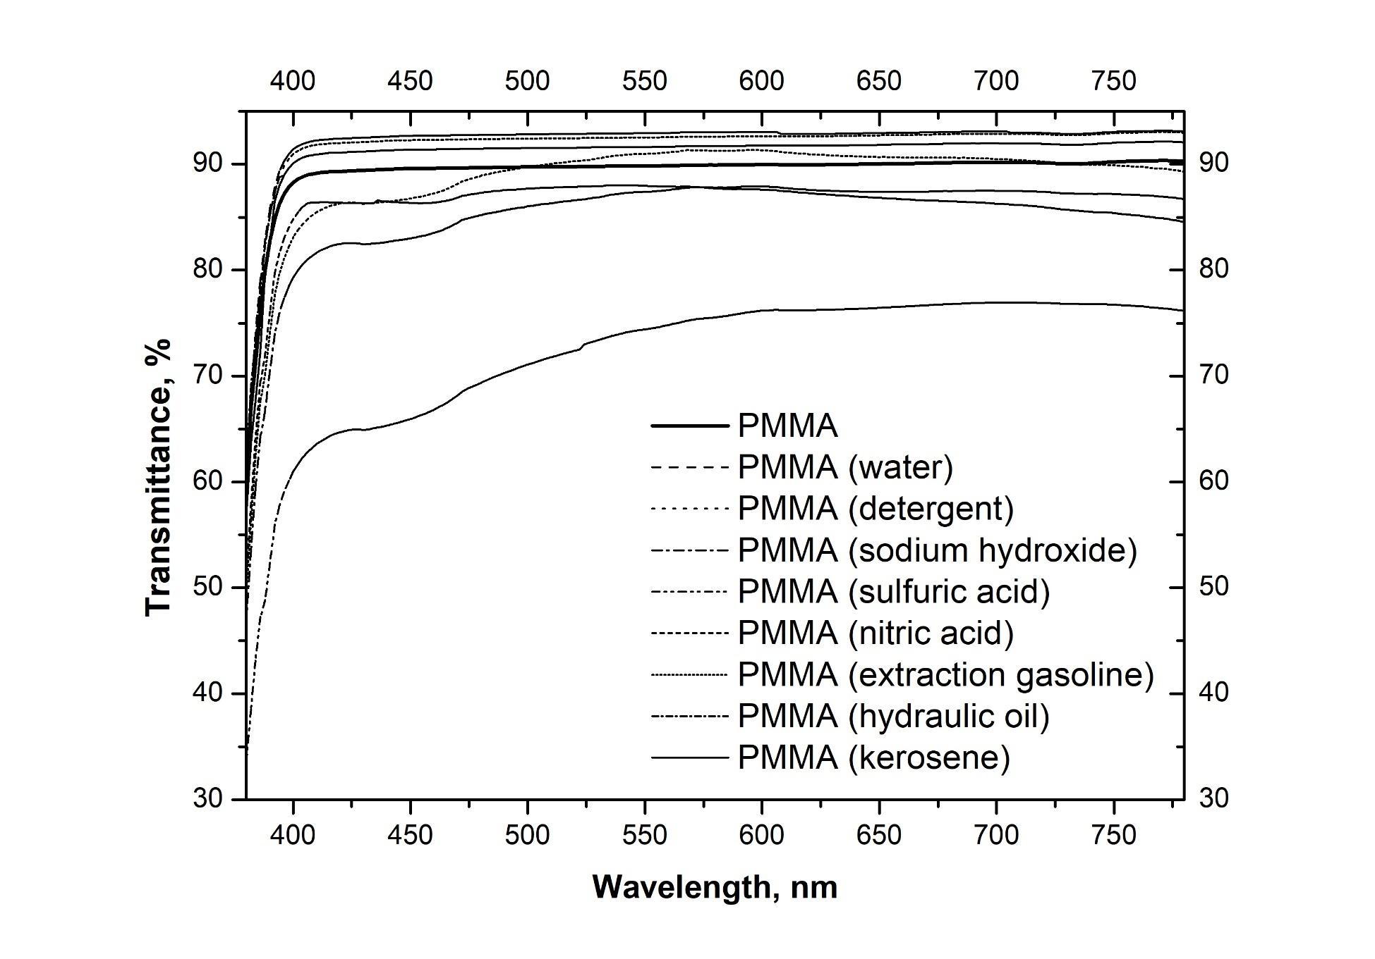
Fig. 7. VIS spectra of PMMA after contact with liquid chemicals

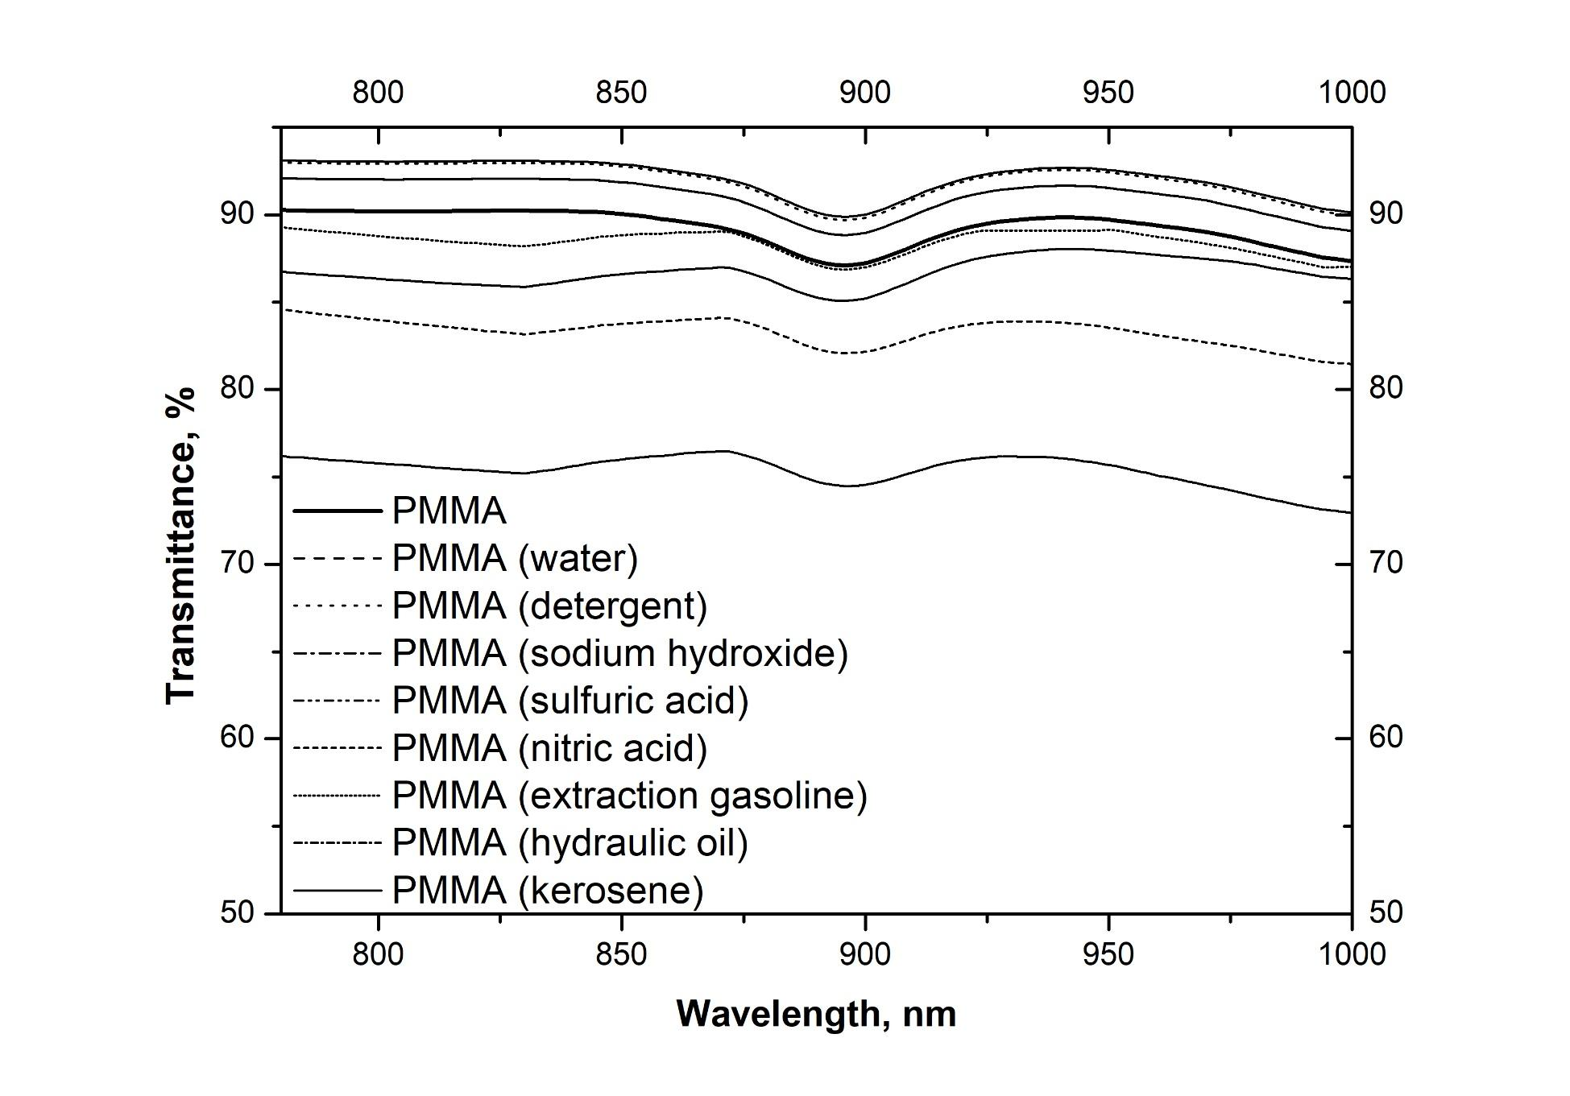
Fig. 8. IR-A spectra of PMMA after contact with liquid chemicals
4. Conclusions
Accidental splashing of the cover can reduce the transparency of the polymer coating, affecting its use quality. When choosing the cover material, it should be considered whether it can come into contact with basic industrial solvents like acetone, toluene and methanol. Although contact with other liquids has not resulted in drastic changes in the material’s transparency, exposure to diluted acids and bases, particularly sulfuric acid, should be avoided. Reducing radiation transmittance in the tested range does not reduce the harmful effect of radiation on humans. Further research by the authors will concern the impact of increased temperature chemical substances on the polymer shields (conditions typical for some production and processing processes).
References
Statistics Poland, Local Data Bank (2022). Retrieved from: https://bdl.stat.gov.pl/bdl/start
Kolek, Z. (2006). Oddziaływanie promieniowania optycznego na człowieka: korzystny wpływ i zagrożenia. Prace Instytutu Elektrotechniki, 228, 269-281. Retrieved from: http://yadda.icm.edu.pl/baztech/element/bwmeta1.element.baztech-article-BPS2-0038-0022
Pawlak, A. (2021). Ocena zagrożenia promieniowaniem nadfioletowym na wybranych stanowiskach pracy. Bezpieczeństwo Pracy, 5, 1-27. DOI: 10.5604/01.3001.0014.8772
Pawlak, A. (2020). Źródła ekspozycji na nielaserowe promieniowanie optyczne w środowisku pracy i życia. Retrieved from: www.ciop.pl (25.09.2022)
Naskręcki, R. Grzonka, M. (2016). Blue Light Hazard, czyli czy i jak chronić się przed nadmiarem światła niebieskiego. Optyka, 3(40), 36-39. Retrieved from: http://yadda. icm.edu.pl/baztech/element/bwmeta1.element.baztech-1579b1be-ed75-4bf5-a9d8-3650300b9471
EN 169:2002 Personal eye-protection – Filters for welding and related techniques – Transmittance requirements and recommended use
EN 170:2002 Personal eye-protection – Ultraviolet filters – Transmittance requirements and recommended use
EN 171:2002 Personal eye-protection. Infrared filters – Transmittance requirements and recommended use
EN 60825-4:2006/A2:2011 Safety of laser products – Part 4: Laser guards
ISO 14120:2015 Safety of machinery – Guards – General requirements for the design and construction of fixed and movable guards
EN 12198-3:2002+A1:2008 Safety of machinery – Assessment and reduction of risks arising from radiation emitted by machinery – Part 3: Reduction of radiation by attenuation or screening
Sastri, VR (2014). Plastics in medical devices. Properties, requirements and application. 2nd Edition. William Andrew
Krala, K., Ubowska, A., Kowalczyk, K. (2014). Mechanical and thermal analysis of injection molded poly(methyl methacrylate) modified with 9,10‐dihydro‐9‐oxa‐10‐phosphaphenanthrene‐10‐oxide (DOPO) fire retarder. Polymer Engineering & Science, 54(5), 1030-1037. DOI: 10.1002/pen.23644
ISO 175:2010 Plastics – Methods of test for the determination of the effects of immersion in liquid chemicals

