|  |  |  |  |
| --- | --- | --- | --- |
|  |  | | |
| **Rocznik Ochrona Środowiska** | | |
| Volume 24 | Year 2022 ISSN 2720-7501 | pp. 260-275 |
|  | https://doi.org/10.54740/ros.2022.019 open access | | |
|  | Received: 10 October 2022 Accepted: 02 November 2022 Published: 14 November 2022 | | |

Probability Function Estimation for the Maximum Precipitation Model Using Kernel Estimators

Maciej Karczewski*

Department of Mathematics, Faculty of Environmental Engineering and Geodesy, Wroclaw University of Environmental and Life Sciences, Poland  
https://orcid.org/0000-0001-8811-8916

Bartosz Kaźmierczak

Department of Water Supply and Sewerage Systems,   
Faculty of Environmental Engineering,   
Wroclaw University of Science and Technology, Poland  
https://orcid.org/0000-0003-4933-8451

Andrzej Michalski

Department of Mathematics, Faculty of Environmental Engineering and Geodesy, Wroclaw University of Environmental and Life Sciences, Poland  
https://orcid.org/0000-0001-9705-9276

Leszek Kuchar

Department of Mathematics, Faculty of Environmental Engineering and Geodesy, Wroclaw University of Environmental and Life Sciences, Poland  
https://orcid.org/0000-0002-4157-0910

*corresponding author’s e-mail: maciej.karczewski@upwr.edu.pl

**Abstract:** The distribution of maximum rainfall level is not a homogeneous phenomenon and is often characterised by multimodality and often the phenomenon of the heavy right-hand tail. Modelling this phenomenon using classic probability distributions leads to ignoring multimodality, thus underestimating or overestimating the predicted values in the tail tails – the most important from the point of view of safe dimensioning of drainage systems. To avoid the difficulties mentioned above, a non-parametric kernel estimator method of maximum precipitation density function was used (in the example of rainfall data from a selected station in Poland). The methodology proposed in the paper (for use on any rainfall data from other meteorological stations) will allow the development of more reliable local models of maximum precipitation.

**Keywords:** maximum precipitation; kernel estimation; hydrology

1. Introduction

One of the most critical infrastructures in the urban area is the stormwater drainage system, which is used to drain excess rainwater from the catchment area to natural receivers, such as rivers or lakes – away from urban areas. The construction of urban drainage systems is one of the most expensive infrastructural investments of constantly growing agglomerations. Such systems are usually designed to last at least 50 years or even 100 years. Stormwater drainage systems should protect against the effects of extreme rainfall, flooding, or floods, causing significant economic and social losses (Kotowski et al. 2016). However, it is impossible to achieve its fully reliable operation, both now and in the future, due to the stochastic nature of precipitation and its high time-spatial variability.

Safe design of sewerage systems aims to ensure an adequate standard of drainage of the area, which is defined as adapting the system to accept estimated maximum rainwater streams with a frequency equal to the permissible (socially acceptable) frequency of their flooding in the area. The European standard (EN:752 2017) proposes distinguishing the permissible frequency of overflows from the sewage system in a seven-level scale of the impact of the threat on the environment, i.e. for seven defined examples of locations – land development. The standard limits the permissible frequency of sewer overflow from once a year (*C*= 1, where *C* is the occurrence period) for areas of very low importance (e.g. roads and open spaces located away from buildings) through, among others, the frequency of once every five years (*C* = 5) for areas of medium importance (e.g. roads and open spaces located near buildings), to the frequency of once every 50 years (*C* = 50) for areas of very high importance (e.g. critical infrastructure).

For dimensioning of drainage systems, the rainwater stream (, dm3/s) that is meaningful for dimensioning can be calculated using the following formula:

|  |  |
| --- | --- |
| $Q_{m}=q_{max}\left(t,C\right)ΨF$, | (1) |

where: $q_{max}\left(t,C\right)$ – the maximum unit intensity of rain (dm3/s·ha) with the duration $t$ (min) and occurrence period $C$ (years) – calculated from DDF (depth-duration-frequency) curves; $Ψ$ – runoff precipitation (rainwater) ratio; $F$– drained catchment area (ha).

The relationships of the intensity (intensity or amount) of rainfall with the duration and frequency of occurrence developed for many geographical regions of the world are qualitatively similar. However, this does not mean they are quantitatively identical, especially on a local scale. Numerous environmental factors determine an area’s precipitation regime, including geographic location, distance from seas and oceans, topography and elevation of the area above sea level, cover and land use. One of the fundamental problems of drainage system design is a lack of appreciation of the differences in rainfall distribution patterns and urban hydrology in different parts of the world. For example, many developing countries lie in humid tropical regions where annual rainfall distribution is characterised by a monsoon season, with much higher rainfall intensities than those in temperate regions. The rain is concentrated during a few months of the year (Parkinson 2002).

The issue of rainwater drainage from urbanised areas has gained special significance in recent years. On the one hand, the progressive sealing of the land surface increases the value of runoff rainwater coefficients, leading to the hydraulic overloading of stormwater drainage systems. On the other hand, more and more attention is paid to the occurring climate changes (Ahmed & Tsanis 2016, Kuchar et al. 2014, Kundzewicz et al. 2012, Saboia et al. 2017), especially in the context of global warming (Dai 2011, Fleig et al. 2015) and the increase in the occurrence frequency of extreme weather events (Hermida et al. 2013, Kaźmierczak & Kotowski 2014, Kuchar et al. 2017, Schiermeier 2011, Walsh et al. 2016). Much attention is also paid to improving the methods for estimating the dependence of maximum rainfall on the duration and probability of exceeding (Schardong et al. 2014, Kaźmierczak & Kotowski 2015). Despite development over the years, designing an effective functioning drainage system remains a significant challenge. In particular, impacts due to climate change and urbanisation have been widely acknowledged, which could entail a substantial increase in the frequency and magnitude of urban flooding in many regions of the world (Qianqian 2014). Changes to the timing and magnitude (depth) of rainfall events as a result of climate change are predicted to significantly alter the flooding experienced in many urban areas of the world (IPCC 2014, Yang et al. 2013) and, without suitable mitigation, lead to increased future flood risk and associated damages (Miller & Hutchins 2017).

The basic form of a quantitative description of rains, among others for design purposes, are models of the dependence of precipitation height ($h$, mm) from its duration ($t$, min) and the probability of exceedance $p$. The relationship between precipitation height and duration is presented in the form of DDF (depth-duration-frequency) curves for various exceedance probabilities $p$ or interchangeable frequency $C=1/p$. To determine the DDF curves, a series of several dozen years of homogeneous observation is necessary. World Meteorological Organization (WMO) recommends using periods of a minimum of 30 years, starting from the first year and ending with an entire decade, e.g. 1981-2010 (WMO 2017). Because short-term heavy torrential rainfall and long-term rainfall of lower intensity can cause environmental damage, the DDF curves should be determined based on the maximum precipitation amounts over several times of duration from 5 minutes to several days (Kotowski & Kaźmierczak 2013).

Drainage systems currently in use in Poland were measured (in the 20th century) using the Błaszczyk formula for rain intensity based on rainfall data from 1837-1925. This formula lowers the current rainfall (by 40% on average). Existing systems may not therefore meet modern European standards regarding the permissible frequency of floods from canals and flooding areas (Ben-Zvi 2009). Nowadays, precipitation models are based on theoretical probability distributions (Gupta & Kundu 2007, Onyutha & Willems 2015).

Models based on theoretical probability distributions are considered the most accurate and are currently the standard in constructing dependence of precipitation amount on its duration and the probability of exceedance. Determining the theoretical function of a probability distribution best suited to the studied phenomenon is not easy because we do not have theoretical premises to clearly determine the distribution type appropriate for the variable describing the studied phenomenon. The most commonly used distributions in hydrology to describe maximum phenomena are Fréchet, gamma, Gumbel, log-normal, Weibull and generalised exponential (GED) distributions (Kuchar et al. 2014, Ben-Zvi 2009, Gupta & Kundu 2007, Onyutha & Willems 2015, Wdowikowski et al. 2016). Models can be evaluated by using the root mean square percentage error (Göçken et al. 2016):

|  |  |
| --- | --- |
| $RMSPE=\sqrt{\frac{1}{N}\sum_{i=1}^{N}{{\left(\frac{h_{o, i}-h_{e, i}}{h_{o, i}}\right)}^{2}}}∙100$, | (2) |

where: $h_{e}$– estimated precipitation level, mm; $h_{o}$– observed precipitation level, mm.

A parametric approach, due to its rigid attachment to the shape of the distribution function, cannot adapt to the irregularly changing probability of occurrence of different rainfall levels. The result may be a weaker fit in the tail of the distribution, a lack of ability to match the irregular dynamics of probability changes, and ignoring multimodality.

The paper aims to propose a non-parametric way of estimating probability density function, i.e. kernel density estimation (KDE), to describe the maximum rainfall levels – used in practice by designers for dimensioning urban areas drainage systems in Europe (Silverman 1986). This approach will be more accurate than in the case of classic models’ estimation of the dependence of maximum rainfall levels on its duration and the probability of exceeding it.

2. Materials and Methods

2.1. Materials

Archival pluviograms from the Institute of Meteorology and Water Management – National Research Institute (IMGW-NRI) Legnica station from the years 1961-2010 constituted the research material. As the paper aims to attempt to implement (based on an example) a non-parametric way of estimating probability density to describe the maximum precipitation, the station’s location was selected randomly. The authors primarily wanted the measurement data to be reliable. The measuring station in Legnica, as part of a national measurement and observation network at hydrological and meteorological service, is a synoptic station participating in the international weather monitoring program (Weather World Watch) as part of the (WMO), of which Poland is a member. The station building is located on the south-east outskirts of Legnica (Fig. 1), at an elevation of 122 m above sea level.

To implement the national measuring program station in Legnica uses standard equipment, typical for synoptic stations: meteorological instruments connected to the automatic MAWS workstation. Rainfall measurement is carried out in parallel with the automatic SEBA rain gauge and with the participation of a meteorological observer who collects rainfall data using traditional Hellman rain gauge in the 6 hours checksums and the daily totals.

Annual totals in Legnica varied and ranged between 351 mm (in 2003) and 765 mm (in 1977). The average value of the long-term period 1961-2010 was 521 mm. Participation of the warm season V-X each year was between 53.9% and 82.5%, reflecting the typical climatic conditions of Lower Silesia precipitation patterns. The largest monthly sum shall cover the period from May to September, with the maximum values in July.



**Fig. 1.** Location of measuring stations

For this paper, using the total review method (Shinyie et al. 2014) there were isolated from the tested 50-year period top 50 maximum amounts ($h$, mm) of rainfall for each of the 20 following rainfall durations ($t$, min): 5, 10, 20, 30, 40, 50, 60, 90, 120, 180, 360, 720, 1080, 1440, 2160, 2880, 4320, 5760, 7200 and 8640 min (durations used in practice by designers for dimensioning stormwater drainage and retention reservoirs in urban areas in Europe).

2.2. Methods

In many typical engineering problems (e.g. hydrological or soil science), knowledge of the density function $f$ of the probability distribution of random variable $X$ describing the phenomenon studied) is essential. Specifying the function $f$ gives a natural description of the distribution of $X$ and allows determining the probabilities $P(X∈(a,b))$ for $a<b$. The analysis of the following example shows imperfections when using parametric methods.

Fig. 2 presents an example of a histogram of the occurrence frequency of various precipitation heights (duration $t$ = 5 min) with the density curves of the fitted Weibull distribution and selected kernel estimator (log-normal KDE) imposed on it. The height of the bar indicates the frequency of occurrence of the determined range of empirical precipitation heights, while the x-axis different rainfall heights ($h$, mm). As seen in the graph, the distribution of precipitation does not have to be a homogeneous phenomenon, and its structure may have more than one characteristic “hump”, demonstrating the multimodal distribution (local mode at a point of 15 mm with a relatively low frequency). Adjusting with classic distributions will either ignore this place or re-evaluate it in earlier values.

**`**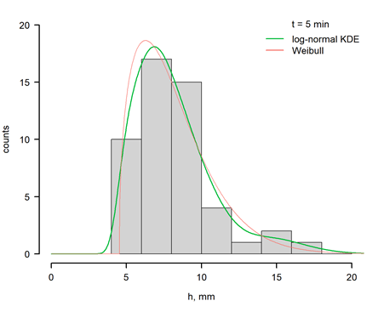

**Fig. 2.** Empirical distribution functions of the highest precipitation amounts   
from the 50-yr observation period in Legnica

An essential aspect of probabilistic modelling is the study and assessment of the consistency of the considered empirical distribution with the postulated theoretical distribution (Michalski 2016). In the case of particularly strongly skewed distributions (significant deviation from symmetry), it may not be possible to achieve the optimal solution using the maximum likelihood estimation (MLE). The solution at the beginning of the interval may strive for infinity, leading to an additional statistical error.

An alternative and competitive approach are to build the density function based on the collected data using a non-parametric kernel estimator (Karczewski & Michalski 2018a, Karczewski & Michalski 2018b). Due to the lack of a specific function shape, the kernel estimator better detects multimodality in the empirical distribution and is also free from the peculiarities of MLE solutions, e.g. towards infinity. For a given random sample $X_{1}, X_{2}, …, X_{n}$ the kernel estimator ${\hat{f}}_{n}$ with kernel $K$ is defined by:

|  |  |
| --- | --- |
| ${\hat{f}}_{n}(x)=\frac{1}{ns}\sum_{i=1}^{n}{K}\left(\frac{x-X_{i}}{s}\right)$, | (3) |

where kernel $K$ is a positive function integrating to one, and $s>0$ is the smoothing factor, usually called the bandwidth or window width. The fundamental problem in kernel density estimation is that of the joint choice of $s$ and $K$ in the absence of a priori information regarding density function $f$. The selection of the *s*parameter affects the range of observation smoothing. A too low value will give a lot of small jumps and a significant error ( $s$ = 0.2 in Fig. 3), while a too high value will smooth the whole into one unified curve ( $s$ = 1.5 in Fig. 3), thanks to which important distribution features will disappear (e.g. multimodality).

An optimal solution to the problem of bandwidth *s* selection is the minimalisation of the integrated squared error given by:

|  |  |
| --- | --- |
| $$ISE\left(s\right)=\int{{\hat{f}}^{2}\left(x\right)dx}-2E\left[\hat{f}\left(x\right)\right]+\int{f^{2}\left(x\right)dx}=$$ $=R\left(\hat{f}\right)-2E\left[\hat{f}\left(x\right)\right]+R\left(f\right)$, | (4) |

where $R\left(f\right)$ denotes a measure of the roughness of a given function $f$, defined by $R\left(f\right)=\int{f^{2}\left(t\right)dt}$.

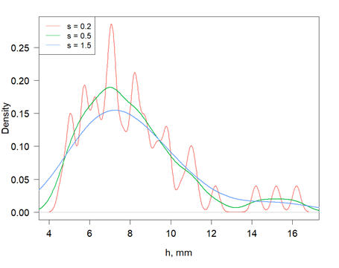

**Fig. 3.** Examples of the bandwidth *s* for experimental data (groundwater levels)   
and the Gaussian kernel

Currently, there are many methods for calculating this error, of which the most popular are cross-validation and plug-in methods. They differ almost exclusively in how they approach solving optimality of bandwidth parameter *s*. In practice, none of them can be called “best” in every situation, and it is hard to create a general intuition about how those methods might affect bandwidth selection. It is advised to calculate some of them and compare the fit of density estimators. This paper presents the results of the Silvermann method for calculating the optimal bandwidth parameter (Wand & Jones 1995).

The choice of kernel function is also essential for the quality of the fit. For heavily skewed distribution, using an asymmetrical kernel is a better choice than using a standard Gaussian kernel. Therefore, in this paper, we will consider kernel based on the log-normal distribution for comparison. Statistical analysis was performed in the R for windows program (R Core Team 2020). Kernel estimation was performed using the kdensity, and logKDE packages (Moss et al. 2019, Nguyen et al. 2018) used inside the R environment.

3. Results

In the paper (Kotowski et al. 2011), the Fréchet, Gamma, GED, Gumbel, Log-normal and Weibull distributions were tested for meteorological data from Legnica. The parameters of distributions were estimated by the maximum likelihood method, and then the results were compared using the relative mean square residual error. The proposed criterion allowed Weibull distributions to be chosen as a probability distribution that best described the measured data. Additionally, we present the results for Frechet, Gumbel and Gamma distributions. A good fit of the Weibull distribution with the empirical distribution determined based on measurement data can be observed, especially for 9 rainfall periods: 10, 40, 50, 60, 120, 180, 720, 1080, and 1440 min (RMSPE less than 3%). The goodness of fit for Gamma distribution was considered suitable for 8 rainfall periods: 10, 40, 50, 60, 120, 180, 720, 1080. Frechet distribution showed good fit only in one rainfall period: 720. Gumbel distribution had RMSPE higher than 3% for all

The Silvermann estimator used in this paper with the log-normal kernel function showed a much better fit to empirical data (in fact, to the empirical distribution). The calculated fit error was lower than 1.5% for all tested rainfall times and only for $t$ = 5 min. the error was greater than 1%. The RMSPE error averaged for all precipitation times was 0.28%. The plot of the density functions (Weibull and kernel estimator) compared to the distribution for the observed data shows a better fit of kernel estimators to irregular changes in the probability of precipitation – especially for higher precipitation heights (see Fig. 4).

The RMSPE error averaged over all rainfall lengths gave us 3.098% for Weibull distribution, 3.11% for Gamma, 5.793% for Frechet, 6.67% for Gumbell and 0.28% for Silvermann plug-in with the log-normal kernel (Table 1).

The RMSPE error of tail estimation averaged over all rainfall lengths gave us 1.185% for Weibull distribution, 1.204% for Gamma, 2.012% for Frechet, 4.879% for Gumbell and 0.414% for Silvermann plug-in with the log-normal kernel (Table 2).

A good fit of the Weibull and Gamma distributions with the tails of empirical distribution can be observed mainly for all rainfall periods. Frechet distribution showed a good fit for all but one rainfall period (5 min). Gumbel distribution had RMSPE higher than 3% for all rainfall periods.

Kernel estimator with Silvermann method for selection of *h* and log-normal kernel showed a good fit for all rainfall periods. Similarly to the calculation for whole distribution, the Kernel estimator showed a much better average fit than the classical method. The RMSPE error of tail estimation averaged over all rainfall lengths gave us 1.185% for Weibull distribution, 1.204% for Gamma, 2.012% for Frechet, 4.879% for Gumbell and 0.414% for Silvermann plug-in with the log-normal kernel.

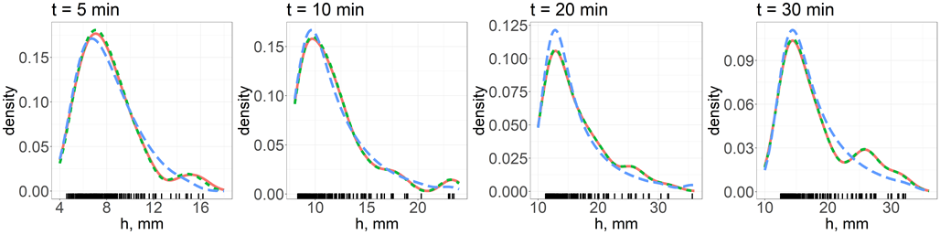

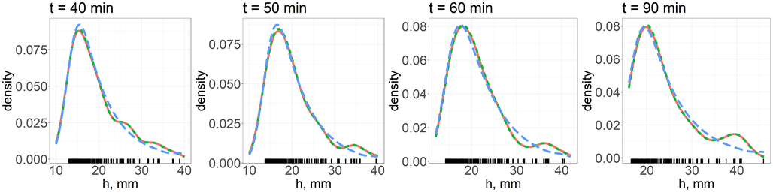

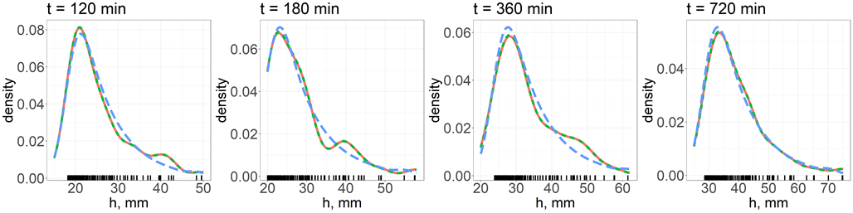

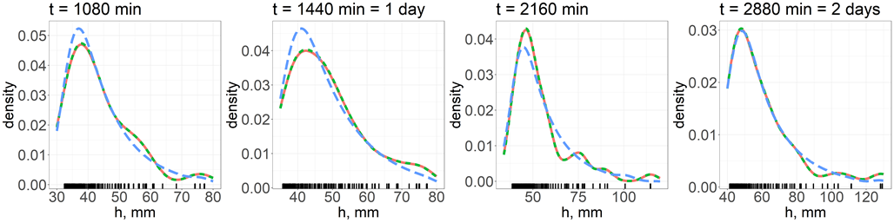

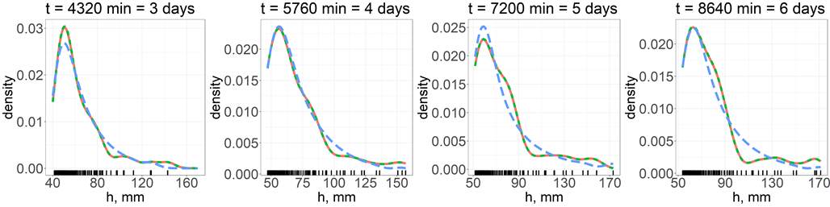

**Fig. 4.** Comparison of three density functions: empirical density for observed data (red), log-normal KDE (green) and Weibull (blue)

**Table 1.** The values of the mean square percentage error (RMSPE)

|  |  |  |  |  |  |
| --- | --- | --- | --- | --- | --- |
| *t*, min | Log-normal KDE | Weibull | Frechet | Gumbel | Gamma |
| 5 | 1.415 | 3.262 | 3.011 | 4.064 | 3.021 |
| 10 | 0.408 | 2.597 | 3.705 | 6.455 | 2.642 |
| 20 | 0.311 | 3.657 | 11.334 | 7.328 | 3.258 |
| 30 | 0.322 | 4.364 | 12.138 | 7.579 | 4.182 |
| 40 | 0.308 | 2.585 | 7.196 | 6.711 | 2.519 |
| 50 | 0.416 | 2.402 | 4.503 | 6.260 | 2.330 |
| 60 | 0.508 | 2.421 | 3.073 | 5.193 | 2.456 |
| 90 | 0.335 | 3.217 | 6.069 | 6.347 | 3.298 |
| 120 | 0.089 | 2.995 | 7.017 | 7.213 | 2.944 |
| 180 | 0.203 | 2.475 | 5.415 | 6.450 | 2.443 |
| 360 | 0.176 | 3.167 | 6.351 | 6.604 | 3.226 |
| 720 | 0.173 | 2.153 | 2.349 | 5.082 | 2.237 |
| 1080 | 0.148 | 2.124 | 3.258 | 4.705 | 2.189 |
| 1440 | 0.159 | 2.618 | 3.037 | 3.686 | 3.351 |
| 2160 | 0.144 | 3.239 | 3.008 | 6.856 | 3.175 |
| 2880 | 0.128 | 3.134 | 7.056 | 8.540 | 3.259 |
| 4320 | 0.161 | 3.696 | 3.302 | 8.148 | 3.640 |
| 5760 | 0.052 | 3.819 | 10.240 | 9.300 | 3.930 |
| 7200 | 0.073 | 3.873 | 7.509 | 8.138 | 3.809 |
| 8640 | 0.115 | 4.165 | 6.281 | 8.668 | 4.286 |

**Table 2.** The values of the mean square percentage error (RMSPE) of the distribution tail

|  |  |  |  |  |  |
| --- | --- | --- | --- | --- | --- |
| *t*, min | Log-normal KDE | Weibull | Frechet | Gumbel | Gamma |
| 5 (15) | 2.127 | 2.493 | 3.341 | 3.329 | 2.882 |
| 10 (13) | 0.487 | 0.723 | 1.910 | 4.644 | 0.678 |
| 20 (12) | 0.475 | 1.127 | 1.442 | 6.045 | 1.372 |
| 30 (10) | 0.412 | 0.889 | 1.684 | 5.864 | 0.903 |
| 40 (10) | 0.410 | 0.566 | 1.729 | 5.464 | 0.465 |
| 50 (12) | 0.584 | 1.287 | 2.781 | 5.384 | 1.071 |
| 60 (13) | 0.621 | 1.390 | 2.885 | 4.231 | 1.189 |
| 90 (11) | 0.545 | 1.025 | 2.099 | 4.610 | 1.155 |
| 120 (11) | 0.150 | 1.808 | 1.154 | 5.004 | 1.894 |
| 180 (11) | 0.297 | 0.894 | 1.976 | 5.095 | 0.740 |
| 360 (9) | 0.292 | 0.641 | 1.712 | 3.566 | 0.541 |
| 720 (15) | 0.271 | 1.308 | 1.615 | 3.004 | 1.498 |
| 1080 (12) | 0.237 | 0.745 | 1.632 | 3.303 | 0.732 |
| 1440 (11) | 0.211 | 1.171 | 2.187 | 3.097 | 1.345 |
| 2160 (18) | 0.235 | 1.430 | 2.710 | 3.454 | 1.457 |

Table 2. cont.

|  |  |  |  |  |  |
| --- | --- | --- | --- | --- | --- |
| *t*, min | Log-normal KDE | Weibull | Frechet | Gumbel | Gamma |
| 2880 (13) | 0.228 | 0.702 | 1.361 | 6.204 | 0.804 |
| 4320 (19) | 0.283 | 2.396 | 1.458 | 4.412 | 2.548 |
| 5760 (12) | 0.092 | 1.348 | 1.687 | 7.746 | 1.412 |
| 7200 (14) | 0.121 | 1.204 | 2.679 | 6.840 | 0.986 |
| 8640 (13) | 0.200 | 0.557 | 2.192 | 6.298 | 0.420 |

4. Discussion

The traditional approach allows for the development of maximum rainfall models (with a given duration and exceedance probability) with an accuracy of about 3% RMSPE. One of the most frequently used formulas for this purpose is the Weibull distribution, although, by design, it will not consider multimodality. As shown in Fig. 4, the distribution of precipitation does not have to be a homogeneous phenomenon, and its structure may have more than one characteristic “hump”, demonstrating the multimodal distribution. Estimation using classic distributions will either ignore this place or revaluate it in earlier values, and result in underestimation of the probability of very high levels of maximum rainfall. The proposed solutions will significantly reduce errors in estimating the amount of rainwater for which rainfall water collectors are designed.

The Silvermann estimator used in this paper with the log-normal kernel function allowed to achieve much greater accuracy in the description of precipitation data – the mean RMSPE equal to 0.28% for whole distribution and 0.414% for tail estimation (Table 1). Only for rainfall of the shortest duration (t = 5 min) the error exceeded 1% (RMSPE = 1.415% for whole distribution and 2.127% for tail estimation). Nevertheless, the error is still smaller than traditional models (3.262-4.064% for the whole distribution and 2.493-3.341 for the distribution tail). It should be noted that the measurements of such intense short-term rainfall are already burdened with a significant error, which may be the reason for the difficulties in their mathematical description. In the work (Kotowski et al. 2011), the accuracy of recording the amount of rainfall in Legnica was analysed using a traditional pluviograph and a tipping bucket pluviograph with digital recording, compared to a standard Hellmann’s rain gauge. The evaluated pluviographs were considered sufficiently accurate and approximately equivalent for the balance periods of the month and day. However, the analysis showed that the most significant rainfall differences occur in short-term, very intense rainfall events. In the case of very intense rainfall, reaching the height of several millimetres within 5 minutes, differences in the recorded rainfall levels were noted at the level of up to 15%.

Since the construction of urban rainwater drainage systems is one of the most expensive infrastructure investments, the accuracy of mathematical models describing rainfall is crucial during design. The consequence of choosing the wrong calculation method is the possibility of designing oversized channels, which would be economically unjustified, or channels with insufficient capacity, which overload the network and creates a risk of flooding streets and basements or flooding buildings.

When designing hydrodynamic models for drainage networks on a large city scale, the analysis of historical precipitation data is crucial as it serves as the basis for technical studies on the expansion or modernisation of combined and rainwater sewage systems. Both short-term, short-range torrential precipitation and long-term precipitation of lower intensity but on a larger scale may cause environmental damage to urban infrastructure.

The precipitation model formulated in the study for Legnica will help designers meet the requirements of EN 752 in terms of the frequency of outflows from sewage systems. The relationships between rainfall intensity and the duration and frequency of occurrence developed for many regions of Poland are similar, which does not mean that they are identical, especially on a local scale. Numerous environmental factors, including geographic location, distance from seas and oceans, topography and elevation of the area above sea level, cover, and land use, determine an area’s rainfall regime.

From the perspective of designing safe-to-operate sewage systems, it is appropriate to create models for the maximum amount of local rainfall, separately for each meteorological station, and then, on this basis, to create precipitation maps throughout the country.

5. Conclusions

The study led to the following conclusions:

* A parametric approach, due to its rigid attachment to the shape of the distribution function, cannot adapt to the irregularly changing probability of occurrence of different rainfall levels. The result may be a weaker fit in the tail of the distribution, a lack of ability to match the irregular dynamics of probability changes, and ignoring multimodality.
* The kernel estimation method, by its non-parametric structure, is not burdened with assumptions about the probability distribution. As a result, it allows better tailoring of the distribution tails – the most important from the point of view of safe dimensioning of land drainage systems.
* The kernel estimator with a kernel in the form of a log-normal function eliminates the above problem while maintaining the strengths of KDE (i.e. no attachment to a particular distribution function), which results in the best fit. Due to the large spatio-temporal variability of precipitation, local precipitation models developed for individual cities should replace the regional models used in Poland.
* The method proposed in the paper will allow for the development of reliable local rainfall models, enabling designers to meet the requirements of EN 752 regarding the frequency of outflows from sewage systems. Authors recommend using R for Windows, which has several packages that provide an easy interface for finding optimal bandwidth parameter and generating data based on the created estimator (Moss et al. 2019, Nguyen et al. 2018). Kernel density estimation is also possible using Python and SAS. Results presented in our paper are an example of use tied to a dataset obtained on a specific geographical region (city of Legnica). Because of that, similar calculations on different regions might result in different optimal kernel estimators, similar to how parametric approach might result in different distribution functions and parameters.

References

Ahmed, S., Tsanis, I. (2016). Climate Change Impact on Design Storm and Performance of Urban Storm-Water Management System – A Case Study on West Central Mountain Drainage Area in Canada. *Hydrol. Current Res*., *7*(1), 1-11. DOI: 10. 4172/2157-7587.1000229

Ben-Zvi, A. (2009). Rainfall intensity-duration-frequency relationships derived from large partial duration series. *J. Hydrol*., *367*(1-2), 104-114. DOI: 10.1016/j.jhydrol.2009. 01.007

Dai, A. (2011). Drought under global warming: a review. *WIREs Clim. Change,* *2*(1), 45-65. DOI: 10.1002/wcc.81, 2011.

EN 752: Drain And Sewer Systems Outside Buildings – Sewer System Management, Comité européen de normalisation, 2017.

Fleig, A.K., Tallaksen, L.M., James, P., Hisdal, H., Stahl, K. (2015). Attribution of European precipitation and temperature trends to changes in synoptic circulation. *Hydrol. Earth Syst. Sci*., *19*, 3093-3107. DOI: 10.5194/hess-19-3093-2015

Göçken, M., Özçalıcı, M., Boru, A., & Dosdoğru, A.T. (2016). Integrating metaheuristics and Artificial Neural Networks for improved stock price prediction. *Expert Systems with Applications*, *44*, 320-331. DOI: 10.1016/j.eswa.2015.09.029

Gupta, R., Kundu, D. (2007). Generalised exponential distribution: existing results and some recent developments. *J. Stat. Plan. Inference,* *137*, 3537-3547. DOI: 10.1016/ j.jspi.2007.03.030

Hermida, L., Sánchez, J.L., López, L., Berthet, C., Dessens, J., García-Ortega, E., Merino, A. (2013). Climatic trends in hail precipitation in France: spatial, altitudinal, and temporal variability. *Sci. World J*., 494971. DOI: 10.1155/2013/494971.

IPCC. Climate Change 2014: Impacts, Adaptation, and Vulnerability (Part A: Global and Sectoral Aspects). Contribution of Working Group II to the Fifth Assessment Report of the Intergovernmental Panel on Climate Change; Field, C.B., Mach, K.J., Mastrandrea, M.D., Eds.; Cambridge University Press: New York, NY, USA, 2014.

Karczewski, M., Michalski, A. (2018a). The study and comparison of one-dimensional kernel estimators – a new approach. Part 1. Theory and methods. *ITM Web Conf.* *23*, DOI: 10.1051/itmconf/20182300017

Karczewski, M., Michalski, A. (2018b). The study and comparison of one-dimensional kernel estimators – a new approach. Part 2.A hydrology case study. *ITM Web Conf.* *23*, DOI: 10.1051/itmconf/20182300018

Kaźmierczak, B., Kotowski, A. (2014). The influence of precipitation intensity growth on the urban drainage systems designing. *Theor. Appl. Climatol*., *118*(1), 285-296. DOI: 10.1007/s00704-013-1067-x

Kaźmierczak, B., Kotowski, A. (2015). The suitability assessment of a generalised exponential distribution for the description of maximum precipitation amounts. *J. Hydrol*., *525*, 345-351. DOI: 10.1016/j.jhydrol.2015.03.063

Kaźmierczak, B., Wdowikowski, M. (2016). Maximum Rainfall Model Based on Archival Pluviographic Records – Case Study for Legnica (Poland). *Period. Polytech.-Civ*., *60*(2), 305-312. DOI: 10.3311/PPci.8341

Kotowski, A., Dancewicz, A., Kaźmierczak, B. (2011). Accuracy of measurements of precipitation amount using standard and tipping bucket pluviographs in comparison to Hellmann rain gauges. *Environment Protection Engineering*, *37*(2), 23-34.

Kotowski, A., Kaźmierczak, B. (2013). Probabilistic models of maximum precipitation for designing sewerage. *J. Hydrometeorol*., *14*, 1958-1965. DOI: 10.1175/JHM-D-13-01.1

Kotowski, A., Wartalska, K., Nowakowska, M. (2016). Uogólniona metoda analityczna wymiarowania przelewowych zbiorników retencyjnych ścieków deszczowych. *Ochrona Środowiska*, *38*(1), 45-52.

Kuchar, L., Iwanski, S., Jelonek, L. (2017). River Flow Prediction for Future Climate Using Long Series of Multi-Site Synthetic Data and MIKE SHE Model. *E3S Web Conf.*, *17*, DOI: 10.1051/e3sconf/20171700046

Kuchar, L., Iwanski, S., Jelonek, L., Szalinska, W. (2014). Application of spatial weather generator for the assessment of climate change impacts on a river runoff. *Geografie,* *119*(1), 1-25.

Kundzewicz, Z. W., Kanae, S., Seneviratne, S. I., Handmer, J., Nicholls, N., Peduzzi, P., Mechler, R., Bouwer, L. M., Arnell, N., Mach, K., Muir-Wood, R., Brakenridge, R., Kron, W., Benito, G., Honda, Y., Takahashi, K., and Sherstyukov, B. (2012). Flood risk and climate change: global and regional perspectives, *Hydrolog. Sci. J*., *59*(1), DOI: 10.1080/02626667.2013.857411

Michalski, A. (2016). The use of kernel estimators to determine the distribution of groundwater level. *Meteorol. Hydrol. Water Manage*., *4*(1), 41-46. DOI: 10.26491/mhwm/ 62708

Miller, J.D., Hutchins, M. (2017). The impacts of urbanisation and climate change on urban flooding and urban water quality: A review of the evidence concerning the United Kingdom. *Journal of Hydrology: Regional Studies*, *12*, 345-362. DOI: 10.1016/j.ejrh. 2017.06.006

Moss J., Tveten, M. (2019). kdensity: Kernel Density Estimation with Parametric Starts and Asymmetric Kernels. R package version 1.0.1, https://CRAN.R-project.org/ package=kdensity

Nguyen, H.D., Jones, A.T., McLachlan G.J. (2018). logKDE: Computing Log-Transformed Kernel Density Estimates for Positive Data, R package version 0.3.2. https://CRAN.R-project.org/package=logKDE

Onyutha, C., Willems, P. (2015). Empirical statistical characterisation and regionalisation of amplitude-duration-frequency curves for extreme peak flows in the Lake Victoria basin, East Africa. *Hydrolog. Sci. J*., *60*(6), 997-1012. DOI: 10. 1080/02626667. 2014.898846

Parkinson, P. (2002). Urban drainage in developing count ries – challenges and opportunities. *Waterlines*, *20*(4).

Qianqian, Z. (2014). A Review of Sustainable Urban Drainage Systems Considering the Climate Change and Urbanization Impacts. *Water*, *6*, 976-992. DOI: 10. 3390/w604 0976

R Core Team. R: A language and environment for statistical computing. R Foundation for Statistical Computing, Vienna, Austria, 2020. URL https://www.R-project.org/

Saboia, M.A.M., Souza Filho, F.A., Araujo Junior, L.M., Silveira C.S. (2017). Climate changes impact estimation on urban drainage system located in low latitudes districts: a study case in Fortaleza-CE. *Braz. J. Water Resour*., *22*(21), 1-15. DOI: 10.1590/ 2318-0331.011716074

Schardong, A., Srivastav, R.K., Simonovic, S.P. (2014). Equidistance quantile matching method for updating IDF curves under climate change. *Water Resour. Manage*., *28*(9), 2539-2562. DOI: 10.1007/s11269-014-0626-y

Schiermeier, Q. (2011). Increased flood risk linked to global warming: likelihood of extreme rainfall may have been doubled by rising greenhouse-gas levels. *Nature*, *470*(7334), 316. DOI: 10.1038/470316a

Shinyie, W. L., Ismail, N., Jemain, A.A. (2014). Semi-parametric estimation based on second order parameter for selecting optimal threshold of extreme rainfall events. *Water Resource Manage*., *28*, 3489-3514.

[Silverman, B.W.](https://en.wikipedia.org/wiki/Bernard_Silverman) (1986). *Density Estimation for Statistics and Data Analysis*. London: Chapman & Hall.

Walsh, K.J.E., McBride, J.L., Klotzbach, P.J., Balachandran, S., Camargo, S.J., Holland, G., Knutson, T.R., Kossin, J.P., Lee, T., Sobel, A., Sugi, M. (2016). Tropical cyclones and climate change. *WIREs Clim. Change*, *7*(1), 65-89. DOI: 10.1002/wcc.371

Wand, M.P., Jones, M.C. (1995). *Kernel Smoothing.* London, Chapman & Hall.

Wdowikowski, M., Kaźmierczak, B., Ledvinka, O. (2016). Maximum daily rainfall analysis at selected meteorological stations in the upper Lusatian Neisse River basin. *Meteorol. Hydrol. Water Manage.*, *4*(1), 53-63. DOI: 10.26491/mhwm/63361

WMO-No. 1203: WMO Guidelines on the Calculation of Climate Normals, Geneva, 2017.

Yang, L., Smith, J.A., Wright, D.B., Baeck, M.L., Villarini, G., Tian, F., Hu, H. (2013). Urbanisation and Climate Change: An Examination of Nonstationarities in Urban Flooding. *Journal of Hydrometeorology*, *14*(6), 1791-1809. DOI: 10.1175/JHM-D-12-095.1