 | Rocznik Ochrona Środowiska
 | Volume 24 | Year 2022 ISSN 2720-7501 | pp. 129-140
 | https://doi.org/10.54740/ros.2022.010 open access
 | Received: 04 July 2022 Accepted: 12 August 2022 Published: 14 November 2022
Environmental and Socio-Economic Assessment of the Dams
at the Salmonid Rivers of Lithuania
Egidijus Kasiulis*
Department of Water Engineering, Vytautas Magnus University, Kaunas, Lithuania
https://orcid.org/0000-0001-6483-7617
Raimondas Šadzevičius
Department of Water Engineering, Vytautas Magnus University, Kaunas, Lithuania
https://orcid.org/0000-0002-7616-6598
Tomas Virbickas
Laboratory of Fish Ecology, Nature Research Centre, Vilnius, Lithuania
https://orcid.org/0000-0002-8141-6184
*corresponding author’s email: egidijus.kasiulis@vdu.lt
Abstract: EU Biodiversity Strategy for 2030 aims to restore 25,000 km of free-flowing rivers across Europe. The critical issue is which barriers should be prioritised for removal. In this study, a set of socio-economic and environmental criteria was chosen to rank the dams on salmonid rivers in Lithuania and recommend them for removal. As these criteria usually contradict themselves, the multi-criteria decision analysis tool was utilised. The results showed that the Anykščiai dam on the river Šventoji could be recommended to be removed first. The removal can significantly increase the salmonid population in the river Šventoji over a significant stretch of the river. Also, this dam is in a protected area, is not listed as a national heritage, and does not have a hydropower plant. Although, this study showed that dams with hydropower plants could also be recommended for removal.
Keywords: dam removal, salmonid rivers, socio-economic criteria, environmental criteria, multi-criteria decision analysis, Lithuania
1. Introduction
The findings of the recently finished H2020 Amber project revealed that there is a dam, weir, culvert, or other types of barriers at every kilometre of a river in Europe (Amber project 2022). Hence, a new EU Biodiversity Strategy for 2030 aims to restore 25,000 km of free-flowing rivers across Europe. The main issue is to identify and prioritise barriers that could be removed (European Commission 2022).
In Lithuania, there are 22,250 rivers and streams that are longer than 0.25 km, and their total length is over 76,000 km (Jablonskis et al. 2007). The total amount of dams built in Lithuania is not clear to this day, the approximation being 1,500. It means that issue of river fragmentation in Lithuania is much less apparent, and the density of dams is only one in approx. 51 km. In fact, the number of barriers found during the Amber project in Lithuania is even less – 1,257 (Amber project 2022).
Therefore, the main issue of dams lies elsewhere. Since the regaining of independence in 1990, no new dam was built in Lithuania. It means that most of them were built during the Soviet Union era, the most intensive period being from 1972 to 1982 (Šadzevičius et al. 2013). Now, these old dams need a good management strategy and an increment of maintenance time and effort, which is not always the case. Furthermore, although this number needs clarification in subsequential studies, it could be that up to a third of all dams in Lithuania are without an owner who would be responsible for maintaining them in good shape.
The study, published in 2013 by Šadzevičius et al., revealed this issue rather well. This study summarised the investigations of the state of the 260 earthfill dams that were carried out between 2002 and 2009. It was found that only 48% of these dams were in good or moderate condition. It also emphasised the worsening of such dams’ state, compared with assessments made in 1997 (Šadzevičius et al. 2013). What needs to be considered is also that this study was published already almost 10 years ago and the approach to dam safety in Lithuania is the same as it was in 2013.
The safety of dams is not a local Lithuanian issue. The need for efficient dam safety management systems to prevent failures is acknowledged globally. Such systems have been developed in South Korea (Jeon et al. 2009) and Spain (Morales-Torres et al. 2019). All dams are essential from this point of view – no matter if they are small dams built for agricultural purposes (Dam et al. 2012) or large arch dams usually built in mountainous regions (Su et al. 2017). Additional pressure on ageing dams that is presented by extreme events caused by climate change is also being studied (Ivetić et al. 2022).
The fundamental issue with the dams is that they are seen as an impervious barrier for fish migration and sediment movement and pose other threats to river ecosystems due to fragmentation (Gido et al. 2015). Dam removal is usually seen as the only efficient method to restore river connectivity (Birnie-Gauvin, et al. 2020). On the other hand, reservoirs and dams create multi-layered socio-economic benefits for society that could be lost if the dam is removed, as they could be used for electricity generation, flood protection, irrigation, recreation, and other purposes (Bonnet et al. 2015). Thus, this study aims to prioritise the dams for removal at the salmonid rivers in Lithuania by considering the environmental and socio-economic factors.
2. Materials and Methods
There are 13 salmonid rivers in Lithuania (Order of Minister of Environment, 2002), and the number of dams on these rivers is 19, of which 10 have small hydropower plants (HPP). The location of salmonid rivers and dams is presented in Fig. 1.

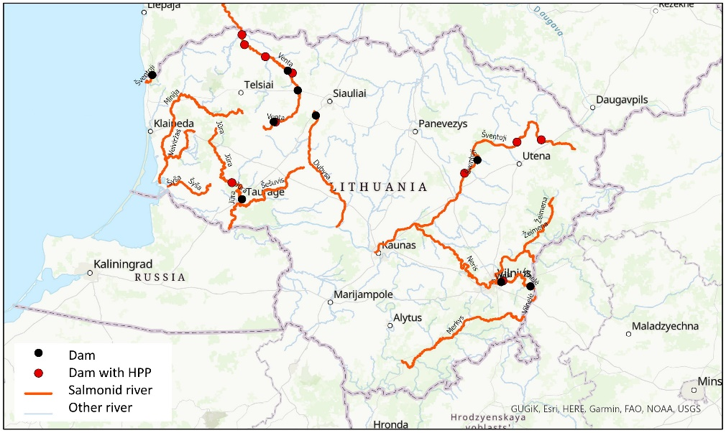
Fig. 1. Locations of dams on salmonid rivers in Lithuania

The method that is used to help to evaluate and use different and usually contradicting criteria is multi-criteria decision analysis or MCDA. In this study Preference Ranking Organisation METHod for Enrichment of Evaluations or PROMETHEE method is used with the help of Visual PROMETHEE software (Visual PROMETHEE 2022). PROMETHEE is based on the pairwise comparison of the chosen alternatives, in this case, dams, by utilising different types of preference functions. It also allows an assignment of criteria weight to reflect the decision maker’s priorities. In this case, weights for all criteria were set equal. An equal number of these criteria were selected to level the possible greater impact of environmental or socio-economic criteria.
In the end, the PROMETHEE ranking is based on the computation of preference flows. The positive preference flow ϕ+(a) measures how much an alternative a is preferred to the other n-1 ones. It is a global measurement of the strengths of the action a. The larger the ϕ+(a) the better the alternative:
$φ^{+}\left(ɑ\right)=\frac{1}{n-1}\sum_{b≠a}{π\left(a,b\right)}$ (1)
The negative preference flow ϕ-(a) measures how much the other n-1 alternatives are preferred to alternative a. It is a global measurement of the weaknesses of the alternative a. The smaller the ϕ-(a) the better the action:
$φ^{-}(ɑ)=\frac{1}{n-1}\sum_{b≠a}{π(b,a)}$ (2)
The net preference flow ϕ(a) is the balance between the positive and negative flows:
$φ\left(ɑ\right)=φ^{+}(ɑ)- φ^{-}(ɑ)$ (3)
It aggregates strengths and weaknesses into one final score. The larger the ϕ(a), the better the action.
Two general, four socio-economic and four environmental criteria were selected to rank the dams for removal. The description of the criteria and the justification of whether the criteria should be minimised or maximised is presented in Table 1. The salmonid fishes taken into consideration here are Atlantic salmon (Salmo salar) and sea trout (Salmo trutta).
The gathered and calculated values of the criteria for each dam on the salmonid rivers in Lithuania that was used as initial data for multi-criteria decision analysis with Visio PROMETHEE software are presented in Table 2.
3. Results and Discussion
The results of the ranking of the dams for removal, starting with the best option and ending with the least according to Visio PROMETHEE software and selected criteria, showed that three dams that were on top are Kuršėnai (ϕ(a) = 0.23) and Augustaitis’ mill dams on the river Venta (ϕ(a) = 0.19) and Anykščiai (ϕ(a) = 0.15) dam on the river Šventoji. The first dam with HPP that came fourth in this ranking is Rokantiškiai dam (ϕ(a) = 0.13) on the Vilnia river. Detailed analysis of why these dams are recommended for removal can be done with the use of the PROMETHEE Rainbow function (Fig. 2). This function allows to analyse in detail not only which criterion represents weaknesses and strengths of each alternative, but also depending on the shown slices – their proportional contribution (flow value times the weight of the criteria). This way, the balance between positive (represents strengths) and negative (represents weaknesses) slices is equal to the ϕ(a) score.

Table 1. Description of criteria for dam removal
Criteria name | Description
General criteria
Cultural heritage  (yes/no) | It is essential to know whether the dam itself or territory within the dam (for example, an old watermill) is listed as national cultural heritage; in this case, the dam cannot be removed. Therefore, this criterion is minimised.
Protected area  (yes/no) | Although not necessary, the protected area in question will be in place to protect fish species. The priority of the Environmental Ministry of environmental NGOs can be first to remove dams that are in the protected areas. Therefore, this criterion is maximised.
Socio-economic criteria
Electricity generation  (average in MWh  from 2016-2021) | Dams with hydropower plants (HPP) are usually better maintained than the ones without them, as the owner of the HPP is interested in the dam’s good condition. Also, HPP provides renewable energy and helps to mitigate the effects of climate change. Therefore, removing dams that provide high amounts of green electricity should not be prioritised. This criterion is minimised.
State of the dam  (score 0 to 10) | The dams that are in good condition should not be prioritised for removal. In this study, dams are scored depending on their condition, with a score of 0 meaning that the dam is in the ideal shape and a score of 10 meaning that the dam is in a critical state. Therefore, this criterion is maximised.
Removal cost  (Euro) | Removal costs were calculated at 2021 prices. These costs include the complete removal of the entire dam – all reinforced concrete, stone weir, and earthfill elements if such are present. In practical economic terms, priority should first be given to the cheapest removals. Therefore, this criterion is minimised.

Table 1. cont.
Criteria name | Description
Socio-economic criteria
Bridge  (score 1 to 5) | The crest of modern dams usually serves as a road surface. So complete removal of the dam can force the issue of building a bridge or other structure for cars to pass. In this study the score is given to the dam depending on the importance of the road on its crest. Score 5 meaning highway, score 4 meaning road of national importance, score 3 meaning road of regional importance, score 2 meaning road of local importance and score 1 is given to dams without a road on their crests (for example, weirs of old watermills). Therefore, this criterion is minimised.
Ecological criteria
Fishpass  (yes/no) | Fish passes have been constructed on some of the salmonid rivers in Lithuania. Therefore, they are not completely blocking the river during migration periods. In this study, the priority for removal is given to the dams that do not have fish passes. This criterion is minimised.
Distance  (km) | It is the possible distance of the freed river for salmonid fish migration. Environmentalists often use this criterion to promote dam removals. This criterion is maximised.
Potential  (Euro/y) | The cost of potential salmonid fish upstream of the dam was calculated based on areas suitable for spawning for this type of fish upstream if the dam was to be removed, considering the survival rate. The cost in Euro was estimated based on the damage rate for illegally caught salmon or sea trout in Lithuania. This criterion is maximised.
Riverbed  (score 1 to 3) | The dam can be in an area already unsuitable for salmonid fish migration. Not suitable in this case, meaning that the river water level is increased by damming of the closely situated another dam (score 2) or the watercourse is artificially straightened (score 1). Score 3 is given to the natural riverbed. So, this criterion is maximised.

Table 2. The initial data for the dams on the salmonid rivers used for multi-criteria decision analysis
Dam name | Criteria
 | Heritage  (y/n) | Protected  area (y/n) | El. generation (MWh) | State (score) | Removal  cost (Euro) | Bridge  (score) | Fishpass  (y/n) | Distance  (km) | Potential (Euro/y) | Riverbed (score)
Antalieptė | no | yes | 6023.3 | 6.0 | 155095 | 3 | no | 34.8 | 0.0 | 3
Užventis mill | no | no | 17.5 | 5.4 | 135004 | 3 | no | 2.0 | 0.0 | 2
Kavarskas | no | yes | 5878.4 | 7.0 | 836003 | 1 | yes | 17.9 | 32478.1 | 3
Balskai | no | yes | 7229.7 | 5.6 | 738267 | 3 | no | 93.8 | 107959.5 | 3
Kuodžiai | no | no | 2261.9 | 7.0 | 893418 | 1 | yes | 10.1 | 2086.3 | 3
Viekšniai mill | yes | yes | 369.2 | 4.5 | 607144 | 1 | yes | 29.9 | 3858.8 | 3
Užpaliai | no | no | 927.4 | 4.0 | 254792 | 1 | yes | 57.5 | 0.0 | 3
Rudikiai | yes | yes | 210.7 | 7.0 | 322437 | 1 | yes | 4.5 | 603.0 | 3
Jautakiai | yes | no | 492.5 | 6.0 | 785768 | 1 | yes | 22.8 | 1687.7 | 3
Rokantiškiai | no | yes | 371.6 | 7.0 | 309647 | 1 | yes | 48.5 | 4606.5 | 3
Užventis | no | no | 0.0 | 5.4 | 230708 | 3 | no | 11.0 | 0.0 | 3
Mirskiškė | yes | yes | 0.0 | 7.0 | 13152 | 2 | no | 4.9 | 0.0 | 3
Kuršėnai | no | no | 0.0 | 10.0 | 2924 | 1 | no | 47.7 | 0.0 | 3
Tauragė | no | no | 0.0 | 5.0 | 290960 | 1 | yes | 35.0 | 55938.7 | 3
Belmontas | yes | yes | 0.0 | 6.0 | 119304 | 1 | yes | 4.2 | 2451.4 | 3
Anykščiai | no | yes | 0.0 | 5.0 | 346216 | 3 | yes | 66.7 | 205472.5 | 3
Margiai | no | no | 0.0 | 6.0 | 33779 | 2 | no | 19.5 | 0.0 | 1
Laukžemė | no | no | 0.0 | 5.0 | 127413 | 1 | yes | 51.9 | 1413.0 | 3
Augustaitis‘ mill | yes | yes | 0.0 | 10.0 | 30658 | 1 | no | 26.1 | 12858.3 | 3

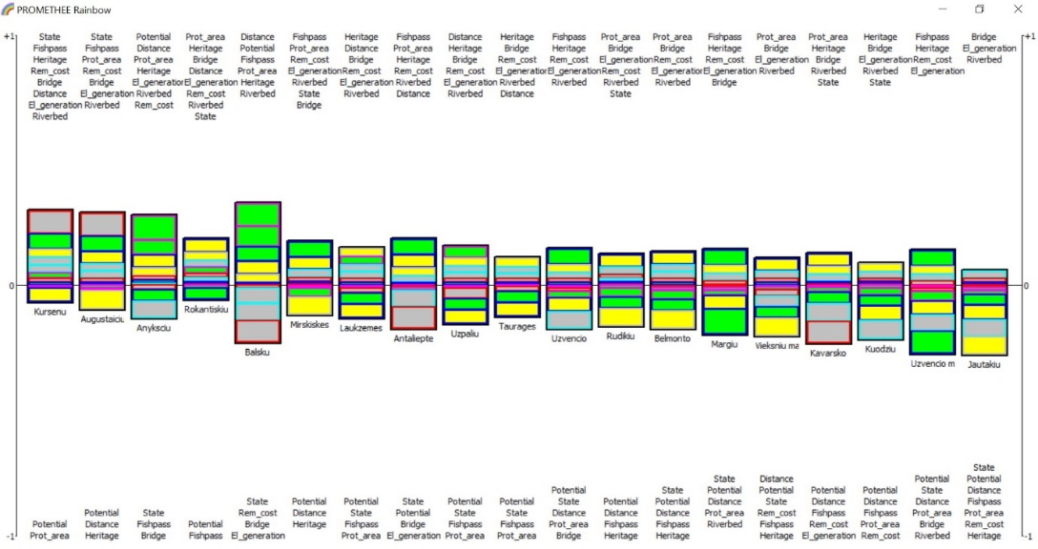
Fig. 2. The impact of each criterion on the final ranking (strengths and weaknesses)
As seen from the satellite image, Kuršėnai dam is an old watermill-like stone weir. The year when it was built is unknown. First, it is recommended for removal because it is in the critical state, has no fish pass and is not listed as a cultural heritage. Furthermore, it is the cheapest dam to remove (2,924 Eur.), there is no need for bridge construction, and it does not have HPP. It would also open up quite a significant distance for salmonid fish migration (47.7 km) and has a favourable natural riverbed downstream to the other dam.
In this case, the two criteria that show weaknesses are more critical. Firstly, the Kuršėnai dam is not in a protected area. And secondly, it has no potential for salmonid fishes to migrate upstream. It means that a dam downstream (Augustaitis‘ mill) is blocking the river, and the removal of Kuršėnai dam will not provide any added value. Therefore, it should not be removed first.
According to the MCDA tool, the second dam for removal is Augustaitis’ mill dam. It is the site of an old watermill, built in 1932 (Fig. 4). The main reasons for these recommendations are that this dam is in a critical state, has no fishpass and is in a protected area. Other strengths are that it does not have HPP, there is no need for a bridge, the downstream stretch has a natural riverbed, and the removal would not be expensive (30,658 Eur.).

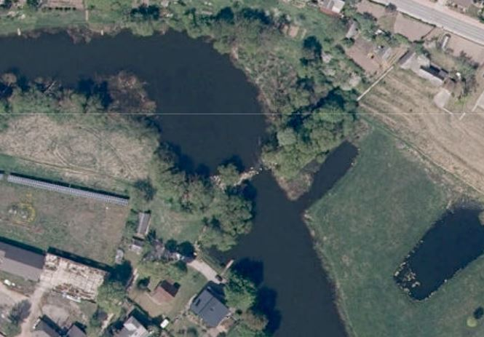 | 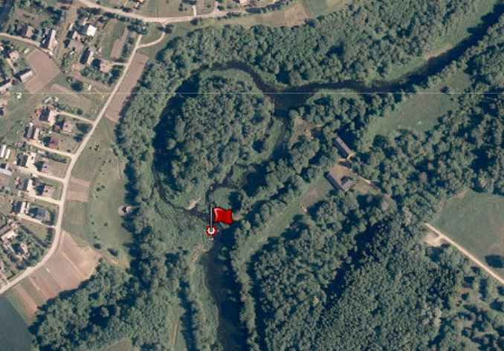
Fig. 3. Satellite view of the Kuršėnai dam (image from geoportal.lt) | Fig. 4. Satellite view of the Augustaitis’ mill site. The location of the dam is marked with the flag (image from  geoportal.lt)
Still, the weaknesses of Augustaitis’ mill dam are the factors that should be considered when deciding. Yes, it has moderate potential for salmonid fish upstream (12,858.3 Eur/y) and an average stretch length that can be freed for migration (26.1 km). It is also clear now that the next dam upstream is Kuršėnai dam. Removing both could significantly increase the salmonid population in the river Venta at the significant river stretch with relatively low cost as all other dams downstream have fish passes. However, removing the Augustaitis’ mill dam is not currently possible since it is listed as a national cultural heritage.
The third dam recommended for removal is the Anykščiai dam. It is an old watermill site, built in the centre of Anykščiai city in 1910. During the Soviet Union era, the site was reconstructed into HPP and generated electricity until 1969. the dam gained its current view in the latest reconstruction in 1986 (Fig. 5)
The factors that are in favour of this dam removal are: it has the largest potential for salmonid fishes of all the dams that are considered in this study (205,472.5 Eur/y), it will free a considerable length of the river Šventoji upstream for fish migration (66.7 km) and has a natural riverbed downstream. Furthermore, it is in a protected area, does not generate electricity and is not listed as cultural heritage. Also, it is not the most expensive dam to remove (346,216 Eur).
The factors against the removal are that it is in a relatively good state and already has a fish pass. Still, it is not an effective fish pass, so this dam blocks salmonid fish migration. Furthermore, the bridge would be needed to be re-build as this is the centre of the resort city with recreational infrastructure constructed in the area. Overall, the advantages of this dam removal clearly outweigh the disadvantages. Therefore, this dam could be the first recommended for removing all the dams on the salmonid rivers in Lithuania.
Lastly, looking at the Rokantiškiai dam example, why the dam with HPP can be recommended for removal may be analysed. Rokantiškiai dam was built in 1934. The reconstruction into HPP (installed capacity of 132 kW) was made in 2004 (Fig. 6).

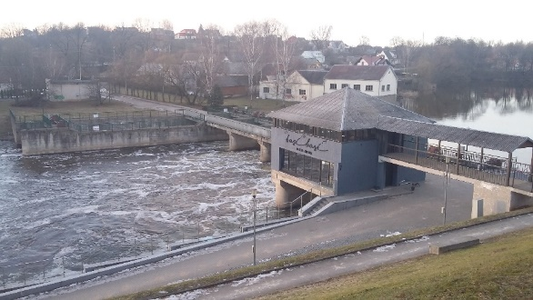 | 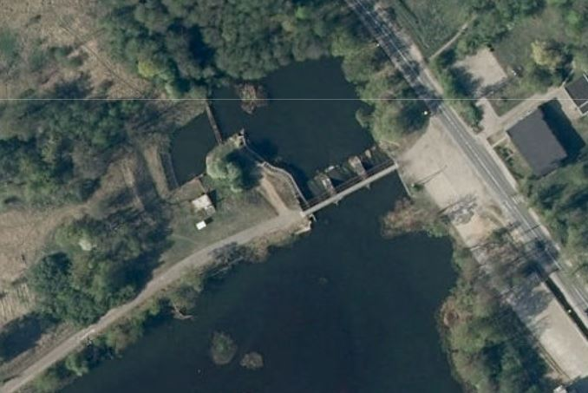
Fig. 5. The view of the Anykščiai dam (photo by EK) | Fig. 6. The Satellite view of the Rokantiškiai dam site (image from  geoportal.lt)
The Rokantiškiai dam has a fish pass and a relatively low potential for salmonid fishes (4,606.5 Eur/y). Still, it is an old dam in a bad state. It is the fourth worst dam according to electricity generation (371.6 MWh) of all dams on salmonid rivers in Lithuania with HPP. Furthermore, it is a dam in the protected area with no need for a bridge. The removal will free the 48.5 km of the river Vilnia, which would cost approximately 309,647 Eur. Can that justify the removal; it remains to be seen.
The general idea for using MCDA to select dams for removal is to rank them so that the removal would provide the highest environmental revenue with the lowest losses in the socio-economic aspect. Using this logic, dams with HPPs should not be among those selected for removal. It coincides with the recommended best practice from European Commission for hydropower development – to upgrade existing hydropower plants and to utilise existing in-stream structures (Kasiulis et al. 2020). The reality is that due to the strict environmental laws, the last HPP in Lithuania was commissioned in 2017. Since 2021 HPPs in Lithuania are not supported by feed-in tariffs, a new water tax is planned. Therefore, the probability of removing the dam with HPP in Lithuania is high.
4. Conclusions
Dam removal and the process of first dam selection for removal may be controversial. The socio-economic and environmental aspects that usually contradict each other should be considered. Multi-criteria decision analysis system can be utilised to solve this issue. In this case, Visual PROMETHEE software was used. Four socio-economic and four environmental criteria were used, giving them equal importance.
Dams on salmonid rivers in Lithuania were assessed, and three dams that were recommended for removal were Kuršėnai and Augustaitis’ mill dams on the river Venta and Anykščiai dam on the river Šventoji. Although removing the Kuršėnai and Augustaitis’ mill dams could significantly increase the salmonid population in the Venta river over a significant river stretch at a relatively low cost, this option at this day is impossible in Lithuania as the Augustaitis’ mill dam is listed as a national cultural heritage.
Therefore, according to the MCDA results, the first dam that could be recommended for removal is Anykščiai dam. Removal could also significantly increase the salmonid population in the river Šventoji over a significant river stretch. This indicator is the best among all other dams on salmonid rivers. Furthermore, the dam is not listed as a national cultural heritage, is in a protected area and has no hydropower plant.
The dams that have hydropower plants can also be recommended for removal. In the case of the Rokantiškiai dam, it is mainly that the dam is old and in a bad state. It is not listed as a national heritage but is in a protected area. Still, what needs to be considered is that this dam already has fish pass and the potential for salmonid fishes spawning upstream is not that high.

References
Amber project. Retrieved from: https://amber.international/ (30-06-2022).
Birnie-Gauvin, K., Nielsen, J., Frandsen, S.B., Olsen, H-M., Aarestrup, K. (2020). Catchment-scale effects of river fragmentation: A case study on restoring connectivity. Journal of Environmental Management, 264, 110408. DOI: 10.1016/j.jenvman.2020.110408
Bonnet, M., Witt, A., Stewart, K., Hadjerioua, B., Mobley, M. (2015). The Economic Benefits of Multipurpose Reservoirs in the United States – Federal Hydropower Fleet. Tennessee, USA: Oak Ridge National Laboratory.
Dam, T.T., Burritt, R.L., Pisaniello, J.D. (2012). Adequacy of policy and practises for small agricultural dam safety accountability and assurance in Vietnam. Agricultural Water Management, 112, 63-74. DOI: 10.1016/j.agwat.2012.06.006
European Commission. Retrieved from: https://ec.europa.eu/environment/news/free-flowing-rivers-commission-advises-how-select-sites-and-finance-removal-obsolete-barriers-2021-12-21_en (30-06-2022).
Gido, K., Whitney, J., Perkin, J., Turner, T. (2015). Fragmentation, connectivity and fish species persistence in freshwater ecosystems. In G. Closs, M. Krkosek, & J. Olden (Eds.), Conservation of Freshwater Fishes (pp. 292-323). Cambridge: Cambridge University Press. DOI: 10.1017/CBO9781139627085.011
Ivetić, D., Milašinović, M., Stojković, M., Šotić, A., Charbonnier, N., Milivojević, N. (2022). Framework for dynamic modelling of the dam and reservoir system reduced functionality in adverse operating conditions. Water, 14, 1549. DOI: 10.3390/w14101549
Jablonskis, J., Kovalenkovienė, M., Tomkevičienė, A. (2007). Channel Network of the Lithuanian Rivers and Small Streams. Annales Geographicae, 40(1), 46-56.
(in Lithuanian).
Jesung, J., Lee, J., Shin, D., Park, H. (2009). Development of dam safety management system. Advances in Engineering Software, 40, 554-563. DOI: 10.1016/j.advengsoft.2008.10.009
Kasiulis, E., Punys, P., Kvaraciejus, A., Dumbrauskas, A., Jurevičius, L. (2020). Small hydropower in the Baltic States – current status and potential for future development. Energies, 13, 6731. DOI: 10.3390/en13246731
Morales-Torres, A., Escuder-Bueno, I., Serrano-Lombillo, A., Rodríguez, J.T.C. (2019). Dealing with epistemic uncertainty in risk-informed decision making for dam safety management. Reliability Engineering and System Safety, 191, 106562.
DOI: 10.1016/j.ress.2019.106562
Order No. 362 of the Minister of the Environment of the Republic of Lithuania on the division of water bodies, Vilnius, 10 July 2002. Retrieved from: https://e-seimas.lrs.lt/portal/legalAct/lt/TAD/TAIS.179375?jfwid=32wf8rcn (01-07-2022). (in Lithuanian).
Su, H., Yan, X., Liu, H., Wen, Z. (2017). Integrated multi-level control value and variation trend early-warning approach for deformation safety of arch dam. Water Resources Management, 31, 2025-2045. DOI: 10.1007/s11269-017-1631-8
Šadzevičius, R., Damulevičius, V., Skominas, R. (2013). The technical state of earth dams in Lithuania. Journal of Environmental Engineering and Landscape Management, 21(3), 180-188. DOI: 10.3846/16486897.2012.662910
Visual PROMETHEE software. Retrieved from: http://en.promethee-gaia.net/(01-07-2022).

